Learning French in Multilingual Contexts: The Impact of Extracurricular Activities Among Students in Postsecondary Institutions in Ghana and Nigeria

Abstract
In anglophone multilingual countries like Ghana and Nigeria, extracurricular activities have long supported the learning of French. Activities such as French club, exposure to francophone culture, and excursions to cultural or historical sites allow learners to practise French beyond formal classroom hours. However, there is limited research on their influence in anglophone multilingual contexts. Drawing on the theory of socialisation, this study explores how these activities influence the learning experiences of students studying French in public postsecondary institutions. Using a mixed-methods design, it combined an online questionnaire with semi-structured interviews. Data were collected from 401 survey respondents and 24 interview participants at postsecondary institutions that offer French in Ghana and Nigeria. Survey data were analysed descriptively, while interview data were analysed thematically. Findings show that regular participation in extracurricular activities improves students’ communicative competence and sustains engagement in French, although funding and organisational challenges continue to limit full participation.
Keywords:
Extracurricular activities, French club, Nigeria, Ghana, French as a foreign language, French student, postsecondary institution, multilingualism

Competing interest: The authors have no competing interests to declare.

- Introduction
Multilingualism has become an asset for both national and personal development in an increasingly globalised world. While English still maintains its status as a global lingua franca (Selvi et al., 2023), the acquisition or learning of other major international languages remains essential for many fields, including diplomacy, international business, and cultural exchange (Okoedion, 2019). Languages such as French, Spanish, and Portuguese, which were bequeathed by colonisation, continue to hold a recognised status in nearly all African countries more than sixty years post-independence (Akinpelu, 2024; Akinpelu & Yegblemenawo, 2023). These languages are used for official and administrative functions, including education.
In many Anglophone countries, the teaching and learning of French as a foreign language have become a strategic priority within education systems. Hence, for countries like Nigeria and Ghana, which are surrounded by Francophone countries, learning French is not just beneficial but increasingly essential for facilitating cross-border trade, regional integration and effective communication among citizens.
Although French has enjoyed official recognition (particularly in education) since 1998, following a declaration by the Nigerian government, the Ghanaian government has always shown a strong commitment to French. In 2019, Ghana announced its intention to adopt French as the second official language, alongside English (Ministry for Foreign Affairs and Regional Integration, 2019). This commitment led to Ghana being granted full membership status in the Organisation Internationale de la Francophonie (OIF) in October 2024 (Ministry for Foreign Affairs and Regional Integration, 2025), following a transition from associate membership, which it had held since 2006 (OIF, 2022).
The language-in-education policies in both countries support the teaching and learning of French despite challenges such as limited learner motivation, unavailable teaching and learning resources, difficulty of French graduates in securing employment, and lack of conducive environments for practising oral communication in French outside the language classroom, among others (Akinpelu & Yegblemenawo, 2023; Okoedion, 2019). Although classroom contact hours remain very relevant for language learning, they do not fully address the need for oral proficiency development and affective dimensions of language learning, particularly in non-francophone environments where there is limited access to opportunities for authentic communicative experiences (Akinpelu & Yegblemenawo, 2025; Agbotah, 2021; Akuneme et al., 2021; Akanbi, 2020; Marinze, 2019a).
Activities outside the classroom that provide supplementary opportunities stand to complement and reinforce classroom-based approaches. Indeed, extracurricular activities can help address these constraints by complementing academic learning with social, cultural, and personal development opportunities. Beyond the classroom, activities such as excursions to cultural centres or historical sites and participating in French club activities expose learners to diverse cultural narratives and support real-life cultural immersion in the target language (Yegblemenawo & Yegblemenawo, 2025). Participation in these activities can also enhance learners’ motivation and attitudes towards the learning of foreign languages (Albayrak & Şener, 2021). Such initiatives could serve as a bridge between the formal teaching and learning of language in the classroom and authentic language use.
The overall goal of this research is to examine the impact of extracurricular activities in French on learners’ proficiency development and learning experiences in Ghana and Nigeria. Specifically, this paper seeks to:
- identify common extracurricular activities among postsecondary French students in Nigeria and Ghana and explore the relationship between these activities and formal classroom learning.
- examine the languages used during extracurricular activities and the level of exposure to Francophone culture.
- explore strategies adopted for funding these extracurricular activities in the various institutions.
- outline key challenges associated with organising these activities and make recommendations.
The research questions guiding this study are:
- How do learners of French in postsecondary institutions in Ghana and Nigeria navigate their language proficiency experience outside the classroom?
- Which major challenges do members of French clubs face, and how can these be mitigated to make these activities more beneficial to the students?
- What impact do extracurricular activities have on learners’ overall competence in French?
The study contributes to a better understanding of the importance of promoting and supporting extracurricular activities, as they offer an opportunity for students learning French in Anglophone and multilingual settings like Ghana and Nigeria to enhance their oral and written proficiency, which, in turn, would have a positive impact on the quality of French students who graduate each year.

- Literature Review
Previous research shows that extracurricular activities organised within language clubs can influence language learning beyond the formal classroom. Such activities create opportunities for members of these clubs to be exposed to the cultural aspect of the language and practice what they learnt in class, thereby promoting literary engagement and language learning (Alcântara et al., 2024). This role is particularly important in postcolonial contexts such as Ghana and Nigeria, where language serves not only as a medium of communication but also as a marker of cultural identity, social mobility and a tool for educational advancement (Hulstaert, 2018).
This supportive role is important, as evidence from both Ghana and Nigeria shows recurring challenges with learners expressing themselves spontaneously and fluently. Among the causative factors are: anxiety, fear of making errors, insufficient vocabulary, phonological interference, and the anglophone context the learners find themselves in (Fiagbe, 2023; Afari et al., 2023; Yegblemenawo et al., 2023; Akanbi & Kezie-Osuagwu, 2020; Inegbe, 2020; Dumenyah, 2015), despite a reported use of the communicative approach aimed at improving their communicative competencies.
Other literature on extracurricular activities pushes for support for these club-based activities, as these activities enhance cognitive and social outcomes. Chan (2016, p. 2) argues that these activities “may enhance students’ problem-solving, analytical and critical skills through co-operative activities and hands-on experiences.” This is supported by a broader literature affirming their positive impact on students’ academic and personal development while fostering essential social connections (Christison, 2013; Stuart et al., 2011; Blomfield & Barber, 2009; Fredricks & Eccles, 2008; Eccles et al., 2003). Longitudinal evidence from Fredricks & Eccles (2008) and Eccles et al. (2003) is particularly persuasive that engaging in structured extracurricular activities, such as school clubs and sports, results in better academic outcomes, higher school engagement, stronger prosocial peer networks, and reduced risky behaviours among adolescents. Recent studies demonstrate that exposing learners to culture through media, native-speaker interaction, and curriculum content, as well as engaging in language club-based activities, not only improves learner motivation, communication skills, and oral fluency but also develops learners’ social competencies and confidence (Chung & Long, 2024; Benabbes et al., 2024), thereby reinforcing the importance of extracurricular activities outside the classroom.
Students are more likely to complete a foreign language programme when they appreciate its relevance to their personal or professional goals. In Ghana, for instance, Csajbok-Twerefou et al. (2014) found that many students of French at the University of Ghana acknowledged the importance of French for employment in international organisations. Similarly, in Nigeria, Oyeniyi (2014) and Agbor & Ashabua (2018) found that when students know the importance of learning French, it influences the attitude they have towards it. More recent studies associate proficiency in French with increased opportunities for competitiveness in both the local and international job markets, particularly in fields such as diplomacy, tourism, teaching, and it also strengthens cultural ties with neighbouring Francophone countries (Egbe-John & Umukoro, 2024; Braimah & Bito, 2023).
Despite these positive insights, challenges remain in the teaching and learning of French in anglophone settings. Afari et al. (2023) report the urgent need to adopt more contextually appropriate methods for teaching oral French. Their evaluation of the oral component of the French WASSCE Examination revealed a lack of spontaneity, fluency, and understanding of examination questions. These deficits are compounded by systematic challenges such as students’ inability to form complete sentences, an insufficient number of qualified French teachers, overcrowded classrooms, and a lack of standardised teaching and learning resources (Marinze, 2019b). Such challenges reinforce the importance of complementary safe spaces where learners of French can practise French without stress, thereby developing confidence and sustaining interactions in French.
However, although the importance of extracurricular activities, such as those organised by French clubs is widely acknowledged, there remains a limited understanding of how French learners in both Ghana and Nigeria develop their language proficiency outside formal classrooms and how participating in these French club activities contributes to their communicative competence and overall learning experience. Existing literature primarily focuses on classroom-based extracurricular interventions, often neglecting the role of extracurricular activities undertaken in informal language classroom settings in supporting language learning.
- Theoretical Framework
This paper draws on the language socialisation theory, which came from early research works of Ochs and Schieffelin in the 1980s, based on their studies of Samoan and Kaluli caregivers, in response to the limited attention given to the diversity of languages and cultures in the study of first-language acquisition. Language socialisation entails “socialisation through language and socialisation into language” (Ochs and Schieffelin, 2017, p. 6). Although considered an interdisciplinary field at the intersection of many fields, such as anthropology, linguistics, and developmental psychology, the guiding principle of research in language socialisation is that language is central in the process of understanding socialisation (Brown and Gaskins, 2014; de León & García-Sánchez, 2021). Two types of language socialisation can be identified, according to Brown and Gaskins (2014): (1) socialisation through mastering language forms and (2) socialisation through participating in interaction.
On the one hand, socialisation through mastering language forms involves the understanding and internalisation of a particular language by a speaker. While it was developed largely from research in monolingual societies, the concept was later extended to include bilingual and multilingual societies, taking into account various issues associated with language contact, such as code-switching. Socialisation through participating in interaction, on the other hand, refers to the function and purpose of interaction in the process of socialisation. It holds that “cultural information is communicated through talk during everyday interactions. [Learners] get socialised through interaction not only to language practices but also to the full range of cultural practices and their meanings” (Brown and Gaskins, 2014, p. 205).
Drawing on language ecology that stresses the study of interactions between a language and its environment, Steffensen and Kramsch (2017) highlight the relationship between second/foreign language learning/acquisition and second language socialisation. According to them, the ecology model questions the early second-language acquisition research which holds that “language is a structural entity sui generis; it traces cognition to an inner, mental realm; and it separates learners from their sociocultural and autobiographic contexts” and neglects “the influence of the social context in the development of language use or communicative competence … because it took for granted that language could have no other function than for communication” (p. 19). However, since the 1990s, sociocultural theorists and sociolinguists have established that language does not function only as a mode of communication but also as a symbol of social and cultural identity, thereby establishing the connection between language acquisition and language socialisation. Additionally, an ecological perspective of second language (L2) acquisition views the notion of language socialisation differently, as it relates to adolescents and adults. According to Steffensen and Kramsch (2017):
From an ecological point of view, the concept of language socialisation differs when it comes to adolescents and adults learning a second language from when a child is socialised through his/her mother tongue into a given cultural setting. The L2 socialisation processes of adolescents and adults who are already socialised in their primary community are saturated with reflexivity regarding identity, social relations, and their political implications. Their language acquisition is inseparable from the secondary socialisation that follows from being transplanted into a non-native culture or into the culture of the educational system. (p. 21)
Consequently, second/foreign language acquisition or learning is more than just educational settings but also includes various other learning contexts (Steffensen and Kramsch, 2017), such as extracurricular activities outside the classroom.
Moreover, the importance of extracurricular activities in learning a foreign language has already been established. Recent studies have shown the pertinence of these activities not only in providing learners with opportunities to interact in the language in authentic and meaningful contexts but also in promoting social interaction (Mondada and Doehler, 2000; Santiago-Garabieta et al., 2023). Interactions within the context of language learning create a space and opportunities for meaningful learning and the construction of new knowledge (Canelas-Trevisi & Thévenaz-Christen, 2002). It also favours the Zone of Proximal Development (ZPD) - the distance between what a learner can do independently and what the learner can do when the needed assistance is provided - which occurs through guided participation and support from more capable peers, mentors, or teachers (Vygotsky, 1978).
In both Ghana and Nigeria, extracurricular activities are an integral part of the experience for students pursuing a French programme at the postsecondary level (university and college of education). Typically organised as extracurricular activities within the framework of a French Club or a French Students’ Association, these initiatives are typically student-run. In sum, extracurricular activities in second or foreign language learning provide a dynamic and enriching learning environment where learners can develop their linguistic, cultural and social skills in a meaningful way. This observation supports the constructivist approach to learning, which highlights the active role of learners in constructing their understanding of the world. This is facilitated by providing opportunities for learners and students to engage in meaningful language use, problem-solving tasks, and collaborative learning activities (Nunan, 2012).
4. Extra-curricular Activities within French Clubs
Language clubs are defined as extracurricular activities where learners meet regularly to practice their target language and engage in related cultural activities outside the formal curriculum (Ávila & Riveros, 2024; Demydovych & Holik 2020). Characteristics of these activities include being generally voluntary with a regular participation schedule, some structure and rules and being organised around particular competencies (Fredricks, 2008). Related names, such as conversation clubs (Ávila & Riveros, 2024; Şenbayrak & Ortaçtepe Hart, 2024), foreign language clubs (Nealon, 1950), and speaking clubs (Demydovych & Holik 2020), are used in some existing literature to describe these extracurricular language activities. In this study, we prefer to use French Students Association and French Club interchangeably to reflect the terminology used in institutions in both Ghana and Nigeria.
While the precise origins of these activities are difficult to trace, they have evolved into various tasks which aim to facilitate academic achievements. Activities across campuses in both countries include music and dance, drama, debate and symposiums, and excursions, as well as targeted writing and oral communication workshops.
In Ghana, for instance, the French Students Associations at the Kwame Nkrumah University of Science and Technology, the University of Ghana and the University of Cape Coast propose a variety of weekly activities, such as News Club, Debate and Reading Club, Dance and Music Clubs, Drama and Poetry Clubs, Special Events and Excursions, etc., to meet different interests and learning needs.
Similar student-led initiatives are found in postsecondary institutions in Nigeria, such as the University of Ibadan and Obafemi Awolowo University. These activities provide authentic contexts for cultural immersion, allowing students to use the French language in real-life interactions and bridging the gap between classroom instruction and practical application.
More broadly, extracurricular activities, such as structured debates, poetry, theatre, sports, professional development and “my hobby” workshops, excursions, and festivals, encourage students to collaborate and engage with others, developing creativity alongside intercultural competence. Institutions maintain linkages with the Organisation Internationale de la Francophonie (OIF) to support language and culture initiatives and partnerships in cross-national education and student development. In 2025, for instance, French club members were invited to participate in the Francophonie Festival 2025, themed “Je m’éduque, donc j’agis”. It featured music concerts, theatre performances, poetry events, sports, seminars/lectures, and a cultural parade, promoting the value of education and cross-cultural programming. (Francophonie Festival, 2025). Campuses also host weekly sessions for students to participate in or lead debates, poetry, music, and excursions that provide a platform for students to engage with French while interacting with students with Francophone backgrounds. Additional cultural events, such as movie nights, quizzes, and reading clubs, are sometimes organised in collaboration with Campus France.
Collectively, these activities demonstrate ways in which extracurricular activities expand and facilitate student learning outside of conventional classroom contexts, deepening linguistic competence while developing cultural consciousness and meaningful social relationships.

5. Methods

5.1 Research design and setting
This research adopted a mixed-methods convergent design, combining an online questionnaire and semi-structured interviews to collect both qualitative and quantitative data. The primary objective was to carry out a situational analysis of the impact of extracurricular activities on French undergraduate students in postsecondary institutions in Ghana and Nigeria. Specifically, it examined students’ perceptions of the role of French club activities in supporting the development of the French language, sustaining engagement, and the perceived academic and social benefits associated with participation.

5.2 Participants, sampling and eligibility criteria
For the survey participants, the target population comprised undergraduate students majoring in French in postsecondary institutions in Ghana and Nigeria. A purposive sampling technique was adopted to select the participants. Eligibility criteria included (1) being a French student enrolled in a postsecondary institution in Ghana and Nigeria; (2) having spent at least one academic semester in the current institution; and (3) participating in extracurricular activities organised by the French Students’ Association (French Club) in their department since enrolling in the school. Participants were recruited by sending promotional materials to postsecondary institutions in Nigeria and Ghana to disseminate among students of French and by using social media platforms.
For the qualitative data, a semi-structured interview guide was used to ensure consistency across interviews. Data were purposively collected from 24 participants across both countries (16 from Nigeria and 8 from Ghana). To ensure a national representation, each country was divided into three geographical zones: Northern, Middle and Southern belts.
5.3 Data Collection Procedures
Data for this research were collected using an online questionnaire administered through the University of Regina’s Qualtrics platform and through semi-structured interviews with selected members of the French clubs in Ghana and Nigeria. The questionnaire had both open-ended and closed-ended questions and was administered from February to October 2024 in both Ghana and Nigeria. These questions captured students’ participation in the French club activities and their perceived benefits.
The semi-structured interviews were conducted through Zoom in both countries between September and November 2024. Each interview lasted approximately 25 minutes. The interviews were audio recorded with the consent of individual participants and then transcribed for analysis.
5.4 Ethical Considerations
This project was reviewed and approved on ethical grounds by the University of Regina Research Ethics Board. All ethical standards were met in line with the approval granted. Participation in this survey was entirely voluntary. Informed consent was obtained from all respondents before completing the online questionnaire and participating in the semi-structured interviews. In addition, participants were assured of the confidentiality and anonymity of their responses. Interview recordings and transcripts were stored securely, accessible to only the research team and used solely for this study.

6. Data analysis and interpretation
Data from both instruments were analysed separately. Quantitative data were analysed using descriptive statistics such as frequency tables and percentages to summarise the responses collected. These are procedures used to describe and summarise data through pictorial or graphical representations (Cooksey, 2020). Qualitative data from the open-ended questionnaire items were repeatedly read to help familiarise with the data. NVivo 15 was then used to identify, code, and categorise the key ideas that emerged from participants’ responses. Similar codes were then grouped into broader themes to reflect the various experiences students shared (Braun & Clarke, 2006; Vaismoradi et al., 2013).
The semi-interview transcripts were transcribed and assigned a unique code to protect confidentiality and anonymity. Ghanaian participants were coded GH 1 - GH 8, while Nigerian participants were coded NG 1 to NG 16, rather than identifying them by institution or by their personal names
The findings from both Nigeria and Ghana were integrated and presented concurrently. This approach helped compare, synthesise and interpret quantitative and qualitative strands of data within a single discussion. This was necessary because integration in mixed-methods research approach allows for areas of convergence, divergence and complementarity to be identified, thereby providing a more comprehensive understanding of the experiences across both countries (Bazeley, 2024).

6.1. Demographic data of participants
In total, 401 students participated in the online survey, with 130 respondents from Ghana and 271 from Nigeria. This exceeded the initial target sample of 300 respondents across both countries. In terms of the gender distribution, the sample from Ghana indicates a nearly balanced representation. Out of the 130 respondents, 51% identified as female and 48% as male, with only 1% preferring not to disclose their gender and none identifying as non-binary or third gender. The scenario is a bit different in Nigeria, where the gender distribution favours the female category. Out of the 273 people who participated in the online survey, more than two-thirds (67%) identified as female, while about a third (32%) identified as male. Only 1% of them chose not to disclose their gender, whereas none identified as non-binary or third gender. See Figure 1 below.

While data shows a broad geographic representation across both countries, respondents are mainly from the Ashanti region in Ghana (33%) and the South-West region in Nigeria (45%). In addition, although French students at all levels participated in the online survey, students in their third and final years represented 71% of the respondents in Nigeria, while participants in Ghana were mainly in the second, third and fourth years of their programme – 28%, 28% and 33% respectively.
Interview data were collected from 8 participants from Ghana and 13 participants from Nigeria who have enrolled in postsecondary institutions which offer French in both countries. Out of the 8 participants from Ghana, 3 are females, and 5 are males. In Nigeria, out of the 13 participants, 4 are males, and 9 are females. All interviewees were active members of the French club in their institutions. Three executives and one non-executive member were interviewed.

6.2 Common extracurricular activities
Various extracurricular activities are held at the French Students’ Association meetings, including storytelling in French, spelling bee competitions, drama, symposiums, debates, singing competitions, quiz competitions, poetry recitation, games, interuniversity competitions, dance, pick and act, music and movie sessions, etc. However, as survey data revealed (Figure 2), in Nigeria, the most popular activities among French students are drama (64%), debate (62%), and dance (34%). In Ghana, drama (79%), dance (56%) and debates (30%) top the list.

6.3 Funding the extracurricular activities
Extracurricular activities in Nigeria and Ghana are mainly funded through contributions made by French students. These contributions are usually mandatory and vary from institution to institution, ranging from 10 to 30 cedis in Ghana and 1,000 to 10,000 naira in Nigeria on a semester or yearly basis. They are normally added to the student’s school fees, and in some cases, collected by the department as indicated in the following excerpts from respondents.
The HOD [Head of Department] is the one taking care of the money. They have an account for the French club. Okay. Yeah. So, as the money is being paid, then the list, the number of those who pay will be given to the HOD and the HOD will submit and then the money will be saved by the bank. Okay. (GH 3)
There’s this dues we pay as students of the French department as Cercle français Levy. All students. We are bound to pay for it. It’s compulsory. It’s not optional just for departmental clearance. So we paid the sum of 1500 naira, and the student was issued a receipt Cercle français, which has been approved by not only the department, not only the faculty but by the university. (NG10)
To better fund their extracurricular activities and enhance services offered to their members, some French students’ association leaders have adopted other means, such as grocery sales and fundraising activities, as mentioned by some participants from Ghana.
We pay dues every semester. Okay. So out of the dues that we use to prepare some foodstuffs, then we use as get-together before the semester ends. Within the department, we have a printer, we have a fridge. So these two machines give us money. With the fridge, we use it to sell water. At first, we used to sell other things like yoghurt. Okay. Later, we realised that the yoghurt was draining us… Then we focus on the water. And then with the printer, we use it to print at an affordable price. Right. Okay. (GH 8)
We started fundraising. It is our first time, though we are trying. We offer some t-shirts and then French, the club t-shirts ... So, through the t-shirts you purchase, we get funds from that. (GH 1)

6.4 Languages used during extracurricular activities
Although activities at French language association meetings are meant to be conducted exclusively in French, findings reveal that these meetings are essentially dominated by the use of French and English in both countries. As data from the online survey shows in Figures 1 and 2 below, in Ghana, the majority of the respondents (73%) reported using both French and English during these activities, while only 13% indicated an exclusive use of French, and 14% stated that they engage in multilingual use of languages, combining French, English and a local language. Only 1% of the respondents indicated the use of French and a Ghanaian language. In Nigeria, 76% of the respondents indicated using French and English, compared to only 11% who use French only and 12% who use French, English and a local language during these meetings. Only 1% of the respondents from Nigeria indicated using French and Pidgin during these activities.

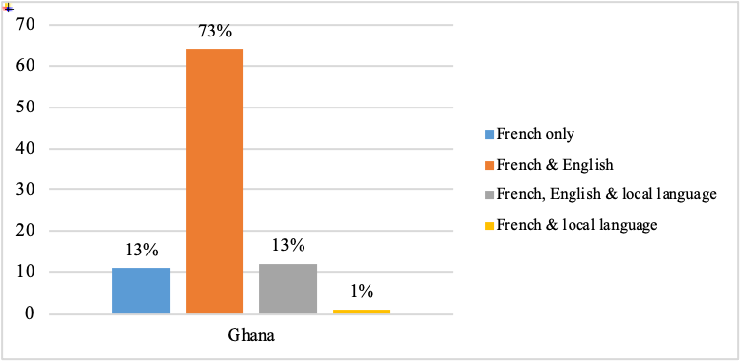
Figure 1: Languages used during French association activities in Ghana

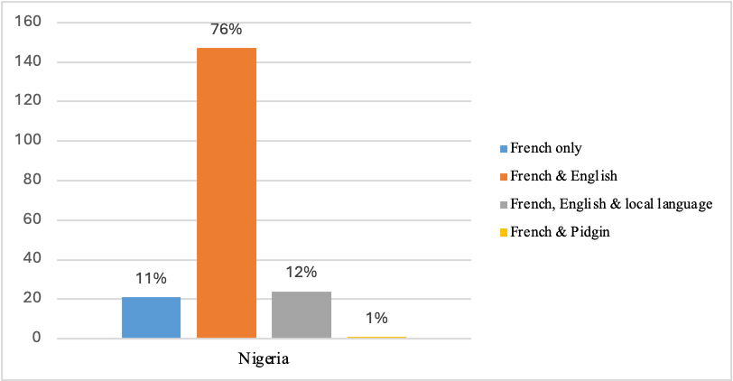
Figure 2: Languages used during French association activities in Nigeria

Data from the interviews support this finding and provide reasons for the language choice. First, French students’ associations bring together students at different academic levels – some are in the first year of their undergraduate programme and their proficiency level in French is still developing. As a result, the English language is often used as a tool for inclusion and to aid understanding. This is illustrated in the interview excerpts below:
I would say it was a mélange [blend]. It was a mélange. So when we were with the level 100, for instance, we spoke more English than French. But for the other levels, especially 300 or 400, it was more French than English. Mainly because we felt like, you know, you are at a stage, for 300 or 400, you are at a stage where you should be able to construct. Logical sentences is in French, so, you know, just to help everyone. So, it was more French than English. But then when, you know, given that it’s an Anglophone setting, it’s one of the setbacks we face. How do we balance the two, you know? In order to get the message across, should it be more French than English or more English than French? It was one of the struggles. But depending on the level and the context, it was either more English to French or more French to English. (GH 7)
Okay. Yes, French is the language, but since we are also learners, there are times that somebody is hooked. English is also used. So it’s a mixture of French and English. So those let’s say 100 level students that we are trying to bring them so that next time they don’t feel discouraged, there are times we allow them to also use English, so the major language is French, but English is also there so the 2 languages are English and French. (NG 7).
Second, there seems to be a general sense of linguistic insecurity due to a broad low level of proficiency in French among students, as mentioned in the excerpts below.
Okay, officially, we all agree that it’s French that we are supposed to use. But you know, whenever we go to meetings like this, even though it is agreed that it’s French, some people still try to bring in the English because they are scared of expressing themselves because they are afraid, they might be laughed at. But it’s strictly French. (GH 5)
So the main language we use is French. But sometimes they use English because, you know, we are Anglophone as I said earlier, so it’s not every word or every vocabulary in what they say that we understand. So they use English, they use French, but they ensure they use more French sometimes… (NG 8)

6.5 Link between formal classroom learning and extracurricular activities
Interview participants indicated a direct link between formal French learning and the activities organised during the French students’ association meetings. To several of them, these meetings provide them with the opportunity to go over topics not well understood in the classrooms. Additionally, activities such as théâtre (drama), symposium, atelier (workshop), etc. help students develop oral communication skills, as mentioned by some participants below.
Yes, I think they do… In the classroom, I believe that we are not taught how to express, per se. I would say we are taught the pedagogical knowledge, like what to teach when we go to the classroom. It’s mainly, let me not say, it’s mainly exam per say, but they focus on the course content. Yes, even though there are times where we have other engaging activities in class, but the priority is the course content. So, the activities that we engage in in the clubs, it helps with the day-to-day conversation, not only the course content. It helps you to be able to converse with someone else. It just helps you build upon your French as a person, not just to learn for exams. (GH 5)
Yes, absolutely. Of course, you see that, for example, this atelier normally is based on whatever they teach or whatever that is being practised. It is based on the course content for the particular semester. OK, everything is based on what the drama is, the drama aspect, the theatre, the reading aspects or the speaking aspect. Everything is based absolutely on the course contents that we’re supposed to be taught. So, you see, we combine them. Levels 100, 200, but of course, the facilitators look at what level 100 is supposed to look at, what level 200 is supposed to treat this semester and then blend them. (GH 6)

That’s some of them are not taught in class and sometimes we do expose on some topics probably topics we have used for like a like exposing class. Like a symposium probably because we have some courses where the lecturer will choose some groups of people or students to talk about a particular subject and some other group as well. So talk about some other things where we students, we ask questions. And our colleagues, our other students in other groups they answer. So we bring some of these topics taught there or treated there to our social education activities. (NG 1)
Most of the courses that the students are finding difficult most of the topics. In maybe Grammaire, culture civilisation, and the other literary courses as well. Some students would like those who are good in each area to come and throw more lights to help them understand the topics properly. (NG 10)

6.6 Exposure to Francophone culture
While members attending the French Students’ Associations are normally exposed to French culture through regular activities, qualitative data revealed that the Francophonie Week event - La Semaine de la Francophonie - which is held yearly in March, constitutes the moment when students have the opportunity to immerse themselves in the francophone culture in many aspects of its diversity.
We also had this every single day there was a word and the minute that we give out to the students for them to learn. We also had expression de la semaine that is every Wednesday to had an expression. We had one called en Francais s’il vous plaît. That means on every Friday it’s only French that we speak on our pages in classroom, everywhere it is French. …Yeah, that is for the academic aspect when it comes to the fun aspect of it, we had a trip. We had two trips so one was among ourselves so we went to I think Kwame Nkrumah Museum and then Aburi botanical gardens. The second trip we did it with the school from the Côte d’Ivoire called Tifa. So, we went to with them on a trip around Accra to different places and when we were doing that as we were doing that we were speaking French with them and they were speaking English with us. (GH 7)
Then that is on a Saturday. We also have the talent show, where people come and only perform a talent; we give the space. But all the talents are performing in French, like singing in French, dancing to a French song. You are reciting a poem in French. You are doing something in French. That is for the talent show. Then on a Sunday, we go back and then do Thanksgiving. And then the Thanksgiving mass is also done in French. And we have been able to do that three consecutive times, which is something we can boast about. (GH 3)

“Okay, we… introducing the French culture we do something they called like when we have our semaine francophonie, we do what we call the French food basically. And some French songs.” (NG1)
We were much in class for the activities. And we learned, we talked about la Journée de la Francophonie and that was, that was a great one where we have one of our lecturers who spoke on la Journée de la Francophonie, and we went ahead to ask the students questions and they were able to give positive responses to these questions (NG 3).

6.7 Impact of activities on participants’ overall proficiency in French
Findings from quantitative data show that participants who attended the extracurricular activities regularly find them very beneficial to their knowledge of French and their oral proficiency in French (see Figures 3, 4 and 5).

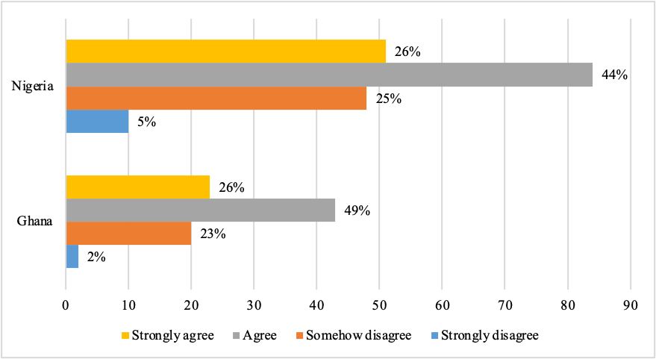
Figure 3: Impact of extracurricular activities on participants’ knowledge of French

As Figure 3 above shows, 44% of participants in Nigeria agree and 26% strongly agree that activities held during the French association meetings are beneficial to them, while 25% somehow agree, and a small portion (5%) strongly disagree. In Ghana, 49% of the respondents indicated that participating in these activities has helped them improve their knowledge of the francophone culture, 26% of the participants stated that they strongly agree, 23% also affirmed that it has somehow helped them, and 2% of the participants stated that they strongly disagree.
Respondents were also asked to rate their oral proficiency in French as a result of attending and participating in the socio-educational activities organised by their French clubs. As shown in Figure 4, students in Nigeria rated their oral proficiency between 4 and 9 on a scale of 10, with the highest value being 5 and 6 cited by 24% and 18% of them, respectively. In Ghana, most respondents rated their oral proficiency between 4 and 8, with the highest value being 6 (24%). This is followed by the ratings of 5 and 8, which represent 22% and 14% of the responses (see Figure 5):

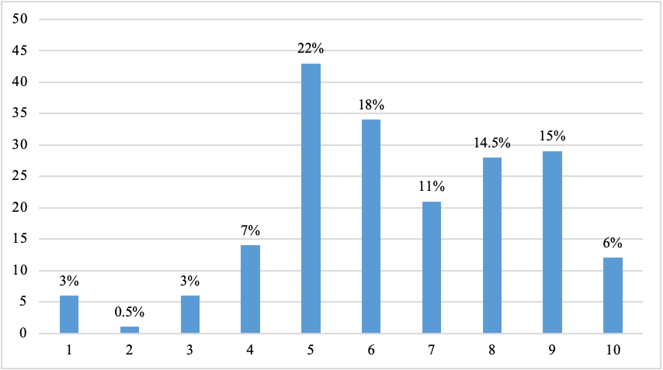
Figure 4: Participants’ self-assessment of their oral proficiency in French (Nigeria)

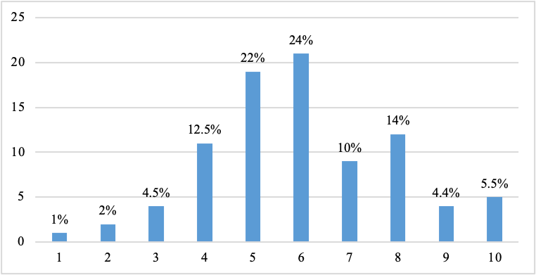
Figure 5: Participants’ self-assessment of their oral French proficiency (Ghana)

Data from the interviews conducted in both countries have also shown that French students who attend these activities derive many benefits from them, including the opportunity to practise their French while socialising, and a sense of belongingness.
Very important. One, it helps when you are part of those types and you engage in, it brings sense of belongingness. You feel belong to a group of people, and then you all share your ideas. You get to have time to talk to people who have the opportunity to learn from others. You have the opportunity to have fun and get educated as well. So, it’s very important. (GH 5)
For example, now, because of this, social educational activities, I’m able to like, when a teacher asks a question, I’m able to express myself a little. At least you will know what to say. Because before I started this French club something. I was not able to express myself. Sometimes you can even ask me a question I will not know what you are saying. (NG 12)
This socio-educative has really helped, especially me talking, it has really helped me a lot. Like they used to tell us that, learn a new word, learn a new word every day, but it used to be hard for us students because in the college of education, it is not only French, you combine two courses. (NG 8)

7. Challenges
In spite of the many benefits associated with attending activities held by French Students’ Associations, students who took part in this study have highlighted several challenges that continue to undermine the effectiveness of these associations. A major challenge reported across all the associations in Nigeria and Ghana is inadequate funding and limited sponsorship, as contributions made by students themselves are insufficient. As a result, some executive members of these associations indicated that they use their personal resources to finance some activities.
So, part of the funding came from the association coffers, of course and when, of course, when we started, basically, we took dues and we thought, yes, and all that. So, some of the money all came from there… So, I had to convince them how it works. We contributed a lot for several other programmes so we could have it. And some of them had to sponsor it on my own. But for external sponsors, we never had one. We never even had a couple from anyone, I remember, I don’t know what to tarnish any organisation, but they couldn’t help us. We went to them. We had a conversation with them many times about our programme. So, we started. We never really disappointed. So, yeah, external organisation, nothing, everything was from me. Not even campus, France. Oh, not even a person, even French employees, no money. (GH 7)
Well, we’ll do that sometimes because like I said, I’m the president of my club and sometimes, the schools contribute and sometimes. We call for sponsor if there is one among our students and some people like myself for instance some days I just fund it. As far as my capacity can go. So that’s how we do because the truth is that we don’t have much fund for these activities. (NG 1)
Attendance at these extracurricular activities constitutes another challenge. All French students’ associations in both countries do experience low participation of student members. The fact that executive members have to work with the classmates or agemates, coupled with the absence or lack of enough support from lecturers who are often not present at these meetings, exacerbates the situation.
Okay, our challenges, the first one will be the attendance. They either don’t come at all or when they come, they come very late. Okay, a major problem with how they show up for meetings or programmes is either they don’t come at all, or they come, and then they are very late, maybe an hour late. The other problem was the finances to organise more programmes… and then financial difficulties. (GH 4)
So it is stressful going around gathering the students. it is written in the constitution of the department that it’s way from noon to 2 pm every Wednesday, no lecturer. (NG 10)
Some of the challenges we face are number one: The department. From our lecturer, basically there is not much emphasis on this activity. It is what we students try to make effective among ourselves. The school is not really putting in much effort to ensure that all students participate. (NG 1)

8. Discussion and Conclusion
Findings in this study offer some interesting details about extracurricular activities held during the French Students’ Associations meetings in Nigeria and Ghana. Generally speaking, French Students’ Associations offer many advantages to their members. First, they continue to be an integral part of French language learning in both countries, with drama and debate standing as the most popular and choicest events during these gatherings due to their ability to help learners develop and improve their oral proficiency skills. Second, they complement formal classroom learning, as they constitute a tutoring platform whereby stronger and senior students are able to assist weaker and junior ones with topics not well understood in the classroom. Third, activities such as dancing and gastronomy are commonly used as a means of exposure to francophone culture. However, in Ghana, as well as in Nigeria, the yearly Francophonie Week event (La Semaine de la Francophonie) gives the students the opportunity to learn more about francophone culture in its diversity, including the cultures of neighbouring francophone countries. Despite their many benefits, French Students’ Associations are faced with many challenges, such as the lack of adequate resources to fund their activities, challenges in learning a foreign language in a multilingual and anglo-dominant context, and a lack of support from lecturers. Notwithstanding, for French students who attend these extracurricular activities regularly, they find that they have aided their overall knowledge of French, including their oral proficiency in the language.
In short, extracurricular activities continue to be relevant to learning French in diverse sociolinguistic contexts, such as Nigeria and Ghana, as they offer students the opportunities to socialise through interactions in the language being learned and its culture (Brown and Gaskins, 2014). In this perspective, socio-educational activities complement formal language learning which, for the most part, tend to neglect communicative and oral competencies, which are crucial in foreign language learning. These associations also provide a safe place for students to socialise, have fun and support one another’s French learning in highly multilingual and Anglo-dominated contexts.
We offer a few recommendations based on this study’s findings. First, while payment of association fees is mandatory in most institutions, attendance at the French Associations’ meetings is not. To mitigate the attendance challenge, we suggest that every institution integrate extracurricular activities as part of the French curriculum design and make them a required component of the programme by assigning some university credits to them – the number of credits may vary from institution to institution. This would further strengthen the link with what is learned in the classroom and serve as the practical component of the learning experience. Also, it would encourage the full support of lecturers, which is currently lacking and foster the development of oral communication skills in French in each learner, which continues to be a serious challenge. Our second recommendation draws on the first one. To alleviate the funding challenge, French departments should consider including their French students’ associations as part of their budget and encourage their institutions to invest more in French language teaching and learning. Additionally, French departments are better placed to initiate sponsorships from external bodies (private sectors, embassies, etc.) than the students themselves. Finally, while making attendance mandatory would give more control of the extracurricular activities to French departments, provisions must be made for fun activities organised by students for students.
Ultimately, extracurricular activities offer several benefits to French as foreign/second language learners. They promote socialisation and social interaction by encouraging learners to communicate in the language with their peers, teachers, and other native or non-native speakers (Vygotsky, 1978). They also help to contextualise learning by connecting language knowledge to concrete situations, which promotes the retention and application of linguistic knowledge. Additionally, these activities increase learners’ motivation by engaging them in interesting and stimulating activities (Ménard, 2021), and help develop their intercultural competence by exposing them to the cultural diversity of the French-speaking world (Mouto, 2013), while stimulating learners’ autonomy by giving them the freedom to choose activities based on their interests and linguistic needs.

References
Afari, S. K. E., Yegblemenawo, C. A. A., & Bakah, E. K. (2023). Oral production assessment among learners of French in Senior High Schools in Ghana: the case of WASSCE French examination. Akofena, 327-344. https://doi.org/10.48734/akofena.s007v3.29.2023.
Agbottah, S. Y. (2021). L’étude du français comme matière dans un contexte anglophone: Le cas de trois Établissements postsecondaires au Ghana. The University of Regina (Canada).
Akanbi, B. T., & Ndidi, K. O. C. (2020). Improving Learners’ Oral Proficiency in French through the Communicative Approach: Colleges of Education in Oyo in Focus. Journal of Curriculum and Teaching, 9(1), 55-62.
Akinpelu, M. (2024). Défis et perspectives de l’enseignement en langue maternelle en Afrique. In M. Adjeran & M. Akinpelu (Eds.), Enseignement-apprentissage en langues africaines. Mythe ou réalité après plus de soixante ans d’indépendance ? (pp. 21-34). Bénin : Éditions du Sodylary (Presses du Sodylary).
Akinpelu, M., & Yegblemenawo, S. A. M. (2023). Teaching French as a foreign language in multilingual and Anglophone contexts: The experiences of teachers in Nigeria and Ghana. Educational Considerations, 49(2), 7. https://doi.org/10.4148/0146-9282.2345
Akinpelu, M., & Yegblemenawo, S. A. M. (2025). L’apprentissage du français langue étrangère en contextes multilingues et anglophones d’Afrique de l’Ouest: l’expérience des apprenants au Nigeria et au Ghana. Canadian Journal of African Studies/Revue canadienne des études africaines, 59(1), 1-22. https://doi.org/10.1080/00083968.2024.2388074.
Akuneme, C. C., & Nwosu, K. C. (2021). French and Chinese third language learners’ communication apprehension in a Nigerian university: Influence of prior knowledge and their demographic profiles. Journal of Educational and Social Research, 11(5), 54-65.
Alcântara, E. M. de S., Santos, D. V. dos, & Figueiredo, P. de M. S. (2024). Leitura literária em foco: mapeamento dos clubes de leitura no Brasil contemporâneo. REVISTA DELOS, 17(62), e3269. https://doi.org/10.55905/rdelosv17.n62-138.
Ávila, L. R. Á., & Riveros, R. A. M. (2024). Bolstering Intercultural Communication among EFL Learners in Online Conversation Clubs. GIST–Education and Learning Research Journal, 29(29).
Bazeley, P. (2024). Conceptualizing integration in mixed methods research. Journal of Mixed Methods Research, 18(3), 225-234. https://doi.org/10.1177/15586898241253636
Benabbes, S., & Taleb, H. A. A. (2024). The effect of storytelling on the development of language and social skills in French as a foreign language classrooms. Heliyon, 10(8). https://doi.org/10.1016/j.heliyon.2024.e29178.
Blomfield, C. J., & Barber, B. L. (2009). Brief report: Performing on the stage, the field, or both? Australian adolescent extracurricular activity participation and self-concept. Journal of Adolescence, 32(3), 733-739. https://doi.org/10.1016/j.adolescence.2009.01.003.
Braun V, Clarke V. 2006. Using thematic analysis in psychology. Qualitative Research in Psychology, 3(2): 77–101. https://doi.org/10.1191/1478088706qp063oa .
Brown, P., & Gaskins, S. (2014). Language acquisition and language socialisation. In N. J. Enfield, P. Kockelman, & J. Sidnell (Eds.), Cambridge handbook of linguistic anthropology (pp. 187-226). Cambridge: Cambridge University Press.
Canelas-Trevisi, S. & Thévenaz-Christen, T. (2002). L’étude des interactions en classe de français langue étrangère et langue maternelle : deux « didactiques » au banc d’essai ? Revue française de pédagogie, 141, 17-25. https://www.persee.fr/doc/rfp_0556-7807_2002_num_141_1_2911.
Chan, Y. K. (2016). Investigating the relationship among extracurricular activities, learning approach and academic outcomes: A case study. Active Learning in Higher Education, 17(3), 223-233. https://doi.org/10.1177/1469787416654795.
Christison, C. (2013). The Benefits of Participating in Extracurricular Activities. BU Journal of Graduate Studies in Education, 5(2), 17-20. https://www.brandonu.ca/master-education/journal/.
Chung, D., & Long, N. (2024). Language learning through a cultural lens: Assessing the benefits of cultural understanding in language education. International Journal of Social Science and Human Research, 7(7), 5345-5352. https://doi.org/10.47191/ijsshr/v7-i07-82.
Cooksey, R. W. (2020). Descriptive statistics for summarising data. In Illustrating statistical procedures: Finding meaning in quantitative data (pp. 61-139). Singapore: Springer Singapore.
De León, L., & García-Sánchez, I. M. (2021). Language socialization at the intersection of the local and the global: The contested trajectories of input and communicative competence. Annual Review of Linguistics, 7(1), 421-448. https://doi.org/10.1146/annurev-linguistics-011619-030538.
Demydovych, O., & Holik, O. (2020). Speaking club as an interactive extracurricular activity in learning English for professional purposes at medical universities. Advanced Education, 7(14), 4-10.
Dumenyah, J. K. (2015). Impact de l’approche communicative sur la performance orale des apprenants de FLE dans quelques lycées de la Métropole d’Accra (M.Phil dissertation, University of Ghana).
Eccles, J. S., Barber, B. L., Stone, M., & Hunt, J. (2003). Extracurricular activities and adolescent development. Journal of social issues, 59(4), 865-889. https://doi.org/10.1046/j.0022-4537.2003.00095.x.
Egbe-John, A. U., & Umukoro, G. M. (2024). Perception and Attitude towards French for specific purposes among Linguistics Students in the University of Calabar. Journal of English Language Teaching. 11(1), 226-237. http://dx.doi.org/10.26858/eltww.v11i1.65139
Fiagbe, F. K., Fiadzawoo, J. K., & Agbo, J. K. (2023). Systemic barriers to effective teaching/learning of French in Ghana: Policy and curriculum perspectives. European Journal of Language Policy, 15(1), 105-126.
Fredricks, J. (2008). Extracurricular activities. In Encyclopedia of Educational Psychology (Vol. 2, pp. 388-392). SAGE Publications, Inc., https://doi.org/10.4135/9781412963848.n104
Fredricks, J. A., & Eccles, J. S. (2008). Participation in extracurricular activities in the middle school years: Are there developmental benefits for African American and European American youth? Journal of Youth and Adolescence, 37, 1029-1043. https://doi.org/10.1007/s10964-008-9309-4.
Hulstaert, K. (2018). “French and the school are one”–the role of French in postcolonial Congolese education: memories of pupils. Paedagogica Historica, 54(6), 822-836.
Inegbe, M. S. (2020). Communicative and speech challenges of teaching, learning and speaking French as a foreign language in Nigeria. AKSU Journal of English, 3(1), 171-181.
Marinze, I. (2019a). Spoken French evaluation of National Diploma II secretarial studies students of selected polytechnics in Nigeria. International Journal of Arts, Languages, Linguistics and Literary Studies, 8(1), 22-28.
Marinze, I. (2019b). French Language in Nigerian Polytechnics-What Future for Oral Proficiency? Journal of Modern European Languages and Literatures, 11, 73-95.
Ménard, L. (2021). La motivation au cœur de l’apprentissage. In B. Raucent, C. Verzat, C. Van Nieuwenhoven and C. Jacqmot (Eds.). Accompagner les étudiants : rôles de l’enseignant, dispositifs et mises en oeuvre (p. 87-105). De Boeck Supérieur. https://doi.org/10.3917/dbu.rauce.2021.01.0087.
Ministry for Foreign Affairs and Regional Integration. (2019). Ghana Committed to the Acquisition of French as a Second Language – Foreign Minister https://mfa.gov.gh/index.php/ghana-committed-to-the-acquisition-of-french-as-a-second-language-foreign-minister/.
Ministry for Foreign Affairs and Regional Integration. (2025). Ghana Commemorates the 55th Anniversary of La Francophonie. https://mfa.gov.gh/index.php/ghana-commemorates-the-55th-anniversary-of-la-francophonie/#:~:text=He%20recalled%20Ghana’s%20journey%20towards,support%20during%20this%20transition%20phase.
Mondada, L., & Doehler P. S. (2000). Interaction sociale et cognition située : quels modèles pour la recherche sur l’acquisition des langues ? Acquisition et interaction en langues étrangères, 12, 1-21. https://doi.org/10.4000/aile.947.
Mouto Betoko, C. (2013). Compétence interculturelle et enseignement des langues maternelles en Afrique francophone contemporaine. Multilinguales, 1, 95–104. https://doi.org/10.4000/multilinguales.3163.
National Commission for Colleges of Education. (2025). https://ncce.gov.ng/AccreditedColleges.
National Universities Commission. (2025). https://www.nuc.edu.ng.
Nealon, J. (1950). The Foreign Language Club as an extra-curricular activity. The Modern Language Journal, 34(1), 58-60.
Nigerian Scholars. (2025). https://nigerianscholars.com/school-finder/french/.
Nunan, D. (2012). Learner-centered English language education: The selected works of David Nunan. Routledge. (1st ed.). New York: Routledge. https://doi.org/10.4324/9780203096888.
Nwaukoni, A. & Ezeamaka, J.E. (2024). Making the Teaching and Learning of French Relevant to the Technological Needs of Polytechnic Education in Nigeria. International Journal of Academia, 7(1), 1-13. https://acjol.org/index.php/academia/article/view/4926.
Ochs, E. & Schieffelin, B. (2017). Language Socialisation: An Historical Overview. In Duff, P., May, S. (eds). Language Socialisation (pp. 3-16). Encyclopaedia of Language and Education. Springer, International Publishing AG. https://doi.org/10.1007/978-3-319-02327-4_1-1.
Okoedion, E. G. (2019). A Review of the Benefits and Obstacles of Learning French Language in Nigeria. International Journal of New Economics and Social Sciences IJONESS, 9(1), 341-351. http://dx.doi.org/10.5604/01.3001.0013.3054.
Olaseinde, F.O. & Olaseinde, B.O. (2024). From Constraints to Control: The French Language Classroom in Multilingual Nigeria. International Journal of Education, Learning and Development, 12(3), 1-11. https://doi.org/10.37745/ijeld.2013/vol12n3111.
Onah, G. (2019). Issues in French Language Learning in Nigeria. Available at SSRN: https://ssrn.com/abstract=3479777 or http://dx.doi.org/10.2139/ssrn.3479777
Organisation Internationale de la Francophonie. (2022). La langue française dans le monde 2019-2022. Éditions Gallimard. https://www.francophonie.org/sites/default/files/2023-03/Rapport-La-langue-francaise-dans-le-monde_VF-2022.pdf.
Santiago-Garabieta, M., Zubiri-Esnaola, H., García-Carrión, R., & Gairal-Casadó, R. (2023). Inclusivity, friendship and language learning: boosting collaboration in interactive groups. Educational Research, 65(2), 189–203. https://doi.org/10.1080/00131881.2023.2189433.
Selvi, A. F., Galloway, N., & Rose, H. (2023). Teaching English as an international language. Cambridge University Press.
Şenbayrak, M., & Ortaçtepe Hart, D. (2024). Exploring social justice dialogues in EFL conversation clubs: discursive moves and affordances. Language, Culture and Curriculum, 37(3), 327–342. https://doi.org/10.1080/07908318.2024.2339316
Steffensen, S. V., & Kramsch, C. (2017). The ecology of second language acquisition and socialization. In Duff, P.A., May, S. (eds.), Language socialization, Encyclopedia of Language and Education (pp. 17-32). Springer, International Publishing AG. https://doi.org/10.1007/978-3-319-02255-0_2
Stuart, M., Lido, C., Morgan, J., Solomon, L., & May, S. (2011). The impact of engagement with extracurricular activities on the student experience and graduate outcomes for widening participation populations. Active Learning in Higher Education, 12(3), 203-215. https://doi.org/10.1177/146978741141.
University of Ghana (n.d.). Exploring FRENSA-UG: A Hub for French Language and Culture at the University of Ghana. https://www.ug.edu.gh/french.ug/student/news-info/exploring-frensa-ug-hub-french-language-and-culture-university-ghana.
Vaismoradi, M., Turunen, H. and Bondas, T. 2013. Qualitative descriptive study. Nursing and Health Sciences, 15: 398-405. https://doi.org/10.1111/nhs.12048.
Vygotsky, L. S. & Cole, M. (1978). Mind in society: The development of higher psychological processes. Harvard University Press.
Yegblemenawo, C. A., Afari, E. S., De-Souza, A. Y., & Ayakwa, A. N. (2022). Dramatization and Foreign Language Learning Anxiety: The Case of French in Ghana. Journal of Educational Development and Practice, 6(1), 1-15.
Yegblemenawo, D. E. E., & Yegblemenawo, S. A. M. (2025). Critical Pedagogy in The French Language Classroom in Ghana: Challenges and Perspectives. Educational Considerations, 50(3), 8.

