Syntactic and Multimodal Representation of Ideology in Nigerian ‘Tinubunomic’ Internet Memes

ABSTRACT:
Internet memes as principal semiotic practices through which netizens engage in political participation have been explored from varied dimensions. However, online memes on Tinubunomics in a post-election context has received little to no attention in linguistic scholarship; hence, the need for the present study. The study investigates the syntactic and multimodal representation of ideology in Nigerian ‘Tinubunomic’ Internet Memes. It identifies the linguistic and semiotic resources in the memes; explores the interplay between the linguistic elements and semiotic resources depicting participants in the memes; and illuminates the ideological meanings underlying the humour rhetoric embedded in the various resources. Data for this study consist of verbal-visual humorous internet memes that centre on Tinubunomics, and shared on Tiktok Lite, Whatspp, Instagram and Nairaland between June 2023 and June 2024. The study integrates Kress & van Leeuwen’s socio-semiotics, van Dijk’s ideological square with Neuendorf, et al.’s multiple senses of humour. Findings unearthed that syntactic elements in the memes range from words, catchphrases to sentences; while images and colour were utilised as semiotic resources; both the syntactic elements and the visual elements worked together as multimodal ensembles to produce repetition, allusion, ironic sarcasm, name-calling, and foregrounding. Also, it was discovered that the memes presented Tinubunomics dark and disparaging humours that serve the ideological dual purposes of denigrating Tinubunomics as impoverishing economism while emphasising in positive terms Nigerians’ resilience in the face of oppression. The study concluded that Tinubunomic meme practices bear socio-political significance as visuals of discontent and protest.

KEYWORDS: Humour; Ideology; Internet Memes; Multimodal representation; Semiotics; Tinubunomics

¹Corresponding author: Joel Iyiola Olaleye
Author’s ORCID ID: 0000-0002-1181-8794

1. INTRODUCTION
The contemporary ubiquitous term ‘meme’ surprisingly predates digital evolution. Its root could be traced to Dawkin (1989), an evolutionary biologist; its etymology is connected to the Greek word, mimema, which denotes ‘imitated thing’; and its original biological semantics signifies cultural replication (Holm, 2021, p. 2). However, with the ascent of the internet, meme usage has now been expropriated by internet users, thereby giving the word a digitised sense known as internet meme. Thus, internet memes are multimodal ensembles with meaning potentials created by and shared among netizens in today’s digital culture (Miltner, 2017; Nissenbaum & Shifman, 2018; Scott, 2021). These digital contents could be an image, a GIF, an audio image, or a short video clip thematically (re)framed to evoke some illocutionary force across meme-contexts (Han & Smith, 2023).
Internet memes, politics and humour are intricately connected. From the glut of viral genres on the social mediascape, internet memes serve as the principal semiotic practices through which netizens appraise political information and situations to engage in political participation. Adegoju and Oyebode (2015, p. 645) conceptualise them as ‘artefacts of political communication’. Meme collectives laden with politics-based concerns have, therefore, been thematised as ‘political internet memes’ (henceforth, PIMs). PIMs thus refer to a category of ‘a collective practice of political expression performed by internet users who engage in de- and re-contextualisation of political content’ (Johann, 2022, pp. 1 & 3). At play in PIMs are diverse linguistic and visual elements fraught with political information; prominent among them is humour (Oyemade & Adeagbo, 2020; Moussa, Benmessaoud & Douai, 2020). Humour chiefly seeks to amuse as it has been equated with hilarity symbol in the digital world (Tay, 2014), and construes as the ‘… linguistic playfulness that accompanies many internet memes’ (Miltner, 2017, p. 416). Underlining its political potency and relevance however, Adegoju (2022) defines it as the ‘hallmark of the digital revolution and creativity in the deployment of communicative artifacts to serve social and political goals’ (p. 261).
In essence, in linguistic scholarship, internet memes have immensely gained traction mainly because they hold the greatest potential for multimodality in language use and activism. They represent multiple-mode semiotic resources often laden with humorous but satirical meanings reflecting sociocultural specificities (Miltner, 2017; Han & Smith, 2023). Social context is thus fundamental in memetic interpretation (Ugah, 2022). Every meme is discursive with its own theme, situational association and attitudinal frame that are context-specific (Diedrichsen, 2018). In consequence, the contextual affordances of internet memes as meaning-making social semiotic practices have engendered academic engagement among linguists in contemporary times (e.g., Holm, 2021; Ugoala, 2022).
However, in much of the extant literature, studies on political memes are foremost because internet memes have become popular digital tools for political expressions and practices since they are now often used to start and trendify political realities to provoke political conversations or criticisms (Ross & Rivers, 2017; Moreno-Almeida, 2021; Halversen & Weeks, 2023). Political memes reflect (non) verbal contents, actors, ideologies, harmonies, discords, etc. with political motif; and can as well influence physical and virtual political participatory outcomes (Johann, 2022). As a result, the memeification of politics, which Johann (2022, p. 2) calls ‘memeified politics’ (meme usage for political expression), has become a focus of linguistic scholarship. Political memes in diverse discursive contexts such as political dissent or protest (e.g., Okesola & Oyebode, 2023), presidential elections (e.g., Ross & Rivers, 2017; Oyemade & Adeagbo, 2020), political propaganda (e.g., De Leon & Ballesteros-Lintao, 2021), among others, are increasingly being examined using different linguistic theories.
Tinubunomics (short for Tinubu + economics) is a nominalised compounding in which the clipped form of economics, nomics, is suffixed to the surname of Tinubu, Nigeria’s incumbent president. The coinage is often used in Nigerian media-political discourse to denote the ruinous state of the Nigerian economy under the leadership of President Bola Ahmed Tinubu (henceforth, PBAT), who assumed office on May 29, 2023 on the platform of the ruling party, the All Progressives Party (APC) (Abati, 2023). On assuming office as Nigeria’s president, PBAT and his team introduced some economic policies which they claimed would improve the already battered Nigerian economy and make life better for Nigerians (Akande, 2024). Tinubunomics is, therefore, the omnibus term for PBAT’s economic reforms which PBAT himself highly lauds and demands global recognition for (Fasan, 2024). The reforms were kick-started with the removal of the controversial fuel subsidy which led to astronomical increases in food prices and basic commodities and plunged Nigeria into a chaotic economic quagmire as everyone is seeing groaning with no solution in sight.
In response to the unfolding harsh day-to-day realities occasioned by the economic reforms, the Nigerian populace started appropriating the resources of Internet memes to parody and criticise PBAT’s government as well as the socio-economic post-election realities in the country. This digital activism reflects ‘… the tension that citizens experience between their democratic ideals and the possibility of seeing these ideals made reality through democratic institutions’ (Van Wessel, 2010, p. 506 as cited in Adegoju, 2022, p. 257). Online meme usage comes in handy for the Nigerian public since its creation is inexpensive, unregulated and anonymous (Miltner, 2017). These Tinubunomic memes are thus verbal-visual images created and imitated by online users, and shared on social media platforms to satirically engage the positive and negative sides of Tinubunomics, question how the Nigerian economy fares under BAT’s reformatory economic blueprint, and humour how Nigerians are adapting to the new normal economic realities.
Despite this growing body of linguistic research, the memeification of Tinubunomics (a category of PIMs) on social media sites has received little or no attention in the literature. By implication, Tinubunomic meme discourse is largely unpopular among academic scholars, specifically linguists. This study is, therefore, a leadoff exploration on Tinubunomic discourse in linguistic scholarship which draws insights from Kress and van Leeuwen’s (2006) socio-semiotics, van Dijk’s socio-cognitive approach to critical discourse studies and Neuendorf et al.’s (2014) multiple senses of humour (SOH). Thus, it investigates the syntactic and multimodal representation of ideology in Nigerian ‘Tinubunomic’ Internet Memes. To achieve this, the study identifies the linguistic and semiotic resources in the memes; explores the interplay between the linguistic elements and semiotic resources depicting participants in the memes; and illuminates the ideological meanings underlying the humour rhetoric. By so doing, the study will be a rich addition to the expanding body of literature on the semiotic affordances of humour discourse in political internet memes.

2. THEORETICAL FRAMEWORK
Kress and van Leeuwen’s (2006) social semiotic approach to visual grammar is a culture-specific approach to describing the visual-text resources of a certain group and their implicit and explicit representations within the broad normative practices of that group. The framework is a socio-semiotic approach to visual analysis that describes broadly social, historical and situational structures as well as social actors, attitudes and value positioning that constitute visual semiotics (Machin & Mayr, 2012). Meaning is multimodally and socio-culturally coded and decoded, hence, the theory’s focus on signifying modes and how they represent meanings. Hinged on Halliday’s (1978) three metafunctions, the semiotic modes perform ideational (representing objects and their relations in our world experiences), interpersonal (establishing social relation between a sign producer, viewer and the sign object) and textual (composing a text of semiotic modes that cohere internally and externally) functions (Kress & van Leeuwen, 2006). In visual semiotics, these functions are respectively known as representation, interaction and composition.
Meme constructs are non-neutral, they rather articulate attitudes, biases, power relations and ideologies representative of concrete societal experiences (Dike, 2018). Hence, visual semiotics should be analysed from the angle of social critique (Kress & van Leeuwen, 2006). Adopting van Dijk’s (1995; 1998; 2008) socio-cognitive ideological approach thus provides the means of representing memes as visual discourses ideologically articulated. The approach connects discourse, social cognition and society in a triangular conceptual structure (van Dijk, 2008). The structure depicts how group members’ mental representations (cognition) systematically mediate between their everyday practices of interaction (discourse) and social structures (society). Ideologies are, therefore, social and cognitive (van Dijk, 1995). Revolving round the polarisation of Self (Us) and Others (Them), ideologies are coordinated by the dual objective of de-emphasising our good things while emphasising their bad points within a social struggle context (van Dijk, 1995, 1998, 2008). This polarisation is organised by an evaluative framework known as the ‘ideological square’ functionally guided by these four strategies: a) emphasise our good properties/actions; b) emphasise their bad properties/actions; c) mitigate our bad properties/actions; d) mitigate their good properties/actions (van Dijk, 1998, p. 10). The framework seeks to analyse all opinions and attitudes in visual structures that systematically express this ideological polarisation by the dominant group or the dominated group.
Deconstructing humour in the memes is hinged on Neuendorf et al.’s (2014) theoretical notion that relies on multiple senses of humour (SOH) in filtering public opinions and attitudes about marginalised groups within a socio-political context. Neuendorf et al. (2014) identify four broad mechanisms of humour appreciation within the interdisciplinary scholarly literatures on humour: superiority/disparagement, dark/arousal humour, incongruity, and social currency. Although many scholars within these literatures consider one particular mechanism to be paramount to the exclusion of others, Neuendorf et al. (2014) contend that a multiple approach where all the mechanisms simultaneously come into play is possible and any humour appreciation must start with this taxonomy. The superiority/disparagement mechanism is hinged on the aggression-based theory in which laughter is engaged to bear malice, express anger, hatred as well as superiority over others in a way that accentuate social power or antagonism between the humourist and the humour object (Raskin, 1985; Adegoju & Oyebode, 2015). By belittling the other through laughter, the humourist gets the satisfaction of a superior because people usually feel good about themselves through comparison with others (Ferguson & Ford, 2008). Dark/arousal humour originates from the early works of philosophers Immanuel Kant and Herbert Spencer in which they explicate humorous response as the means of releasing repressed feelings or emotional tension (Neuendorf et al., 2014; Adegoju & Oyebode, 2015). It is premised on the psychoanalytic theory which is concerned with the psychological effects of humour on its recipient (Krikmann, 2006).
Incongruity humour occurs when two distinct stimuli are simultaneously experienced; and the humour pleasure comes from ‘solving’ the incongruous puzzle (Neuendorf et al., 2014). It thus involves two different planes that are mutually incompatible, but share a commonality that makes possible the shift from one to another (Krikmann, 2006). These two planes are the set-up and the punchline, where the set-up initiates the script while the punchline completes it. Laughter is achieved when the punchline opposes all prior interpretations of the set-up (Nijholt, 2020). Social currency performs a phatic function as it is concerned with deploying humour in establishing and maintaining social relationships and regulating distance in those relationships (Neuendorf et al., 2014). It can also be experienced as pleasure from playful interaction, the establishment of social hierarchy and a sense of group affinity (Neuendorf et al., 2014).
For a more comprehensive delineation of both language constructions and semiotic resources in the memes, this study also amalgamates syntax with multimodal discourse analysis. Watson and Ducharme (1990, pp.404–405) argue that “the structure of language is…the key to the structure of mind”. Croft (2001) also emphasises that a grammatical construction is a symbolic unit which embodies form and conventional meaning. Therefore, attention is given to the grammatical units used in the memes. Osisanwo (1999) highlights five grammatical units (sentence, clause, group/phrase, word and morpheme) which are set up within the frameworks of the systemic functional linguistics. Syntactic explorations of these grammatical units enable analysts to unearth inventory of symbolic units contained in memes.
Although the various mechanisms discussed function independently, Neuendorf et al. (2014) validates a multi-dimensional approach in which they all operate simultaneously. The synergy of these theories will provide a comprehensive analytical base to understanding how visual and textual elements are interfused in Tinubunomic memes to construct humour and socio-political ideologies.
3. DATA AND METHODS
Data for this study consist of verbal-visual humorous internet memes that centre on Tinubunomics which were created and shared on Tiktok Lite, Whatspp, Instagram and Nairaland by Nigerian online users in response to PBAT’s economic policies. The four social media platforms are dominant multi-participant platforms notable for producing, modifying and cross-sharing popular memes on trending political happenings in Nigeria. Data from the sites are meant for public consumption, hence they require no access permission. The data were collected between June 2023 and June 2024, a time frame that marks PBAT’s first year of his four-year term of office as Nigeria’s President. Collating memes within this time span further afforded us the opportunity to assemble a broad collection of diverse Tinubunomic internet memes. Keywords such as ‘Tinubunomics’, ‘Tinubu humorous memes’ and ‘political memes on Tinubu’ helped in searching for the memes. Although diverse issues on PBAT and his government dominate the social mediascape, only memes that spotlight one or more of the following issues were purposively selected: a) PBAT’s perpetuation of Buhari’s legacies; b) the (dys)functionality of PBAT’s economic policies; c) upsides and downsides of Tinubunomics on Nigeria(ns); d) Nigerians’ coping mechanisms to the new normal economic realities; e) PBAT’s attitude to Nigeria’s economic challenges and Nigerians’ discomfort.
Fifty (50) memes were initially collected while only eight from the bulk were deployed for analysis after expunging humourless, duplicative, and immaterial ones. The selected data thus represent a modest sample from the trendiest humorous Tinubunomic memes having a number of modified variations across the social media platforms since popular humorous internet memes are often remixed creatively to facilitate intertextuality among a series of theme-related online meme forms (Džanić & Berberović, 2017). The data analytical approach was drawn up from a synergy of Kress & van Leeuwen’s (2006) socio-semiotics and van Dijk’s (1995; 1998; 2008) socio-cognitive approach to ideological analysis. The synergy was complemented with Neuendorf et al.’s (2014) theoretical perspectives on humour. These theoretical leanings are most apposite for the study because Tinubunomic online memes are predominantly multimodal humours.
4. ANALYSIS AND DISCUSSION
Utilising the tenets of the theoretical approaches explained in the precursory section, this section contains the investigation of the syntactic elements and the multimodal representation of ideology in Nigerian ‘Tinubunomic’ Internet Memes. For convenience’s sake the analysis of each meme garnered for this study is conducted under the three subheadings aligning to the set objectives.
Figure 1 below combines linguistic and visual resources to construct a sarcastic swipe against the economic policies by the Tinubu-led administration as demonstrated in the analysis that follows.
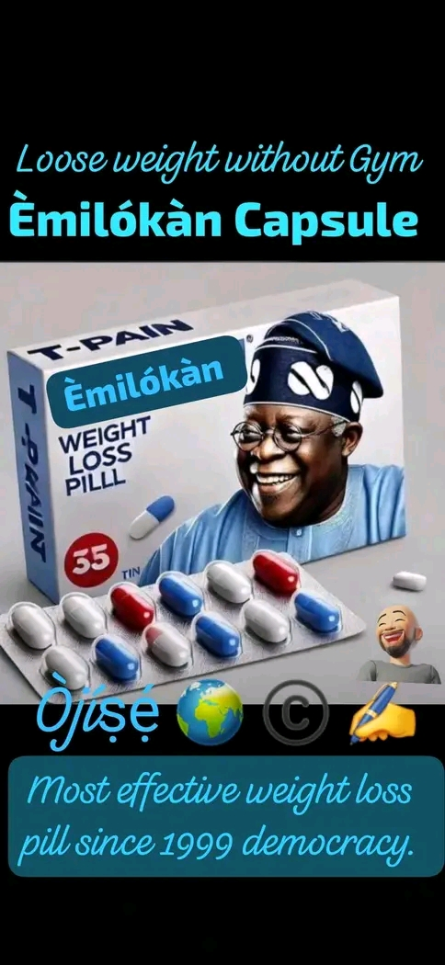
Figure 1: Emilokan [It’s-my-turn] Capsule
Linguistic Resources:
Syntactically, the linguistic resources: Emilokan Capsule at the upper section of the image is a Nominal group employed as a catchphrase for labelling the prescribed pill. Above the expression is also an imperative sentence: ‘Loose weight without Gym’, expressing the potency of the pill to provide succour for the weight loss. The nominal word: T-PAIN (a wordplay inscribed vertically and horizontally on the case) is morphologically generated from the first letter ‘T’ in the name ‘Tinubu’ blended with the highly unpleasant word ‘Pain’ to form a nominal compound. This ironically creates a negative impression that PBAT’s policies are causing pains to Nigerians. The Nominal group – ‘most effective weight loss pill since 1999 democracy’ at the lower section provides a context to the origin of mass starvation of Nigerians by humorously showcasing the effectiveness of the pills to provide a succour. The resultant humour pleasure is ideologically deployed to depict Tinubunomics as the most poverty-aggravating economic policy ever adopted since Nigeria became a democracy in 1999. The Adverb: Ojose is a Yoruba expression meaning, ‘weekly’. This provides a parody of the pill prescription.
Visual Resources:
In terms of visual mode, the images in the middle section ostensibly visualise the capsules fusing with a smiling political figure, PBAT to represent both as a single inseparable element. The fusion is the punchline that creates a symbolic process conferring the weight loss properties of the capsules on PBAT (the carrier) to humorously typify him as a poverty-aggravation president whose policies are emaciating Nigerians. Incongruity humour pleasure also occurs here in the attempt to equate PBAT with a weight loss pill. In terms of mode of colour, some of the linguistic resources and images are saturated in blue colour.
Interplay of the Resources and Ideological Meaning
It is obvious from the above analysis that both the linguistic resource and visual element work together as multimodal ensemble to project ideological meaning. For instance, the nominal group: Emilokan Capsule is ostensibly represented through the vivid images. Ideologically, the foregrounding attempt on the effectiveness of the pill creates a punchline which opposes the prior denouncement of the pill. PBAT’s glamorous appearance stands in sharp contrast to the weight-loss appeal of his Emilokan capsule. The contrast underscores the subtle creation of poverty and hunger by Nigerian politicians to subjugate the masses which lends credence to Bonga’s (2023) revelation on the weaponisation of poverty by political elites to manipulate the poor masses. We thus see the polarisation of the discourse between Nigerian politicians (the affluent) and the masses (the impoverished) in order to sarcastically intensify the negative attributes of PBAT in line with the ideological square.

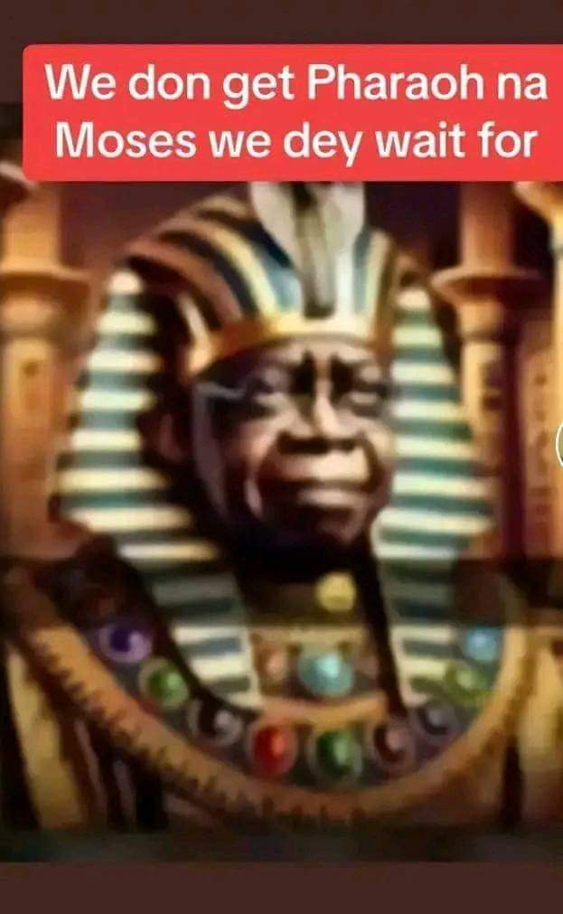
Figure 2: Tinubu as Pharaoh
Linguistic Resources:
In figure 2 above, the Nigerian pidging expression: “We don get Pharaoh na Moses we dey wait for” is syntactically a complex sentence which can be glossed as: We have gotten Pharaoh (Main Clause) while we have been expecting Moses (subordinate clause). This sentence expresses how the hope of Nigerians is disappointed in PBAT-led government. The repetitive usage of ‘We’ in the expression foregrounds the polarised structure of the meme which is organised as Nigerians (We) versus PBAT/the ruling party (They) in an oppressed-oppressor relationship.
Visual Resources:
In figure 2, the image act offers PBAT from a close distance as the viewers’ object of dispassionate scrutiny. A dark humour of oppression is emphasised in the lower section of the image with the punchline of the humour caricaturing PBAT in an Egyptian costume as the Pharaoh. PBAT is represented as a non-transactional reactor who looks on with a curious smirk. Vertically composed, the upper section is fully textual captioned in white against a saturated red background, presenting a recontextualised verbal representation of Nigeria as a Pharaoh-like country in need of a Mosaic rescue.
Interplay of the Resources and Ideological Meaning
Both the linguistic and visual resources in the meme work together to portray PBAT as an enslaver of the people and an enemy of God rather than the Mosaic analogy represents Moses’ deliverance of people from oppression. Pharaoh and Moses are thus visual metaphors for PBAT, the tyrant and imaginary saviour, respectively. Thus, in line with van Dijk’s ideological polarisation, PBAT’s negative attributes are emphasised while his positive attributes are muted in order to express Nigerians’ popular discontent with his government and their desperate call for a redeemer from his oppression.

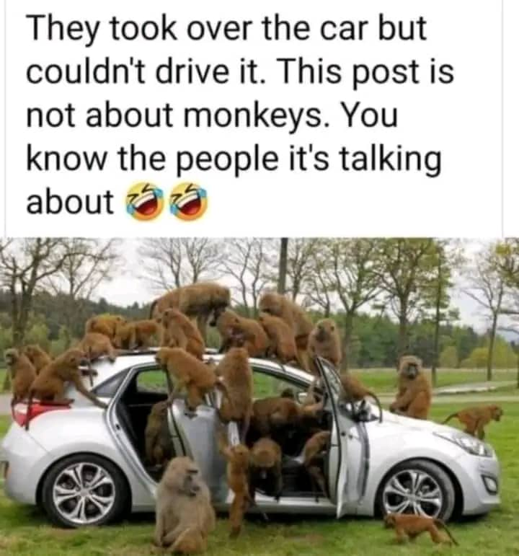
Figure 3: Clueless Leaders
Linguistic Resources:
The top section contains three declarative sentences: ‘They took over the car but couldn’t drive it. This post is not about monkeys. You know the people it’s talking about.’ The visual image, the car, typifies Nigeria and the Verb Phrase ‘couldn’t drive it’ indicates APC’s inability to govern the country. Although the ‘They’ in the first sentence literarily refers to the group of monkeys, the plural pronoun symbolises PBAT and the ruling party, who took over the reign of governance in Nigeria since May 29, 2023.
Visual Resources:
Figure 3 is a narrative structure which presents an unfolding dramatic action between two foregrounded represented participants (RPs), a group of moneys and a car. The visual representation is a socio-political allusion that symbolises the act of governing. The lower section is more practical as it visualises the cluelessness of the monkeys (APC) to drive the car (country) to sustainability.
Interplay of the Resources and Ideological Meaning
Both the image and the linguistic resources provide a verbal-visual humorous representation of how APC’s incompetence has rendered motionless and unprogressive Nigeria’s growth. The punchline of the humour in this meme reflects a metaphorical representation of APC members as a group of monkeys trying to drive a car, an act ordinarily unexpected of animals. The humour thus creates the impression that APC as a party is politically inept. By belittling APC members as monkeys, the image producer assumes superiority over them in a sarcastic way that bears heavy negativities around otherness as espoused in van Djik’s ideological polarisation.
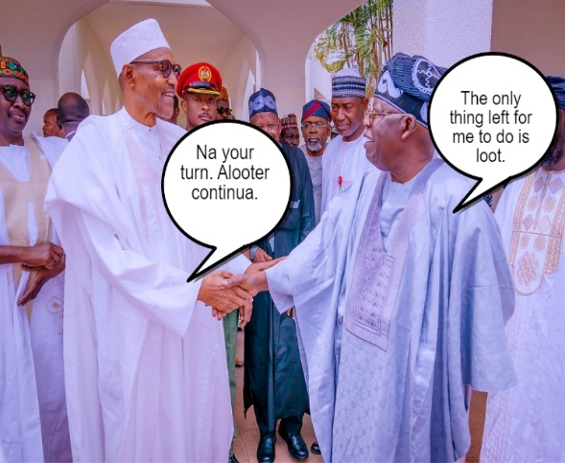

Figure 4: Alooter Continua [Looting Continues]
Linguistic Resources:
Figure 4 above presents a pair of conversational drill between two interlocutors in the following Nigerian pidgin expressions: ‘Na your turn. Alooter continua’ and a declarative sentence: ‘The only thing left for me to do is loot’. The conversation reflects how the predecessor is handing over the reins to his successor. The phrase: ‘Alooter continua’, is pejorative expression morphologically coined from a popular expression “A luta continua’ to embody an implicit meaning of ‘a looter’. This is set as the given information already known to viewers. This that demonstrates that predecessor subscribes to the established practice of public treasury looting by Nigerian political office holders. The successor’s response is indicative of their shared looting agenda.
Verbal Resources:
Figure 4 contains the images of some notable political figures in Nigeria, among whom are two RPs, General Muhammudu Buhari (GMB), the immediate past Nigerian President and PBAT, the Nigeria’s incumbent President, connected through a handshake vector which makes them not just interactors but collaborators. From the point of view of interaction, the image act offers GMB and PBAT as foregrounded RPs in medium shot, presenting them as objects to be critically examined and setting them against the background of other RPs in long shot.
Interplay of the Resources and Ideological Meaning
The linguistic and visual resources in in figure 4 are harmonious in horizontal structure. Aside the handshake vector, the two dialogue balloons protruding from both participants form speech vectors connecting the RPs to their commitment to looting as an understood ideology in Nigerian political discourse. The humour creates a sense of social affinity between PBAT and GMB. The punchline of the humour aligns with van Dijk’s (2008) socio-cognitive model on how power abuse and dominance transcend individualities, but involve social collectivities. Thus, we find semiotically represented in Figure 4, the looting continuum ideology that supposedly controls the cognition and social practices of Nigerian politicians irrespective of party affiliation.

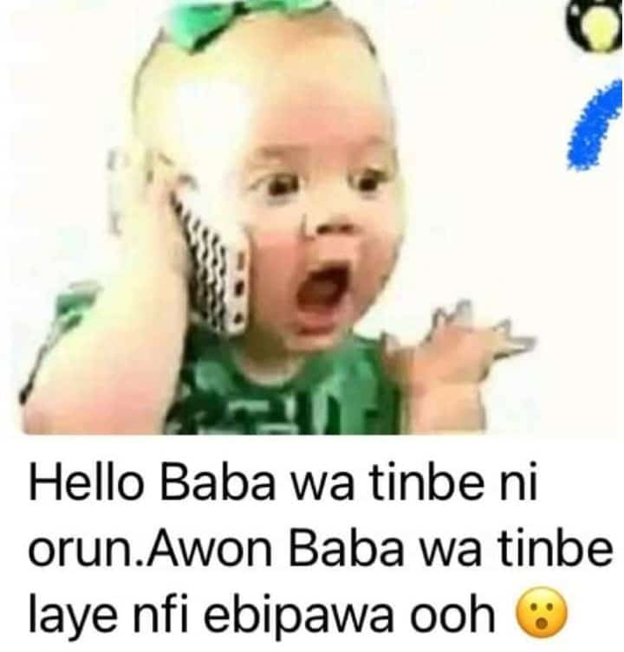
Figure 5: Child’s Phone Call to God
Linguistic Resources:
The bottom section contains two sentences in Yoruba language: ‘Hello Baba wa tinbe ni orun. Awon Baba wa tinbe laye nfi ebipawa ooh’ translated in English thus: ‘Hello, our father in heaven. Our fathers on earth are making us hungry’. Functionally, the sentences contain the message of hunger overemphasising the helpless state of the Nigerian masses to the unseen receiver. The phone call typifies Nigerians’ all-prayer attitude.
Visual Resources:
Figure 5 represents the narrative act of praying as the image realises a toddler (the Actor) on an assumed phone call to God (the implicit Goal) in a non-transactional relation that mediates two distinct discourses: the experiential religious world of praying; and the helplessness of a child seeking divine help. The implicit Goal makes the visual structure to be analogous to the intransitive equivalent, ‘the child prays’, in linguistic representation which in reality can be transcoded as ‘Nigerians pray’. The visual ‘Goal deletion’ structure offers the child Actor in a close shot as the most salient participant displayed as a specimen for viewers’ critical observation. The image is vertically composed in such a way that the upper section visualises an emotive representation of the world of a child making an urgent phone call.
Interplay of the Resources and Ideological Meaning
Both the linguistic and visual resource harmoniously create the humour in the meme, which is the playful attempt to equate a child’s phone call of hunger complaint to Nigerians’ prayer of protest against PBAT’s food-depriving regime. By so doing, the text ideologically plays the dual role of representing the visual as a prayer of protest against PBAT; and secondly expressing Nigerians’ discontent with Tinubunomics which is symbolic of poverty and hunger in the society. Although the incongruity of the humour would stimulate laughter in viewers, its punchline invokes a sense of disparagement of the person of the president and Tinubunomics. Thus, the visual’s top-bottom vertical structure conforms with van Dijk’s ideological square as we find the semiotic resources being polarised ideologically into ‘us’ (positive in-group representation) and ‘Our father on earth’ (negative other-representation). The local meanings of the visual associate good qualities such as innocence, helplessness and God-dependence to Us and bad qualities like food-deprivation and oppression to the Other in an attempt to deprecate Tinubunomics.
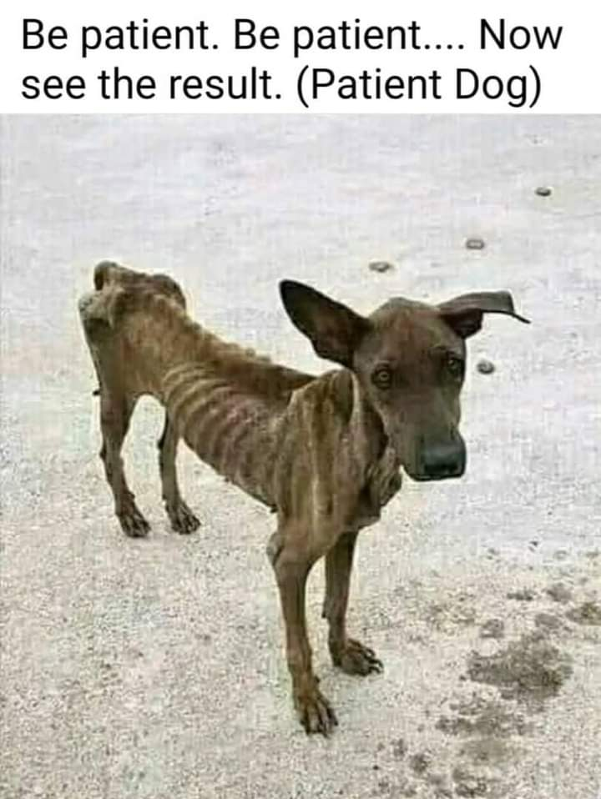
Figure 6: The Patient Dog
Linguistic Resources:
Three syntactic elements which were used in the figure above are: a repetition of the imperative sentence: ‘Be patient’; this is followed by another imperative sentence: ‘Now see the result’; and a noun phrase: ‘Patient Dog’. Functionally, the first alludes to the ‘common’ statement of PBAT appealing to Nigerians to endure the present hardship. The second imperative sentence expresses a command or request underlying an ironic sarcasm. The noun phrase complements the sarcasm by identifying an emaciated dog for being resilient.
Visual Resources
The image in Figure 6 is a non-transactional reaction process in which an emaciated, gaunt, scrawny, cachectic and skeletal dog is the Reacter looking helplessly at something invisible to viewers. By gazing at viewers, the image enacts a demand act that explicitly acknowledges viewers and connects them to the dog-participant in what Kress and van Leeuwen (2006) calls ‘a visual form of direct address’ (p. 117). The gaze demands that viewers enter into social affinity with the participants thus creating in the viewers a sense of identification with the plight of the dog.
Interplay of the Resources and Ideological Meaning
Both the syntactic elements and the image of the emaciated patient dog harmoniously create humour metaphor that provides practical negative consequences of Nigerians’ excessive resilience in the face of oppression. The punchline in the humour metaphor is the incongruous realisation of ‘an emaciated dog’ that contrasts what obtains in the original English proverb, ‘The patient dog eats the fattest dog’. In line with van Dijk’s ideological square on identity construction, Nigerians’ excessive resilience in the face of oppression is largely emphasised via the emaciated dog metaphor in such a way that PBAT’s economic policies are downgraded as hopelessly unproductive. The polarisation thus creates an innocent/resilient attitude around the in-group such that an unrepentant oppressive attitude is associated with the other.

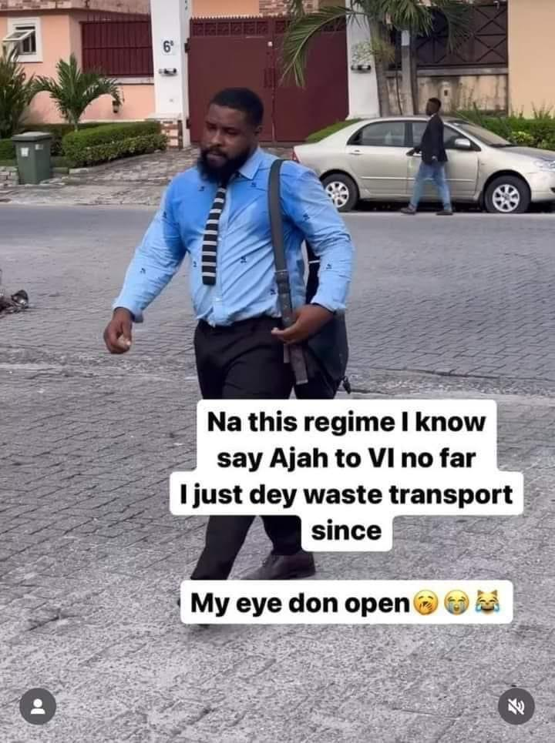
Figure 7: Eye-Opening Regime
Linguistic Resources:
The linguistic resources presented in the meme is a Nigerian pidgin expression: ‘Na this regime I know say Ajah to VI no far. I just dey waste transport since. My eye don open’ (Gloss; three sentences: ‘It is through this regime that I know that Ajah to VI is not far. I have only been wasting my fares since. My eyes have opened’). The assertions subtly depict the mental representation of the participant’s thoughts in the heat of the untold hardship depriving Nigerian citizens means of mobility during the PBAT-led regime. The nominal word: ‘Ajah’ is relatively a new town located between Victoria Island (VI) and Epe Town in Lagos State. His assertion that Ajah to VI is not far is a heavy irony because the distance is about 10 kilometres.
Visual Resources:
Figure 7 also visually realises a non-transactional action process in which a man seen walking and sweating profusely becomes the Actor. The visual is a vertical structure that portrays the Actor as an office worker assumedly trekking to work. The non-transactional trekking action of the man represents him as the most salient participant for viewers’ close scrutiny.
Interplay of the Resources and Ideological Meaning
Both the linguistic and visual resources are harmoniously laden with ironic sarcasm meant to expose the plight of Nigerian working class in the face of the high fuel hike occasioned by PBAT’s removal of the fuel subsidy, an action that exponentially increased transportation costs forcing many Nigerian workers to resort to trekking to and fro the office or skip going to work. Humour is achieved through the Actor’s sarcastic lauding of PBAT’s regime for making him realise that the distance is trekkable. While the incongruity in the humour achieves some laughter to release the emotional tension surrounding the fuel price hike, the punchline of the humour emphasises the untold hardship the fuel price hike has subjected the Nigerian labour force to. The man’s sweaty shirt stands in contrast to his sarcastic gratitude to PBAT. The image representation thus portrays the worsened living conditions of the Nigerian working class and reinforces the deleterious effects of Tinubunomics on the economic power of Nigerian workers. The placement of the text on the Actor’s legs creates an overall visual symmetry between the semiotic resources so as to ideologically foreground Tinubunomics as an onerous system. This ideology polarises along the lines of Nigerians’ resilient spirit (positive in-group depiction) and PBAT’s oppressive policies (negative other depiction).
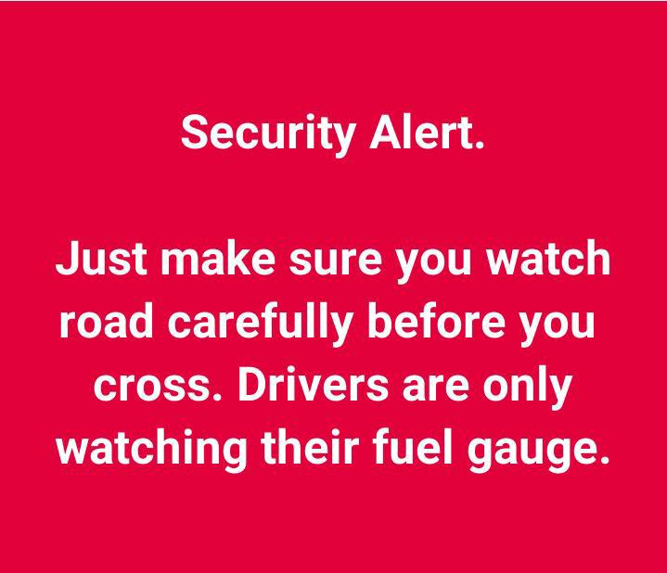
Figure 8: Fuel Gauge Watching
Linguistic Resources
The image contains three syntactic elements: the nominal group used as caption: ‘Security Alert’; an imperative sentence: ‘Just make sure you watch road carefully before you cross.’; and a declarative sentence: ‘Derivers are only watching their fuel gauge’.
Visual Resources
The mode of colour (red) in the background of the linguistic resources reinforces the message of danger alert.
Interplay of the Resources and Ideological Meaning
The narration in Figure 8 is mediated via a mental process observed through the verbal contents of the thoughts of an implicit Senser. By not visibly representing the Senser, the participant whom the thoughts emanate from, the structure is non-transactionally realised to make salient the thoughts as a demand act instructing Nigerians on pedestrian road safety tips occasioned by the fuel price hike in the country. The directive creates a relation of playful social bond between the image producer and Nigerians. Vertically composed, the general essence of the visual communication is placed at the top, ‘Security Alert’. The alert text is a traffic sign of warning for pedestrians on the new rule to follow when crossing Nigerian roads. The lower section is more directive as it instructs Nigerian pedestrians to be hypervigilant when crossing – ‘Just make sure you watch road carefully before you cross’. The concluding sentence in the bottom resources, ‘Drivers are only watching their fuel gauge’, is a humorous economic justification for the new traffic directive which subtly implicates that fuel gauge monitoring is one of the cost-pruning measures now being used by Nigerian drivers to survive the economic hardship.
‘Road vigilance’ has thus been humorously recontextualised as ‘fuel gauge vigilance’ as Nigerian drivers’ post-subsidy removal driving habit. Although laughter is achieved in the incongruity, the punchline in this playful recontextualisation emphasises the negative impacts of the fuel price hike on Nigerian drivers’ purchasing power making them to monitor their fuel gauges more than the road. The saturated red background of the visual unifies the verbal resources as a danger sign meant to warn that the fuel price hike has impaired Nigerian drivers’ mental state and attitude which could lead to road accidents. The alert expresses the humourist’s sense of superiority over his ability to be more concerned with pedestrians’ plight than the Nigerian government. The humour thus weaves negativities and deprecation around Tinubunomics while depicting Nigerians as innocent victims of the policies, in line with van Dijk’s ideological discourse polarisation.

5. FINDINGS AND SYNTHESIS
As garnered from the analysis conducted in the preceding section, the syntactic elements identified in the figures are: word (as in figure 1), catchphrases (as in figures 1, 4, and 8), clauses (as in figure 2), and sentences (as in figures 1, 3, 4, 5, and 7). These syntactic elements were recontextualized in the memes to work as multimodal ensembles in order to reinforce the message contained in the visual images. In terms of visual mode, the analysis unearthed images (as in figures 1 to 8) and colours (as in figures 1 and 8). Thus, while the visual mode presented ostensible identifications of issues, object, and political figures (especially, PBAT and the ex-Nigerian President Muhammad Buhari, in figure 4), the syntactic elements complemented the images to produce repetition, allusion, ironic sarcasm, name-calling, and foregrounding. Also, it was discovered that the memes presented Tinubunomics dark and disparaging humours that serve the ideological dual purposes of denigrating Tinubunomics as impoverishing economism while emphasising in positive terms Nigerians’ resilience in the face of oppression.
Many of the humour memes have afforded the humourists the opportunity to evaluate Nigerians’ collective resilience mechanisms against the harsh economic aftermath of Tinubunomics. By so doing, Nigerians (in-group) are positively depicted as a resilient people under pressure. The humour in the memes collectivise the Nigerian masses as an oppressed group surviving in the face of oppression. The humour memes are thus discursively resistive as they give voice to the negative experiences of Nigerians in the hands of PBAT, which aligns with van Dijk’s (2008) postulation that critical discourse studies (CDS) inclusively explore how dominated groups discursively resist domination. Social currency humour is therefore broadly activated in the memes through the establishment of group affinities that map out Nigerians (Us) as the in-group facing oppression and PBAT/Tinubunomics (Other) as the out-group oppressing Nigerians. This oppressive social hierarchy coordinates the ideological structure of the memes into positive in-group representation and negative other representation emphasised in van Dijk’s ideological polarisation. In reinforcing the ideological meanings and humour senses in the memes, the image producers strategically deployed some narrative semiotic processes by presenting unfolding dramatic actions composed vertically for viewers’ contemplation as exemplified in Figure 5 to 8.
This study validates the role of online humour memes in political critique and protest like previous studies such as Adegoju and Oyebode (2015) and Adegoju (2022). In Adegoju’s (2022) study on the semiotics of humour in Nigerian politics, political humour was explored as a powerful means of demonstrating Nigerians’ disaffection with GMB’s/APC’s poor program-to-policy post-election linkage which has brought the country to a standstill. This supports our findings that PBAT’s Tinubunomics is an economic weapon meant to further impoverish the poor masses. This aligns with Yusuf’s (2024) stance that Tinubunomics ‘is not just witchcraft-economism, it is also witchcraft-politicism. It speaks tirelessly from both sides of the mouth; makes endless promises but hardly fulfills any”. However, as pointed out by Adegoju and Oyebode (2015), these humour memes thus far have been conceived as mere playful politics-based critiques lacking the potency of political transformation.
This study evidences the theoretical possibility of synergising social semiotic theory with critical discourse analysis and humour theories to deconstruct internet memes as socio-political ensembles of protest in a developing democracy. By so doing, the study has provided evidence on the non-neutrality of these memes in support of van Dijk’s position. To expand this study’s findings delimited to verbal-visual memes, it is hoped that further studies can explore video-audio memes on Tinubunomics.

6. CONCLUSION
The study has investigated the syntactic elements and the multimodal representation of ideology in Nigerian ‘Tinubunomic’ Internet Memes. It focused specifically on verbal-visual memes to unearth how these unified semiotic structures ideologically polarised into positive in-group and negative out-group representation. The analysis revealed that semiotic choices in the memes predominantly bear non-transactional narrative visual structures largely vertically composed into top and bottom sections offered for viewers’ contemplation. The choices are imbued with discursive practices such as visual metaphor, repetition, symbolism, allusion, ironic sarcasm, analogy, name-calling and foregrounding. While humour pleasure was largely achieved in all the memetic practices, the analysis demonstrated that the multiple humour senses in the memes derogate PBAT in order to weave around Tinubunomics humour subsets such as hunger, poverty, emaciation, oppression and no-fuel humour. These subsets are all dark, disparaging humour that serve the dual ideological purposes of denigrating Tinubunomics as impoverishing economism while simultaneously emphasising in positive terms Nigerians’ resilience in the face of the oppression. In essence, it is safe to conclude that the meme practices bear socio-political significance as visuals of discontent and protest.
REFERENCES
Abati, R. (October 10, 2023). Tinubunomics: matters arising. Retrieved from
https://www.premiumtimesng.com/opinion/632257-tinubunomics-matters-arising-by-reuben-abati.html?tztc=1
Adegoju, A. (2022). Semiotics of humor in Nigerian politics. Semiotica 247, 255-282.
Adegoju, A., & Oyebode, O. (2015). Humour as discursive practice in Nigeria’s 2015 presidential election online campaign discourse. Discourse Studies, 17(6), 643-662.
Akande, T. (2024). What Tinubunomics reveal to Nigerians: Economics does not respond to tribe or religion. It responds to brilliance, patriotism and productivity. Retrieved from https://kolaking.substack.com/p/what-tinubunomics-reveal-to-nigerians
Bonga, W. G. (May 31, 2023). Investigating weaponisation of poverty by political organisations: A case for Zimbabwe. Retrieved from http://dx.doi.org/10.2139/ssrn.4645135
Croft, W. (2001). Radical Construction Grammar. Oxford: Oxford University Press.
De Leon, F. M. G. D., & Ballesteros-Lintao, R. (2021). The rise of meme culture: Internet political memes as tools for analysing Philippine propaganda. Journal of Critical Studies in Language and Literature, 2(4), 1-13.
Diedrichsen, E. (2018). Cognitive mechanisms and emergent grammatical features in internet memes. Linguistics Beyond and Within 4, 22-37.
Dike, D. (2018). Countering political narratives through Nairaland meme pictures. Cahiers d’études Africaines [En ligne], 230, 493-512.
Džanić, N. D., & Berberović, S. (2017). #ForgiveUsForWeHaveSinned: Conceptual integration theory and political internet humour. European Journal of Humour Research, 5(2), 4–22.
Fasan, O. (February 19, 2024). The economic illiteracy at the heart of Tinubunomics. Retrieved from
https://businessday.ng/columnist/article/the-economic-illiteracy-at-the-heart-of-tinubunomics/
Ferguson, M. A., & Ford, T. E. (2008). Disparagement humor: A theoretical and empirical review of psychoanalytic, superiority, and social identity theories. HUMOR, 21(3), 283-312.
Halliday, M. A. K. (1978). Language as social semiotics. Edward Arnold.
Halversen, A., & Weeks, B. E. (2023). Memeing politics: Understanding political meme creators, audiences, and consequences on social media. Social Media + Society, 9(4), 1-11.
Han, Y., & Smith, B. E. (2023). An ecological perspective on the use of memes for language learning. Language Learning & Technology, 27(2), 155-175.
Holm, C. H. (2021). What do you meme? The sociolinguistic potential of internet memes. Leviathan: Interdisciplinary Journal in English 7, 1-20.
Johann, M. (2022). Political participation in transition: Internet memes as a form of political expression in social media. Studies in Communication Sciences, 22(1), 149-164.
Kress, G., & van Leeuwen, T. (2006). Reading images: The grammar of visual design (2nd ed.). Routledge.
Krikmann, A. (2006). Contemporary linguistic theories of humour. Folklore: Electronic Journal of Folklore, 33, 27-58.
Machin, D., & Mayr, M. (2012). How to do critical discourse analysis: A multimodal introduction. Sage Publications, Inc.
Miltner, K. M. (2017). Internet memes. In J. Burgess, A. E. Marwick & T. Poell (Eds.), The SAGE handbook of social media 55, (pp. 412-428). Sage Publications Ltd.
Moreno-Almeida C. (2021). Memes as snapshots of participation: The role of digital amateur activists in authoritarian regimes. New Media & Society, 23(6), 1545-1566.
Moussa, M. B., Benmessaoud, S., & Douai, A. (2020). Internet memes as “tactical” social action: A multimodal critical discourse analysis approach. International Journal of Communication 14, 5920-5940.
Neuendorf, K. A., Skalski, P. D., Jeffres, L. W., & Atkin, D. (2014). Senses of humor, media use, and opinions about the treatment of marginalised groups. International Journal of Intercultural Relations, 42, 65–76.
Nijholt, A. (2020). ‘All the world’s a stage’: Incongruity humour revisited. Ann Math Artif Intell 88, 405-438 (2020).
Nissenbaum, A., & Shifman, L. (2018). Meme templates as expressive repertoires in a globalising world: A cross-linguistic study. Journal of Computer-Mediated Communication 23, 294-310.
Okesola, S. O. & Oyebode, O. O. (2023). ‘The soro-soke [speak up] generation’: Multimodality and appraisal choices in selected #EndSars civil protest-related memes in Nigeria. Language and Semiotic Studies, 9(2), 290-312.
Osisanwo, W. (1999). An Introductory analytical grammar of English. Lagos: Femolus-Fetop Publisher.
Oyemade, O. & Adeagbo, A. (2020). Memes as ideological representations in the 2019 Nigerian presidential campaigns: A multimodal approach. Language and Semiotic Studies, 6(1), 78-103.
Raskin, V. (1985). Semantic mechanisms of humour. D. Reidel.
Ross, A. S., & Rivers, D. J. (2017). Digital cultures of political participation: Internet memes and the discursive delegitimisation of the 2016 U.S. presidential candidates. Discourse, Context & Media, 16, 1–11.
Scott, K. (2021). Memes as multimodal metaphors: A relevance theory analysis. Pragmatics and Cognition, 28(2), 277-298.
Tay, G. (2014). Binders full of LOLitics: Political humour, internet memes, and play in the 2012 US Presidential Election (and beyond). European Journal of Humour Research, 2(4), 46-73.
Ugah, H. U. (2022). Internet memes as deconstructions of myths: A pragma-semiotic approach. Marang: Journal of Language and Literature 35, 71-85.
Ugoala, B. (2022). Multimodal analysis of memes in tweets of responses to Nigeria’s minister of health’s statement on resident doctors in Nigeria. Zamfara International Journal of Humanities, 1(3), 1-22.
van Dijk, T. (1995). Discourse analysis as ideology analysis. In C. Schaffner & A. L. Wenden (Eds.), Language and Peace (pp. 17-36). Academic Publishers.
van Dijk, T. (1998). Opinions and ideologies in the press. In A. Bell & P. Garrett (Eds.), Approaches to media discourse (pp. 21-63). Blackwell.
van Dijk, T. (2008). Critical discourse studies: A sociocognitive approach. In R. Wodak & M. Meyer (Eds.), Methods of critical discourse analysis (pp. 62-86). Sage.
van Wessel, M. (2010). Political disaffection: What we can learn from asking the people. Parliamentary Affairs, 63(3), 504-523.
Watson, E. A. &, Ducharme, E. W. (1990). Literary criticism: Ten approaches, an introductory
reader. Toronto: Canadian Scholars’ Press Inc.
Yusuf, A. A. (July 6, 2024). Tinubunomics as witchcraft economism. Retrieved from https://www.premiumtimesng.com/opinion/710264-tinubunomics-as-witchcraft-economism-by-ahmed-aminu-ramatu-yusuf.html?tztc=

