Esan questions Prosody: a revisit of the Esan question marker
Abstract
Earlier studies on the quality of pitch on Esan questions were focused essentially on the interaction of tone and tonal patterns on Esan questions. This paper re-examines these earlier efforts on the basis of contemporary linguistic research, that the mood of a sentence is marked by intonation rather than by lexical pitch in most spoken languages. Empirical evidence from acoustic investigations validates this claim in Esan. Data comprised a series of Esan questions, which were elicited from 24 L1 speakers of Esan across 12 varieties of the language. Available data spanned three question types to include the Interrogative pronoun question, the Yes/No and the Questioned- word question types. Tonal patterning as well as the fluctuating pitch melody of intonation, which occurred with the identified question types were identified and compulsorily marked on all available data They are audio recorded and analyzed using PRAAT. Observations showed that the difference in quality of voice pitch between the three question types in Esan and their declarative counterparts lies in what may be described as the effect of intonation on tonal patterning. Specifically, whereas the pitch of voice is generally low at the termination of a declarative sentence in the language, it rises to a high in its question counterpart, irrespective of the question type. The resulting general effect of intonation on questions in Esan is that the high and low tones on the lexical constituents are raised above or lowered below their initial pitch levels. This raising or lowering climaxes at sentence final position with a distinct rise or fall in voice pitch. This change in voice pitch, which is traceable to pitch quality of questions in most languages, may be termed a question morpheme or tomorph. This study is an additional improvement on the study of questions in Esan.
Key words: Pitch, Intonation, Tone, Tonal patterning
- Introduction
This study re-examines the Esan question prosody. Specifically, it seeks to clarify the question of the quality of pitch melody on question utterances in the language. This re-examination is motivated by the linguistic view that, in many spoken languages of the world, the mood of a sentence is determined by intonation rather than by lexical pitch, also known as tone. In other words, the pitch quality of intonation often determines the status of a sentence as a question, a statement, a command, or an exclamation. Lexical tone, on the other hand, is perceived as being more significant than intonation because it causes changes in meaning and grammatical distinction between words in tone languages. Ejele(2003b), in her study of contour tones in Esan, identifies questioned-word questions in Esan. Yuka & Ikoyo-Eweto (2022) identify the interrogative pronoun question and the Yes/No question types in Esan.
A sub goal of this paper is to fault the general but often subconscious assumption among some language researchers that there is a clear cut unbridgeable divide between tone languages and intonation languages in the distinctions of pitch quality. In other words, the position that tone languages may not also feature the effects of intonation in utterances, by virtue of the fact that pitch quality in those languages is mostly lexical, may not be correct. In this regard, Gimson (1975:52) states:
In some tone languages, e.g. many oriental and African
languages, a pitch feature distinguishes the meaning
of words. In English and most European languages, the
chief function of pitch variation is related to the whole
sentence.
Similarly, Egbokhare(1994:67) states:
English employs falling, falling-rising and rising-falling
intonation to signify a statement, question, doubt and
certainty respectively. In most African languages, speech
melody is best defined as a property of the word. Thus a
change in speech melody may result in a change in meaning
of a word. Speech melody, when it behaves in this way, is
called tone.
This assumption, which seems to have trailed the study of tone languages for some time now, has inadvertently caused an apathy in the investigation of the possible interaction of tone and intonation in so called ‘tone languages’. This study seeks to lift a corner of this perceived veil with this study in the quality of pitch on Esan questions.
The Esan language is the Mother tongue of the Esan people. The Esans occupy five out of the Eighteen Local Government Areas of Edo State of the Federal Republic of Nigeria – Esan South East, Esan South West, Esan Central, Esan North and Igueben. The language is classified as a member of the Proto North Central Edoid branch of the Edoid group of languages (NCE) (Elugbe 1989). The Edoid group belongs to the Benue Congo group of Williamson (1989). The language has, as immediate neighbours on the classificatory chart, the dialect cluster of Ora-Emai- Iuleha to the right and Edo(Benin) to the left. The total population of L1 Speakers of the language is put at 587,858 out of the 3,218,332 of the entire Edo State population as at 2006 (Edo State National Population Commission). Records show that Esanland occupies an area of about 2,987.52square kilometers and is located North east of Benin City (Okogie and Ejele 1987). Esan is empirically proven to be multi-dialectal, comprising as many as 12 dialects (Osiruemu 2010). The various empirical studies on the language also confirm that it is a tone language.
1.1 Research question
This paper focuses on the effect of intonation on Esan questions. Earlier works have on this aspect of Esan syntax, sought answers to the question of the question marker in Esan questions solely in the combinatorial patterns of tone on this sentence type in the language. However, the present effort seeks to deviate from this norm. This change in direction is informed by the knowledge that questions of mood change and related issues are often influenced by the voice pitch quality of intonation. The question the paper seeks to propose answers to therefore is: How does intonation affect the question sentence types in Esan?
  - Methodology
Data for this investigation comprised questions in Esan of three genres to include the Interrogative pronoun question, the Yes/No and the questioned-word questions. Data were elicited by direct interview as well as by participant observation from a total of 24 L1 Speakers of Esan. These consultants comprised two speakers each, one male and one female, from each of 12 varieties of the language to include Ebhoato, Ebhohimi, Ekpoma, Ewu, Igueben, Irrua, Ubiaza, Udo, Ugboha, Ugbegun, Uromi, Ogua, (Ikoyo-Eweto 2008, 2016; Osiruemu 2010; Yuka & Ikoyo-Eweto 2022). Secondary data were sourced from previous studies on questions in Esan.
A sum of 50 Esan questions were gathered, and formed the data base for this study. Available data were manually documented mostly orthographically and phonetically, using the proposed Esan orthography as well as results from its review (Ikoyo-Eweto 2016). Tone [ ́ ̀ ] and intonation [ / \ ] were compulsorily marked on available data. The interaction of tonal patterning and intonation on the identified question types were observed and compared across and between these question types in order to identify their individual and collective effects on the Esan question types. Data were analysed with the aid of the Praat, which helped to display the F₀ of each utterance on a spectrogram. The measurements of the results are based on the frequency-duration display on the spectrograms.
2. Review of literature
This section of the work highlights key concepts employed in the paper and reviews previous studies relevant to it.
2.1 Questions
The question which is classified as a functional sentence type in the literature is also referred to as the interrogative sentence. As the term suggests, a question is a sentence that is employed to seek some information or to confirm already received information (Gimson 1975:62). In English, this definition could be illustrated with the examples: Are you hungry? Did you say you are hungry?
Questions or interrogative sentences are classified into various types. Three question types which occur in Esan are of interest in this study as follows.
The interrogative pronoun question – This question type (wh- question in English) is so named because it is introduced with an interrogative pronoun. In Esan, this question type may be introduced using any of the following interrogative pronouns as determined by the nature of information requested by the communicator or interrogator – kόό/hόό(who?); bézélè(why?); éghélá (when?); bé (how/what?). Dialectal variations and re-syllabification processes do determine the choices of the forms of interrogative pronouns as well as phonotactic changes in the forms themselves. These occurrences are illustrated as follows with the interrogative pronouns underlined and free translations in English.
- Kόό lé όnί ébàlè
Who ate the food?
- Hόό khὶ ὸ nί
Who is that?
- Bézélé nὶ ὸlè náá vὶè
Why is he/she crying?
- Ѐghèlá úwé ré vá déè
When are you coming?
- Bé é nό ὸ/ Bè lá à
What is it (what is the problem)?
- Bé á ré gbènό yè è
How is sweeping conducted?
The Yes/No question – This question type requires a ‘yes’ or ‘no’ response from the communicatee to the interlocutor, who asks the question. This question type in Esan is differentiated from its declarative counterpart solely in tonal patterning (Osiruemu 2005, Yuka & Ikoyo-Eweto, 2022). These occurrences are illustrated as follows:
Declarative sentence Yes/No question
- Ùwè lé ébàlè Ùwè lé ébàlè́
You have eaten food. Have you eaten food?
- Égbè dán ùwè Égbè dán ùwè́
You are well. Are you well?
The questioned word question – A questioned word may be defined as a single word that asks a question. The use of these questioned words usually indicate that information previously provided was either not understood or was considered incredible. Welmers (1973) states that the questioned-word question behaves like the Yes/No question type because it elicits a yes or no answer, like the former. Illustrations of these occurrences are presented as follows:
- H^{w}èán kὸnὸ ébé ὸrίwὸ dzί ὶmè ébé ὸrίwὸʹ
Please pluck me some bitter leave. bitter leaf?
- Sà àmè rè kpé ábὸ à ábὸʹ
Fetch some water to wash your hands. hands?
- Nè ίbàtà ίmè dzί ὶmè ίbàtàʹ
Bring me my shoes. shoes?

2.2 Prosody: Intonation/Tone
The term prosody or prosodic describes the voice quality of speech. This description concerns the accentual and rhythmic patterns of utterances in spoken language, which are different from variations in the speech sounds themselves. This division in the constitution of an utterance may also be termed segmental and non- segmental. The segmental constituents may be defined as the consonants and vowel sounds because they are easily separated and identified as individual sound units. The non- segmental which captures the voice quality of speech is prosodic and may not be capable of being segmented into individual units like their segmental counterparts.
Prosody comprises the syllable and pitch of voice quality of an utterance. This study is concerned with the pitch of voice quality, specifically of questions in Esan. Describing pitch, Gimson (1975) states that the spoken form of a language consists not only of variations in sounds and accentual rhythmic patterns, but also of significant changes in the musical pitch of the voice. Egbokhare (2003) describes pitch as the perceptual correlate of the frequency or rate of vibration of the vocal chords per second. He explains further that a high rate of vibration manifests as high pitch of voice while a low rate of vibration is perceived as low pitch. A mid- level rate of vibration may be recognized as a pitch height between low and high. Intonation, tone, stress accent and idiolect are various realisations of the pitch phenomenon. The identification of pitch as any of the aforementioned phenomena is essentially determined by the function or behavior of the former in any utterance of a given language. The pitch phenomena of concern in this paper however, are those of intonation and tone.
Intonation and Tone – Intonation and tone are two different realisations of the pitch quality of voice. Thus, the pitch quality of voice may be realised as intonation or tone, depending on their particular function in a given utterance. When the pitch quality of voice changes the mood of a sentence without bringing about a change in its meaning, it is termed intonation. Four different types of intonation are identified as follows:
- Rising intonation, with the pitch of the voice rising over time.
- Falling intonation in which the pitch of voice falls with time.
- Dipping or Fall-rise intonation which falls and then rises
- Peaking or Rise-fall intonation which rises and then falls.
However, when pitch quality of voice results in a change in meaning, particularly of lexical items, which, otherwise, have identical segmental composition, pitch quality of voice is contrastive and is called tone. Gimson (1975) and Egbokhare (2003) make similar distinctions between intonation and tone as different pitch qualities of speech as well as their various effects on the mood and or meaning of an utterance/sentence. Both authors submit that while intonation may affect the sentence as a single unit, and possibly cause a change in its mood, accent or grammatical structure, tone would result in lexical contrast, in which case, a change in tone between two similar words would result in a change in their meanings. It is on the basis of this behavior in pitch quality of voice of speech that tone languages are identified. Pike (1948) defines a tone language as one having lexically significant, contrastive, but relative pitch on each syllable of a word. In other words, for a language to qualify as a tone language, it must employ pitch as part of lexical structure and the different pitch levels must contrast.
2.3 Previous studies
Esan tone system – Like most Edoid languages, Esan is a tone language for reasons already explained. Ejele (1994), Osiruemu (2010), Yuka & Ikoyo-Eweto (2023) all agree that Esan features the high [ ʹ] and low [ ˋ] level tones as well as the falling [ ̂ ] and rising [ ˇ] contour tones. The difference in meaning of Esan words as a result of changes in pitch height is illustrated in the following minimal pairs of words:
- éfèn HL rat
- èfén LL edge
- ékpà HL vomit
- èkpà LL punch
- áwà HL dog
- àwà LL taboo
The occurrence of the falling and rising contour tones in Esan sometimes result from vowel elision processes, which result in re-syllabification. Thus a falling contour may be formed, when the level tones on the vowel sequences are HL, whereas a rising contour results from a LH sequence of occurrence as illustrated below.
xviii. ὸkpά ♯ ὸkpά → ὸkpôkpά
one one singly
ixx. ѐvά ♯ ѐvά → ѐvêvά
two two in twos
xx. ὸnà♯ ὸnà → ὸnônà
this this always this
xxi. údό ♯ údὸ → údûdὸ
stone stone all stones
xxii. áwà ♯ áwà → áwâwà
Osiruemu (2010), Yuka and Ikoyo- Eweto(2020, 2022) propose that in Esan, bisyllabic nouns feature the LL, HL, LHL and HHL tonal patterns while trisyllabic nouns feature the HHL, HLL, LLL, LHL and the HLHL patterns. Verbs in Esan, which may be monosyllabic or bisyllabic feature an all L tonal pattern while serial verb constructions(SVCs) generally transit from an all L in citation of the constituent verbs to a LH dispensation of the SVCs. Ikoyo-Eweto (2018) state that adjectives in Esan bear an all L pattern, numerals may be bisyllabic or multisyllabic with the cardinals bearing a LH, HL or a LHL, and the ordinals, a HLL or a LLL(L). Dietics in Esan bear a LL, LH or a HLHL tonal pattern.
Esan question markers – Earlier studies on the Esan question marker include Ejele (2003b). The work which is a study of contour tones in the language identifies question word questions and postulates a “floating high tone” as marker for questioned- word questions. By auto-segmental tenets (Goldsmith 1976), the level tone on an elided vowel segment from an utterance is not deleted but remains floating until it is able to link with another tone bearing unit. Ejele’s argument is that one of such floating high tones marks the questioned –word question in Esan. The following illustrations are culled from that work.
Word questioned word
xxiii. ènî → ènî ́
there/those there/those?
xxiv. ὸlê → ὸlê ́
outside outside?
xxv. úwâ → úwâ ́
house house?
Osiruemu (2005) and Yuka & Ikoyo-Eweto (2022) postulate a high tone question morpheme as marker for the Yes/No question type. According to them, ‘A high tone question morpheme attaches to the low tone of the final vowel segment of a declarative sentence to derive a rising contour tone as marker for the Yes/No question type. Illustrations of this occurrence are presented as follows.
Declaratives Yes/No questions
xxvi. Áhὶhὶ sá όmὸ → Áhὶhὶ sá όmǒ
An ant bit the child → Did an ant bite the child?
xxvii. Ùwè lá á lé ébàlè → Ùwè lá á lé ébàlě
You are about to eat food Are you about to eat food?
xxviii. Òhàmwèn há gbè όlè → Òhàmwèn há gbé όlě
He is hungry Is he hungry?
xxix. Édè wélè → Édè wélě
It is dawn Is it dawn?
xxx. Ùwè ré όnί úkpù → Ùwè ré όnί úkpǔ
You took the cup. Did you take the cup?
The Esan question prosody
This section of this paper presents the propositions made in this study about the Esan question marker. These postulations on how questions are marked in the Esan language, have arisen essentially from the examination of available data for this study. The latter was conducted with the background knowledge from existing literature, about the role of the quality of the pitch of voice, especially as it relates to questions in most spoken languages of the world. Specifically, the pitch of voice quality of intonation is known to indicate a change of mood and sentence types, without causing a change in the meanings of the affected sentences. Thus, a change in the intonation of a sentence could change a sentence type from a statement to a question, command or a request. This change in intonation also distinguishes moods such as those of anger, joy, excitement and other moods not mentioned here. Analysis of available data in this study proved very interesting as it showed that the interaction of intonation and tone played the principal role as question marker for some question types in Esan.
3.1 Data analysis.
The analysis of data in this study concerned the three Esan question types of the Interrogative pronoun question, the Yes/No question and the Questioned -word question. The results of data analysis are presented in this order.
- The Interrogative pronoun question – The pronoun question type in Esan is marked by a question pronoun, which usually introduces it in sentence initial position. It is usually marked with a low tone in sentence final position. The analysis for this question type in the language is that the falling intonation, which usually marks the interrogative pronoun question in spoken language lowers the final low tone of this sentence type below its initial level. This occurrence results in a final falling contour tone as question marker for this Esan question type. Data presented below illustrate this occurrence.
- Bé ùwè tà yȇ?
What did you say?
- Kόό lé όnί ébàlȇ ?
Who ate the food?
- Hόό khὶ ὸ nȋ ?
Who is that?
- Bézélé nὶ ὸlè náá vὶȇ ?
Why is he/she crying?
- Ѐghèlá úwé ré vá dȇ ?
When are you coming?
- Bé é nộ? / Bè lâ?
What is it (what is the problem)?
- Bé á ré gbènό yȇ ?
How is sweeping conducted?
Thus the rise-fall contour tone [ᴧ] termed a question morpheme or tomorph, is proposed as marker for the Interrogative pronoun question in Esan. Fig. 1 shows the pitch track of this question type for the question Bé ùwè tà yȇ? What did you say?
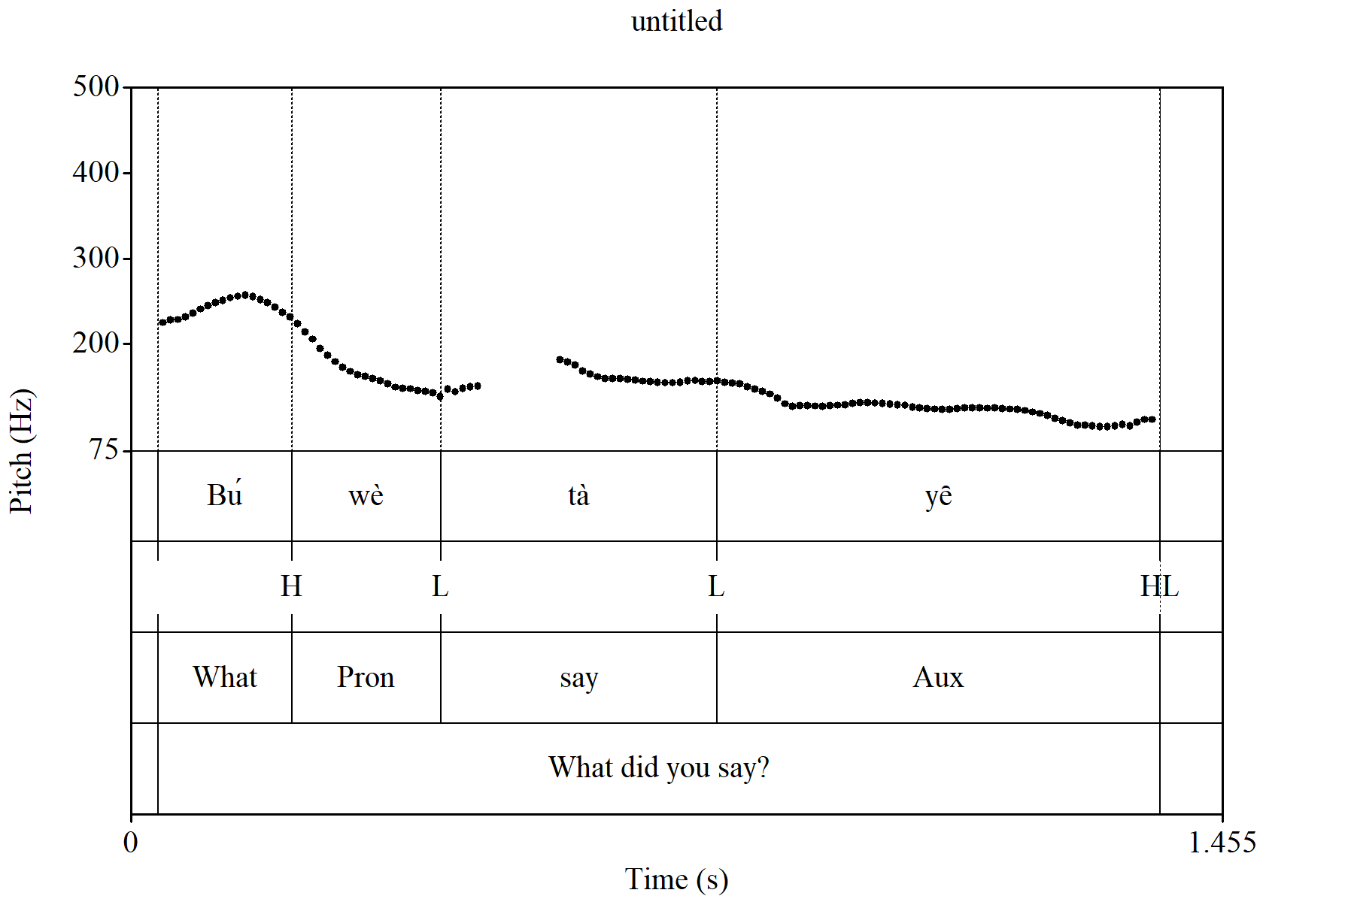
Fig. 1. Pitch track of Bé ùwè tà yȇ? What did you say?
The pitch track shows the falling intonation, which usually marks the interrogative pronoun question. The final low tone of this sentence type is below its initial level. The F₀ value of the initial L is 147.12Hz and that of the final L is 106.66, this is despite a H tone before it.
- The Yes/No question – Previous studies show that Yes/No questions and their declarative counterparts in Esan are differentiated only in their final sentence quality of pitch. Specifically, analysis of available data show that while a declarative sentence type generally terminates in a low tone, its Yes/No question counterpart terminates in a high. However, the effect of the rising intonation, which is known to mark this question type in speech, not only generally raises the tone levels of this question type, but also influences the occurrence of a final rising contour tone as marker for this question type in Esan.
Declaratives Yes/No questions
xxvi. Áhὶhὶ sá όmὸ → Áhὶhὶ sá όmǒ /
An ant bit the child → Did an ant bite the child?
xxvii. Ùwè lá á lé ébàlè → Ùwè lá á lé ébàlě /
You are about to eat food Are you about to eat food?
xxviii. Òhàmwèn há gbè όlè → Òhàmwèn há gbé όlě /
He is hungry Is he hungry?
xxix. Édè wélè → Édè wélě /
It is dawn Is it dawn?
xxx. Ùwè ré όnί úkpù → Ùwè ré όnί úkpǔ /
You took the cup. Did you take the cup?
An examination of the pitch tracks of the Yes/No question and its declarative counterpart in the utterance Áhὶhὶ sá όmὸ ‘An ant bit the child’ and Áhὶhὶ sá όmǒ ? ‘Did an ant bite the child?’ in Fig. 2a and 2b show that the declarative sentence type terminates in a low tone while the Yes/No question counterpart terminates in a high.
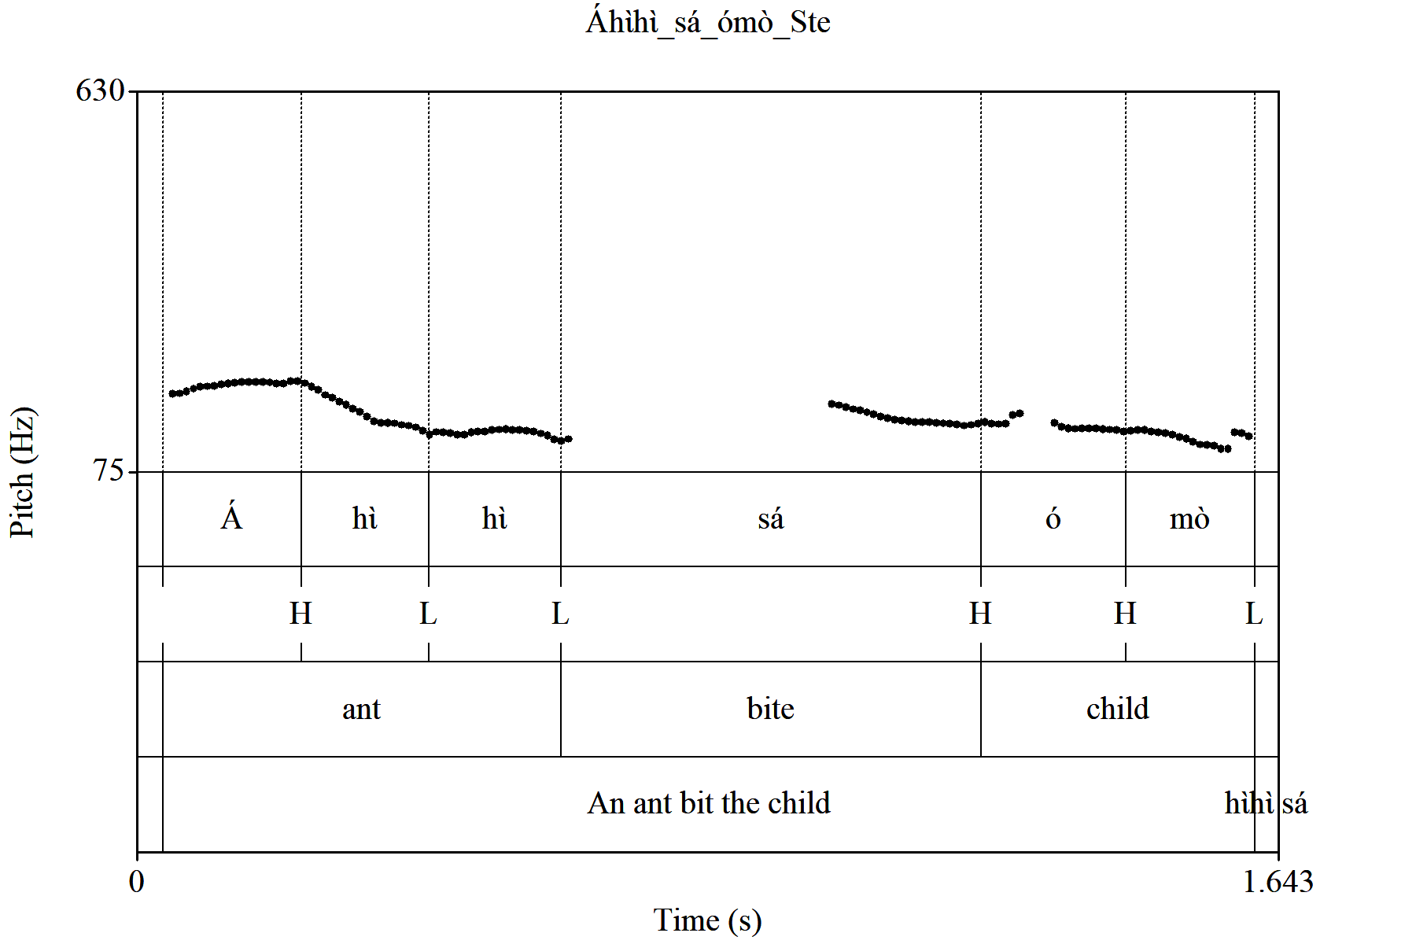
Fig. 2a: Pitch track of Áhὶhὶ sá όmὸ ‘An ant bit the child’
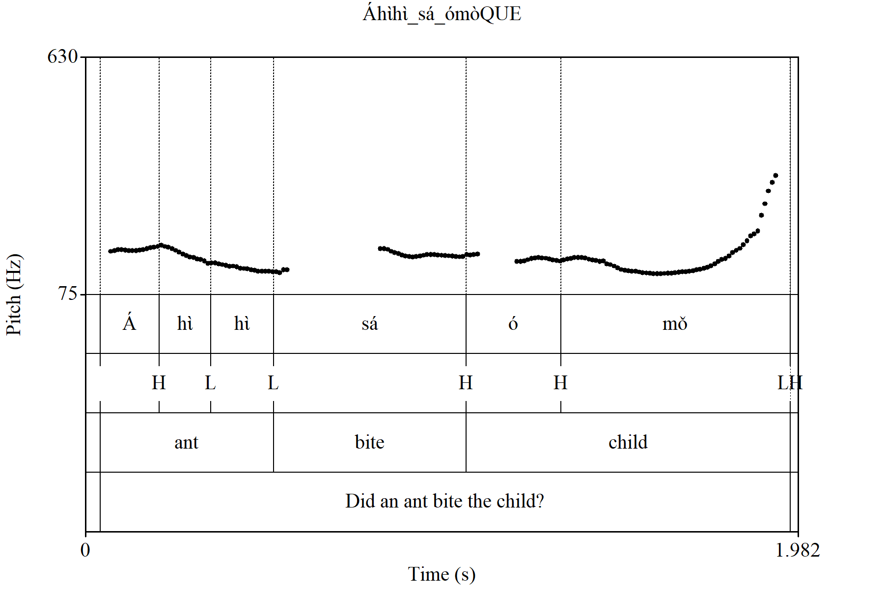
Fig. 2b: Pitch track of Áhὶhὶ sá όmǒ ? ‘Did an ant bite the child?’

Thus the fall-rise contour tone [ᴠ] termed a question morpheme or tomorph, is proposed as marker for the Yes/No question type in Esan.
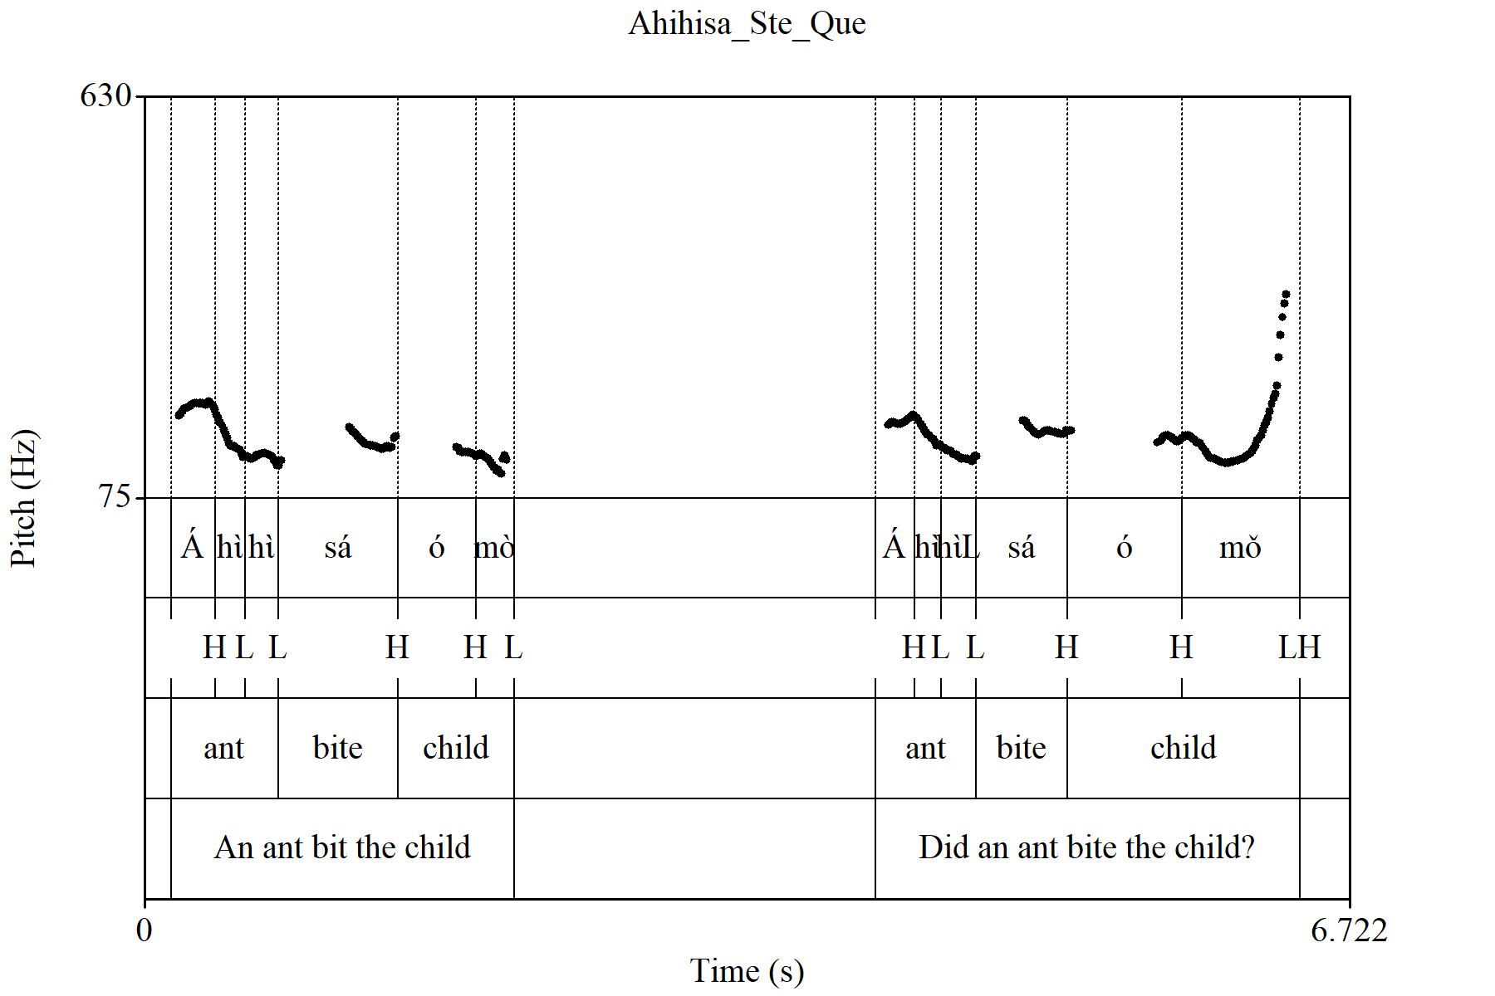
Fig. 3: Pitch tracks of Áhὶhὶ sá όmὸ ‘An ant bit the child’ and Áhὶhὶ sá όmǒ ? ‘Did an ant bite the child?’
Fig. 3 presents the pitch tracks of both the YNQ and declarative utterances to highlight the differences between them which can be attributed to intonation.
- The questioned –word question – As the term indicates, questioned-word questions in Esan tend to question words in a previously rendered sentence. Observation shows that like their Yes/No counterparts, they feature a rising contour tone, which is traceable to the effect of the rising intonation akin to such questions in most languages. This occurrence is illustrated as follows:
Statement Question
- H^{w}èán kὸnὸ ébé ὸrίwὸ dzί ὶmè ébé ὸrίwǒ /
Please pluck me some bitter leave. bitter leaf?
- Sà àmè rè kpé ábὸ à ábǒ /
Fetch some water to wash your hands. hands?
- Nè ίbàtà ίmè dzί ὶmè ίbàtǎ /
Bring me my shoes. shoes?
Figures 4 and 5 below show the pitch tracks of both the statement and questioned-word question in H^{w}èán kὸnὸ ébé ὸrίwὸ dzί ὶmè ‘Please pluck me some bitter leave’ and ébé ὸrίwǒ? Bitter leaf?
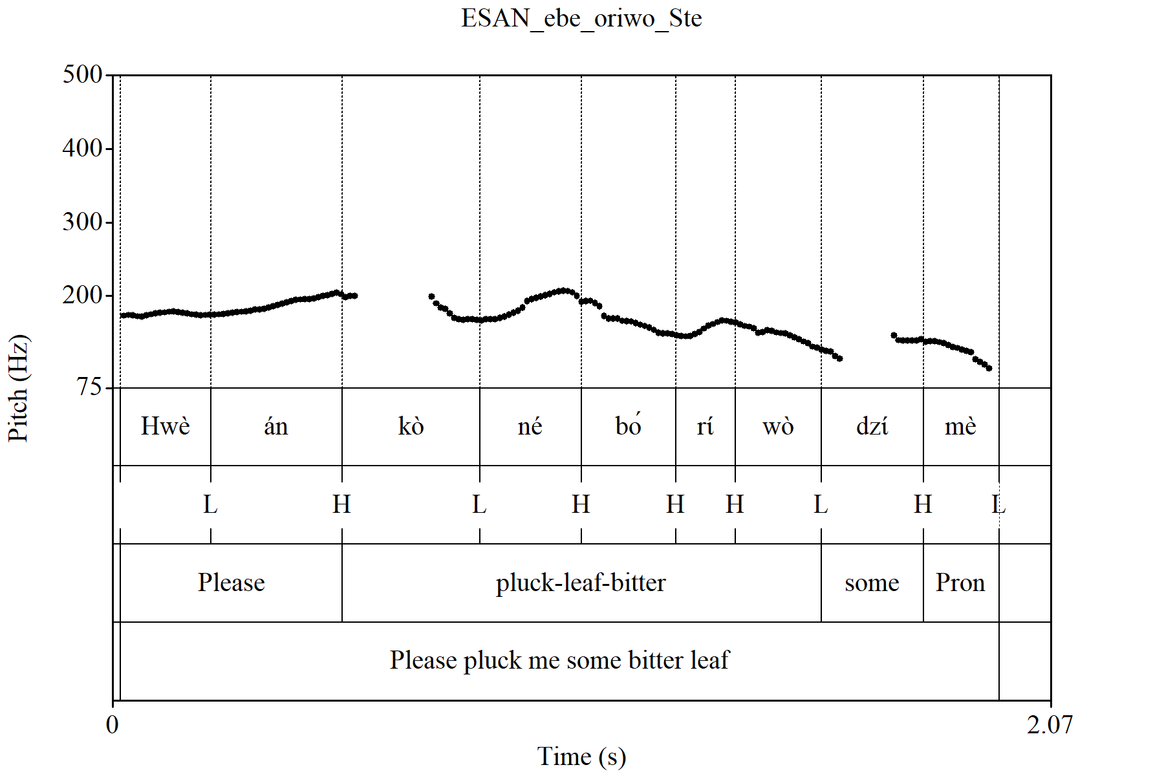
Fig. 4: Pitch track of H^{w}èán kὸnὸ ébé ὸrίwὸ dzί ὶmè. Please pluck me some bitter leave.
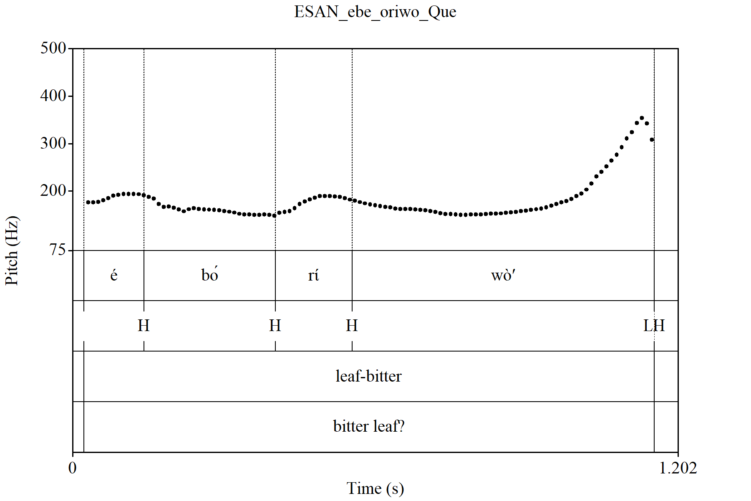
Fig. 5.: Pitch track of ébé ὸrίwǒ? bitter leaf?
Fig. 6 presents the pitch tracks of both the statement and questioned-word question in H^{w}èán kὸnὸ ébé ὸrίwὸ dzί ὶmè ‘Please pluck me some bitter leave’ and ébé ὸrίwǒ? Bitter leaf? An inspection of the pitch tracks shows a falling intonation for the statement H^{w}èán kὸnὸ ébé ὸrίwὸ dzί ὶmè ‘Please pluck me some bitter leave’ and a rising intonation for its question counterpart.
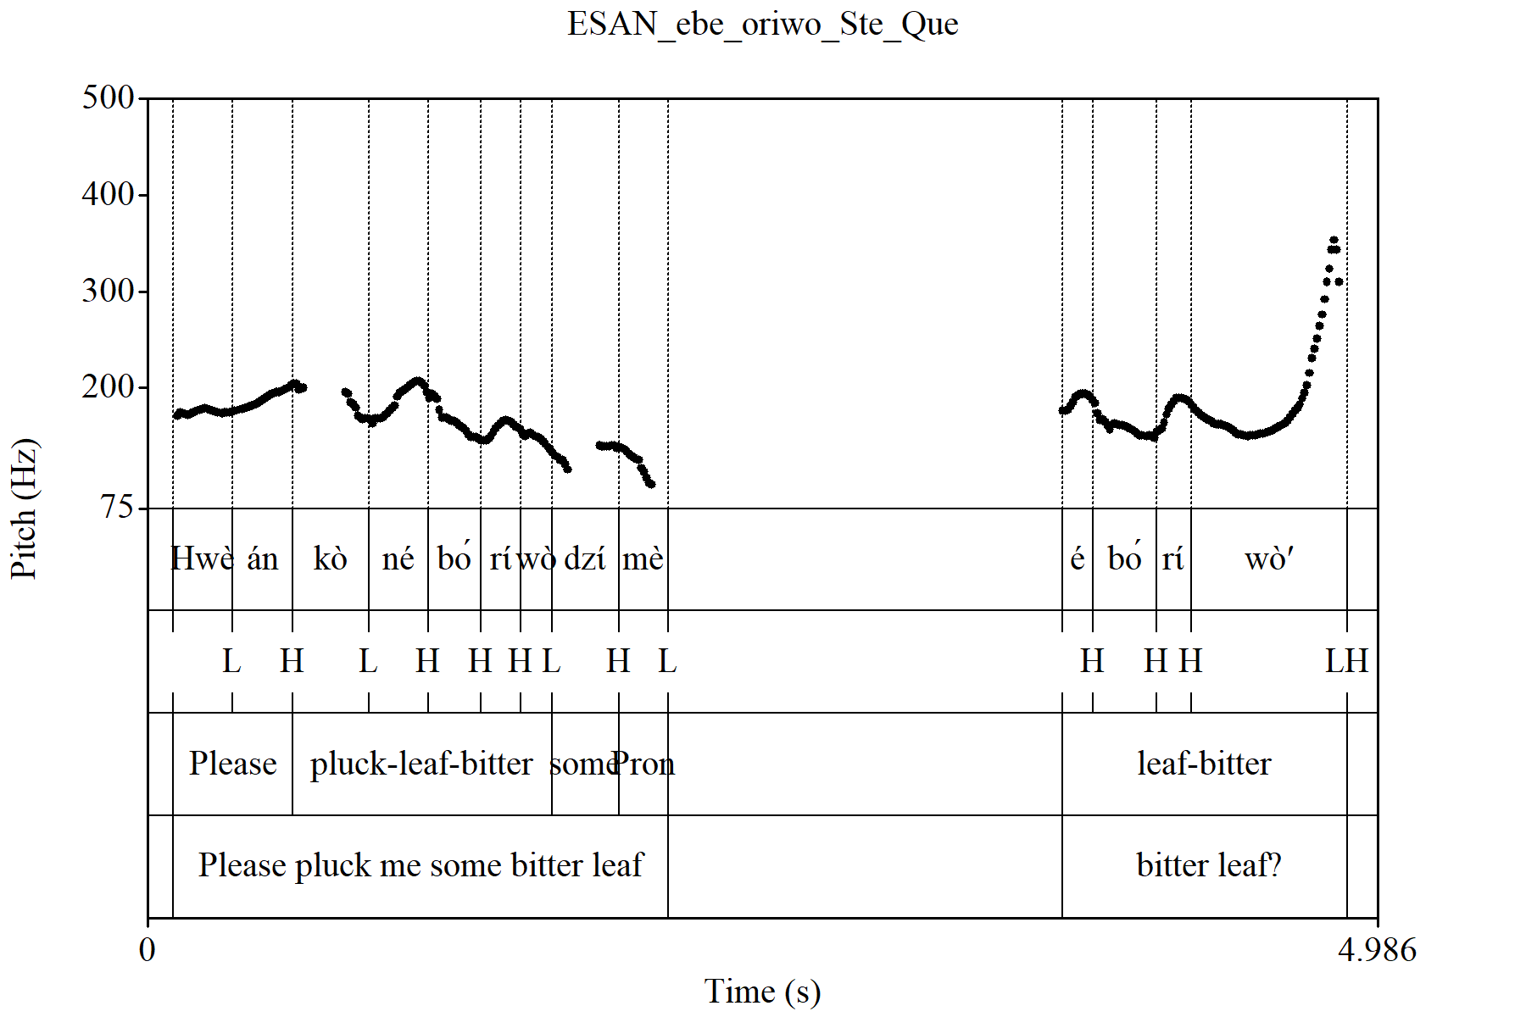
Fig. 6: Pitch tracks of H^{w}èán kὸnὸ ébé ὸrίwὸ dzί ὶmè. ‘Please pluck me some bitter leave’ and ébé ὸrίwǒ? Bitter leaf?
This question type features the rising intonation, the pitch of voice is generally low at the termination of a declarative sentence in the language, it rises to a high in its question counterpart, irrespective of the question type.
Other isolated examples include the following:
Word Questioned- word question
iv. ènî → ènǐ /
there/those there/those?
v. ὸlê → ὸlӗ /
outside outside?
vi. úwâ → úwǎ /
house house?
The fall-rise contour tone [ ᴠ] question morpheme or tomorph, is also proposed as marker for the Questioned-word question type in Esan. This does not come as a surprise because this question type features the rising intonation, like its Yes/No counterpart.

Summary, Conclusion and Recommendations
This paper essentially sought to re-examine previous studies on the question marker in the Esan language. Also going forward and guided by contemporary knowledge, the study postulates alternative markers for questions in the language. Esan is classified as Edoid and in spoken by the Esans in Edo State of Nigeria.
Three question types – the Interrogative pronoun question, the Yes/No and the Questioned word question types in Esan were identified for this study. Data were gotten from primary and secondary sources, by direct interview and previous studies on Esan question markers respectively. Primary data were elicited from 24 L1 Speakers of the language selected from 12 Esan varieties.
Analysis of available data resulted in an enhanced identification of the question marker for Esan question types. This was primarily due to the consideration of the effect of the voice quality of intonation, which is generally known to be the question prosody in most spoken languages and which previous studies on Esan question markers did not seem to have taken into consideration. Specifically therefore, the rise-fall contour tone [ᴧ] termed a question morpheme or tomorph , is proposed as marker for the Interrogative pronoun question in Esan, the fall-rise contour tone [ ᴠ] termed a question morpheme or tomorph , is proposed as marker for the Yes/No question type and the Questioned –word question types. Acoustic testing confirms these findings.
References
Egbokhare, F. (2003). Introduction to Phonetics: A Course Book on Articulatory Phonetics. Ibadan: Sam Bookman Educational and Communication Services
Ejele, P. (1994). The Semantic input of Serial Verb Constructions in Communication. Journal of Nigerian Language Studies (NILAS). 2. 60-68
Ejele, P. (2003). Contour tones in Esan. Ndimelo, O. Ed. Four decades in the Study of Languages in Nigeria: A Festscrift for K. Williamson. Aba: National Institute for Nigerian Languages.
Elugbe, B. (1989). Comparative Edoid: Phonology and Lexicon. Delta Series. No 6. Port Harcourt: University of Port Harcourt Press.
Gimson, A. (1975). A Practical Course of English Pronunciation: A Perceptual Approach. London: William Clowes & Sons Limited.
Ikoyo-Eweto, E. (2013): The Proposed Esan Orthography: Critique and Resolutions. Research in African Languages. Vol. 12. 92-107.
Welmers, W. (1973). African Language Stuctures. Los Angeles: University of California Press.
Yuka, L. C. & Ikoyo-Eweto, E. O. (2022). An Introduction to Esan Grammar. Benin City: University of Benin Press.

