Stop consonant cues in Hausa, Igbo, and Yoruba by L2 Nigerian speakers
Abstract
Previous studies (Adekeye et al., 2019; Oti-Owom, 2021) have explained stop consonants in Hausa, Igbo, and Yoruba (HI&Y). These studies without acoustic evidence show that the three languages do not have phonetic stop contrast. This study, therefore, examines experimental evidence describing stop cues in HI&Y and claims that the voiced-voiceless distinction is more appropriate for the description of stops in HI&Y. The study focuses on closure duration, intensity, voicing bar, and preceding and following vowels—six adults who speak HI&I as their first language were recruited for the study. The stimuli with stops intervocalically have 76 words with default vowels [a, e, i, o, ɔ, u] in the languages. Their recordings are made at a sample rate of 44khz, analyzed in Praat, and a total of 1,864 tokens are elicited. The findings reveal three primary cues: intensity, vocal vibration, and closure duration for HI&Y. However, the most reliable cues are closure and the voicing bar interaction. We discover a stronger correlation between the closure and the voicing bar for the voiced stops than for the voiceless. Similarly, we identify intensity as another cue differentiating voicing contrast for the single stops than for the double stops in HI&Y.
Keywords: Nigerian languages; Phonetic cues; Stop cues; voiced-voiceless distinction

1. Introduction
Stop consonants play a critical role in the phonetic and phonological systems of Hausa, Igbo, and Yoruba (HI&Y), serving as foundational components in speech production and linguistic contrast. These consonants are characterized by their articulatory closure and abrupt release of airflow, producing unique acoustic signatures that are vital to the intelligibility and structure of these languages. Despite their linguistic significance, the specific acoustic properties and cues distinguishing stop consonants in HI&Y remain underexplored.
While previous studies (e.g., Adekeye et al., 2019; Oti-Owom, 2021) have examined the phonological features of stop consonants in these languages, most have relied on theoretical analyses without experimental or acoustic evidence. These works generally assert that HI&Y does not exhibit a phonetic stop contrast, but this claim lacks robust empirical support. To address this gap, the current study provides an acoustic analysis of stop consonants in HI&Y, focusing on closure duration, intensity, voicing bar, and the interaction with preceding and following vowels.
2. Literature Review
Stop consonants, characterized by a complete closure of the oral cavity followed by an abrupt release of airflow, have been extensively studied across languages for their role in speech production and acoustic distinctiveness (Blumstein & Stevens, 1979; Carney et al., 1977; Tabain, 2019). In Nigerian languages, Maddieson et al. (1996) revealed notable differences in stop consonant inventories: Yoruba has six stops, Hausa has sixteen, and Igbo has ten. These differences highlight the phonetic diversity in stop contrasts across these languages. Grawunder et al. (2011) explored voicing in Yoruba, finding that voiced and voiceless labiovelar stops exhibit vocal fold vibration, with the voicing bar being longer for voiced stops. However, these studies often lack a comprehensive approach to single and intervocalic stops, particularly in Igbo and Yoruba.
Research on Igbo stop consonants (Nkamigbo, 2011, 2022) reveals a two-way voicing contrast with voiced (/b, d, g/) and voiceless (/p, t, k/) stops. These studies identify VOT as a primary cue for onset stops. The voiced stops have longer closure durations than voiceless stops. For instance, the voiceless bilabial /p/ has a closure duration of 19 ms, whereas the voiced /b/ has 58 ms. Similar patterns are observed in alveolars and velars, with durations increasing for more posterior articulations. Ladefoged (2003) supports this trend, noting that VOT increases with backness in articulation. Despite these findings, Nkamigbo (2011) identifies phonological effects on voiceless stops, suggesting that the influence of preceding and following vowels impacts closure quality, particularly for intervocalic stops.
While prior research describes onset stops, intervocalic stops have not been explored. Similarly, other acoustic features have not been further examined to describe stop consonants in Nigerian major languages. For example, the role of intensity in distinguishing voicing contrasts in Hausa, Igbo, and Yoruba is underexplored. While spectrogram analysis suggests that voiced stops exhibit greater bursts and amplitudes than voiceless stops, comprehensive data on intervocalic and complex stops are lacking. Studies like Crystal and House (1988) have shown that acoustic cues, such as closure duration and intensity, significantly affect speech perception. However, their application to Nigerian languages, especially with the inclusion of complex stops like labiovelars, requires further investigation.
Research gaps also extend to Hausa and Yoruba, where the absence of contrastive labial stops in their phonemic inventories poses challenges to understanding voicing distinctions. Previous studies, such as Ufomata (1991), have documented the gradual introduction of voiceless labial plosives in Yoruba, yet the implications for voicing contrast remain unclear. Similarly, while Hausa exhibits robust ejective stops, the interplay between voicing bar and closure duration in Hausa stop production has not been systematically analyzed. These gaps necessitate a more nuanced, comparative approach to understanding stop consonants across Hausa, Igbo, and Yoruba.
This study builds on previous work by examining stop production through acoustic parameters such as closure duration, voicing bar, intensity, and their interaction with surrounding vowels. By focusing on intervocalic contexts and comparing single and complex stops, this research aims to uncover the distinct cues that characterize voicing contrasts in Hausa, Igbo, and Yoruba. Furthermore, the study seeks to evaluate how these acoustic properties vary across places of articulation (labial, alveolar, and velar), contributing to a more comprehensive understanding of the phonetic systems of these languages.
The primary research gap addressed by this study lies in the lack of detailed acoustic analyses of stop consonants in Hausa, Igbo, and Yoruba. While phonological studies have identified general voicing contrasts, the specific acoustic cues underlying these distinctions remain insufficiently explored. This research aims to fill this gap by analyzing closure duration, voicing bar, and intensity, particularly in intervocalic contexts. Additionally, the study seeks to extend the investigation to complex stops, such as labiovelars, to assess whether the findings for single stops hold across more intricate articulatory patterns.
The objectives of this study are twofold: first, to investigate the acoustic cues shaping voicing contrasts in Hausa, Igbo, and Yoruba, and second, to explore how these cues vary across different places of articulation and linguistic contexts. By addressing these objectives, the research aims to advance our understanding of the phonetic and phonological systems of Nigerian languages and provide insights into cross-linguistic variation in stop consonant production.

2. Speakers and procedure
2.1 Participants
Six native Hausa, Igbo, and Yoruba speakers were recruited for this study. All participants had proficiency in either Hausa, Igbo, or Yoruba as their first language (L1) and were residents of Nigeria. They were also fluent in English and used it alongside their L1. None of the participants had a history of hearing disorders that could significantly impact their speech production. The participants were selected based on their age (18-40), gender (male, female), level of education (university degree), and first language. The study follows the University of Pittsburgh ethics committee's ethics and regulations. Informed consent was obtained from all participants, ensuring their privacy and anonymity would be strictly maintained throughout the study.
2.2 Materials
High-quality audio recording equipment was utilized to capture the speech samples of the participants in a controlled and quiet environment to minimize background noise interference. The stimuli comprised 76 words commonly used in daily conversations, each containing stop consonants in the wordlist's intervocalic (VCV) positions. These words contained default vowels [a, e, i, o, ɔ, u] in the respective languages (Hausa, Igbo, and Yoruba).
2.3 Labelling
Participants were given clear instructions and were asked to read aloud the provided words containing stop consonants in intervocalic positions. The recorded speech samples were then manually annotated using Praat 6.3.09 software. The annotations included labeling the preceding vowel (V1), closure duration (vv), voicing bar (vb), and the following vowel (V2) for each recorded token. A Praat script was utilized to elicit intensity, V1, V2, vv, and vb measurements from the recordings of the six speakers.
2.4 Statistical Analysis
A total of 1831 tokens were elicited from the prepared stimuli read by the participants. The number of tokens varied across the languages: Hausa (616), Igbo (809), and Yoruba (406). The collected data underwent detailed statistical analysis aimed at identifying potential variations in stop consonant production among the three languages, focusing on the cues associated with stops in each language. For vowel measurements, the duration of V1 (the initial vowel) was captured from its onset to its conclusion before the following consonant sound, while for V2, the interval measured spanned from the end of the consonant release to the completion of the vowel release during stop production. Closure duration was measured from the termination of V1 to the beginning of V2, with a 5-millisecond buffer applied to both V1 and V2 to minimize potential vowel influence. The presence of the voicing bar, indicating vocal fold vibration, was assessed for both voiced and voiceless stops. The full duration of the voicing bar, from onset to completion, was recorded and represented with the notation ‘vb.’ Consonant closure intensity was measured by calculating the average intensity level across the entire closure duration, providing valuable insights into the acoustic properties of the closures and their potential role in distinguishing voicing characteristics.
3.0 Data analysis
The data analysis section explains the analysis to answer the research questions. Using descriptive and inferential techniques, the analysis identifies key features of stop consonants.
3.1: Duration of stop consonant
3.1.1 Duration of stop production by voicing
The duration of the voiceless stops is longer than the voiced stop consonants, both at the word-initial and intervocalically. Voiceless consonants tend to have a longer duration than voiced consonants due to several factors related to their production and perception, and voiceless consonants require more muscular effort and longer constriction of the vocal tract compared to their voiced counterparts. For example, producing a voiceless /p/ sound requires completely closing off the airflow by tightening the lips together. The additional effort and longer duration of constriction for voiceless sounds contribute to their longer duration.
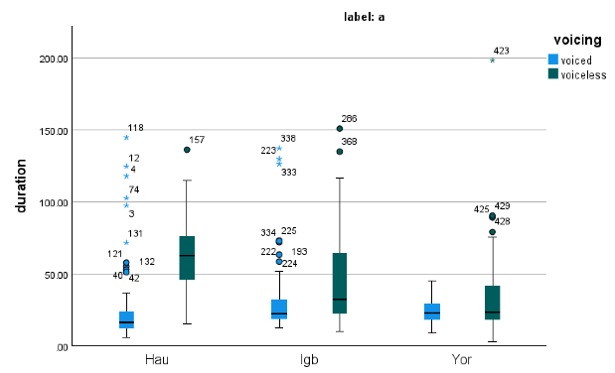
Figure 1: Duration of stops by voicing, position, and language
The longer duration provides a more robust acoustic cue for listeners to identify and differentiate between voiceless and voiced sounds. Significantly, the duration of consonants varies across languages.
The linear regression analysis investigated the relationship between the duration of voiced and voiceless stops, but the result revealed no significant differences (β = -1.04, SE = 5.63, p = 0.853). Though the relationship was not statistically significant, the voiceless are shorter than the voiced stops. The comparisons between languages demonstrated significant variations. Specifically, Hausa and Igbo differed in voicing and duration (β = 81.22, SE = 6.4, p < .001), as did Hausa and Yoruba, albeit to a lesser extent (β = 47.42, SE = 7.6, p < .001). Although no interaction between voiceless and voiced stops was identified, closure duration varied across languages in both intervocalic and onset positions. Post-hoc analysis showed a voicing contrast (F(3, 1864) = 54.43, p < .001). Preceding vowel durations also differed significantly by voicing for Hausa and Igbo, with shorter durations for voiceless stops, but no such differences were observed in Yoruba. Conversely, no significant relationship emerged between stops and the following vowels (V2) across the languages, indicating that V2 does not influence stop production by voicing or language (see Figure 2).

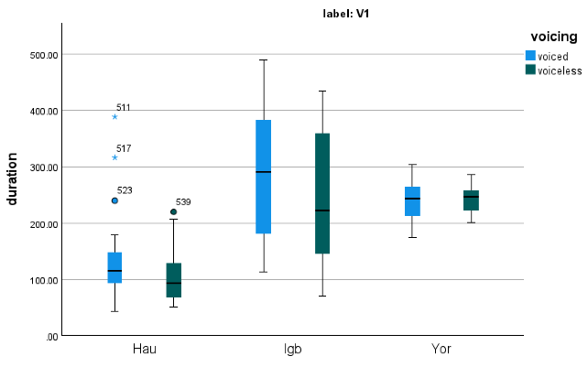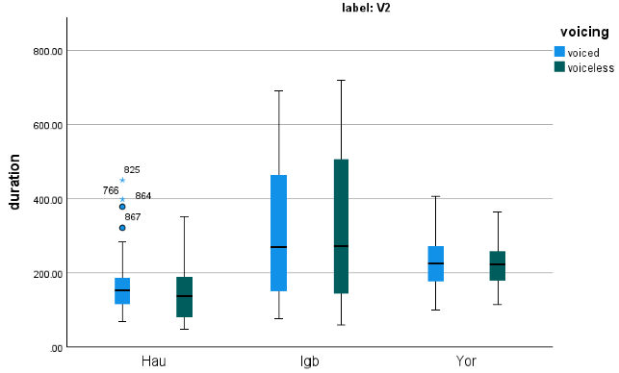
Fig 2a: duration of pre-voicing Fig 2b: duration of the following vowel
Figure 2: Stop duration of preceding and the following vowels

3.1.2: Duration of closure and voicing bar by voicing and language
The analysis of closure duration and voicing bar by voicing and language revealed that for voiceless stops, the duration of the voicing bar during closure is shorter than the closure length, indicating that closure length does not determine voicing for voiceless stops. However, for voiced stops, the length of the voicing bar is strongly correlated with closure duration, with significant interactions observed between these two factors across languages. The regression model demonstrated a significant relationship between closure and voicing bar for voiced stops (p < .001), with an adjusted R² = 0.494 and F(4, 1684) = 256.2, p < .001. Specifically, the intercept for stop release was estimated at 34.763, with voicing bar and closure coefficients of 79.997 and 136.419, respectively, reflecting their substantial contributions to voiced stops. In contrast, no significant relationship was found between voicing bar and voiceless stops (p = .307). Cross-linguistic comparisons showed significant differences in closure and voicing bar durations between Hausa and Igbo (β = 77.115, SE = 4.774, p < .001) and Hausa and Yoruba (β = 45.473, SE = 5.642, p < .001). These findings underscore the critical role of closure and voicing bar in distinguishing voiced from voiceless stops across languages.
Table 3: Regression for the duration of the closure and voicing bar by voicing and language
Coefficients: | Estimate | Std. Error | t-value | Pr(>ǀtǀ)
(Intercept) | 34.763 | 4.755 | 7.311 | 3.95e-13***
Duration-vb | 79.997 | 6.540 | 12.233 | <2e-16***
Duration-vv | 136.419 | 7.352 | 18.556 | <2e-16***
Voicing-voiceless | 4.550 | 4.449 | 1.023 | 0.307
Hausa-Igbo | 77.115 | 4.774 | 16.154 | <2e-16***
Hausa-Yoruba | 45.473 | 5.642 | 8.059 | 1.37e-15***
3.1.3: Duration of voicing contrast in stop production
The closure duration of labial stops (/p/ and /b/) varies significantly by production and language. On average, the voiceless labial stop (/p/) is 166 ms, while the voiced labial stop (/b/) is shorter at 128 ms. Language-specific patterns further complicate these observations. For example, in Igbo, /p/ exhibits a longer duration than /b/, while in Yoruba, /b/ has a longer duration than /p/, indicating no consistent voicing pattern across languages. Notably, Yoruba and Hausa, which do not traditionally include voiceless bilabial plosives in their consonant inventories, exhibit /p/ production as an adaptation in their English varieties. The statistical analysis confirms significant variability in closure duration across languages, with differences in how voicing is realized for labial stops (p < .001). These findings highlight how phonetic realization of /p/ and /b/ diverges in Nigerian languages compared to English (see Figures 4 – 5).
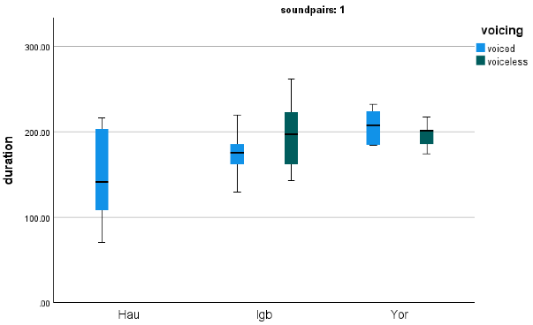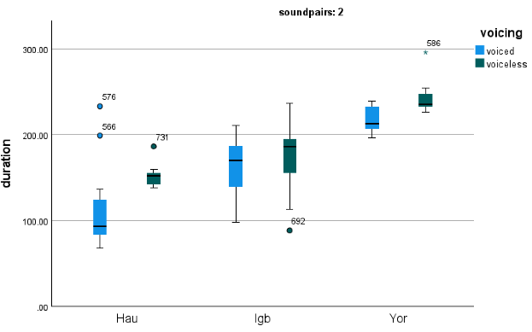
Fig 4a: /p/ vs /b/ Fig 4b: /t/ vs /d/
Figure 4a: Duration of voicing contrast in labial and alveolar by language
In Figures 5 and 6, alveolar and velar stops also show significant variation in closure duration by language and voicing. For alveolars, voiced stops (/d/) exhibit longer closure durations (158 ms) compared to their voiceless counterparts (/t/, 142 ms), with substantial differences across languages. Hausa shows the most pronounced contrast, suggesting that voiced alveolars may feature longer negative VOTs than voiceless ones. In contrast, velar stops (/k/ and /g/) exhibit the opposite pattern, with voiceless stops averaging longer durations (143 ms) than voiced stops (149 ms). The small difference between voiced and voiceless velars suggests that aspiration reduces as the tongue retracts to produce back sounds. For labiovelar stops (/kw/, /gw/, /kp/, and /gb/), Hausa and Igbo exhibit distinct patterns, with voiced stops (/gb/, 185 ms; /gw/, 124 ms) generally longer than voiceless stops (/kp/, 172 ms; /kw/, 140 ms). However, the data indicate that duration alone does not reliably differentiate labiovelars by voicing.
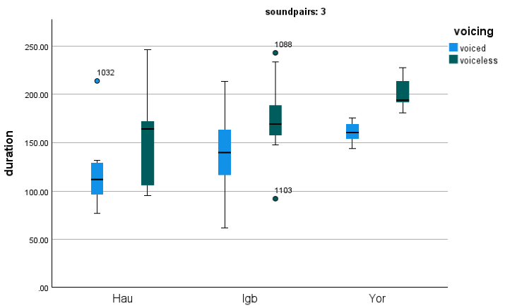
Figure 5: Duration of velar (/k/ vs /g/) by voice contrast and language
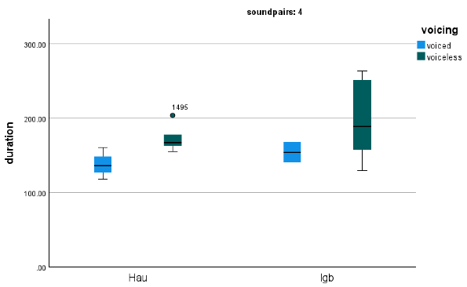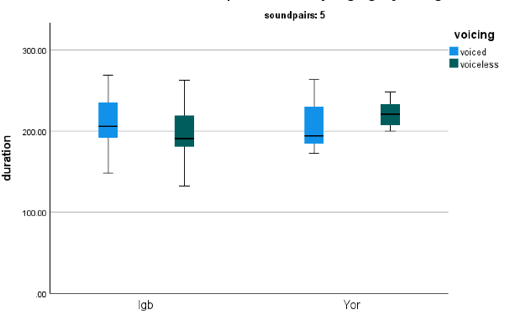
Fig 6a: /k^{w}/ and /g^{w}/ Fig 6b: /kp/ and /gb/
Figure 6: Duration of closure in labiovelars by voicing and language

3.1.4: Duration of aspiration in voicing contrast in stop production by language
The analysis of aspiration duration in voicing contrasts across languages reveals notable variations. For bilabial plosives, the voiceless stop in Igbo demonstrates significantly longer aspiration compared to its voiced counterpart (p < .001), whereas Yoruba shows the opposite pattern, with voiced stops exhibiting longer durations than voiceless ones. This suggests that Yoruba voiceless stops may lack aspiration. The range of aspiration duration for plosives across all languages is between 0 and 40 ms, with the presence of aspiration contributing to these differences. For alveolar stops, voiceless stops show markedly longer aspiration durations than voiced stops, with a 15 ms difference on average. Voiceless alveolars display a wide aspiration range (15–150 ms), while the voiced counterparts remain within 0–25 ms. These patterns underline significant cross-linguistic differences in aspiration.
In velar stops, voiceless stops have longer aspiration durations than voiced stops, though the distinction is less pronounced than in alveolars. This suggests a reduction in aspiration as articulation moves from the front (alveolar) to the back (velar). For labiovelars, the voiceless /kw/ has a longer aspiration duration (140.58 ms) than the voiced /gw/ (124.04 ms), with significant differences (p < .001). However, Yoruba shows no significant voicing differences for labiovelars like /kp/ and /gb/, whereas Igbo exhibits distinct patterns. The absence of significant aspiration differences in Yoruba labiovelars may reflect unique phonetic characteristics of the language. Overall, while aspiration duration fails to differentiate sound pairs within individual languages (p = .08), significant interactions exist between languages, particularly Hausa and Yoruba (p < 2e-16) and Hausa and Igbo (p < 4.29e-09), highlighting both shared and unique phonological processes among these languages.
3.2: Intensity of stop production by languages
The analysis of stop consonant intensity across Hausa, Igbo, and Yoruba reveals no significant relationship between pre-voicing intensity or the following vowels and stop production. Boxplot analyses confirm a lack of interaction between voiced and voiceless stops regarding pre- or post-voicing intensity. This suggests that intensity is not a reliable cue for describing voicing contrasts in the three languages, as higher or lower intensity does not consistently correspond to voiced or voiceless stops. Unlike in English, where voicing distinctions are marked by the presence or absence of vocal fold vibration, the intensity patterns in Hausa, Igbo, and Yoruba are influenced by energy distribution during closure rather than by voicing distinctions. For example, while Hausa and Yoruba show lower intensity for voicing in voiced stops compared to voiceless stops, Igbo does not differentiate between the two. Statistical analysis further supports these findings, showing significant intensity effects across variables related to V1, V2, voicing bar, and closure (p < 2e-16).

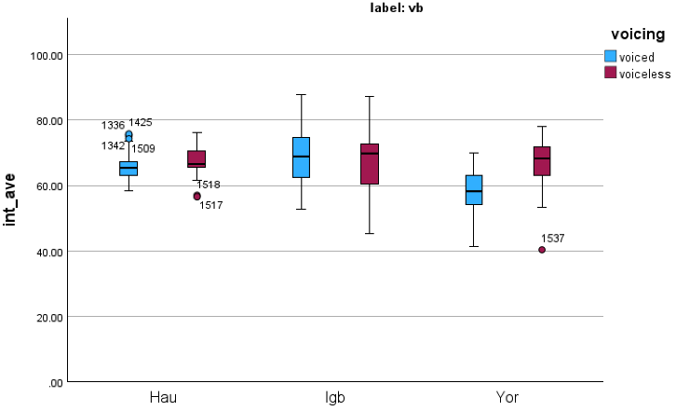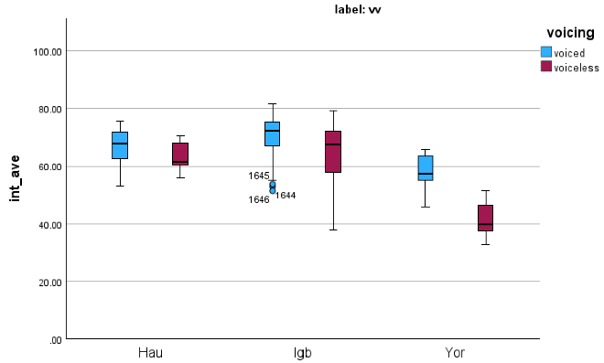
Figure 14: Intensity of voicing bar and closure by voicing and languages
Language-specific patterns further emphasize variation in intensity by voicing. While Hausa and Igbo exhibit relatively uniform intensity values (within 20 dB) for voiced and voiceless stops, Yoruba displays significantly distinct intensity during closure, differentiating voiced from voiceless stops. However, the potential influence of background noise may compromise these results, necessitating further analysis with filtered samples. Interestingly, for labiovelar stops (/kw/ and /gw/) in Igbo, voiceless stops exhibit higher intensity than voiced stops, contradicting Nkamigbo’s (2011) assertion that intensity is consistently higher for voiced stops. Despite this exception, the results broadly align with the idea that stronger vocal fold vibration corresponds to greater intensity for voiced stops, although this relationship is not absolute. The findings suggest that intensity, while influenced by voicing, varies across languages and contexts, limiting its reliability as a universal descriptor for voicing contrasts (p < 1.70e-07).
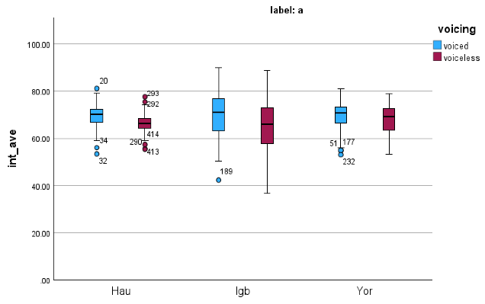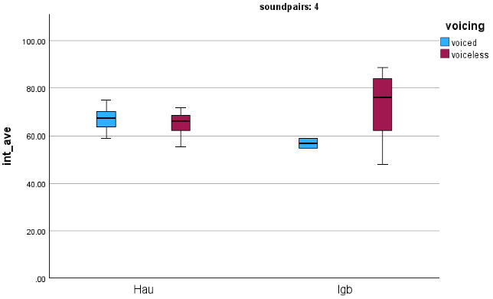
Fig 16a: Stop production by voicing Fig 16b: /k^{w}/ vs /g^{w}/ in Hausa and Igbo
Figure 16: Intensity for the stop release by voicing and language

4.0 Discussion
4.1 Closure duration
Closure duration, during which airflow is completely occluded in stop consonant production, varies across voiced and voiceless stops. This study finds that voiced closures are generally longer than voiceless closures; however, the duration of voiced stops differs across Hausa, Igbo, and Yoruba. These findings align with earlier research emphasizing the variability in closure duration due to differences in the manner of articulation and other phonetic factors (Repp & Williams, 1985). While closure duration often serves as a cue for distinguishing between voiced and voiceless stops (Keating, 1984; Stathopoulos & Weismer, 1983; Lisker, 1957), this study reveals that it is unreliable across the three languages. Instead, a stronger correlation between closure and vocal fold vibration for voiced stops emerges as a more consistent cue for voicing contrast intervocalically. This suggests that, although closure duration may play a role, its similarity between voiced and voiceless stops could lead to perceptual ambiguity or challenges in differentiating the two categories, particularly for Nigerian speakers (Fowler, 1992; Davis & Summers, 1989).
The lack of a clear closure duration distinction for voiceless stops in Hausa, Igbo, and Yoruba may contribute to increased phonetic variation across individual speakers and regions, further complicating the perception and categorization of stops (Hankenar et al., 1989; Hillenbrand et al., 1984). This variability could weaken the phonemic contrast between voiced and voiceless stops, potentially leading to reduced intelligibility and clarity in speech. Over time, these patterns might drive phonological restructuring in these languages, as alternative cues—such as formant transitions or voicing bar intensity—may become more prominent to maintain voicing contrasts. Similar trends have been observed in other languages, where shifts in phonetic cues respond to inconsistencies in traditional markers like closure duration (Crystal & House, 1988). These findings suggest that Nigerian languages may also develop additional strategies to compensate for the unreliability of closure duration in voicing distinction.

4.2 Voicing bar
Apart from the closure duration, the relationship between closure duration and the voicing bar emerged as a critical cue for distinguishing voiced and voiceless stops in this study. A strong correlation between closure duration and the voicing bar in voiced stops enhances their perceptual distinctiveness, creating clearer boundaries between the two categories. This alignment of acoustic cues strengthens phonemic contrasts and facilitates intelligibility, allowing listeners to identify and differentiate voiced from voiceless stop consonants more accurately. Consistent with findings by Crystal and House (1988), the robust relationship between closure and voicing bar helps stabilize phonemic contrasts, reducing the likelihood of phonological reorganization. This consistency is particularly important in Nigerian languages, where voicing contrasts are maintained despite variability in acoustic properties like closure duration (Stathopoulos & Weismer, 1983; Lisker, 1957).
However, the lack of a strong voicing bar cue for voiceless stops suggests that closure duration may be more prominent in compensating for this gap. This reliance aligns with observations in other studies, where the absence of clear voicing cues increases the salience of alternative markers (Shultz et al., 2012). Nigerian languages, particularly Hausa, Igbo, and Yoruba, may exhibit increased phonetic variation as speakers adjust closure duration patterns to reinforce voiceless stop distinctions. For example, voiceless stops may exhibit greater variability across individual speakers or regions, further complicating their categorization. These findings underscore the interplay of acoustic cues in maintaining phonemic contrasts and highlight how variations in one cue, such as the voicing bar, can influence the salience and reliability of others, like closure duration (Repp & Williams, 1985). The study contributes a deeper understanding of how voicing contrasts are managed in diverse linguistic contexts.

4.3 Intensity
The findings of this study reveal that voiced stops consistently exhibit higher intensity than voiceless stops across labial, alveolar, and velar articulations in Hausa, Igbo, and Yoruba. This increased energy, linked to vocal fold vibration during voiced stop production, enhances their perceptual salience and makes them more distinguishable for Nigerian speakers. However, an exception was observed among Igbo speakers for complex stops like /kw/, where voiceless stops showed higher intensity than voiced ones. This suggests that intensity is a more reliable cue for single stops rather than complex ones in these languages. The correlation between higher intensity and voiced stops underscores their prominence in speech, supporting clear phonemic contrasts between voiced and voiceless stops. This alignment with earlier studies, such as Stevens (1993), highlights how acoustic energy distribution plays a critical role in the intelligibility and categorization of voicing contrasts.
The increased intensity of voiced stops may provide a perceptual advantage by enhancing auditory prominence, drawing listeners’ attention to these sounds, and facilitating their interpretation of linguistic information. This phenomenon aligns with earlier observations that voiced stops often require greater vocal fold activity and articulatory effort, contributing to their energetically robust acoustic signal (Stathopoulos & Weismer, 1983). This physiological basis includes heightened activity in respiratory muscles and sustained vocal fold vibration, which amplifies the acoustic output of voiced stops. Consequently, the enhanced intensity difference not only aids perception but also reinforces phonemic contrasts, ensuring that voiced stops remain distinct and intelligible even in languages with diverse phonetic and phonological systems, such as Hausa, Igbo, and Yoruba. These findings align with evidence from cross-linguistic studies that link intensity to voicing distinctions, albeit with variation across complex and single stops (Blumstein & Stevens, 1980).

5.0 Conclusion
This study examined the acoustic properties of stop consonants in Hausa, Igbo, and Yoruba, focusing on the relationship between closure duration and the voicing bar as primary cues for voicing contrast. The findings reveal that a strong correlation between closure and vocal fold vibration characterizes voiced stops, while voiceless stops show weaker or absent correlations. This pattern differs significantly from other languages, such as English, where voiceless stops typically lack a voicing bar. In Nigerian languages, the vocal cords remain active during voiced stop production, sustaining vibration from the preceding vowel to the stop release. For Igbo labials, voice onset time (VOT) serves as an additional cue, with voiceless stops lasting 38 ms longer than their voiced counterparts. However, this VOT distinction is less consistent for alveolar and velar stops, where durations are comparable or reversed. The study also highlights that VOT is not a reliable cue for intervocalic stops across these languages, as the vocal cords remain open throughout the stop release and into the following vowel, diverging from Nkamigbo’s (2011) findings on onset stops.
These results underscore the importance of closure duration, voicing bar, and intensity as key acoustic markers for distinguishing voicing contrasts in Nigerian languages. The study challenges prior assumptions that VOT is a universal cue for voicing and highlights cross-linguistic variation in stop consonant production. Future research should explore additional phonetic cues, such as formant transitions and aspiration, to provide a more comprehensive understanding of voicing contrasts in these languages. Moreover, further investigation into intra- and inter-speaker, as well as spectral approach, may reveal how sociolinguistic factors influence stop consonant production.

References
Adekeye, B., Na’Allah, A., & Amaechi, M. (2019). Chapter twelve contrastive study of Hausa, Igbo and Yoruba consonants. Language, pedagogy & social discourse, 148-159.
Blumstein, S. E., & Stevens, K. N. (1979). Acoustic invariance in speech production: Evidence from measurements of the spectral characteristics of stop consonants. The Journal of the Acoustical Society of America, 66(4), 1001-1017.
Carney, A. E., Widin, G. P., & Viemeister, N. F. (1977). Noncategorical perception of stop consonants differing in VOT. The Journal of the Acoustical Society of America, 62(4), 961-970.
Davis, S., & Van Summers, W. (1989). Vowel length and closure duration in word-medial VC sequences. Journal of Phonetics, 17(4), 339-353.
Dixit, R. P. (1989). Glottal gestures in Hindi plosives. Journal of Phonetics, 17(3), 213 237.
Fowler, C. A. (1992). Vowel duration and closure duration in voiced and unvoiced stops: There are no contrast effects here. Journal of Phonetics, 20(1), 143-165.
Gut, U. (2008). Nigerian English: Phonology. Varieties of English, 4, 35-54.
Halle, M., Hughes, G. W., & Radley, J. P. (1957). Acoustic properties of stop consonants. The Journal of the Acoustical Society of America, 29(1), 107-116.
Hankamer, J., Lahiri, A., & Koreman, J. (1989). Perception of consonant length: Voiceless stops in Turkish and Bengali. Journal of Phonetics, 17(4), 283-298.
Hillenbrand, J., Ingrisano, D. R., Smith, B. L., & Flege, J. E. (1984). Perception of the voiced voiceless contrast in syllable‐final stops. The Journal of the Acoustical Society of America, 76(1), 18-26.
Keating, P. A. (1984). Phonetic and Phonological Representation of Stop Consonant Voicing. Language, 60(2), 286–319. https://doi.org/10.2307/413642.
Ladefoged, P. (2003, August). Phonetic fieldwork. In Proc. 15th ICPhS (pp. 203-206).
Lisker, L. (1957). Closure Duration and the Intervocalic Voiced-Voiceless Distinction in English. Language, 33(1), 42–49. https://doi.org/10.2307/410949.
Lisker, L., & Abramson, A. S. (1964). A cross-language study of voicing in initial stops: Acoustical measurements. Word, 20(3), 384-422.
Maddieson, I. (1984). The effects on F0 of a voicing distinction in sonorants and their implications for a theory of tonogenesis. Journal of Phonetics, 12(1), 9-15.
Maddieson, I., Hardcastle, W. J., & Laver, J. (1996). Phonetic universals. UCLA Working Papers in Phonetics, 160-178.
Nkamigbo, L. (2011). Experimental Analysis of Voicing Contrasts in Igbo. UJAH: Unizik Journal of Arts and Humanities, 12(2), 189-203.
Nkamigbo, L. C. (2022). Màdá Stop Consonants: An Instrumental Study. Journal, 1(2).
Oti-Owom, E. U. (2021). The sound systems of English, Yoruba and Igbo: a contrastive analyses and their interference in second language acquisition. GSJ, 9(6).
Repp, B. H., & Williams, D. R. (1985). Influence of following context on perception of the voiced voiceless distinction in syllable‐final stop consonants. The Journal of the Acoustical Society of America, 78(2), 445–457.
Shultz, A. A., Francis, A. L., & Llanos, F. (2012). Differential cue weighting in perception and production of consonant voicing. The Journal of the Acoustical Society of America, 132(2), EL95-EL101.
Stathopoulos, E. T., & Weismer, G. (1983). Closure duration of stop consonants. Journal of Phonetics, 11(4), 395–400.
Stevens, K. N., & Blumstein, S. E. (1978). Invariant cues for place of articulation in stop consonants. The Journal of the Acoustical Society of America, 64(5), 1358-1368.
Tabain, M. (2019). The phonetic properties of consonants. In The Routledge Handbook of Phonetics (pp. 264-288). Routledge.
Watkins, J. (2000). Notes on creaky and killed tone in Burmese. SOAS Working papers in Linguisitics and Phonetics, 10, 139–149.
Adekeye, B., Na’Allah, A., & Amaechi, M. (2019). Chapter Twelve, A Contrastive Study of Hausa, Igbo, and Yoruba consonants. Language, Pedagogy & Social Discourse, 148 - 160
Sani, M. A. Z. (2005). An introductory phonology of Hausa. Kano: Benchmark Publishers Limited Second Edition.
Ugoochi, I., Nkechi, O. & O. Yusuf (2008). Igbo acculturation lexis, structure, and culture of Igbo. Aba: Institute for Nigerian Languages. Pp.148-160. University of Ilorin

