Intonation Cues in Doctor-Patient Interactions in South-West Nigeria: Implication for Nigerian Spoken English Medical Discourse

Abstract
The study recorded twenty interactions between doctors and patients in selected private and public hospitals in Osun State. The qualitative and quantitative methods were adopted for the study. Data garnered were subjected to David Brazil’s Discourse Intonation Theory and PRAAT acoustic analysis. Findings revealed that doctors use repetition as a major tool for correcting patients and for affirming whether the patient knows his/her actual reason for visiting the hospital. The study also discovered that doctors use circumlocution in their interactions with patients, which aligns with falling tunes to make the patient feel comfortable and also not be offended. It was observed that the tune used by the male doctor differs from that of the female doctor when welcoming a patient into the office. The male doctor uses proclaiming tunes often as a greeting pair while the female doctor uses proclaiming and referring tunes as a greeting pair for patients. Overall, it was discovered that doctors used 17 proclaiming tunes (42.5%), 1 referring tune (2.5%), 2 proclaiming and referring tunes (5%) as well as 1 referring and proclaiming tune (2.5%). Patients used 2 proclaiming tunes (5%), 4 referring tunes (10%), 9 proclaiming and referring tunes (22.5%) and 4 referring and proclaiming tunes (10%). It was observed that out of 40 frequency instances of use, doctors used 21 (52.5%) tunes and patients used 19 (47.5%) tunes in the study. It was observed that meaning is negotiated through the participant’s choice of intonation in this study doctors and patients used the low pitch to pract appealing, falling tune practs informing, inquiry, worrisome, the mid-pitch to pract sincerity, rising tune to pract affirming, power and control depending on the context. Hence, the study concludes that the structure of doctor-patient interactions can be categorized and described in line with Brazil’s discourse intonation.
Keywords: doctor-patient interaction, intonation pattern, medical discourse intonation

- INTRODUCTION
Intonation is prominent in all aspects because without it our speeches would likely remain on one pitch throughout but when it is used in a speech, such will be melodic. In the same vein, Suciu (2016) also avows that intonation is all about how we say the words and express them, rather than what we say. It means that intonation is the way to say some words in different ways. Then she also adds that speech without intonation is like a machine or a robot. Fery (2017, p.7) concurs with this, as the scholar describes intonation as “the total structure of speech making up the melody produced by the larynx”. Prosodic features of speech are regarded as the melodic features of linguistic units which are beyond the description of segmental phonology. Thus, they are also known as supra-segmental (Chun 2002; Skandera and Burleign 2005; Fery 2017). Prosody is characterized by intonational features and intonation needs both prosodic domains and their phonetic correlates. Skandera and Burleigh (2005, p.5) corroborate the view of Fery (2017) to say that “prosody is concerned with those features of pronunciation that cannot be segmented because they extend over more than one segment or sound which include stress, intonation and rhythm”. However, Adejuwon (2016) identifies intonation as the prime example of prosodic features and enumerates others as stress and tone. He acclaims further that intonation has domains which are different from other features because it has phrase, clause or sentence as its domain while tone and stress have syllable, morphemes or words as their domains (Adejuwon, 2016).
1.1 Acoustic Description of Intonation
A lot of controversies exist among linguists as several criticisms tend to erupt against auditory analyses. Some critics claim that the methods are unscientific and too impressionistic, while some hold the view that those trained to listen to pitch patterns in language will hear only what they have been trained to hear and thus, myths are propagated (Cruttenden, 1986). There are three elements which are considered to be paramount in the linguistic analysis and description of prosody; loudness, pitch and length. The physical properties of these features are frequency, duration and intensity. Pitch may be described as the height of sounds produced in speech. Pitch is produced by the vibration of the vocal cords within the larynx. This vibration of vocal cords can be measured acoustically. The acoustic correlate of vocal fold vibration is the fundamental frequency or F of the sound wave generated at the glottis, measured in Hertz (Hz) and also referred to as ‘cycles per second’. Chun (2002) submits that the fundamental frequency among male speakers is between 180Hz and 400Hz with an average of 120Hz for men, 225 Hz for women and 265 Hz for children. Fery (2017) submits that a woman’s voice is typically higher than a man’s voice, because vocal folds are thinner and shorter in women and as a result, they vibrate more quickly. While young women speak at 220Hz, young men speak at 130Hz. Fery (2017) further posits that as a result of the shorter vocal folds of children, they have a higher pitch and very young children have an average pitch of 400Hz.
1.2 Medical discourse
Wilce (2009, p.199) describes medical discourse as “discourse in and above healing, curing or therapy, expressions of suffering; and relevant language ideologies”. Schneider and Baroon (2014, p.492) argue “that the study of medical discourse, including its verbal and non-verbal components is a prerequisite for understanding the enterprise of medicine”. Medical Discourse is a kind of discourse that explores the interrelation between discourse and healthcare. Discourse is described as stretches of 'contextuality sensitive written and spoken language produced as part of the interaction between speakers and hearers and writers and readers' (Adolphs & Harvey, 2012). Therefore, it can be described as a central activity within the concept of healthcare that helps to determine successful (or otherwise) outcomes and patient satisfaction. Medical discourse not only allows medical professionals to communicate with each other but it is also the link between the medical profession and the public, including the patients. It is a kind of discourse that illustrates the procedures of extracting information from the patient, to be able to examine and prescribe the right drug and dose for the concerned patient. The major participants in medical discourse include the doctor and the patient. Doctors need information to diagnose and give treatment while the patients need information about what happened, the cause, damage it has done to the body system if any, and the assurance that they will be cured.
Odebunmi (2016) analyses and categorises various forms of discursive repetitions, as well as identifies the constituents involved in Nigerian clinical meetings. Additionally, it seeks to establish correlations between these repetition types and the different voices that are expressed during interactions. Furthermore, the study investigates the role of discursive repetitions and voices in the negotiation of clinical outcomes. The study asserts that within consultative meetings in Nigerian hospitals, all four voices of discursive repetitions hold importance. However, the medical scientific voice and the lifeworld cultural voice seem to have a more direct influence on patients' trust in the medical process and their willingness to cooperate for effective information and medical outcomes. Dhea, Laila and Rahmat (2022) conduct a study on an analysis of medical discourse on online news on Instagram social media. The study examines medical terminology extracted from online news articles on Instagram, specifically those posted by the @cnnindonesia account. The analysis focuses on the theory of meaning, encompassing both lexical and contextual dimensions. The present study examines medical terminology within the framework of lexical semantics, utilising medical dictionaries, online health and medical dictionaries, and comprehensive health dictionaries specifically focused on Covid-19, as published by the Ministry of Health of the Republic of Indonesia. Additionally, the analysis incorporates the contextual meaning theory, which encompasses the contextual aspects of individuals, locations, and objects. In this study, we investigate the intonation patterns in doctor-patient interaction.
1.3 Literature Review
Discourse intonation has been explored in language teaching (Clennell, 1997; Chapman, 2007; Pickering, 2018), social communication and gender (Gbadegesin, 2018; Ali, 2020), advertising (Odeyemi, 2017), medical encounters and health care (Ho, 2010), among others. Several research has utilised Brazil's discourse intonation to examine the intonation characteristics of non-native speakers in contrast to native speakers (Goh, 2001; Pickering 2001; Rui, 2007; Mat Nayan & Setter, 2016). Limited research has been conducted on the specific function of intonation in elucidating concealed or intended meanings within various contexts, such as commercials, BBC programmes, and radio interviews (Herczeg-Deli, 2012; Miyauchi, 2014: Odeyemi, 2017).
Pickering (2004) investigates the utilisation of intonational paragraphs as a means of organising the instructional discourse employed by native speaker teaching assistants and non-native speaker international teaching assistants within the context of a North American institution. Similarly, Pickering, Hu and Baker’s (2012) study is phono-pragmatic. The purpose of this study is to examine the use of prosodic (mis)matching as a means of expressing (dis)agreement among native speakers of American English (AES) and Chinese learners of English (CLsE). By doing so, this research aims to enhance our comprehension of cross-cultural expressions of speech acts and further our knowledge of the acquisition and instruction of intonation in second language learning. The findings indicated that both AESs and CLsE exhibited pitch concord in most of the agreement sequences. Nevertheless, it is worth noting that whereas the Advanced English Speakers (AESs) frequently employed pitch mismatching as a means to express disagreement with their conversation partner, the same pattern was not observed in the Conversational Language Speakers of English (CLsE) discourse. This discrepancy implies that there may be a need for pedagogical intervention to address this issue.
Ali (2020) demonstrates the effective clarification of meanings and their functions in Mohammad Ali Clay's interview through the utilisation of the components found in Brazil's model of discourse intonation. Specifically, the study focuses on the information tones associated with the key and termination levels, along with their respective meanings, as well as the influence of dominance and non-dominance factors. In relation to the concepts of dominance and non-dominance, both the young Muslim and Clay exhibited agency in their discourse on novel knowledge. Nevertheless, the individuals in question refrained from assuming subordinate positions when discussing information already familiar to the audience. The prevailing role in their discourse is typically that of non-dominance, which elucidates the characteristics of the young Muslim and Clay. They engage in conversation using a straightforward manner of speech and a notably subdued tone. Despite these scholarly efforts, this study delves into an under-researched aspect of phonological analysis. It analyses how intonation patterns index meaning in doctor-patient interaction. Sánchez-Alvarado (2022) investigates the developmental patterns observed in the intonational grammar of individuals who are native speakers of American English and are learning Spanish. The focus is on analysing their use of intonational elements. The examination of the findings is situated within Mennen's L2 Intonation Learning theory, which takes into account the multifaceted nature of intonational grammars and the intricate nature of the acquisition process that arises from them. The study investigated individual aspects associated with the learners' experience, namely their experience overseas and the number of hours of exposure. The findings revealed that extended periods of immersion, lasting more than 8 months, had a beneficial impact.
In the same vein, Pešková (2022) investigates various categories of non-neutral statements, namely those characterised by limited focus, statements of the obvious, and what-exclamatives. These statements were collected through the use of a Discourse Completion Task. The study indicates that intonation can be acquired by Czech learners of Italian and Spanish. However, it is important to note that both groups of learners differed from native speakers in various aspects. In contrast to their proficiency in acquiring novel nuclear position patterns, learners encountered more challenges in acquiring boundary tones, regardless of the presence or absence of the tone in their native language. Akindele and Akano (2023) examine the production and interpretation of intonation in the Nigerian context and investigate the ability of second language (L2) learners to recognise and create syllables in accented words within English utterances. The results confirm that there is a notable disparity in the production and comprehension of accentual intonation patterns among second language (L2) learners. The findings also provide confirmation that second language acquisition of accentual intonation tends to result in high proficiency in accurately interpreting accentual tunes in written form.
- THEORETICAL FRAMEWORK: DISCOURSE INTONATION
This model has gained the attraction of different scholars. Some researchers believe that it is the most satisfactory explanation for the intonation choices speakers make. Cauldwell (2000) opines that discourse intonation gives a clear way of understanding naturally occurring speeches and continues to gain research patronage across the globe as a current theory. Roach (2006) in a seminar, emphasizes that discourse intonation looks at how speakers use intonation interactively. Chapman (2007, p.6) affirms that “discourse intonation helps to organize and demystify the teaching of intonation”. Adejuwon (2016) affirms that discourse intonation is concerned with the speaker’s moment-by-moment context-referred choice. Therefore, this study will adopt this model since the theory has gained the attraction of many scholars because of its prominent feature of analyzing naturally occurring events effectively. Hence, the four major systems of speaker choice identified in Brazil’s discourse intonation are discussed accordingly.
In Brazil’s model, the choices made by speakers are from four systems- prominence, tone, key and termination. These systems foster intonation to represent the existential context that projects the role-relationship and the state of convergence between the speaker and the listener
Discourse Intonation System

Prominence Tone Key Termination
Prominent Rise-fall high high
non prominent Fall mid mid
Fall-rise low low
Level
Winnie and Lam (2012: 299)

2.1 Prominence
In a conversation, a speaker can make one syllable more prominent than others depending on their intentions. This signifies that all tone units have one or two prominent syllables, but the listener can perceive them as more emphatic than other syllables. Terken and Hermes (2000) claim that prominence is a property of a linguistic entity relative to an entity or a set of entities in its environment. Ali (2020), states that prominence refers to the first prominent syllable in the tone unit which is the onset and it is called the key. Winnie and Lam (2012, p.274) are of the view that a prominent syllable is the one that a hearer recognizes as being in some sense more emphatic than the others in the tone unit. Therefore, a prominent syllable is seen to be produced with more effort than the surrounding syllable(s). In essence, speakers highlight certain syllables to show prominence in order to make meaningful choices. A prominent syllable can be the onset or the tonic syllable. In Brazil’s model, the onset syllable is the first in the tone unit while the tonic syllable is the last. Although these syllables are subsets of prominent syllables, the onset syllable is complimentary to the tonic syllable (Brazil 1997). Adejuwon (2016) affirms that a tonic syllable is a syllable that is prominent and on which there is a major pitch. The tonic syllable carries the tone as such once it occurs in the tone unit, the tone also occurs. A tone unit may contain up to four prominent syllables though tone units with one or two prominences are considered the norm. Tonic syllables are indicated and an arrow symbol is placed at the beginning of the tone unit to specify the tune that is selected. In essence, prominence is highlighted to show a special significance to the listener. In making a selection between prominence and non-prominence, the speaker’s selection is made based on the general paradigm and existential paradigms. The existential paradigm is the set of possibilities that a speaker [sic] regards as actually available in a given situation (that is, it deals with the context of interaction that is understood as the shared knowledge between the speaker and the listener) while the general paradigm is the set of possibilities that is “inherent in the language system” (Winnie & Lam 2012, p.302).
2.2 Tone
Chun (2002) views tone as pitch change that characterizes the tonic segment of a tone group. Douglas and Randi (2015) define a tone as the pitch movement that begins at the tonic syllable (i.e the last prominent syllable in a tone unit). In discourse intonation, a particular communicative value is associated with each of the five possible tones. Brazil (1997) identifies five tones: falling, rising, fall-rise, rise-fall and level. The tone choice that speakers make can be falling, rising or level. The falling tone is chosen to project information as new; the rising tone is chosen to project it as given or recoverable with the level tone used to indicate no particular communicative value. Falling tone (proclaiming tone, p), rising tone (r+), fall-rise (referring tone r) rise fall (p+) and level. A referring tone is selected when there is an assumption that the meaning can be taken for granted by the listener or in questions to make sure about some information. A proclaiming tone is selected when the information is imagined to be new or an inquiry is made to the listener (Kato). In addition to this, Chun (2002, p.52), affirms that old information is “referred to” and new information is “proclaimed.” The dominant speaker may use a rising tone and a rise-fall tone to show control over interaction. Sometimes the speaker may switch to a fall-rise tone to be friendly to the listener.
Chun (2002) acclaims that; a rising tone is an intensified referring tone. This claim is slated in the following sentences:
- //r in the CUPboard (fall-rise) = r (referring tone).
- //r+ in the CUPboard/ (rise) = r+ (intensified tone).
(Chun, 2002, p.33)
Chun explains that the use of a simple referring tone in (i) implies “that is where they always are” whereas if the intensified r+ tone is used (ii) to connote ‘why don’t you ever remember’ (Chun 2002: 33).
Fall-rise tone (r) | Indicates that this part of the discourse will not enlarge common ground assumed to exist between the participants
Rise-tone (r+) | Reactivates something which is part of the common ground between the participants
Fall tone(p) | Shows that the area of speaker-hearer convergence is about to be enlarged
Rise-fall tone (p+) | Indicates addition to the common ground to speaker’s will knowledge at one and the same time
Douglas and Randi (2015, p.98).
Each tone unit has one or two “prominent syllables”. When there are two prominent syllables in a tone unit, the first one is called the onset syllable and the last one is the tonic syllable. Both prominent syllables are indicated in upper-case letters and the tonic syllable is underlined as well. At the tonic syllable, pitch movement starts (Rannali, 2002).
//I think on the whole// that these officials// do a remarkably good job //we have to remember// that// they’re required// by administrative practice// to take these decisions// on paper//and// most often//when they get these decisions wrong// it’s because// they haven’t had the opportunity// of taking// face to face//with the claimant// and really finding// the facts//
Source: (Brazil, 1997, p.6).
2.3 Key
This is the pitch-level system; it contributes to the description of intonation and projects the relevant utterances made by the participants. Winnie and Lam (2012) view it as the pitch level choice associated with the first prominent syllable (onset) in the tone unit. Adejuwon (2016) avers that key is a relative pitch level chosen by speakers for each tone unit from three choices: low, mid and high. Brazil (1997) defines it as the choice associated with the onset syllable in a tone unit.
The key has three levels which are low, mid and high. The description differs depending on where the key movement occurs. Brazil (1997) opines that the word that represents the key is capitalized and the word that represents the termination is capitalized and underlined in which both the key and the termination are enclosed by a pair of slashes.
Each pitch level represents a specific intonational meaning. High key is used to indicate when the matter of the tone unit is presented as being contrary to the expectations of the hearer, low key occurs where the message is supposed to perfectly meet the hearer’s expectations while mid-level showcase that there is no particular assumption upon the part of the speaker about what the hearer’s expectations are, that is, the content of the respective mid key tone unit is just an addition to what has already been said before.
2.4 Termination
Termination denotes the specific pitch levels of tonic syllables. The function of termination differs from that of a key in that it is not so much concerned with the hearer’s expectations but rather with the speaker’s expectation with regard to the key of the hearer’s response. Termination also has three levels: high, mid and low. However, high termination signals that the speaker expects a high key response from the hearer, e.g. adjudication while mid termination anticipates a mid key response as in concurrence. Low determination has the special function of closing a pitch sequence.
- METHODOLOGY
Following the objectives of this study, two hospitals were sampled in Osun State. A private hospital from Osun Central, Osogbo and a public hospital in Ila Local Government, with a total number of twenty patients and two doctors. Based on medical ethics, getting this data was herculean and it is believed that findings from the sampled hospitals may relatively suffice other doctor-patient interactions in Osun State. Hence, it is assured that the discourse intonation functions from other hospitals in Osun State are not likely going to be different from the findings of the sampled hospitals since the target participants are L2 speakers. The table below shows the gender, age and number of patients observed in the two hospitals.
Table 3.1
Hospitals | Number of Hospitals | Gender | Number of Patients observed | Age of Patients
State | 1 | Male  Female | 3  7 | 18 or below - 2  19 and 34 years -5  35 and above – 3
Private | 1 | Male  Female | 7  3 | 18 or below – 5  19 and 34 years -2  35 and above -3
Total | 2 |  | 20 | 20

In gathering the data for this study, the interactions between doctors and patients were recorded with the aid of a speech software device. The speech software device was officially allowed and used to capture doctor-patient interactions, having entered an agreement with the management that the recordings would be based on research ethics and remain confidential. The use of speech software devices for recordings of conversations in the context of both private and public-owned hospitals in Osun State formed the data for this study. The recordings were made based on approval by Hospital Management and oral consent of patients. Hence, no personal details of patients or hospitals’ names are at any point mentioned in this study. The data for this study were garnered through electronic recording of interactions between doctors and patients in hospitals. The data collected in oral form were later transcribed into written form for easy accessibility. With respect to the aim and objectives of this study, the intonation tunes used by the study’s participants were identified and the frequency of occurrence was determined. The audio recorded was converted to WAP format. This converter allows users to fix audio on PRAAT software on the computer to be able to get the acoustic properties. Finally, the selected excerpts were analysed using Brazil’s Theory of Discourse Intonation.
- RESULTS
Following the objectives of this study, the patterns of intonation used by doctor-patient were identified and the frequency of occurrence of these was determined. The table below shows the excerpt-by-excerpt analysis of the participants’ tone units.
4.1. Overall Tunes Used
Interactants | Contextualisation Cues | Practs | Participants Tone Units
Doctor | Falling tune | Inquiry | 1
Patient | Rising tune | Informing | 1
Doctor | Falling tune | Inquiry | 1
Doctor | Falling tune | Inquiry | 1
Patient | Rising tune  Falling tune | Informing  Reaffirming | 2
Doctor | Falling tune | Inquiry | 1
Patient | Falling tune | Inquiry | 1
Doctor | Falling tune | Depicting inquiry | 1
Patient | Rising tune | Informing | 1
Doctor | Falling tune | Inquiry, power | 1
Patient | Rising tune  Falling tune | Informing  Reaffirming | 2
Doctor | Falling tune | inquiry | 1
Patient | Rising tune  Falling tune | Informing  Reaffirming | 2
Doctor | Rising tune  Falling tune | Affirming  Repetition | 2
Doctor | Falling tune | Inquiry | 1
Patient | Rising tune  Falling tune | Doubting  Worrisome | 2
Doctor | rising tune | Showing surprise | 1
Patient | Falling tune | Doubting | 1
Doctor | Falling tune | Correction | 1
Patient | Rising tune | Affirming | 1
Doctor | Falling tune | Inquiry | 1
Patient | Rising tune  Falling tune | Doubting  Worrisome | 2
Doctor | Falling tune | Displaying power,control | 1
Patient | Falling tune  Rising tune | Informing | 2
Doctor | Falling tune | Affirming | 1
Patient | Emotional reaction | Showing sincerity,confirming | 1
Doctor | Falling tune | Inquiry | 1
Patient | Falling tune  Rising tune | Informing  Reaffirming | 2
Doctor | Falling tune  Rising tune | Appealing | 2
Patient | Falling tune  Rising tune | Informing | 2
Doctor | Falling tune | Inquiry | 1
Patient | Falling tune  Rising tune | Informing | 2
Patient | Falling tune  Rising tune | Informing  Reaffirming | 2
Doctor | Falling tune  Rising tune | Inquiry | 2
Patient | Codeswitching | Confirming | 1
Doctor | Falling tune | Inquiry | 1
Patient | Falling tune  Rising tune | Informing | 2
Doctor | Falling tune | Inquiry | 1
Doctor | Falling tune | Showing surprise,sincerity | 1
Patient | Mid pitch | Appealing, sincerity | 2
Total

4.2 Repetition in Doctor-Patient Interactions
This is an important tool in medical discourse. Certain expressions and words are sometimes repeated for certain communicative purposes. For instance, how a patient will use his drug can be repeated over and over to avoid the wrong consumption of the administered drug. This shows that repetition enables both doctors and patients to draw attention to certain medical information or confirm them. It is mostly used by doctors in their discourses with patients to be certain that the patient knows what he/she is saying to avoid administering the wrong drugs to such a patient and also to be able to provide adequate and effective medications. Below are excerpts that show that repetition is used often in doctor-patient interactions. This is an interaction between a male doctor and a seventeen-year-old girl suffering from constipation.
Doctor: Why are you here this morning what is the problem with your complaints?
Patient: I have pain in my stomach
Doctor: You have pain
Patient: Yes sir
Doctor: Where
Patient: Under my stomach
Doctor: Under your stomach, can I touch the area// (signify making polite request)
From the excerpt above, it can be deduced that the doctor used repetition as a major tool in understanding the patient’s predicament. In line 2, the patient expressed herself but the doctor repeated “pain” just to ascertain that it was exactly what the patient was saying and not that the stomach was swollen but that she was having pain in the stomach. Also in line 7, the doctor used repetition to know where exactly the patient was having the pain before examining her. He used this to be sure that the pain was not sideways but under her stomach.
Doctor: Ok so that’s recorded um um how often do you go to toilet
Patient: Two times in a day
Doctor: Two times in a day. (An enquiry asking the patient whether it is twice or not)
Patient: nods
Sometimes, doctors use repetition to correct patient’s errors. It functions as a repair mechanism which is a feature of Conversation Analysis. In conversation, we do not always say things the correct way we desire to say them. When we do not say what we ought to say, we still have a way of saying them. This is called error repair. Repetition also functions as a repair mechanism since the doctor who has a better understanding of the illness can correct the patient by repeating such words as well as using the right tone to show that the patient did not pronounce the word correctly. Here is an instance of repetition acting as a repair mechanism. The conversation occurred between a male doctor, a mother and a seven-month-old patient. The mother was restless because her child of seven months was not lifting his tongue so she came for a check-up to ascertain what exactly the cause was.
Doctor: How old is your baby?
Patient’s Mother: Seven months
Doctor: Seven month, okay, so what is your complaint?
Patient’s Mother: I want to check if he has tick tongue
Doctor: He has what?
Patient’s Mother: Tick tongue
Doctor: Tick tongue (paused) tongue- tie
Patient’s .Mother: smiles okay tongue-tie
Lines 4 and 6 signify how the mother of the patient pronounced the word “tick tongue”, although the doctor tried to make the patient to understand that she was not pronouncing it well in line 7 the doctor used repetition to show the error before pronouncing it rightly as “tongue tie”.
4.3 Analysis of the Patterns of Circumlocution in Doctor-Patient Interactions
This can be described as a roundabout or indirect way of speaking, that is, the use of unnecessary extra words to describe a situation, an idea or event. This term can be examined in the medical profession, the reason being that it is used for social purposes to avoid the use of offensive expressions. For instance, in a situation whereby a sick patient, who is admitted and receiving drip but determined not to pass a night at the hospital tried to increase the flow of the drip. The doctor said "'this was what killed a patient", here the doctor used circumlocution rather than insulting the patient by telling her that she could die through that act. Below is an excerpt that illustrates circumlocution in doctor-patient interactions
The conversation is between a female doctor and an aged, pastor who came for a check-up as a result of the ailment he was suffering from. In our society, people believe so much in prayer alone rather than backing it up with actions.
Doctor: When last did you check your B.P?
Patient: some days ago
Doctor: No, I don’t want some days, that could be three years, three months or ten days so I want a definite answer.
Patient: like a month
Doctor: (moves to check his blood pressure). Sorry, it is 200/90. I want you to always use your drug. Now do you know the meaning of Hypertension?
Patient: based on your teaching, God forbids, it can cause paralysis
Doctor: If one keeps praying that God should protect us from accident; does that mean you can run into an oncoming car?
Patient: No
Doctor: So everything is not about prayer, even the bible says we should watch and pray. It is when you watch that you will use your drug accordingly, because when bp is too high, it could lead to stroke and stroke could be embarrassing, one can mess up his or her body up, hence a person should guide and protect him/herself from getting to that stage.
Doctor: Do you have ulcer?
Patient: No
Doctor: Okay
The doctor used lines 12-15 as circumlocution to make the patient know the adverse effect of not taking medical advice effectively.
4.4 Acoustic Analysis of Doctor-Patient Interactions
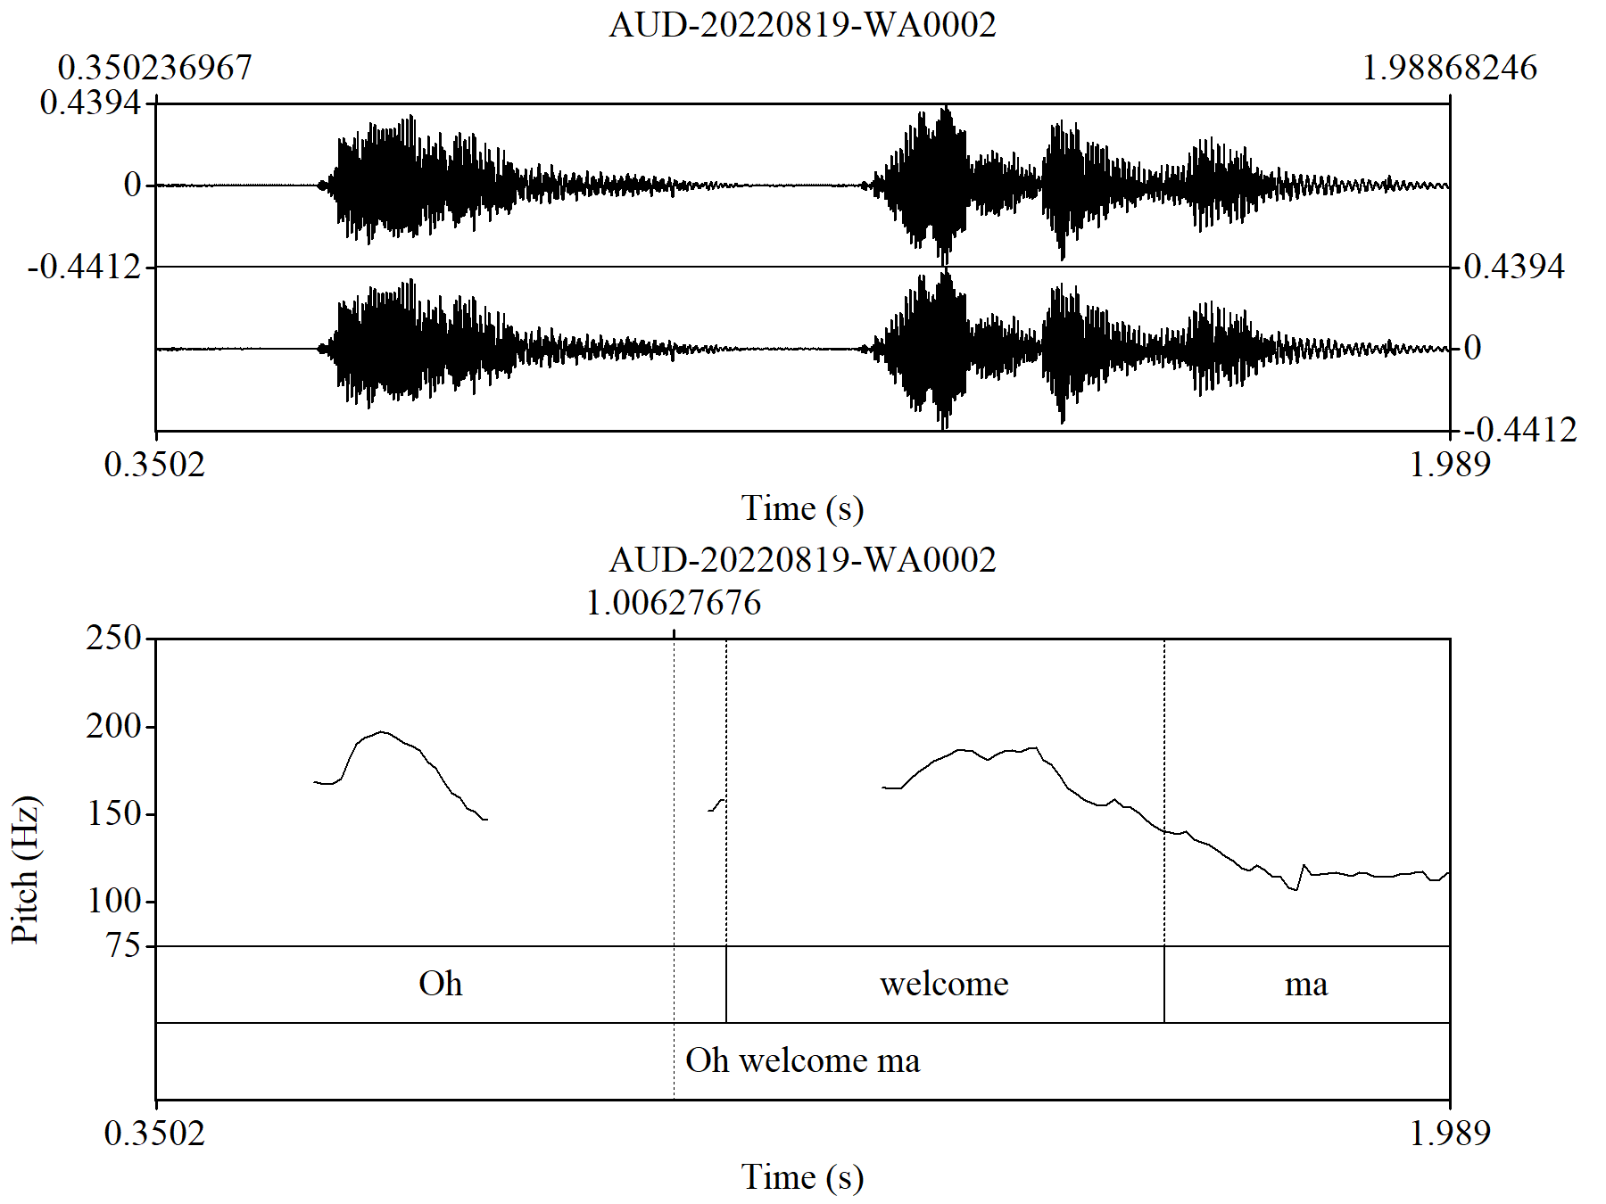
//p oh welcome ma//
The medical personnel represented in figure 1 above seem to have employed a proclaiming tune, in line with Brazil’s concept of discourse intonation. What was observed here is a pitch meter reading of 1.00627676. This simply shows an agreement with discourse intonation idea of ‘newness’ in the meaning of an utterance. As such, ‘oh welcome ma’ could be perceived as inquiry.
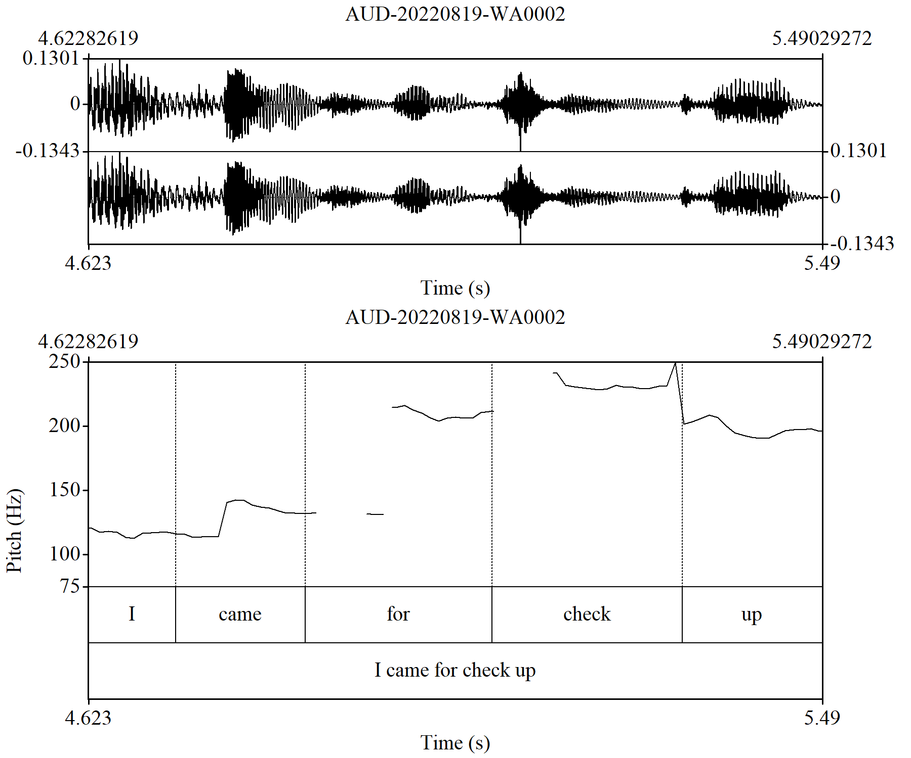
//r I came for check up//
In figure 2, the acoustic analysis shows a referring tune. The participant, a female patient that gave birth to a child through cesarean section, used the referring tune to reactivate the information which is part of the common ground between them. In addition, the decibel range of the patient fluctuate operates between 100 and 250 Hertz. This is an indication that the decibel of the subject is unnaturally highand this indicates emphasis. The patient used the rising tune with the utterance ‘I came for check up’ to show that she is informing the doctor. It indicates an act of informing the doctor the purpose of her visit to the hospital.
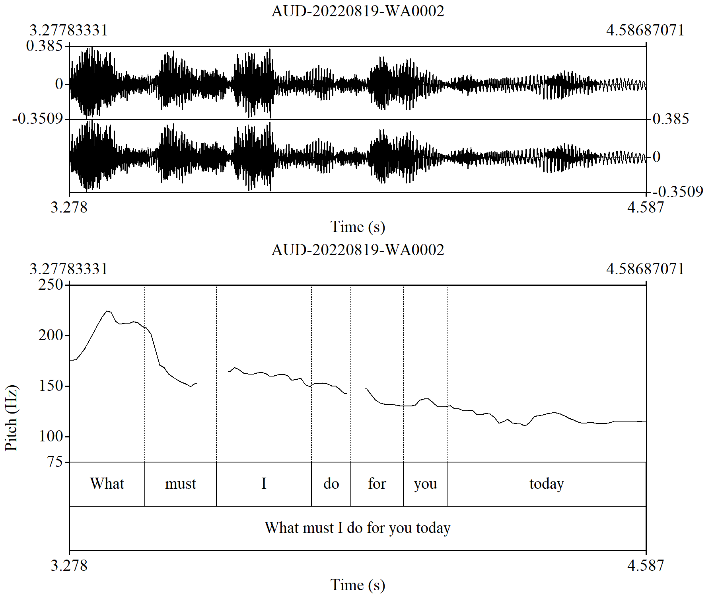
Figure 3 //p what must I do for you today/
Similarly in figure 3, the doctor, used a proclaiming tune to make inquiry from the patient as well as notifying the patient that the area of speaker-hearer convergence is about to be enlarged. Furthermore, the pitch range of this utterance reads 1.3090374. This simply shows a consonance with discourse intonation idea of newness in the meaning of a lexical item. Also the decibel range operates between 150-250 Hertz. The utterance ‘what must I do for you today’ indicates inquiry.
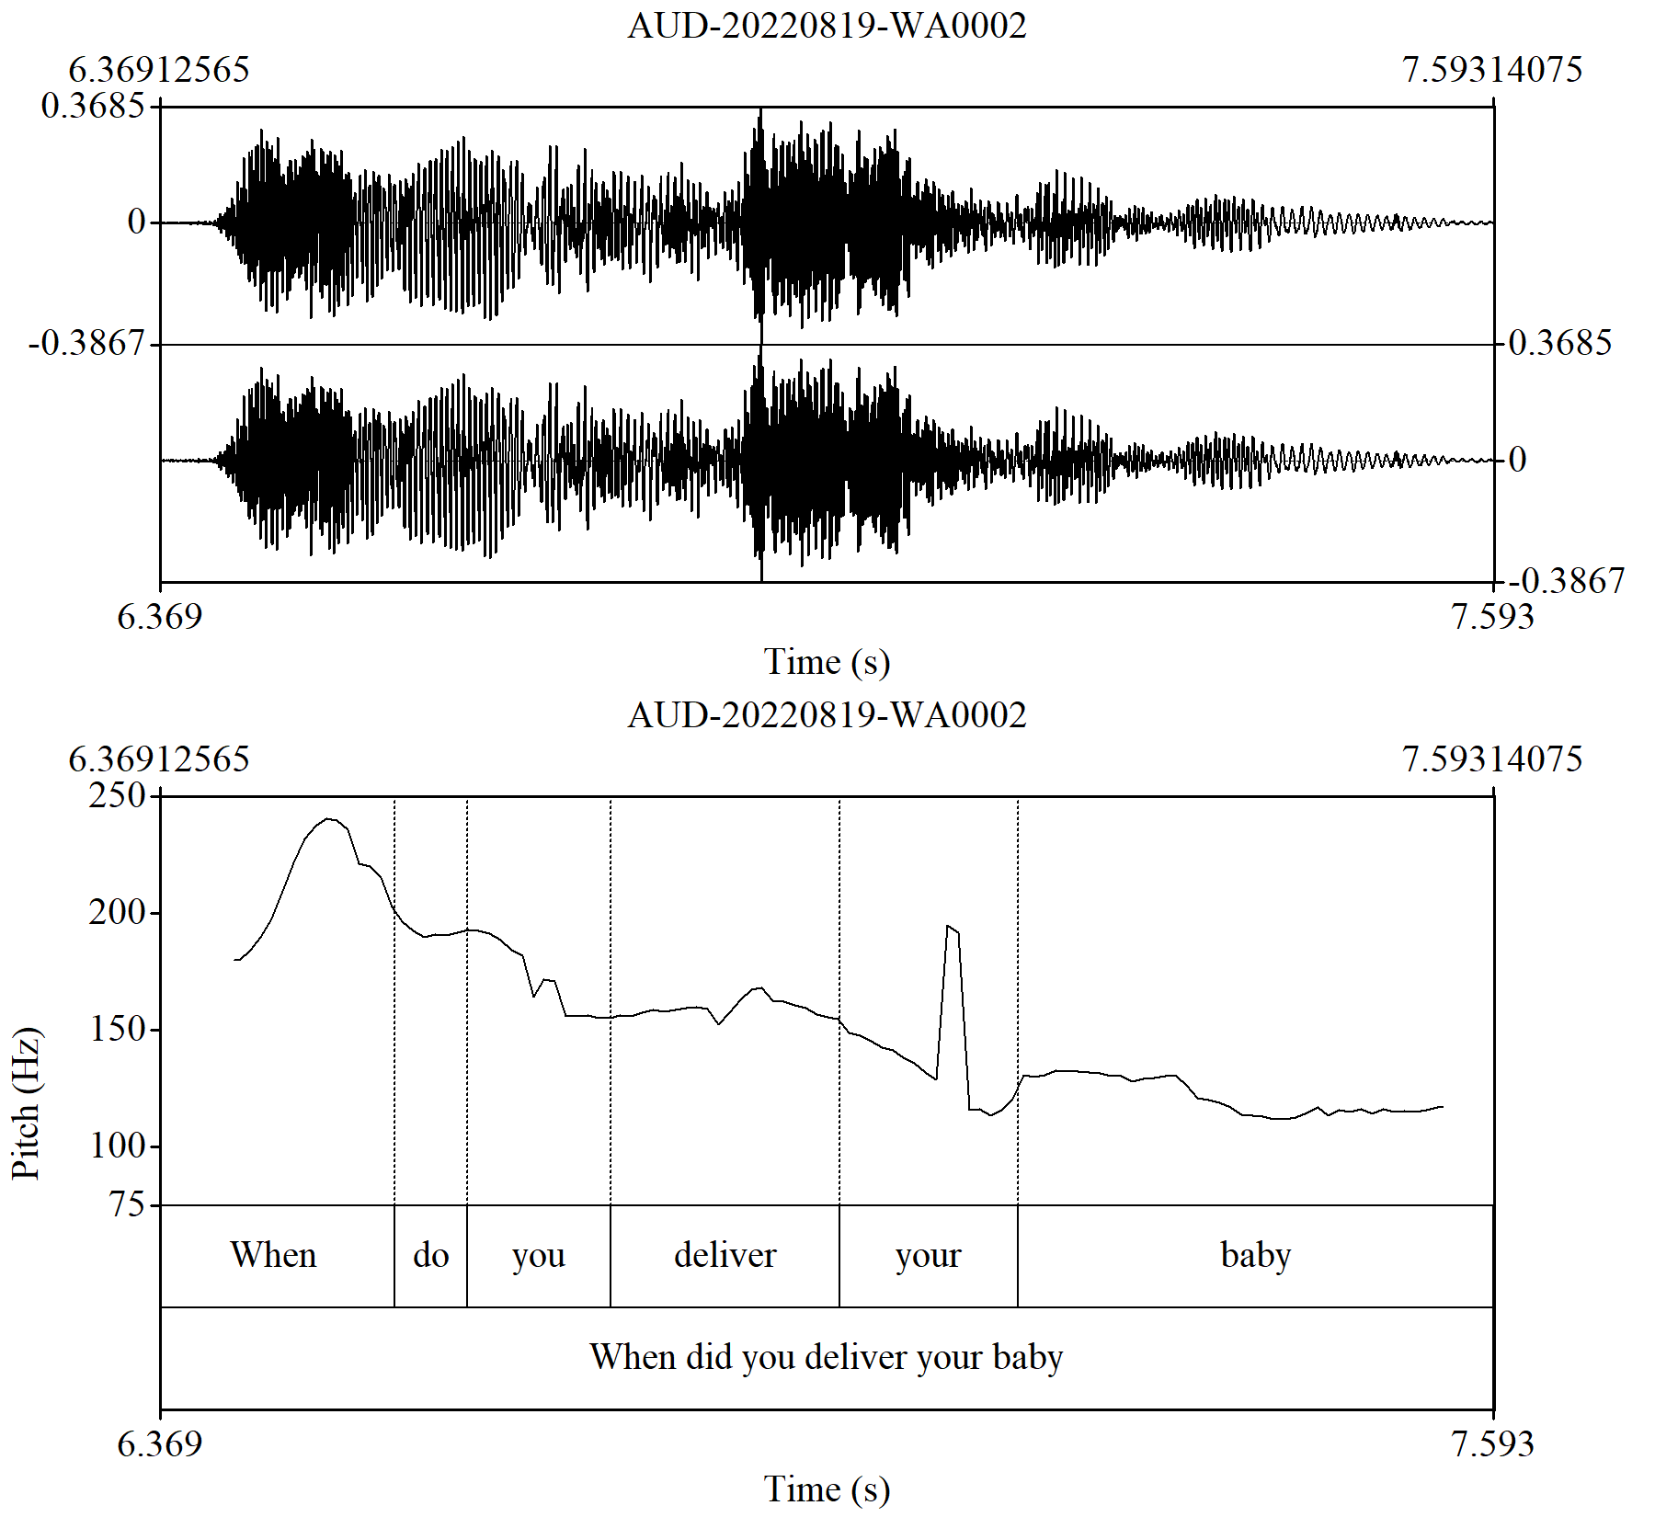
Figure 4 //p when did you deliver your baby//
Figure 4 reveals that the subject, the doctor, used a proclaiming tune here to imagine the information to be new because the speaker does not know or might have forgotten when the patient delivered her baby due to the large number of patients attended to daily. However, the utterance of the participant reveals non-dominant. The decibel range starts from 200 and ends at 100. This is an indication that the decibel of participants varies in each utterance depending on the use of context. The contextualization cue of this utterance signifies inquiry.

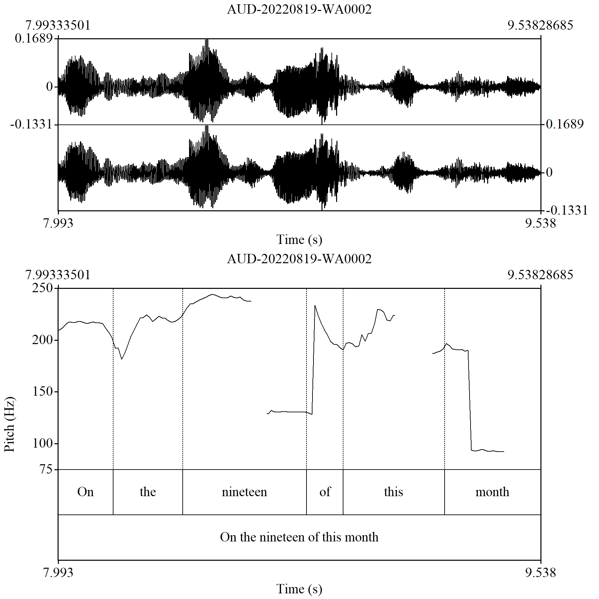
Figure 5 //r on the nineteen/p of this month//
Figure 5 shows that this utterance was meant to remind and inform the doctor that she the participant gave birth to her child on the nineteenth. The participant used both referring tune and proclaiming tune respectively to indicate that information is new and also to reactivate something which is part of the common ground between them, it is seen in Figure 4 that the participant inquired when the patient was put to bed. Thus, the participant used both referring tune and proclaiming tune to answer the question asked in Figure 4. Hence, the referring tune here indicates informing while the proclaiming tune means reaffirming. In addition, what was observed here is a pitch meter reading of 1.54495184. This is an indication that the turn is a consonance with discourse intonation.
4.4 Summary of Findings
In doctor-patient interactions, the structures of intonation patterns of the participants conform largely to discourse intonation. The participants, both the doctors and patients were able to use both the referring tone and the proclaiming tone to reiterate what was already known or previously established and to contribute new information respectively. The result from the acoustic analysis we derived in doctor–patient interaction reveals that the tune used by the male doctor differs from that of the female doctor when welcoming patients into the office. The male doctor uses proclaiming tunes often as a greeting pair while the female doctor uses proclaiming and referring tunes as a greeting pair for patients. It is equally observed that there was a falling intonation wherever a ‘wh.’ question occurs at the beginning of the sentence and this is common in the doctors’ utterances. Figures 3 and 4 reveal that whenever doctors elicit information from the patients the sentence usually ends with a proclaiming tune. This also provides an answer to the first research question; therefore the intonation structure of doctor-patient interaction can be categorized and described in line with discourse intonation.
The outcome from the analysis shows that the contextual use of expressions can determine the participant’s choice of intonation tune in doctor-patient interactions. The study discovered that participants were able to maintain the choice of referring tune in their pattern of tune to avoid being harsh with the patients while correcting them. The doctor used 42.5% proclaiming tunes, 2.5% referring tunes, 5% proclaiming and referring tunes as well as 2.5 % referring and proclaiming tune. Patients used 5% proclaiming tune, 10% referring tune, 22.5% proclaiming and referring tune and 10% referring and proclaiming tune. It is recorded that doctors used 52.5% of tunes and patients used 47.5% of tunes in the study.
Following the second research question, it was observed from the outcome of the acoustic analysis done in this study that meaning is negotiated through participants’ intonation. It is observed here that the participant’s choice of intonation tune was determined by the contextual use of the doctor’s expressions when the patient was able to identify the error in her speech and correct her expression. Discourse intonation differs from all other functions of intonation, the reason being that this theory centres on the pertinence of intonation in communication, that is, it gives meaning to utterances in context. It was observed that meaning is negotiated through the participant’s choice of intonation. The pitch of every individual differs, as such the pitch could be high, mid or low. However, in this study doctors and patients used the low pitch to pract appealing, falling tune pract informing, inquiry, worrisome, the mid pitch to pract sincerity, rising tune to pract affirming, power and control depending on the context. Hence, the study concludes that the structure of doctor-patient interactions can be categorized and described in line with Brazil’s discourse intonation.
In conclusion, findings also revealed that doctors use repetition as a major tool for correcting patients and for affirming whether the patient knows his/her actual reason for visiting the hospital. The study also discovered why doctors use circumlocution in their interactions with patients which aligns with falling tunes to make the patient feel at ease and also not to be offended.
- CONCLUSION AND RECOMMENDATIONS
This research was conducted to establish that doctor-patient interaction can be categorised and described in line with discourse intonation. The investigation further sets to affirm how meaning is negotiated through participants’ intonation. The study employs Brazil’s Discourse Intonation Theory in analyzing the tone units of doctor-patient interactions. This has shown how participants used intonation patterns in naturally occurring events. Doctors are not always conscious of the communicative value of English intonation in discourse rather, they are mainly concerned about the structural types of their utterances and the kinds of tunes used with patients. Also, doctors used circumlocution as a major tool to communicate with their patients to avoid any form of misunderstanding.
From the findings above, it is believed that the recommendation presented below would help to improve language learners' understanding of the use of intonation.
- Language teachers should emphasize the teaching of intonation right from primary education to enable learners to have the maximum use of intonation. This will enhance them to use intonation correctly when communicating among themselves.
- Regular training and workshops should be organized for medical personnel, language teachers and the community at large to make everyone know intonation as this fosters good relationships and communication among them. The reason is that the right use of intonation has the potential to help regulate a patient’s emotion, facilitate comprehension of medical information and allow doctors to easily decode the problem of the patients.
- Only certified language teachers should be allowed to teach intonation in school settings.
- Further studies should be done on why the use of proclaiming tune is more prominent in doctors’ utterances. Could it be because they always lead the conversation? That is, they initiate conversation while patients give a response to the question posed to them either by using verbal form or body signals.

REFERENCES
Adejuwon, Anthony. 2016. Natural Speech Intonation Rule Patterns of Selected Educated Nigerian Speakers of English. Doctoral Dissertation, University of Ibadan, Ibadan.
Akindele, Julianah and Richard Akano. 2023. “Production and Interpretation of Accentual Intonation Tunes in L2 Acquisition: Implications for Nigerian Spoken English Accent”. Ghana Journal of Linguistics 12(1): 73-91.
Ali, Zainab Abbodi. 2020. "A Study of Discourse Intonation In A Selected Interview Of Mohammed Ali Clay: A Phono-Pragmatic Analysis." International Journal of Innovation, Creativity and Change 13(1): 314-330.
Brazil, David. 1997. The Communicative Value of Intonation in English. Cambridge: Cambridge University Press.
Chapman, Mark. (2007). “Theory and Practice of Teaching Discourse Intonation”. ELT Journal 61(1): 3-11.
Chun, David. 2002. Discourse Intonation in L2. Discourse Intonation in L2, 1-303.
Clennell, Charles. 1997. “Raising the Pedagogic Status of Discourse Intonation Teaching”. ELT Journal 51(2): 117-125.
Cruttenden, Allan. 1986. Intonation. Cambridge: Cambridge University Press.
Dhea, Wisye Rahma, Aruna Laila, and Wahyudi Rahmat. 2022. "Analysis of Medical Discourse on Online News on Instagram Social Media." Journal of Asian Studies: Culture, Language, Art and Communications 3(1): 56-64.
Douglas, Biber and Rappen Randi. 2015. The Cambridge Handbook of English Corpus Linguistics.UK: Cambridge University Press.
Ferry, Caroline. 2017. Intonation and Prosodic Structure. Cambridge: Cambridge University Press.
Gbadegesin, Michael. 2018. “Sociocultural Implications of Female Discourse Intonation in Mr & Mrs”. World Wide Journal of Multidisciplinary Research and Development 4(11): 81-87.
Goh, Christine. 2001. “Discourse Intonation of English in Malaysia and Singapore: Implications for Wider Communication and Teaching”. RELC Journal 32(1): 92-105.
Handford, Michael, and James Paul Gee, eds. 2013. The Routledge Handbook of Discourse Analysis. Routledge.
Harvey, Kevin, and Svenja Adolphs. 2013. "Discourse and healthcare." In The Routledge handbook of discourse analysis, 470-481. Routledge.
Herczeg-Deli, Agnes. 2012. “Prosody in Elicitations: A Study of Intonation in BBC Talk Radio Shows”. Romanian Journal of English Studies 9(1): 28-48.
Ho, Sau. 2010. Discourse Intonation in English Conversation: Negotiating Health Care Expertise and Support in Relationship-centred Family Physician-patient Interviewing Style. York University.
Mat Nayan, Noor and Jane Setter. 2016. “Malay English intonation: The Cooperative Rise”. English World-Wide 37(3): 293-322.
Miyauchi, Shinji. 2014. “Pitch Movement Influential to Listeners in the Discourse of Sense and Sensibility”. Journal of English Phonetic Society of Japan 19: 161-171.
Odebunmi, Akin. 2021. “Discursive Repetitions and Voices in Nigerian Clinical Meetings”. Ghana Journal of Linguistics 10(1): 27-72.
Odeyemi, Joseph. 2017. “Context and Discourse Intonation in English-Medium Product Advertisements in Nigeria’s Broadcast Media”. I-Manager’s Journal on English Language Teaching 7(2):13-28.
Pešková, Andrea. 2022. “Intonation Patterns Used in Non-Neutral Statements by Czech Learners of Italian and Spanish: A Cross-Linguistic Comparison”. Languages 7(4): 282.
Pickering, Lucy, Hu, Guiling and Amanda Baker. 2012. “The Pragmatic Function of Intonation: Cueing Agreement and Disagreement in Spoken English Discourse and Implications for ELT”. In Pragmatics and Prosody in English Language Teaching. Educational Linguistics, edited by J. Romero-Trillo. Springer, Dordrecht. https://doi.org/10.1007/978-94-007-3883-6_12
Pickering, Lucy. 2001. “The Role of Tone Choice in Improving ITA Communication in the Classroom”. TESOL Quarterly 35(2): 233-255.
Pickering, Lucy. 2004. “The Structure and Function of Intonational Paragraphs in Native and Nonnative Speaker Instructional Discourse”. English for specific purposes 23(1): 19-43.
Pickering, Lucy. 2018. Discourse Intonation: A Discourse-Pragmatic Approach to Teaching the Pronunciation of English. University of Michigan Press.
Roach. Peter. 2006. A Lecture at 11th seminar on English Phonetics Group Chile at UMCE, Santiago.Retrieved from www.cambridge.org/elt/peterroach.
Sánchez-Alvarado, Covadonga. 2022. The Acquisition of L2 Spanish Intonation: An Analysis Based on Features. Journal of Second Language Pronunciation 8(1): 40-67.
Schneider, Klauss and Anne Barron. 2014. Pragmatics of Discourse. Germany: De Gruyter Mouton.
Skandera, Paul and Peter Burleigh. 2005. A Manual of English Phonetics and Phonology. Germany: GunterNarven.
Suciu, G. (2016). Intonation-The music of everyday speech-and its impact on successful communication. Convergent Discourse: Exploring the Context of Communication 17(4): 180-184.
Terken, Jacques, and Dik Hermes. 2000. "The Perception of Prosodic Prominence." In Prosody: Theory and experiment: Studies presented to Gösta Bruce, pp. 89-127. Dordrecht: Springer Netherlands, 2000.

