# OBIDIOTS OR #JAGABANDITS: IMPOLITENESS STRATEGIES IN POLITICAL TWEETS OF NIGERIAN ELECTORATE ON 2023 PRESIDENTIAL ELECTION
Abstract
The next presidential elections in Nigeria are billed to hold in February 2023 and campaigns have begun already. Thus, as typical of elections, there have been a war of words among candidates of popular political parties not just physically but on the social media space-particularly Twitter. Tweeps, as they are called, not only use tweets but hashtags as well to threaten the faces of their perceived political rivals. This study examines impoliteness strategies deployed in both the tweets and the hashtags. Tweets and hashtags that are associated with the Nigerian presidential elections were analysed particularly tweets that focused on the three leading presidential candidates in the election. Data revealed that tweets and hashtags were characterised by impoliteness strategies, including name calling, ridicule the other, seek disagreement and associate the other with a negative aspect. The findings also showed that hashtags served as strategies of impoliteness since they intensified the contents of the tweets and maximise face attacks. The attacks were directed to the politicians and their supporters as well.
Keywords: Obidiot, Jagabandits, Impoliteness, Presidential Elections, Nigerian Electorates
1. Background to the study
Politics in Nigeria always comes with heated debate with each candidate or political party trying to outsell and outsmart rivals and opponents. Sometimes, in the heat of the debate, there are manifestations of impoliteness and face attacks. This is not a new phenomenon. It is part of the political history of Nigeria, where violence has trailed the conduct of elections. Violence has always been traced to unguarded comments by supporters of different political parties. For example, in the run up towards the 2007 general elections, the then president, Olusegun Obasanjo was quoted to have said that election is a do or die affair. Although years later, he came up to correct the earlier impression, many believe that the violence that trailed elections at that time cannot be unconnected to his earlier speech. Hence, there have been serious campaigns by the government to discourage such comments particularly around election seasons. To forestall this, there are broadcasting codes that guide traditional media on the broadcast of political messages. However, this censorship does not hold sway in the social media space. Therefore, all kinds of inciting, derogatory and denigrating messages are sent by political actors and supporters to attack the face of rivals. This has been a major reason for the call for social media censorship in Nigeria. The social media has been seen as a safe haven for the propagation of hate speech and inflammatory use of language. The focus of this study is to look at how tweeps use Twitter to enact impoliteness, capable of igniting violence in the 2023 general elections in the country.
2. The concept of impoliteness
Impoliteness for a very long time has been seen as a mirror of politeness. Therefore, scholars have paid more attention to the concept of politeness than impoliteness (Mills 2003:121). Bousfield (2008:17) aligns with the submission of Mills as well. He remarked that compared to the robust literature about politeness, there is paltry amount of literature concerning impoliteness. This may not be unconnected to the wrong impression that conversation is a phenomenon that always follows the contract of communication and is always harmonious. However, more recent studies have been advocating that the concept should be studied as a phenomenon on its own. Scholars like Culpeper, Odebunmi, Ajayi, Bousfield and Eelen and Mills among others, have paid some attention to the concept.
There are quite a number of scholars that have made an attempt to define impoliteness. Some of them that is relevant to this research will be given here.
Lakoff (1989: 103) which is one of the early studies on impoliteness opines it is a refusal to use politeness strategies where they would be expected, in such a way that the utterance can only almost plausibly be interpreted as intentionally and negatively confrontational. This definition is narrow in scope because it treats impoliteness merely as an absence of politeness. It does not approach it as phenomenon on its own. However, it is one of the earliest definitions that charted the course of the study of impoliteness.
Beebe (1995:159) opines that rudeness is defined as a face threatening act (FTA -- or feature of an FTA such as intonation -- which violates a socially sanctioned norm of interaction of the social context in which it occurs. She submits that rudeness "is frequently instrumental, and is not merely pragmatic failure" (Beebe, 1995, p. 154). This definition approaches impoliteness as a concept on its own not just the absence of politeness. Even though the definition defines rudeness, there are controversies in literature on where to draw the line between rudeness and impoliteness. However, this definition is chosen because both impoliteness and rudeness are Face Threatening Acts (FTAs).
Culpeper et al. (2003:1546) in one of his earliest submissions, define impoliteness as communicative strategies designed to attack face, and thereby cause social conflict and disharmony. This definition’s strong point is that it shows that impoliteness has a goal. Therefore, it can be said to be a deliberate action to cause conflict and disharmony.
Terkourafi (2008:70) opines that, impoliteness occurs when the expression used is not conventionalized relative to the context of occurrence. He further argued that an utterance can be impolite even if the speaker’s intention was not to be impolite, but the hearer perceived it as such. Bousfield and Culpeper (2005) argued that speakers’ intention and hearers’ recognition of these intentions are both main factors in determining impoliteness.
One major point that must be noted in the study of impoliteness is that it is context specific. What is considered impolite in a context may not be in another context. Therefore, any definition that will adequately describe the concept of impoliteness must take context into the situation. In cognisance of this, Locher and Bousfield (2008) define impoliteness as a behaviour that is face-aggravating in a particular context. Culpeper (2011:23) describes impoliteness as a negative attitude towards specific behaviours occurring in specific contexts. These definitions make a departure from earlier definitions of impoliteness that merely see it as an absence of politeness and does not put context into consideration. This means that recourse must be made to context before an action or utterance can be classified as impolite or not. Culpeper expatiates further by saying that impoliteness is sustained by expectations, desires, and / or beliefs about social organisation, including how a person's or group's identity are mediated by others in interaction.
While politeness seeks for ways to mitigate face-threatening acts, impoliteness explores communicative situations where the speaker’s purpose is to damage a hearer’s face rather than save it. Therefore, when face threatening acts are enacted in a situation where face is at risk, it is clearly a case of impoliteness.
Culpeper used Brown and Levinson’s model of politeness to introduce his theory of impoliteness which he considers a “parasite of politeness”. In opposition to face threatening acts, Culpeper introduces the concept of face-attack-acts (FAA). Therefore, the strategies of impoliteness are:
- Bald-on record impoliteness: This strategy is used when there is much face at risk and when a speaker wants to damage the hearer’s face and thus the impolite utterance will be performed directly and clearly. While Brown and Levinson’s bald-on record is employed when there is minimal risk to the face, Culpeper’s model is employed when there is much risk to the face and the speaker intends to damage the face of the speaker.
- Positive impoliteness: This strategy is used to damage the hearer’s positive face want which is his desire to be accepted. Culpeper proposes a range of sub-strategies used to employ positive impoliteness.
- Ignore or snub the other- fail to acknowledge the other’s presence.
- Dissociate from the other- For example, deny association or common ground with the other; avoid sitting together.
- Seek for disagreements- Selecting a sensitive or undesirable topic. Make the other feel uncomfortable- for example, do not avoid silence, joke, or use small talk.
- Using inappropriate identity markers.
- being disinterested and unsympathetic with the hearer
- using obscure language and inserting secretive words within the discourse
- using taboo words- Swear, or use abusive or profane language
- Call the other names- Use derogatory nominations.
iii. Negative impoliteness: This strategy is designed to attack the hearer’s negative face wants which is the desire to be free from imposition. Negative impoliteness involves:
- Condescend, scorn or ridicule- emphasize your relative power. Be contemptuous. Do not treat the other seriously. Belittle the other.
- Frighten- instill a belief that action detrimental to the other will occur.
- Explicitly associate the other with a negative aspect- personalize, use the pronouns ‘I’ and ‘you.’
- invade the hearer’s space literally or metaphorically- position yourself closer to the other than the relationship permits or ask about information which is too intimate to be given based on the relationship
- Put the other’s indebtedness on record.
iv. Sarcasm or mock politeness: This strategy involves using politeness strategies which are insincere. The speaker uses politeness sub-strategies that are superficially suitable and accepted but deeply they have the opposite meaning.
v. Withhold politeness: In this strategy, the speaker does not perform politeness. He intentionally withholds politeness. For example, refusal to say anything when the hearer ought to be thanked (Culpeper 1996:8-9).

3. Review of relevant literature
Impoliteness has received some scholarly attention in the past few years and in this section, attention will be paid to some works that have investigated impoliteness within the context of politics both online and offline.
Oso (2019) focuses on the pragmatic analysis of exchanges during Nigeria's 2019 presidential election campaigns. In the research, he submits that rather than base their campaigns on issues that affect the masses, Nigerian politicians and their parties launch face attacks using impoliteness strategies to discredit their opponents. He came to this conclusion by looking at the campaign speeches of the two leading political parties in the elections- People's Democratic Party and the All Progressives’ Congress. He submits that politicians deploy impoliteness to attack the face of their opponents rather than focus on issues that will make life better for the masses.
Another research that focuses on campaigns is that of Kariithi (2020). He investigates aspects of impoliteness during 2007 and 2013 presidential election campaigns in Kenya. Adopting Culpeper's (2011) Model of Impoliteness Formulae, he argues that Ruto's campaign was filled with impoliteness strategies. The goal of the use of impoliteness was to demean or disparage 'the foe'. He also does this to outwit politicians from the opposing front with an aim to persuading voters to vote for him.
Ifechelobi and Okpokiri (2020) investigates the improper use of language as a source of political and social instability in Nigeria. They posit that there is a connection between positive impoliteness strategy and insecurity in Nigeria. To provide validity for their arguments, they collected data from campaign speeches of political actors of the two major political parties in Nigeria- People's Democratic Party (PDP) and the All Progressives' Congress (APC). They submit that there is a strong link between positive impoliteness strategy and electoral violence in Nigeria. Positive impoliteness strategies manifested as name calling, dissociating from the other, exclude the other from an activity and others were deployed by our politicians to discredit their opponents and also present themselves as the better option.

Ibrahim (2020) looks at impoliteness in political tweets with a focus on age and gender and how they play a role in enacting impoliteness. He analysed 100 tweets using Culpeper's (1996) impoliteness model. His findings reveal that there is a wide use of impoliteness in the social media particularly on Twitter. He argues that the age bracket 25-35 are the most active age group that comment on political issues. He also posits that they use impolite expressions than any other age group. Based on gender, he submits that the male tweeps recorded the highest frequency in using impolite strategies.
Udoumoh and Orabueze (2022) investigate impoliteness in political campaign hate speeches within the context of the 2015 general elections. Using transcribed speeches from notable online newspapers, they discovered that hate speeches during political campaigns is embedded in impoliteness strategies targeted at the rival political players and translates to the electorates as face threatening acts. They also argue that negative politeness face threatening acts of advice, warnings, and reminding a hearer to do an act were mostly employed by political speakers to coerce the electorate for their votes. Negative impoliteness strategies, in their view, were deployed to flaw, threaten, and disrepute political rivals. They submit that hate speeches in political campaigns is typified by a preponderance of impoliteness strategies and FTAs recurring throughout such speeches without redress.
A similar but different study is that of Ajayi (2019) on impoliteness strategies in the Facebook posts of Nigerian electorate on 2019 presidential elections in Nigeria. He investigates how the electorate use the social media to air their views on election matters. He argues that the Nigerian electorate use different forms of impoliteness strategies including call the other names, ridicule the other, use of taboo words and associate the other with negative aspects to attack and threaten the faces of these major contestants as well as their supporters. This is a major contribution to scholarship because it unveils the strategies used by supporters not just to attack the contestants but also their supporters. The study establishes the fact that impoliteness dominates political discussions online. Even though this aligns with the current study, the social media of focus in this research is Twitter. It is significant to look at impoliteness enacted on Twitter because it is adjudged to be the most toxic social media platform (Oz et al 2017). Also, twitter allows users to know what is trending using its algorithm to detect what users are tweeting about. Therefore, discussions on Twitter are more synchronic than Facebook because users can follow a discussion as soon as it begins to trend. This is one of the reasons why on political matters, Twitter seems to have more engagement than Facebook. As a matter of fact, the former president of the United State became infamous for his impolite tweets. Therefore, to critically appraise impoliteness on the social media, Twitter must be the focus.
From the reviewed literature, there is consensus among scholars that there is a nexus between impoliteness and violence and that politicians deploy impoliteness as a tool for threatening the face of their opponents and their supporters. These have been established in the review both in online and offline contexts. However, there seems to be a neglect in the study of political tweets within the Nigerian context because the bulk of literature on online contexts has not focused on the use of Twitter by electorate to air their opinion about political matters. This is a huge gap in scholarship because Twitter is adjudged to be the most volatile social media platform Oz et al (2017). Therefore, it is expected that there will be more manifestation of impoliteness on the platform. This research seeks to fill this lacuna not just by examining twitter as a whole but narrowing down on hashtags and how they are deployed to enact impoliteness by political actors and the electorates in the forthcoming presidential elections in Nigeria.
4. Methodology
The study is qualitative in nature. In order to find out how hashtags and tweets were used to enact impoliteness, 200 tweets were purposively collected from Nigerian twitter. Data were gathered from January 2022 to December 2022. This period was chosen because it was a season during which primary elections were conducted in the various political parties in the country. It also marked the period during which there was a heightened awareness about the elections that are to take place the following year. The criterion for inclusion is that the hashtag and the tweet must be related to the presidential election in Nigeria. This was done because there were some tweets that were totally unrelated to elections even though the hashtags seemed political. Tweeps did this to get traffic to their pages to get more attention to their profiles. Data are subjected to interpretive cum pragmatic analysis within the purview of Culpeper’s impoliteness theory.

5. Impoliteness Strategies in Tweets
Call the other Names: Use Derogatory Nominations
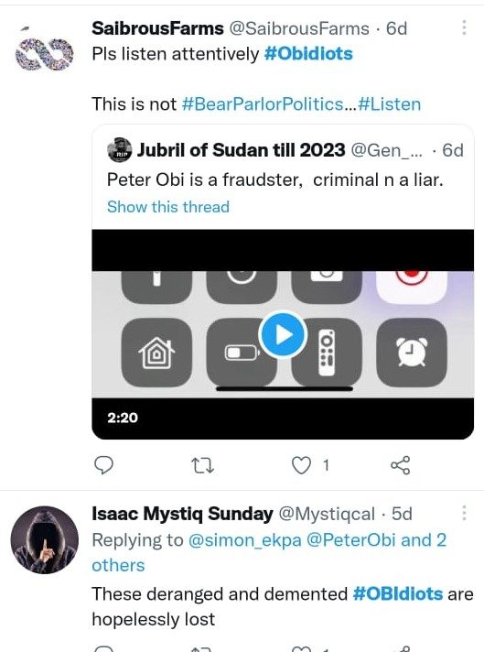
Plate 1

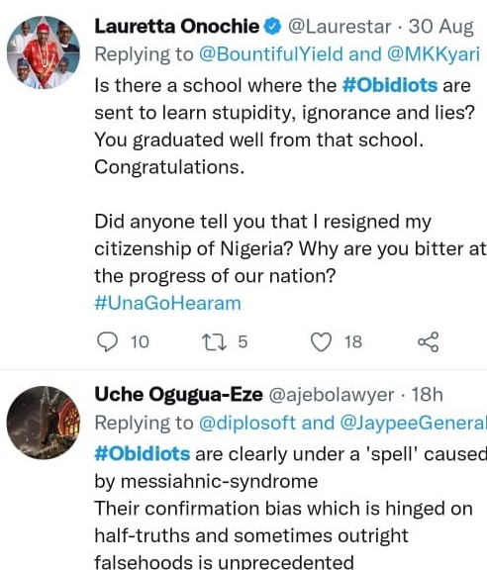
Plate 2

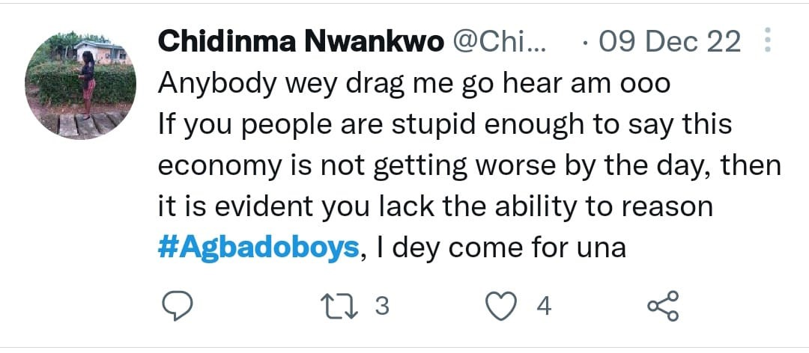

Plate 3

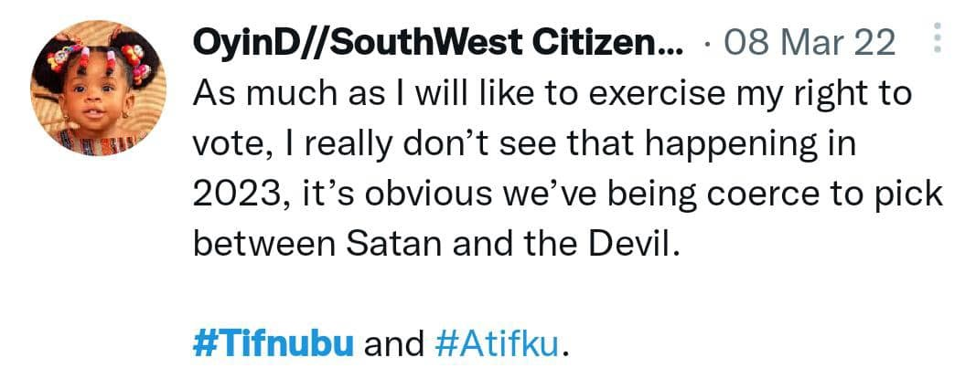
Plate 4
Following Culpeper’s impoliteness theory, both the tweets and the hashtags in the plates above all contain the use of derogatory nominations to damage the face of both the politicians and their supporters.
In plate 1 presented above, the tweep uses the #obidiots. This is a lexical choice targeted at attacking the face of Obi’s supporters. Peter Obi’s supporters on Twitter coined out a name for themselves. They call themselves the obidients/obedient movement. This is a play on words to show that their allegiance to Peter Obi. The word obedient is a product of blending which has the structure: obi+obedient Obidient. This portrays them as loyal to Obi and obedient to his wishes of becoming the president of the country. However, their political rivals also coined out their own term to refer to Peter Obi’s followers. They refer to them as #Obidiots. This is also a product of blending. When two or more words are combined into one, the resulting word may be clipped or partially overlapped. This process is known as blending. It has the structure: Obi+idiotsObidiots. This is to paint the Obi’s followers as idiots who cannot think for themselves. They follow everything Peter Obi says without questioning him. This means that the tweep strongly opines that anyone who votes for Obi is an idiot. In the first plate, the tweep refers to Obi as a fraudster, liar and criminal. This is sheer name calling as no court of law as convicted Peter Obi of fraud or any other criminal conduct. This tweet is geared towards ‘demarketing’ Obi and presenting him to the public as incompetent and not trustworthy. This act is a masterstroke because the major selling point that Obi’s followers claim that he has is his integrity. Hence, this tweet presents him as the same with an average politician who cannot be trusted.
In the second plate, #obidiots are portrayed as stupid and ignorant liars. The tweep believes that that they have been trained to display stupidity and ignorance. She also referred to them as bitter people who do not want the success of the nation. This is a classic example of how supporters, not just politicians are attacked by supporters of rival parties because of their choice of who to vote or support. Another example is found in plate 3 where the tweep opines that the Obi’s supporters who he called #obidiots are under a spell caused by messiahnic (sic) syndrome. This captions Obi’s supporters as people who have lost control of rational thinking. This is clearly why he refers to them as #obidiots. This is a massive threat to the positive face of Peter Obi’s supporters.
The face attacks are not geared towards Obi and his supporters alone. Plate 3 shows how Tinubu’s supporters’ faces are threatened as well. The tweep engages Tinubu’s supporters who are arguing that the economy is not getting worse. She launches a first face attack saying that they lack the ability to reason. Then she proceeds to call them #agbadoboys. #Agbado boys are used to ridicule Tinubu’s supporters on twitter. They are referred to as #Agbado boys because of a statement Tinubu made saying that youths should be recruited to fight Boko Haram. He mentioned that they should be fed cassava and agbado (corn). Even though he might have had the best of intentions saying that, it obviously didn’t go down well with some youths. They not only saw his statement as an insult to the them but they also had issues with the demeaning way he said it. Therefore, their way to get back at him was to ridicule him with the nickname ‘agbado’. Beyond the nickname, is the submission that Tinubu does not have the best interest of the youths at heart. The statement credited to him made him appear heartless and unconcerned about the plight of the youths who are already plagued with unemployment, insecurity, police harassment among other challenges they face. Mindlessly saying that the government should recruit them to fight without feeding them well was unacceptable to them. To some youths, the statement shows that Tinubu cannot really think creatively. For him to suggest that corn should be used to feed those who are going to risk their lives for the nation is unreasonable. This is the link between the tweet and the hashtag used by the tweep. The face attack here is that Tinubu’s supporters are as clueless as he is because they are arguing against reason just like their candidate. To the tweep, it is a no brainer that the economy has progressively gotten worse therefore anyone who argues against this lacks the ability to reason.

Still looking at name calling, in the screenshot above, the presidential candidate of the APC and the PDP are called the Devil and Satan respectively. This is a face attack on both of them launched to damage their positive face. Looking at the attributes of the Devil and Satan, there is no one that wants to associate with him. He is considered to be the cause of all evil- sickness, sadness, corruption, death in fact, nothing good can be traced to him. However, what every citizen of the country wants is that the country should get better. Therefore, if anything good will happen in Nigeria, the tweep subtly opines that both Tinubu and Atiku should be avoided like a plague. Hence, her decision to vote neither of them. Therefore, we can conclude that this tweep considers none of them good enough to be the president of the country. Referring to one as Satan and the other as Devil means that even though they are from different political parties, they are birds of a feather. She takes the face damage a step further in her use of hashtags. She uses #Tifnubu and #Atifku to foreground her tweet. Blending ‘tif’ into their names as her hashtag means a particular attribute that they share in common is that they are both thieves. ‘Tif’ is the pidgin derivation of the word ‘thief’. This means that both candidates are considered to be thieves based on their antecedents and they cannot be trusted with our national treasury. This is a smear on both candidates that attacks both their positive face because integrity is a major quality that Nigerians are looking for in who should be their next president.
Ridicule the other
Another strategy adopted by tweeps on twitter to enact impoliteness is to ridicule the other. The supporters attack the faces of each other by portraying the other person as unserious and incompetent. This is sometimes achieved through satire. Data to support this stance are presented below.
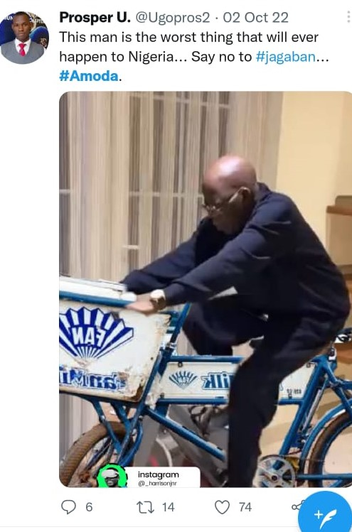
Plate 5
In the plate above, there is a combination of a tweet, hashtag and a picture all geared to ridicule the presidential candidate of the APC, Bola Ahmed Tinubu. In the tweet, Tinubu is referred to as the worst thing that will ever happen to Nigeria. Looking at the picture, we see the image of Bola Tinubu riding an ice cream bicycle. The image is doctored. Critically engaging the post with recourse to shared situational knowledge, the original picture showed Tinubu riding on a stationary bicycle to work out to show that he is not sick as it was being alleged by the opposition. There was public outcry that the image is not real and that it was superimposed to spin a narrative that Tinubu is doing well. This made some youths also edit the same pictures in the most ridiculous way possible to discredit the narrative of the APC standard bearer who they believe cannot ride a bicycle because of his ill health. The author of the tweet expresses his disappointment that such a man who has a history of inconsistence should never be the president. The #Amoda he uses also points to Tinubu’s alleged inconsistency. There had been a story on social media that Tinubu’s birth name is Amoda Ogunlere. It was alleged that he changed his name to Bola Tinubu because of fraudulent reasons. The tweep intentionally uses Amoda as a hashtag to make reference to his alleged fraudulent act to ridicule him and to substantiate his tweet that Tinubu is the worst thing that can ever happen to Nigeria. Therefore, he should not be handed the task to govern Nigeria. T
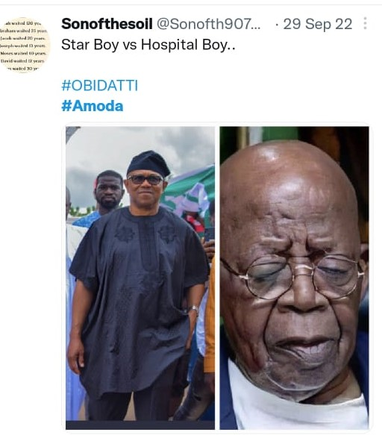

Plate 6

In the screenshot above even though not much is said, there is an attempt to ridicule Tinubu by Peter Obi’s supporters. Here, we have two pictures placed side by side- that of Peter Obi looking vivacious and that of Tinubu looking sickly and wrinkled. There is a tag on the picture- ‘Star Boy’ vs ‘Hospital Boy’. Peter Obi’s positive face is enhanced because he is represented as young, good looking and healthy. He is referred to as the star boy while Tinubu is represented as old, incapable and sickly and tagged hospital boy. This tweet is to ridicule Tinubu and portray him as incapable due to age and ill health. A major issue in the campaign against Bola Tinubu is the state of his health. It has been hotly debated that he has an ailment that he is battling with that he has not disclosed to Nigerians. Some have said that he spends more time in the hospital than in his house. Tinubu has debunked this several times, stating that he is not ill and that the fact that he is old does not mean he is sick. However, his opponents will not allow the matter to rest. Therefore, they flood the social media with pictures that depict him as being sick and sometimes as an invalid to ridicule him. All these are done to discredit him in the eyes of the electorate.
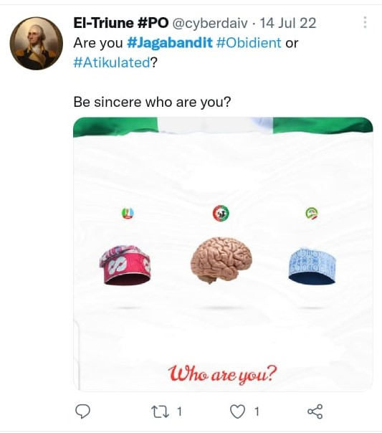
Plate 7
In the tweet above, the tweep also uses pictures to ridicule the presidential candidates of both the PDP and APC. In the picture, the three presidential candidates are represented using icons. For the APC presidential candidate, his cap bearing his insignia was used to represent him. The same was done for the PDP candidate. However, Peter Obi is represented using a picture of the human brain. Looking at this superficially, one may not see anything wrong in the picture. However, this is a covert way to ridicule both the candidates of the APC and the PDP. They are both portrayed as having nothing to offer beyond their caps and that they have no intellectual capacity to govern the country. Peter Obi is represented as an intellectual who has the capacity to rule the country- one who will bring meaningful ideas that will change the fortunes of the country for good.
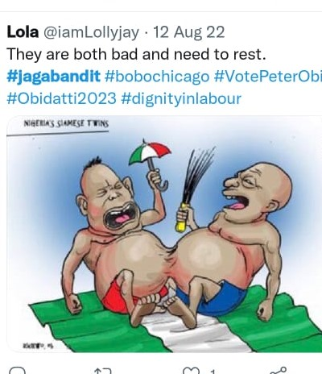
Plate 8
In this tweet, the candidates of the APC and the PDP are depicted as siamese twins who are grumpy and a caption is added that they are both tired and they need to rest. This face attack in this tweet is two-fold. First, that both the APC and the PDP are the same. The two parties are identifiable because of their logos displayed in the pictures. In their campaigns, both parties have been have accused each other of corruption because they have both ruled the country. The PDP ruled the country between 1999-2014 while APC has been in the helms of affairs since 2014. The APC has claimed at different times that the PDP is the source of Nigeria’s woes due to their failure in governance. Hence, they came up with the change mantra. However, the PDP has also accused the APC of destroying the legacy they left arguing that things are worse than they left them. In the screenshot above, the tweep opines that the two parties are not different from each other. Depicting them as Siamese twins, he tweets that they are both corrupt and overfed babies that do not have the interest of the country at heart.

Explicitly Associate the Other with a Negative Aspect
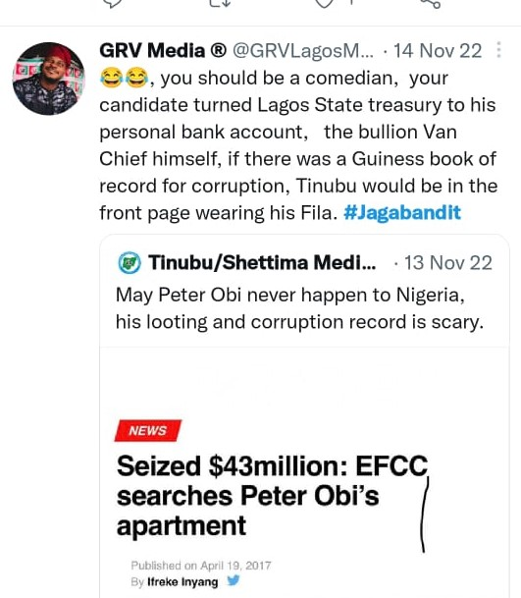

Plate 9

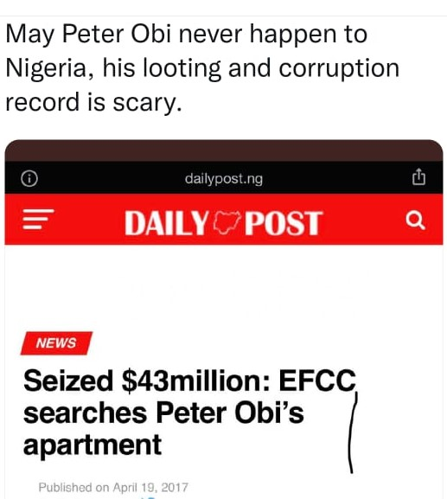

Plate 10
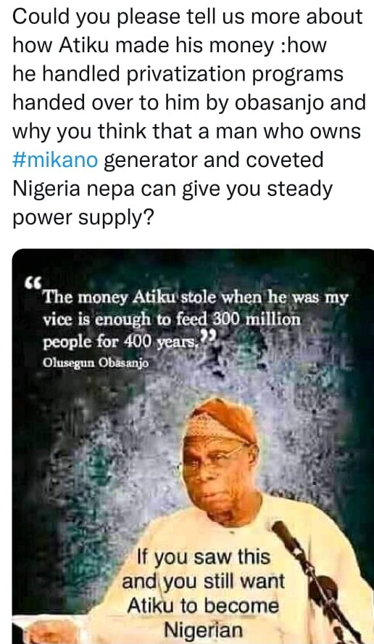
Plate 12
In plate 9 above, the writer launches a face attack on both Tinubu and his supporter. He accuses Tinubu of pilfering Lagos state fund by turning the treasury into his personal account. He also calls Tinubu ‘the bullion van chief’. Making recourse to shared situational knowledge, there has been a case where Nigerians allegedly saw bullion vans in the Bourdillon residence of Tinubu. He was then accused of corruption since bullion vans that are supposed to move large cash from the Central Bank of Nigeria to other commercial banks were seen in his residence. To Nigerians, that only meant one thing- he was moving large cash which were seen as nothing but proceeds of corruption. In this plate, the tweep is associating Bola Ahmed Tinubu with corruption to destroy his positive face. This can go a long way in dissuading the electorate from voting for him. The tweep uses #Jagabandit. This is also a negative association to threaten the face of Tinubu’s supporters. Tinubu has a chieftaincy title which is Jagaban of Borgu. Therefore, one of the nicknames he has is Jagaban. However, the tweep creatively added ‘bandit’ to form Jagabandit. This means that he is associating Tinubu with banditry which has been a major issue that Nigeria has been battling with. Linking this with his tweet accusing Tinubu of turning Lagos State treasury into his personal bank account, one can say that his goal is to show that there is a correlation between how Tinubu has hijacked Lagos State treasury and how bandits operate. Most Nigerians detests bandits because of the havoc they have wrecked on the country. Associating Tinubu with banditry is a face attack that can cause the electorates to loathe him.

In plate 10, the writer, making reference to the news, prays that Obi will never become president because he is a looter and a corrupt person. This is a trying to paint Obi that has been celebrated by his followers as a man of integrity as nothing but a common criminal. Even though the report the tweep referenced said nothing about whether Obi stole the money or not, he/she uses the opportunity to attack Obi’s face. In this case as well, the negative aspect that Obi is being associated with is corruption
In plate 11, the tweep questions the credibility of Atiku Abubakar. The source of Atiku’s money is questioned, his handling of privatisation programmes was also questioned. Atiku is also accused of owning Mikano generator company-one of the leading power generating companies in Nigeria. The grouse Nigerians have with this is that a president who owns a generator company cannot be trusted to fix the power situation in the country. All these questions are a dent to the image of Atiku because they portray him as incompetent and a thief. The tweep also posts a meme where Obasanjo is quoted to have called Atiku a thief. All these are attacks geared to associate Atiku with the criminal tendency of theft and high-level corruption.
Seek Disagreement
The tweeps seek disagreement by raising sensitive issues that can heat up the polity. Such sensitive issues include religion and tribalism. They leave the real issues to attack the faces of the candidates based on where they are from or whether they are muslims or christains.

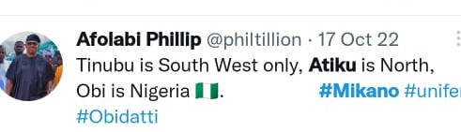

Plate 13

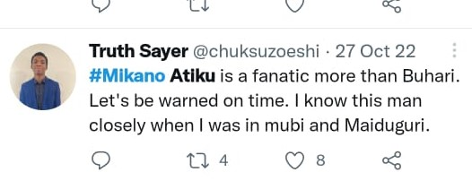
Plate 14

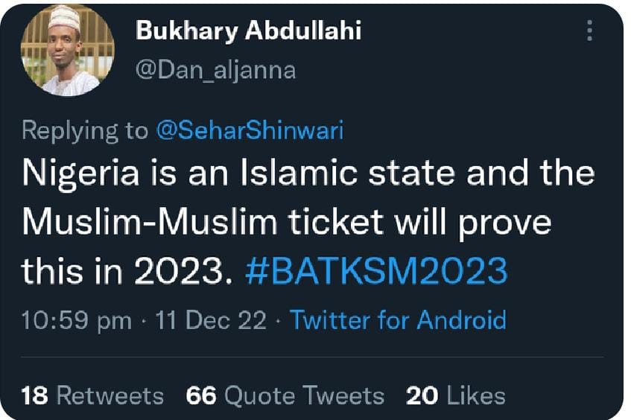
Plate 15

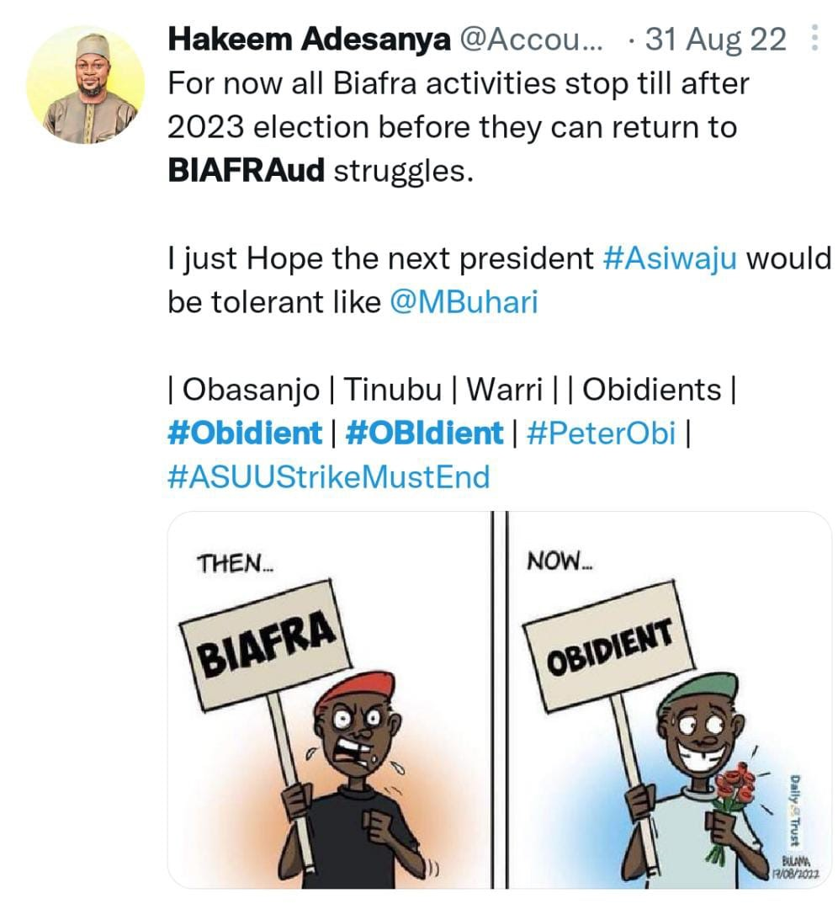
Plate 16

In plate 13, the tweep attacks the face of both Tinubu and Atiku, alleging that their reach is not beyond Southwest and North respectively. This means that they are not influential outside their regions. This is a way to seek disagreement because they are portrayed as not being acceptable to the nation at large. However, Peter Obi is represented as one who is accepted by everyone regardless of their ethnicity.
In plate 14, the tweep accuses Atiku of religious fanatism. Making reference to Buhari who most Nigerians see as very fanatic, the tweep argues that Atiku is worse. This is just a subtle way of stoking religious issues that have nothing to do with politics. Religion is a sensitive issue that many Nigerians will like to avoid due to the multiplicity of religion that exists in the country. Plate 15 is also on the issue of religion. The tweep, a supporter of Tinubu opines that Nigeria is an Islamic state and goes on to support the joint Muslim ticket of the APC. This is an impoliteness strategy geared at attacking the adherents of other religions. Tweets like this can set off a religious crisis in the country because no religious adherent would want his/her faith to be considered irrelevant. Nigeria has had her fair share of religious crises. According to Vanguard Newspaper, between 1980-1992 26 religious riots were recorded with death toll put at 6,775 people. This shows how religiously volatile Nigeria is. It is obvious that the author of the tweet just wants to cause crisis because Nigeria is a secular state where everyone is free to practice whatever religious belief they subscribe to without intimidation.
In plate 16, the author is trying to rubbish the secessionist struggles of the Igbos in Nigeria. Some Igbos have been clamouring for self- government and ‘freedom’ from the Nigerian government stating that they want to be alone to form Republic of Biafra. This was one of the causes of the civil war that broke out in 1967. The tweep damages the face of the Igbos painting the Biafran agitation as insincere and that it has metamorphosed into the obedient movement. This is seen in the lexical choice of ‘Biafraud’ portraying the movement as a fraudulent one.
Conclusion
This study has attempted to investigate the impoliteness strategies in political tweets of Nigerian electorates in the forthcoming 2023 presidential elections. Using the Culpeper impoliteness theory, the study has shown that supporters of political candidates threaten one another's face using tweets and hashtags. These face threats are realised by calling the other names, ridiculing the other, seeking disagreement and associating the other with a negative aspect. This study is significant because it fills the gap in scholarship that exists because previous studies have not focused on tweets and hashtags as tools deployed for impoliteness. The study has shown that the electorate use the social media particularly Twitter to air their opinions on the candidates running for election and their supporters as well. Therefore, the faces of Peter Obi, Asiwaju Bola Tinubu and Atiku Abubakar (three leading candidates in the forthcoming election) have been threatened by tweeps. Tweets are peculiar because unlike other social media platforms, it allows users to speak directly about an issue by trailing the hashtags surrounding that issue. Therefore, any study of political language on social media that does not include tweets and hashtag cannot be said to be comprehensive. Also, unlike the traditional media that is censored, twitter as at the time of this research is uncensored hereby giving tweeps the opportunity to speak their mind without any fear of repercussion.

References
Beebe, L. M. (1995). Polite Fictions: Instrumental Rudeness as Pragmatics Competence. Cambridge:: Cambridge University Press.
Bousfield, D. (2008). Impoliteness in interaction. John Benjamins Publishing Company.
Bousfield, D., & Culpeper, J. (2008). Impoliteness: Eclecticism and Diaspora. An Introduction to the Special Edition. Journal of Politeness Research, 4, 161–168.
Derek, B., & Miriam, L. (2008). Impoliteness in language: Studies on its interplay with power in theory and practice. Berlin and New York: Mouton de Gruyter.
Ibrahim, A. (2020). Five Books of Colleagues. doi:10.13140/RG.2.2.17405.10729
Ifechelobi, J., & Okpokiri, N. (2020). Positive Impoliteness Strategy in Political Discourse: A Textual Analysis Of 2011-2015 Presidential Election Campaign Speeches in Selected Nigerian Newspapers. Interdisciplinary Journal of Asian Studies (IJAAS), 6(2).
Kariithi, F. (2020). Aspects of Impoliteness during 2007 and 2013 Presidential Campaigns in Kenya. Asian Journal of Social Science and Management Technology.
Lakoff, R. T. (1989). The limits of politeness: Therapeutic and courtroom discourse. Multilingua-Journal of Cross-Cultural and Interlanguage Communication, 8(2-3), 101-130.
Udomoh O., & Orabueze , O. (2022). (Im)politeness studies of selected 2015 political campaign hate speeches in Nigeria. Nairobi Journal of Humanities and Social Science.
Oso, I. (2019). A Pragmatic Analysis of Exchanges during Nigeria’s 2019 Presidential Election Campaign. Journal of English Communication in Africa, 161-191.
Oz, M., Pei, Z., & Gina, C. (2017). Twitter versus Facebook: Comparing incivility, impoliteness, and deliberative attributes. New Media & Society. doi:20. 146144481774951. 10.1177/1461444817749516
S, M. (2005). Gender and Impoliteness. Retrieved from https://doi.org/10.1515/jplr.2005.1.2.263
Terkourafi, M. (2008). Toward a unified theory of politeness, impoliteness, and rudeness. Language Power And Social Process.

