Production and Interpretation of Accentual Intonation Tunes in L2 Acquisition: Implications for Nigerian Spoken English Accent

Abstract
Intonation is one of the most problematic aspects of the English prosody for L2 learners. Although studies on Nigerian English (NigE) intonation have claimed that Standard English intonation differs significantly from native Englishes, the interpretation and production of accentual intonation tunes in L2 acquisition have been inadequately explored. Fifty final-year Nigerian university undergraduates in the Department of English were randomly sampled, and each of the respondents was made to read aloud into a digital voice recorder, and to interpret ten English sentences. Respondents’ performance was converted to simple percentages while the voice production of each of the respondents was elicited from Huckvale's Speech Filing System (SFS). Respondents' frequency of occurrence at the production level showed 134 instances of appropriate use while inappropriate use amounted to 366 out of 500 expected results of accentual tunes. Performance on a gender basis revealed males’ and females’ appropriate accentuation at 67 instances each and 183 instances of inappropriate accentuation respectively, with both sexes showing no difference in accentual tunes use. Findings further revealed that out of 500 expected results for the interpretation of accentual tunes, respondents appropriately interpreted the English sentences in 360 instances while 140 respondents misinterpreted the English sentences. Though the results of respondents revealed some level of competence in the interpretation of accentual tunes, at the production level, respondents unsatisfactorily apply accentual tunes to English expressions. The study recommends that the exposure of L2 learners to digitised non-enculturation materials should be imbibed across private and government-owned institutions across the educational strata.
Keywords: Accentual intonation tune, L2 acquisition, native Englishes, Nigerian spoken English accent, university undergraduates

1. Introduction
Intonation is a communicative import that helps to determine the product of communication regardless of the lexical or grammatical meaning of the words used. It is a phonological phenomenon used for giving different meanings to utterances. Generally, intonation is the rise and fall in pitch of voice during speech production. All languages use intonation. That is, the fluctuations of pitch pattern to convey synthetic information; although its uses linguistically vary from one language to another. Most important is that the lexical items in any language are usually spoken with a fixed, unvarying pitch. A static pitch in one's voice is not normal in conversation. Therefore, the pitch of the voice is constantly changing. Where there is no such constant change of the pitch, the spoken utterance will not only sound monotonous, or unintelligible but one is sure to be deprived of an important means of expression (Crystal 1980).
Reviewing works of literature on intonation, it is not difficult to find that most linguists have extensively worked on the functions of intonation, which reveals the important roles intonation plays in the communication of meaning. As vital as the knowledge of intonation is to the perception of meaning, this knowledge may not be common among L2 speakers. Observations show that much attention is not given to it, especially at the primary and secondary school levels in Nigerian classrooms. The reasons could be a result of the fact that it is a suprasegmental feature, its complexity arising from stress syllable on placement, inadequate experts to handle the technicality of the topic, and inadequate facilities such as language laboratory among others. Commenting on this assertion, Cruttenden (1986:181) says “… the literate in any given language tend to know at least something about grammar but little or nothing about intonation”. Furthermore, commenting on the correlation between punctuation (as used in grammar) and intonation, Cruttenden points out that there is a correlation between punctuation and intonation. For instance, a pair of commas will often indicate a parenthesis or a parenthetical type of structure like a non-restrictive relative, and in such a case, the pair of commas will often correlate with the boundaries of a separate intonation group, e.g. Carl Basset, who was expected to win, actually only came second. Intonation is very essential in communication. It determines the meaning the speaker passes across to his or her hearers. Moreover, it betrays the speaker’s attitude and reveals the true intentions of a speaker. Often, this is achieved with the aid of other non-linguistic features such as facial appearances.
Similarly, Cruttenden (1986) describes the scope of intonation as prominent syllables, how they are made prominent, and to what extent they are made prominent. It involves how the movement from one syllable to the next is made. Therefore, the importance of intonation, its functions in communicative events as well as its uniqueness in the study of language, all inform the current study. Apart from that, linguists have observed that many L2 users have challenges perceiving, interpreting and producing the appropriate intonation tunes in English utterances and this could have a great comprehension effect. Intonation performs several functions that are usually grouped under four classifications: grammatical, accentual, attitudinal and discourse functions. Significantly, the two basic intonation tunes are the rise and fall tunes.
Significantly, a significant number of studies on English intonation of L2 Nigerian users (see Atoye 2005; Akinjobi & Oladipupo 2010; Odeyemi 2017; Adejuwon 2019) exists. However, interpretation and production of accentual intonation tunes of L2 acquisition have been sparsely researched. This, therefore, accounts for the essence of this study and to contribute to the body of knowledge on the interpretation and accentuation of intonation tunes among Nigerian L2 learners.
2. Nigerian English Phonology
Nigerian English as defined by Alo (2005: 16), refers to “a domesticated variety of English, functioning within the Nigerian linguistic and socio-cultural setting as a second language (ESL)”. It manifests the linguistic (phonological, syntactic, semantic, pragmatic and socio-cultural) characteristics of the Nigerian environment (social and physical). Nigerian English phonology has been characterised to be remarkably different from Standard British English (SBE) form at both segmental and prosodic levels (see Atoye 1991; Awonusi 2004; Akinjobi 2004; Akindele 2011, 2018, 2020). The heterogeneous linguistic culture and linguistic diversity of Nigeria have not made the task so easy, especially at the level of phonology. Scholars (e.g. Banjo 1979; Jibril 1982; Udofot 2003; Utulu 2014) have observed that the English spoken by the speakers of these Nigerian languages is often influenced by the phonetic features of their mother tongues. Several linguists (e.g. Sunday 2008; Akinjobi & Akindele 2016; Aina 2018) have also commented on the noticeable differences in the accents of NigE and SBE forms. These variations, apart from the segmental features, have been noticed to be more prominent in intonation. Intonation tune assignment has been claimed to be the most problematic for Nigerian users of English (see Okon 2001; Akinjobi & Oladipupo 2005; Oladipupo 2008).
3. Review of extant works on intonation in L2 contexts
A significant number of works have explored intonation in diverse L2 contexts. Some notable empirical studies on intonation are conducted among Spanish English speakers (e.g. Henriksen, Geeslin & Willis 2010; Rao 2016), German L2 speakers of English (e.g. Grosser 1993), Japanese EFL learners (e.g Saito & Saito 2017), French learners of English (e.g. Horgues 2013), Dutch L2 learners (e.g. van Maastricht, Swerts & Krahmer 2013), Finnish learners of English (e.g. Toivanen 2005), Russian learners of English (e.g. Mitrofanova 2012), Indian English speakers (e.g. Puri 2013), Malaysian learners of English (e.g. Yap & Pillai 2018), Cantonese English speakers (e.g. Yiu 2018), Vietnamese learners of English (e.g. Nguyễn & Đào 2018), South African learners of English (e.g. Swerts & Zerbian 2010), Cameroon English speakers (e.g. Ouafeu 2014), Nigerian learners of English (e.g. Atoye 2005; Akinjobi 2012; Femi-Olaleye 2020) among others.
Within the Nigerian context, Atoye (2005) investigated the perception and interpretation of intonation by some Nigerian university undergraduates and discovered that 85.7% of correct perception of changes in intonation and 25.7% of correct interpretation of the meanings normally associated with the intonation contours were obtained from the respondents' performance. The study emphasised intensified efforts in the teaching of the social meaning of English intonation to non-native learners rather than the analysis of its phonological structure. Having investigated intonation use among undergraduate students, Akinjobi and Oladipupo (2010) examined intonation and attitude in Nigerian English to ascertain the extent to which Nigerian speakers of English use English intonation tunes to express an attitude in line with the Standard British English model. The study corroborated existing claims that Nigerian users of English encounter difficulty in appropriately using English intonation, especially attitudinal intonation. Akinjobi (2012) examined how academic competence translates to linguistic performance in Nigerian users of English intonation patterns, postgraduate students of English particularly. The study observed that the academic competence of respondents has little effect on the appropriate assignment of intonation tunes in expressions. Odeyemi (2017) underscored context and discourse intonation in English-medium product advertisements in Nigeria's broadcast media. Taking insights from Brazil's Discourse Intonation, the study discovered that the allocation of prominence to a word is an advertising model's decision based on context-of-use.
Furthermore, Adejuwon (2019) examined discourse intonation patterns in the non-interrogative utterances of selected educated Nigerian speakers of English. Analysis showed that intonation choices in the natural speech of the respondents are contrary to discourse intonation as they deviate from the rules of discourse intonation. Asadu, Okoro and Kadiri (2019) analysed intonation patterns of selected Nigerian bilingual educated speakers of English with orientations from Pierrehumbert’s Auto-segmental Metrical approach, analysis showed a low level of proficiency in the use and assignment of accurate patterns of intonation in the speeches of the participants. Olusola (2019) investigated the English intonation patterns in Nigeria's national assembly sessions. Guided by insights from Brazil's Discourse Intonation and Praat as analytical instruments, the study concludes that there is inconsistency in the discourse intonation of Nigerian federal legislators and that legislators were not conscious of the communicative value of English intonation in discourse but are mainly concerned with structural patterns of tone in units.
More significantly, Femi-Olaleye (2020) focused on the application of Computer-assisted Pronunciation Instruction (CPI) in the intonation activities of the selected primary school pupils, comparing the performance of the pupils before and after the computer-aided exercise. The post-test result showed that respondents in the experimental group improved in understanding and use of intonation patterns more than the control group. The study suggested frequent alignment with computerised instruction much more than the traditional way of teaching English intonation. Although, the foregoing are studies on the intonation of Nigerian users of English, yet, studies on interpretation and production of accentual intonation tunes among Nigerian speakers of English have been sparsely researched. Therefore, this study investigates the production and interpretation of accentual intonation among university undergraduates who study English as a course. Within the realities of interlanguage development which bothers on assessing the proficiency level of L2 learners, this study examines the production and interpretation of accentual intonation tunes of selected L2 learners. It attempts to find out whether or not L2 learners can identify and produce syllables of accented words in the English utterances given. To achieve this goal, the following objectives guide the study.
- To examine the extent to which L2 learners can correctly interpret and produce accentual tunes in English sentences;
- To explore whether or not L2 learners’ accentual intonation pattern conforms to Standard English form;
- To determine the performance of respondents in the accentuation of tunes on basis of sex;
- To explain the implication of respondents’ performance in interpretation and production of accentual tunes for Nigerian spoken English accent.
4. Methodology
Final-year university students of the Department of English, Osun State University, Nigeria, constituted the participants. Through survey method of data collection, data were gathered with the consent of the students. Using the random sampling technique, the study sampled fifty students (25 males and 25 females) to serve as respondents. Questionnaires were administered to assess the respondents’ knowledge of intonation tune interpretation. Complementarily, to test respondents' knowledge of the usage of accentual intonation, respondents were made to read aloud ten sentences into speech analysis software (Huckvale’s Speech Filing System/WASP) for acoustic analysis. The recorded voices of the participants were later played back by the researcher. The researchers were actively engaged in listening to and rating the recorded production of respondents. The first rater and principal author is a trained L2 phonologist/phonetician with over a decade of experience in spoken English teaching and training L2 university students. The second author and rater is also a Nigerian L2 speaker and postgraduate student who has been undergoing speech training in L2 learning for over six years. Both raters independently listened to the recordings and their perceptual results were compared. Aspects of divergence required joint listenership and further disparity necessitated the intervention of another trained phonologist before a consensus was reached. Tokens of occurrences of appropriate and inappropriate accentuation were generated and converted to simple percentages. The highest number of occurrences of inappropriate accentuation was taken as the emerging trend in participants' use of accentual intonation. Voice productions of the participants were also subjected to acoustic analysis with the use of SFS/WASP to show the pitch track of participants and to ascertain if prominence was articulated on the syllable of the accented word as expected in Standard English form. This helped to know how participants were able to accentuate intonation variations. The productions were analysed using tables to show the statistics of the production of respondents' English intonation patterns. The acoustic analyses were done to corroborate the perceptual/statistical analysis.
5.1 Findings and discussion
This section presents findings and discusses the analysed data in statistical and acoustic forms in consonance with the research objectives.
Table 1: Overall performance of interpreted tunes by respondents
No of Respondents | No of Items | Potential Scores | Appropriate Interpretation | % | Inappropriate  Interpretation | %
50 | 10 | 500 | 360 | 72% | 140 | 28%

This section presents the statistical score of administered and filled questionnaires that were returned. The questionnaire contained multiple choice questions that aimed to test how respondents interpreted intonation tunes. Table 1 reveals the overall performance of students in the interpretation of accentual intonation tunes. Out of 500 potential scores, the appropriate interpretation of intonation tunes amount to 360 instances (72%) while the inappropriate interpretation stands at 140 instances (28%). This implies that respondents proved to have more competency in interpreting accentual tunes than in accentuating them.

Table 2: Overall performance of accentuated tunes by respondents

Respondents | Items | Expected Use | Appropriate Accentuation | % | Inappropriate  Accentuation | %
50 | 10 | 500 | 134 | 26.8 | 366 | 73.2

Having transcribed and perceptually evaluated the voice productions of the respondents, the overall statistical assessment of the respondents’ voice production is presented in this section. In Table 2 above, the statistical report of respondents’ performance in tune accentuation is presented. Of the total expected potential use of 500, the number of inappropriate accentuation (366 instances amounting to 73.2%) outweighs 134 instances of appropriate accentuation (26.8%). Unlike the level of competency demonstrated in interpreting accentual tune appropriately as revealed in Table 1, respondents appear to struggle with appropriate accentuation of intonation tune.

Table 3: Overall performance on tunes tested for respondents’ accentuation and interpretation
Respondents | Items | Expected Use | Appropriate Accentuation | % | Inappropriate  Accentuation | % | Appropriate Interpretation | % | Appropriate Interpretation | %
50 | 10 | 500 | 134 | 26.8 | 366 | 73.2 | 360 | 72 | 140 | 28

The table above shows the overall performance of participants. More significantly, Research Objective 1 is addressed in the section. Out of the overall expected production test of 500 overall use, appropriate production use was 134 (26.8%) while inappropriate use was 366 (73.2%). Interpretation of the accented syllables was higher for the participants. Out of 500 expected interpretation use, participants had 360 (72%) instances of appropriate interpretations while 140 (28%) instances of inappropriate interpretations were recorded. There seems to be an opposite performance rate between production performance and interpretation performance in participants’ results. The implication of this is that participants seem to understand the use of prominence on the accented syllables of the focus expression but to articulate it is problematic. This finding aligns with Atoye (2005) who averred that non-native speakers of English in Nigeria have relatively better perceptual ability than interpretation of intonation tunes. Inference can be drawn that if the interpretation of intonation tune is not well-understood by L2 learners, performance in accentuation will be more difficult. Similarly, knowing that accentuation is evaluated in natural spontaneous speech, this study coheres with the submission of Adejuwon (2019) that there is absence of consistency in the educated Nigerian English speakers’ intonation choices in spontaneous speech both in interactional and non-interactional contexts.

Table 4: Performance of respondents’ accentuated tune on basis of sex
Respondents | Items | Expected Use | Appropriate Accentuation | % | Inappropriate Accentuation | %
25 Males | 10 | 250 | 67 | 13.4% | 183 | 36.6%
25 Females | 10 | 250 | 67 | 13.4% | 183 | 36.6%

In this section, we consider contrasting respondents’ performance based on gender, knowing the linguistics-oriented arguments on gender roles and phonological variation. Table 4 shows the performance of respondents on the accentuation of tunes on basis of sex. In response to Research Objective 3, both sexes perform at the same level: 67 instances (13.4%) of appropriate use and 183 instances (36.6%) of inappropriate accentuation. Both sexes' performance on the accentuation of intonation tunes shows the challenge they are embattled with, concerning the accentuation of tunes. Although, the result generated in Table 3 is not sufficient enough to take positions on the ongoing debate on gender performance in Nigerian spoken English, some extant studies (e.g Akinjobi & Oladipupo 2010; Akindele 2011; Oladipupo & Akinjobi 2015; Obasi 2022), have claimed that females tend to be more accurate in speech articulation than their male counterparts. This could also mean that Nigerian female L2 learners are more diligent and focused in learning and practicing accentuation during classroom engagements.
Table 5: Participants' Production/Accentuation Performance
Sentences | Participants | Expected  Tune | Realised Tunes | Accented words | Appropriate  Accentuation | % | Inappropriate  Accentuation | %
↓James likes singing juju music. | 50 | \Fall | 18 | JAMES | 14 | 28% | 36 | 72%
I will ↓celebrate Amina if she makes a first-class degree. | 50 | ↓fall/rise↑ | 12 | CElebrate | 12 | 24% | 38 | 76%
…. while she ↓volunteered to clean the house, she could not complete the task before dinner. | 50 | ↑rise/↓fall | 18 | VOlunteered | 12 | 24% | 38 | 76%
Is there going to be an in ↑crease in the fuel pump in October? | 50 | rise↑ | 20 | INcrease | 12 | 24% | 38 | 76%
Nigeria is a ↓multi-ethnic nation, isn’t it↑? | 50 | ↓fall/↑rise | 11 | MULti-ethnic | 11 | 22% | 39 | 78%
I wish to become a re↓nowned professor in future. | 50 | ↓fall | 22 | ReNOWNed | 12 | 24% | 38 | 76%
Is she ↓wearing a black shirt↑? I mean↓ John | 50 | rise↑/fall↓ | 13 | WEARing | 17 | 34% | 33 | 66%
↓Intonation can be problematic for non-native speakers of English | 50 | ↓Fall | 20 | intoNAtion | 20 | 40% | 30 | 60%
Regular ex↓ercise keeps the body fit. | 50 | Fall | 26 | Exercise | 12 | 24% | 38 | 76%
Do you think re↓gular walk can make a person lose some weight? | 50 | ↑rise | 14 | REgular | 12 | 24% | 38 | 76%
Total | 500 |  | 174 (34.8%) | 326 (65.2%) | 134 | 26.8% | 366 | 73.2%

Following efforts on perceptual assessment of the participants’ recorded voices, table 5 is presented to show how respondents accentuate syllables of the focus words. The performance of the participants showed that out of the expected use of 500, only 174 instances of tunes were appropriately used. The inappropriate use of tunes was higher with a production use of 326 (65.2%). This seems to be one of the reasons why participants cannot accentuate the focus items in the sentences. Addressing Research Objective 2, there is a fundamental challenge with the use of tunes by L2 participants. Many of them cannot produce the tunes appropriately. This has a great effect on the comprehension of English sentences at both perceptual and production levels. This result corroborates Akinjobi and Oladipupo’s (2010) position that non-native speakers are deficient in appropriate accentuation, and this therefore grossly affects their ability to mark attitude with intonation tunes. In the same vein, the result in the above table harps and maintains the view of Asadu, Okoro and Kadiri (2019) who decry the low level of proficiency in the articulatory use and assignment of accurate patterns of intonation by Nigerian speakers of English. In succinct, Nigerian L2 users need to be intentional in dedicating time to the development of intonation communicative skills.
5.2 Acoustic analysis
The perceptual/statistical analysis of data shows that the inappropriate realisation of accentual intonation tune (73.2%) in the production of respondents outweighs instances of appropriate realisations (26.8%). Corroborating this discovery, the spectrograms below provide the graphic representation of respondents' production in two categories: the near accurate and the total deviant. This establishes the findings in the analysis that there were both appropriate and inappropriate instances of accentual tune in respondents’ utterances. In the charts below, “InA” stands for “Inappropriate Accentuation” while “NaA” signifies “Near-accurate Accentuation”.
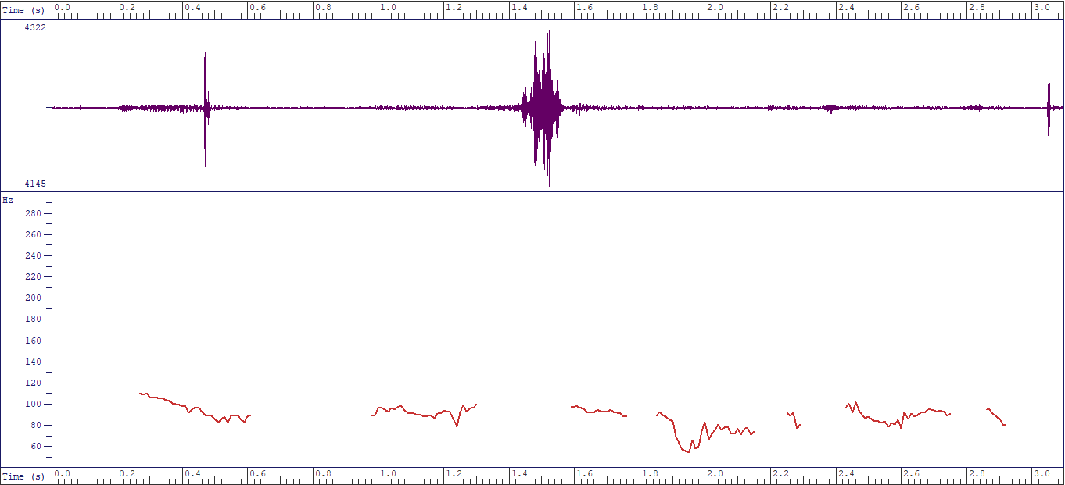
Fig. 1: InA - //James likes singing Juju music//

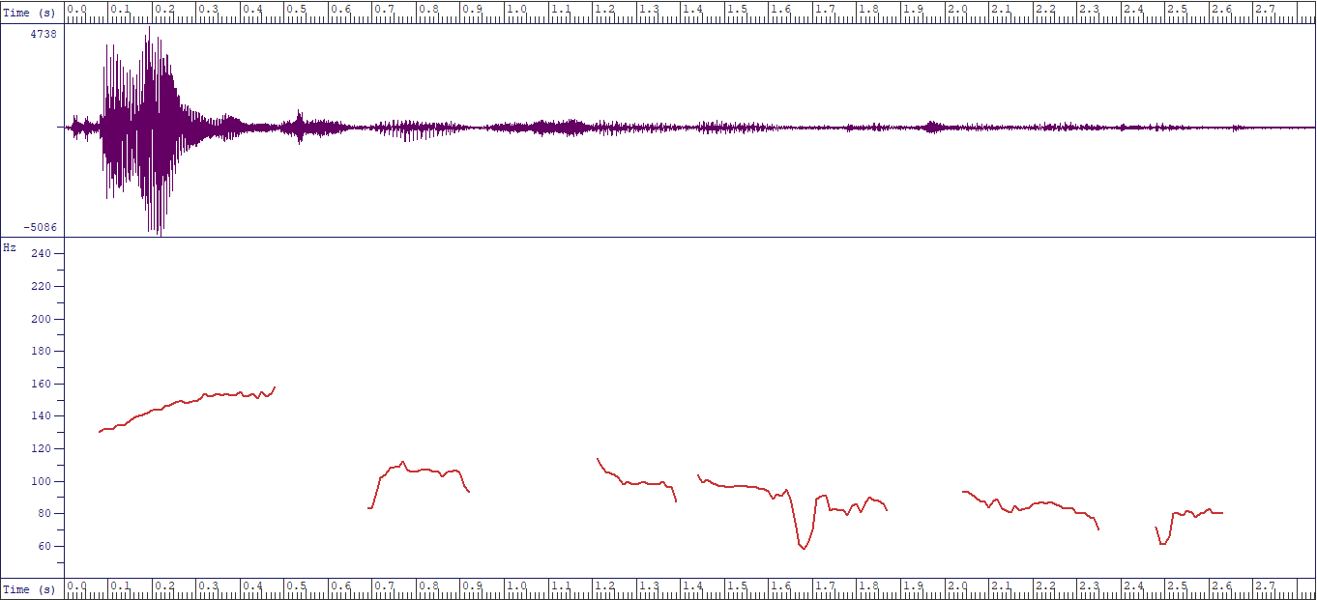
Fig. 2: NaA - //James likes singing Juju music//

The test “James likes singing Juju music” is a declarative sentence providing information. According to the rules of intonation tunes, it is an instance of “fall tune”. Fig.1 is presented as an instance of inaccurate accentuation. It does not convincingly show the first tone unit “James” being accented to rise above other tone units, and to orchestrate the fall or downward glide of pitch on other tone units. Each of the tone units maintains equal modulation which does not represent a fall tune. While the pitch contour in Fig.1 marks a departure from the rules of English intonation tune, Fig.2 shows near-conformity to the SBE intonation. As required, the pitch rises on the accented first tone unit "James" and falls gradually onto the last tone unit “music”.
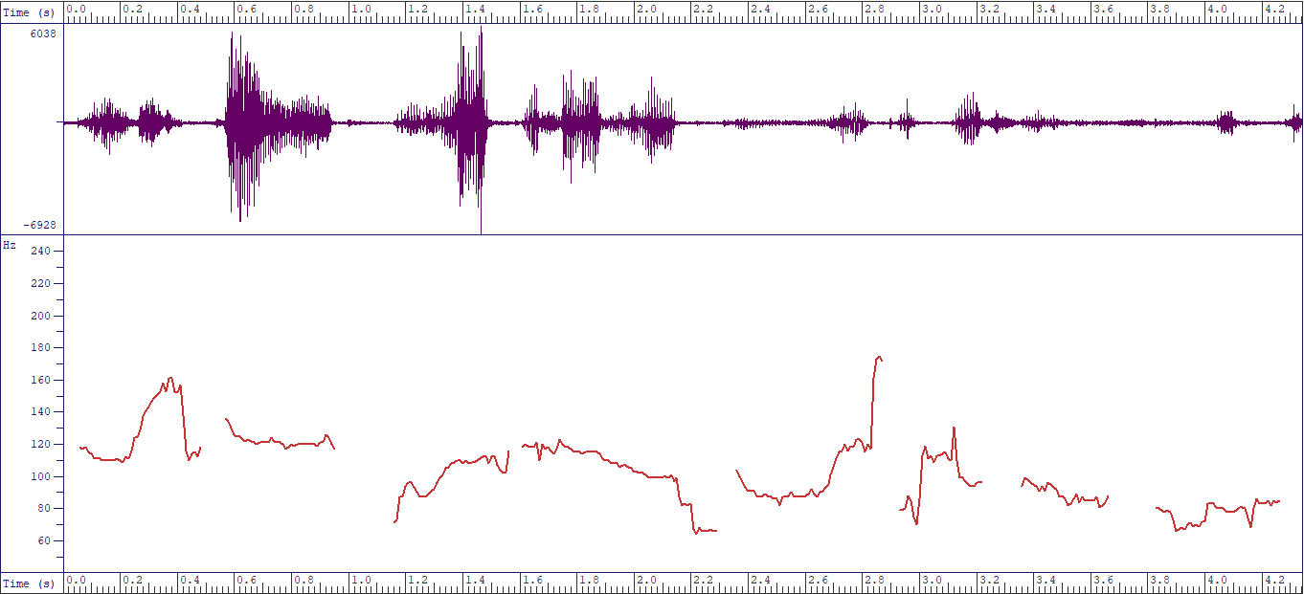Fig. 3: “InA” - //Do you think regular work can make a person lose some weight?//
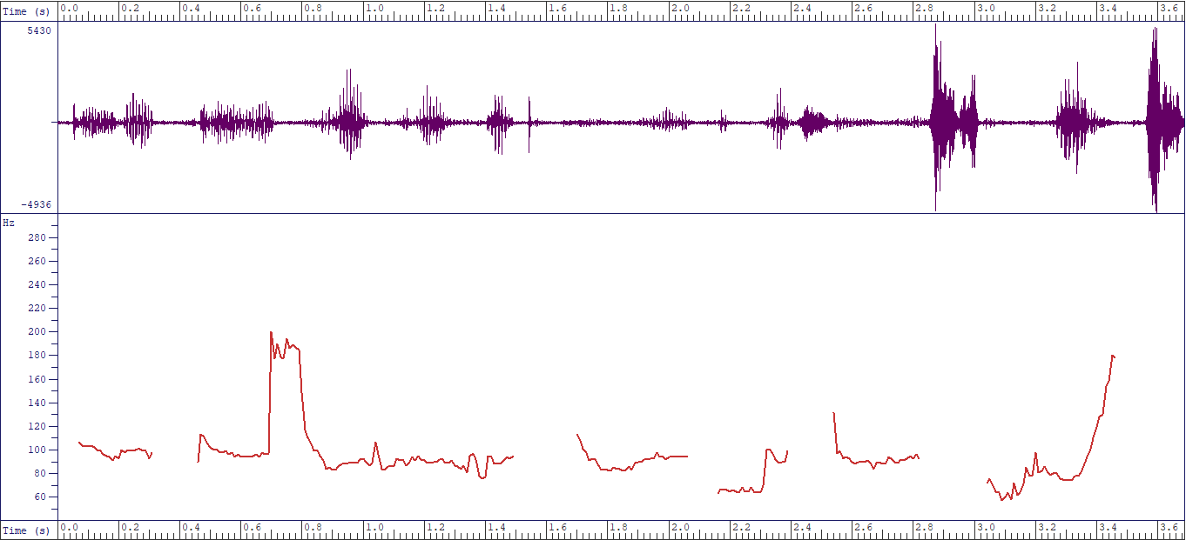 Fig. 4: “NaA” - //Do you think regular work can make a person lose some weight?//

The test item “Do you think regular exercise can make a person lose some weight?” is a question that exemplifies the rising tune. In the above charts. Fig.3 marks an instance of an inappropriate accentual tune. As shown in the pitch contour, the rising of the pitch should have climaxed at the last tone unit "weight", but on the contrary, the pitch falls on it. However, Fig.4 marks contrariwise and shows near-accurate accentuation of the test item. To mark an instance of rising tune, pitch contour shows modulation as the pitch rises on "re", the accented syllable in the first tone unit and climaxes at the final tone unit "weight".
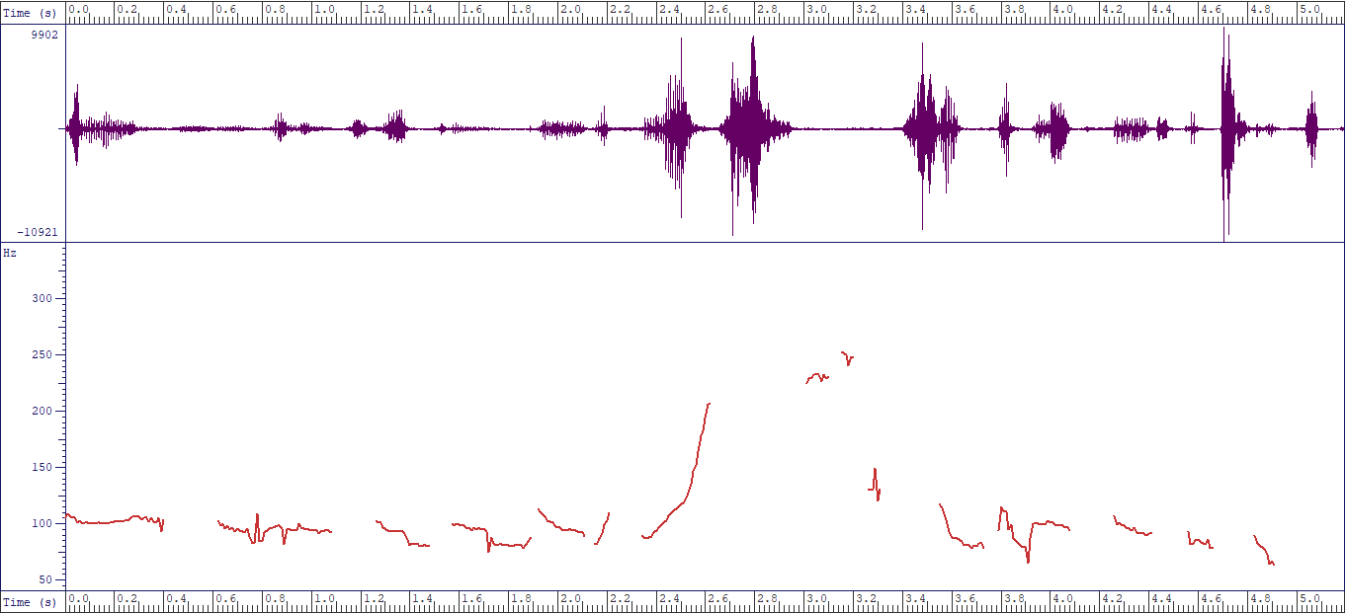Fig.5: “InA”://While she volunteered to clean the house she could not finish the task//
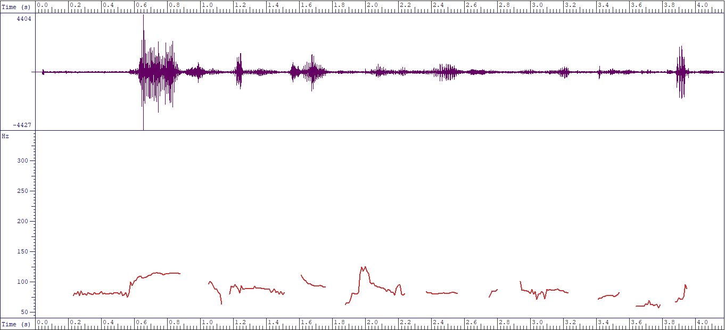 Fig.6: “NaA” - //While she volunteered to clean the house, she could not finish the task//

Furthermore, the test item “while she volunteered to clean the house, she could not finish the task” is a complex sentence expected to be accentuated in the rise-fall intonation tune. While Fig.5 shows near accurate production, Fig.6 marks deviation. As captured in the pitch contour of Fig.6, the pitch modulation does not indicate the accented word that should have triggered a rise in tune. Conversely, the pitch rises on the last word in the first dependent clause "house", and falls on the first word of the main clause "she". Although Fig.5 does not perfectly conform to the SBE rules of intonation, it instantiates near-accurate accentuation where the pitch should have risen on "VO" in volunteer, the first syllable of the first tone unit. Arising from the explanation offered on these spectrograms, accentual intonation is considered problematic to Nigerian non-native users of English, specifically university undergraduates considered in this study although very few of them have seem to have a fairly good understanding of the application of English intonation rules.
6. Conclusion and Recommendations
Respondents' frequency of occurrence at the production level showed appropriate use amounting to 134 instances (26.8%) while inappropriate use was 366 (73.2%) out of 500 expected results of accentual tunes. Out of 500 expected interpretation use, participants had 360 instances of appropriate interpretation (72%) while 140 (28%) inappropriate interpretations are recorded. There seems to be an opposite performance between production performance and interpretation performance results. Though the results of respondents revealed competence in the interpretation of accentual intonation tunes (72%), at the production level, respondents did not apply accentual tunes (26.8%) to English expressions. To corroborate the perceptual analysis, spectrograms showed pitch contours of some respondents' production. The pitch modulation expected on the focus syllable of the accented word was not applied by participants as observed from the acoustic /instrumental analysis. The implication of this is that participants seem to understand the use of prominence on the accented syllable of the focus items in the given sentences but articulating the accented syllables was problematic. It also harps existing positions that the Nigerian spoken English accent differs significantly from native English and should be described as the outer circle English. Also, the performance of production on a gender basis revealed males' and females' appropriate use at 67 (13.4%) each and inappropriate use was 183 (36.6%). Although very rare, findings showed that both males and females showed no difference in accentual tune use at the production level.
There is a significant difference in the production and interpretation of accentual intonation tunes of L2 learners as affirmed by the results. Results also confirm that L2 acquisition in accentual intonation tunes tilts towards excellent performance in the written interpretation of accentual tunes. However, at the production level, where respondents are expected to produce the accented syllables in English sentences given, the respondents had a very low performance (26.8%). This has some pedagogical implications for L2 acquisition as demanded in Research Objective 4. It implies that at the pedagogical level, a gap exists between L2 competence on the subject matter and reality. This implies that there is a gap between the application of classroom knowledge and the actual production of this knowledge, especially because L2 is learned within the classroom setting. This is in response to Research Objective 2 that L2 learners’ accentual intonation pattern differs from the SBE form. Also, many of the L2 learners are from tone language backgrounds. The phenomenon of interference/negative transfer in L2 learning at the phonetic and phonological levels plays out, especially when L2 learners are made to produce some English sounds which cannot be found in the sound system of L2 learners’ native language. This aptly captures the position of Tench (1996) that intonation is put to limited use by tonal languages unlike its elaborate use in stressed-timed languages like English. This also corresponds with the submission of Mohamad, Hanafi and Dako (2021) that mother tongue influence is responsible for the disparity in most L2 learners’ production of some English sounds. On this ground, the linguistic background of L2 learners influence NigE accentuation.
The core areas of the English prosodies of stress and intonation should be introduced to L2 learners as early as possible. I am very much aware in some elite institutions in Nigeria currently expose some L2 learners to native English accents through non-enculturation sources (Akinjobi 2013; Adesanya 2021) such as video tapes, cable networks where native English accents are domiciled (cartoon networks) and materials from native accents in spoken English classes. This exposure should also be emulated and inculcated by government-owned institutions across the educational strata. Adequate provisions should be made by institutions for efficient and effective digital language laboratory drills. Comprehension is very important in speech utterances. When communication is distorted, intelligibility problems set in. Therefore, in L2 acquisition, the pedagogical target should be geared towards proper spoken English drills at the perceptual and production levels. This will eventually help to improve spoken English that is locally, nationally and internationally intelligible.
References
Adejuwon, A. O. 2019. “Discourse intonation patterns in the non-interrogative utterances of selected educated Nigerian speakers of English”. Ghana Journal of Linguistics. 8(2): 86-106.
Adesanya, A. F. 2021. Extending frontiers of Nigerian English vowel reduction: The place of technology-based non-enculturation sources of native English. Paper presented at 1st International Conference of Association of Phonetics and Phonologists in Nigeria, Ile-Ife, Nigeria.

Aina, M. O. 2018. Intonation tune assignment by English language teachers-in-training in selected public universities in southwestern Nigeria. (Unpublished doctoral dissertation). University of Ibadan, Ibadan.

Akindele, J. A. 2020. “Anacrusis and the rhythm of selected educated Edo Nigerian English speakers: Acoustic evidence”. In Phonetics, phonology and sociolinguistics in the Nigerian context: A festschrift for Adenike Akinjobi, edited by R. Oladipupo, J. Akindele and A. Osisanwo, 157-170. Ibadan: Stirling Horden Publishers.
Akindele, J. A. 2018. “Rhythm ratio of educated Edo (Nigerian) English speakers’ duration: An acoustic investigation”. University of Uyo Journal of Humanities. 22(1): 27-41.
Akindele, J. A. 2011. Variable word stress in spoken educated Edo English. (Unpublished master’s thesis). University of Ibadan, Ibadan.

Akinjobi, A. A. 2013. “Non-enculturation sources of standard spoken English for non-native speakers: The Nigerian example”. Lagos Review of English Studies LARES. 17(2): 13-21.
Akinjobi, A. A. 2012. “Academic competence and linguistic performance: A study of English intonation tune assignment by some Nigerian postgraduate students of the English language”. JNESA. 15(2): 1-12.
Akinjobi, A. A. 2004. A phonological investigation of vowel weakening and unstressed syllable obscuration in educated Yoruba English. (Unpublished doctoral dissertation). University of Ibadan, Ibadan.
Akinjobi, A. A. & Akindele, J. A. 2016. “Measuring the speech rhythm of Educated Edo variety of Nigerian English speakers”. Papers in English and Linguistics (PEL). 17(1): 69-81.
Akinjobi A. A. & Oladipupo, O. R. 2005. “Patterns of intonation of some Nigerian television reporters”. Ibadan Journal of European Studies. 5: 1-16.
Akinjobi, A. A. & Oladipupo, O. R. 2010. “Intonation and attitude in Nigerian English”. LWATI: A Journal of Contemporary Research. 7(1): 159-167.
Alo, M. 2005. “Revisiting Issues in English Use and Usage in Nigeria: Implications for ESL Classrooms”. Journal of the Nigerian English Studies Association. 11(1): 114-130.
Asadu, E. U., Okoro, F. O. & Kadiri, G. C. 2019. “Analysis of intonation patterns of selected Nigerian bilingual educated speakers of English”. English Language Teaching. 12(6): 45-54.
Atoye, R.O. 1991. “Word-stress in Nigerian English”. World Englishes 10(1): 1-6.
Atoye, R. O. 2005. “Non-native perception and interpretation of English intonation”. Nordic Journal of African Studies. 14(1): 26–42.
Awonusi, S. 2004. “The function of Nigerian English in relation to other Nigerian languages”. In Nigerian English: Influences and characteristics, edited by S. Awonusi and A.B.K Dadzie, 67-81. Lagos: Concept Publication Ltd.
Banjo, A. 1979. “Towards a standard Nigerian spoken English”. Abidjan: Actes du 8 congress de society linguistique de Africa Occidentials.
Cruttenden, A. 1986. Intonation (4th ed.). Cambridge: Cambridge University Press.
Crystal, D. 1980. The first dictionary of linguistics and phonetics. Boulder, CO: Westview.
Femi-Olaleye, J. B. 2020. Computer-assisted pronunciation instruction for English intonation in Nigerian primary education. (Unpublished doctoral dissertation). Obafemi Awolowo University, Ile-Ife.
Grosser, W. 1993. “Aspects of intonational L2 acquisition”. Current Issues in European Second Language Acquisition Research. 81-94.
Henriksen, N. C., Geeslin, K. L. & Willis, E. W. 2010. “The development of L2 Spanish intonation during a study abroad immersion program in León, Spain: Global contours and final boundary movements”. Studies in Hispanic and Lusophone Linguistics. 3(1): 113-162.
Horgues, C. 2013. “French learners of L2 English: Intonation boundaries and the marking of lexical stress”. Research in Language. 11(1): 41-56.
Jibril, M. 1982. Phonological variation in Nigerian English. (Unpublished doctoral dissertation). University of Lancaster, Lancashire.
Mitrofanova, Y. 2012. “Raising EFL students’ awareness of English intonation functioning”. Language Awareness. 21(3): 279-291.
Muhamad, H., Hanafi, H. & Dako, R. T. 2021. “A study of phonological process: A case on Indonesian EFL students’ pronunciation”. Trans-Kata: Journal of Language, Literature, Culture, and Education. 1(2): 115-123.
Nguyễn, A. T. & Đào, D. M. 2018. “The acquisition of question intonation by Vietnamese learners of English”. Asian-Pacific Journal of Second and Foreign Language Education. 3(1): 1-13.
Obasi, J. 2022. “Variation in boundary consonant deletion in English among selected male and female undergraduates of the University of Nigeria”. Ghana Journal of Linguistics. 11(1): 45-65.
Odeyemi, J. O. 2017. “Context and discourse intonation in English-medium product advertisements in Nigeria's broadcast media”. I-manager’s Journal on English Language Teaching. 7(2): 13-28.
Okon, B. 2001. The intonational structure of Nigerian English. (Unpublished doctoral dissertation). University of Ibadan, Ibadan.
Oladipupo, R. 2008. The English intonation patterns of selected reporters on television stations in Lagos State Nigeria. (Unpublished master’s thesis). University of Ibadan, Ibadan.
Oladipupo, R. & Akinjobi, A. 2015. “A sociophonetic study of young Nigerian English speakers”. Ghana Journal of Linguistics. 4(2): 92-107.
Olusola, D. N. 2019. English intonation patterns in Nigeria national assembly plenary sessions. (Unpublished master’s thesis). Obafemi Awolowo University, Ile-Ife.
Ouafeu, Y. 2014. Intonation in Cameroon English. In Structural and sociolinguistic perspectives on indigenisation, edited by E. Anchimbe, 81-102. Dordrecht: Springer.
Puri, V. 2013. Intonation in Indian English and Hindi late and simultaneous bilinguals. (Doctoral dissertation, University of Illinois Urbana-Champaign, USA). Retrieved from http://hdl.handle.net/2142/45457
Saito, K. & Saito, Y. 2017. “Differential effects of instruction on the development of second language comprehensibility, word stress, rhythm, and intonation: The case of inexperienced Japanese EFL learners”. Language Teaching Research. 21(5): 589-608.
Sunday, A. 2008. “Compound stress in educated Yoruba English”. Papers in English and Linguistics (PEL). 1(9): 78-93.
Swerts, M. & Zerbian, S. 2010. “Intonational differences between L1 and L2 English in South Africa”. Phonetica. 67(3): 127-146.
Tench, P. 1996. The intonation system of English. London: Cassel.
Toivanen, J. 2005. “ToBI or not ToBI? Testing two models in teaching English intonation to Finns”. In PTL05: Proceedings of the Phonetics Teaching and Learning Conference, edited by J. A. Maidment, 1-4. London, UK: UCL Dept. of Phonetics and Linguistics.
Utulu, D. C. 2014. A phonetic analysis of educated Urhobo English segmentals. (Unpublished doctoral dissertation). University of Ibadan, Ibadan.
Udofot, I. 2003. “Stress and rhythm in the Nigerian accent of English: A preliminary investigation”. English World-Wide. 24(2): 201-220.
van Maastricht, L.J., Swerts, M. G. & Krahmer, E. J. 2013. Acquiring native-like intonation in Dutch and Spanish: Comparing the L1 and L2 of native speakers and second language learners. Poster session presented at Phonetics, Phonology, and Languages in Contact 13, Paris, France.
Yap, T. S & Pillai, S. 2018. “Intonation patterns of questions in Malaysian English”. Asian Englishes. 20(3): 192-205.
Yiu, S. W. 2015. Intonation of statements and question in Cantonese English: Acoustic evidence from a smoothing spline analysis of variance. Paper presented at 18th International Congress of Phonetic Sciences, Glasgow, Scotland.

