Production and Interpretation of Accentual Intonation Tunes in L2 Acquisition: Implications for Nigerian Spoken English Accent

Abstract
Intonation is one of the most problematic aspects of the English prosody for L2 speakers. Studies on Nigerian English (NigE) intonation have claimed that Standard English intonation differs significantly from native Englishes but studies on the interpretation and production of accentual intonation tunes of L2 acquisition have been rare. Fifty final-year university undergraduates from Nigeria (25 males and 25 females) were purposively sampled. Each of the respondents was given 10 English sentences to produce and interpret. Interpretations of each of the respondents was captured and converted to simple percentages while the voice production of each of the respondents was elicited from a Speech Filing System (SFS) installed on Hp250 laptop. Respondents' frequency of occurrence at production level showed appropriate use of 134 (26.8%) while inappropriate use amounted to 366 (73.2%) out of 500 expected results of accentual tunes. Production on gender basis revealed males and females appropriate use at 67 (13.4%) each and inappropriate use was 183 (36.6%) respectively, both sexes showing no difference in accentual tunes use. Findings revealed that out of the 500 expected results for interpretation of accentual tunes, respondents appropriately interpreted the English sentences in 360 (72%) instances while 140 (28%) respondents misinterpreted the English sentences. Though, results of respondents revealed competence in the interpretation of accentual tunes (72%) but at the production level, respondents did not apply accentual tunes (26.8%) on English expressions. This study concludes that Nigerian spoken English accent differs significantly from native Englishes and should be described as an outer circle English.
Keywords: Accentual intonation tune, L2 acquisition, Nigerian spoken English accent, university undergraduates, native Englishes

1. Introduction
Intonation is a communicative import that helps to determine the product of communication regardless of the lexical or grammatical meaning of the words used. It is a phonological phenomenon used for giving different meanings to utterances. Generally, intonation is the rise and fall in pitch of voice during a speech production. This study investigates the production and interpretation of accentual intonation tunes of selected L2 learners. The study attempts to find out whether or not L2 leaners are able to identify and produce syllables of accented words the English utterances given. In order to achieve this goal, the following objectives shall guide the study.
- Examine the extent to which L2 learners are able to correctly interpret accentual tunes in English sentences;
- Investigate whether or not L2 leaners’ accentual intonation pattern conforms to Standard English form and the implication for Nigerian spoken accent;
- Find out the outcome of L2 learners’ level of interpretation and production of accentual tunes in Nigerian English
The importance of studying intonation can be seen in the communicative import of intonation. Intonation usually superimposes meanings upon lexical meanings and consequently determines the product of communication regardless of the lexical or grammatical meaning of the words used. To justify the importance of intonation as a determining factor of meaning in an utterance, Pike (1945:23) says:
The intonation meaning… rather than being a stable inherent of words, it is a temporary addition to their basic form and meaning. Rather than being carried by permanent consonants and vowels, it is carried by a transitory extrinsic meaning of a word, it is merely a shade of meaning added to or superimposed upon that intrinsic lexical meaning according to the attitude of the speaker.”
All languages use intonation. That is, the fluctuations of pitch pattern to convey synthetic information; although its uses linguistically vary from one language to another. Most important is that the lexical items in any language are usually spoken with fixed, unvarying pitch. A static pitch in one’s voice is not normal in conversation. Therefore, the pitch of the voice is constantly changing. Where there is no such constant change of the pitch, spoken utterance will not only sound monotonous, or unintelligible but one is sure to be derived of an important means of expressions (Crystal, 1980). Reviewing literatures on intonation, it is not difficult to find that most linguists deal with the functions of intonation, which reveals the important roles intonation plays in the communication of meaning. As vital as the knowledge of intonation is to the perception of meaning, this knowledge may not be common among the L2 speakers. Observations show that much attention is not given to it especially at the primary and secondary school levels in Nigerian classroom. Reasons could be as a result of the fact that it is a suprasegmental feature, its complexity arising from stress syllable on placement, inadequate experts to handle the technicality of the topic, inadequate facilities such as language laboratory among others. Commenting on this assertion, Cruttenden (1986:181) says “… the literate in any given language tend to know at least something about grammar but little or nothing about intonation”. Furthermore, commenting on the correlation between punctuation (as used in grammar) and intonation, Cruttenden points out that “… there are clear correlation between punctuation and intonation e.g. a pair of commas will often indicate a parenthesis or a parenthetical type of structure like a non-restrictive relative and in such a case, the pair of commas will often correlate with the boundaries of a separate intonation group, e.g. ‘Carl Basset, who was expected to win, actually only came second’. Intonation is very essential in communication. It determines the meaning the speaker passes across to his or her hearers. Moreover, it betrays the speaker’s attitude and reveals the true intentions of a speaker. Often, this is achieved with the aid of other non-linguistic features such as facial appearances.
In addition, intonation also betrays the emotional state of speakers. Pike (1972) as cited in Folarin (2015:23) opines further that:
In English, many intonation contours are explicit in meaning. Whenever a certain sequence of relative pitches is heard, one concludes that the speaker means certain things over and above the specific meanings of the words themselves. A change of pitch contour will change the meaning of the sentence.
Similarly, Cruttenden (1986) describes the scope of intonation as syllables that are prominent, how they are made prominent, and to what extent they are made prominent, it is involves how the movement from one syllable to the next is made. Therefore, the importance of intonation, its functions in communicative events as well as its uniqueness in the study of language, all these inform the study. Apart, linguists have observed that many L2 users have challenges perceiving, interpreting and producing the appropriate intonation tunes in English utterance and this could have great comprehension effect. The study attempts to find out the level of the perception, interpretation and production of n; particular syllables of lexical words in order to achieve a particular effect. Intonation performs several functions that are usually grouped under three classifications: grammatical, accentual and attitudinal functions.
The two basic intonation tunes are the rise and fall tunes. Other complex tunes include:
- High-Fall: a falling pitch movement from a relatively high pitch to a low pitch, denoting higher degree of emotional involvement;
- Low-Fall: a falling pitch movement from a mid-pitch to a low pitch, denoting a lesser degree of emotional involvement;
- Rise-Fall: complex pitch movement, starting with a rise from a mid-pitch to high pitch and then a fall from high to low, finishing on a low pitch, denoting either that the speaker is impressed, or that he wants to impress someone; the other meaning of this tone is that of challenge or disapproval.
- Fall-Rise: a pitch movement that first falls from a high pitch to a low pitch and then rises, ending on a mid-pitch, denoting , as fall-rises in general do, non-finality, implying something left unsaid, or denoting reservation;
- Rise-Fall-Rise: a pitch movement starting with a rise from a mid-pitch to a high pitch, then falling from high to low pitch, after which it rises back to mid-pitch;
(Wells, 2006: 216-222)
Basic functions of intonation as captured in Folarin (2015) are:
- Attitudinal - serving to express our attitudes and emotions;
- Accentual - serving to mark certain words or syllables of a word as prominent and therefore important in terms of information;
- Grammatical - serving to identify grammatical structures in speech;
- Informational - serving to show what information in an utterance is new and what is already known;
- Discourse or Cohesive - serving to signal how sequences of clauses and sentences go together in spoken discourse, to contrast or cohere;
- Psychological - serving to organize speech into units easy to perceive, memorize or perform;
- Indexical - serving as a marker of personal or social identity.
2. Nigerian English Phonology and L2 Acquisition
Alo (2005:16) defines Nigerian English as ‘a domesticated variety of English, functioning within the Nigerian linguistic and socio-cultural setting as a second language (ESL)’. It manifests the linguistic (phonological, syntactic, semantic, pragmatic and socio-cultural) characteristics of the Nigerian environment (social and physical). Nigerian English phonology has been characterised to be remarkably different from SE form at both segmental and prosodic levels (Atoye, 1991; Awonusi, 2004; Akinjobi, 2004; Akindele, 2011, 2018, 2020). The heterogeneous linguistic culture and linguistic diversity of Nigeria has not made the task so easy, especially at the level of phonology. Scholars (Banjo, 1979; Jibril, 1982; Udofot, 2003; Utulu, 2014) have observed that the English spoken by the speakers of these languages is often influenced by the phonetic features of their mother tongues. Several linguists (Sunday, 2008; Akinjobi & Akindele, 2016; Aina, 2018) have also commented on the noticeable differences in the accents of NE and SE forms. These variations, apart from the segmental features, have been noticed to be more prominent in intonation. Intonation tune assignment has been claimed to be the most problematic for Nigerians (Okon, 2001; Akinjobi & Oladipupo, 2005; Oladipupo, 2008).
Akinjobi and Oladipupo (2010) investigate intonation and attitude in Nigerian English to ascertain the extent to which Nigerian speakers of English use English intonation tunes to express attitude in line with the Standard British English model. The study corroborates existing claims that the Nigerian users of English encounter difficulty in appropriately using the English intonation, especially attitudinal intonation. Akinjobi (2012) examines how academic competence translates to linguistic performance in Nigerian users of English intonation patterns, postgraduate students of English particularly. The study observes that the academic competence of respondents has little effect on appropriate assignment of intonation tunes in expressions. Odeyemi (2017) understudies context and discourse intonation in English-medium product advertisements in Nigeria's broadcast media. Taking insights from Brazil's Discourse Intonation, the study discovers out that the allocation of prominence to a word is an advertising model's decision based on context-of-use.
Adejuwon (2019) examines discourse intonation patterns in the non-interrogative utterances of selected educated Nigerian speakers of English. Analysis shows that intonation choices in the natural speech of the respondents are contrary to discourse intonation as they deviates from the rules of discourse intonation. Asadu, Okoro and Kadiri (2019) analyse Intonation Patterns of Selected Nigerian Bilingual Educated Speakers of English with orientations from Pierrehumbert’s Auto-segmental Metrical approach, analysis shows a low level of proficiency in the use and assignment of accurate patterns of intonation in the speeches of the participants. Olusola (2019) investigates the English intonation patterns in Nigeria national assembly sessions. Guided by insights from Brazil's Discourse Intonation and PRAAT as analytical instruments, the study concludes s that there is inconsistency the discourse Intonation of Nigerian federal legislators, and that legislators were not conscious of the communicative value of English intonation in discourse but they were mainly concerned with structural patterns of these tone in units. Although, the foregoing are studies on intonation of Nigerian users of English, yet, studies on interpretation and production of accentual intonation tunes among Nigerian speakers of English have been sparsely researched. Therefore, this study investigates production and interpretation of accentual intonation among university undergraduates who study English as a course.
3. Methodology
Final-year university students of Faculty of Humanities, Osun State University, Nigeria, constitute the participants. This data was gathered with the knowledge of the students. The paper employs purposive sampling technique. Fifty students (25 males) and (25) females were drawn. Participants were given ten sentences on accentual intonation to clear ambiguities in the sentences. These sentences were produced into a speech software for voice analyses. The recorded voices of the 50 participants were later played back for analysis into a system recorder that was later played by the researcher. Token of occurrences was adequately captured with appropriate use and inappropriate adequately tracked and converted into simple percentages. The highest number of occurrence was taken as the norm for the participants. Voice production of the participants was also subjected to acoustic analysis on SFS/WASP to show the pitch track of participants if prominence was articulated on the syllable of the accented word as expected in Standard English form. This will help to know how participants are able to interpret intonation variations. The production analysis would be discussed using a table to show the statistics of production of respondents' English intonation patterns. The acoustic analysis was done using Speech Filing system (SFS)/ WASP version 1.3 to corroborate the perceptual/statistical analysis.

4. Analysis
Table 1: Overall performance on tunes tested for respondents’ accentuation
Respondents | Items | Expected Use | Appropriate Accentuation | % | Inappropriate  Accentuation | % | Appropriate Interpretation | % | Appropriate Interpretation | %
50 | 10 | 500 | 134 | 26.8 | 366 | 73.2 | 360 | 72 | 140 | 28

The table above shows the overall performance of participants. Out of overall expected production test of 500 overall use, appropriate production use was 134 (26.8%) while inappropriate use was 366 (73.2%). Interpretation of the accented syllables was higher for the participants. Out of 500 expected interpretation use, participants had 360 (72%) instances of appropriate interpretations while 140 (28%) instances of inappropriate interpretations were recorded. There seems to be an opposite performance rate between production performance and interpretation performance in participants’ results. The implication of this is that participants seem to understand the use of prominence on the accented syllables of the focus expression but articulating it is problematic.
Table 2: Performance of respondents’ accentual tunes based on sex
Respondents | Items | Expected Use | Appropriate Accentuation | % | Inappropriate Accentuation | %
25 Males | 10 | 250 | 67 | 13.4% | 183 | 36.6%
25 Females | 10 | 250 | 67 | 13.4% | 183 | 36.6%
Table 2 shows performance of respondents on accentuation of times on basis of sex. Evidently, both sexes perform at the same level, recording 67 instances (13.4%) of appropriate use and 183 instances (36.6%) of inappropriate accentuation. Both sexes' performance on accentuation of intonation tunes shows the challenge they are embattled with respect to accentuation of tunes.
Table 3: Overall performance of interpreted tunes by respondents
No of Respondents | No of Items | Potential Scores | Appropriate Interpretation | % | Inappropriate  Interpretation | %
50 | 10 | 500 | 360 | 72% | 140 | 28%

Table 3 reveals the overall performance of students in interpreting tunes. Out of 500 potential score, the appropriate interpretation of intonation tunes amount to 360 (72%) instances while the inappropriate interpretation stands at 140 instances (28%). Evidently, respondents proved to have more competency in interpreting accentual tune than in accentuating them.

Table 4: Participants Production/Accentuation Performance
Sentences | Participants | Expected  Tune | Realised Tunes | Accented words | Appropriate  Accentuation | % | Inappropriate  Accentuation | %
↓James likes singing juju music. | 50 | \Fall | 18 | JAMES | 14 | 28% | 36 | 72%
I will ↓celebrate Amina, if she makes a first class degree. | 50 | ↓fall/rise↑ | 12 | CElebrate | 12 | 24% | 38 | 76%
…. while she ↓volunteered to clean the house, she could not complete the task before dinner. | 50 | ↑rise/↓fall | 18 | VOlunteered | 12 | 24% | 38 | 76%
Is there going to be an in ↑crease in fuel pump in October? | 50 | rise↑ | 20 | InCREASE | 12 | 24% | 38 | 76%
Nigeria is a ↓muti-ethnic nation, isn’t it↑? | 50 | ↓fall/↑rise | 11 | MULti-ethnic | 11 | 22% | 39 | 78%
I wish to become a re↓nowned professor in future. | 50 | ↓fall | 22 | ReNOWNed | 12 | 24% | 38 | 76%
Is she ↓wearing a black shirt↑? I mean↓ John | 50 | rise↑/fall↓ | 13 | WEARing | 17 | 34% | 33 | 66%
↓Intonation can be problematic for non-native speakers of English | 50 | ↓Fall | 20 | INtonatation | 20 | 40% | 30 | 60%
Regular ex↓ercise keeps the body fit. | 50 | Fall | 26 | Exercise | 12 | 24% | 38 | 76%
Do you think re↓gular walk cam make a person loose some weights? | 50 | ↑rise | 14 | Regular | 12 | 24% | 38 | 76%
Total | 500 |  | 174 (34.8%) | 326 (65.2%) | 134 | 26.8% | 366 | 73.2%

Table 4 shows the production of accentuated tunes on syllables of focus word. The tunes of the participants showed that out of expected use of 500, only 174 instances of tunes were appropriately used. Inappropriate use of tunes was higher with production use of 326 (65.2%). This seems to be one of the reasons why participants cannot accentuate the focus items in the sentences. There is a basic and fundamental challenge with the use of tunes of L2 participants. Many of them cannot produce the tunes appropriately as affirmed in native English form. This has a great effect on comprehension of English sentences at both perceptual and production levels.
4.1 Acoustic analysis
The perceptual/statistical analysis of data shows that the inappropriate realisation of accentual intonation tune (73.2) in the production of respondents outweighs instances of appropriate realisations (26.8%). Corroborating this discovery, spectrograms below provide the graphic representation of respondents’ production in two categories: the near accurate and the total deviant. This establishes the findings in the analysis that there were both appropriate and inappropriate instances of accentual tune in respondents’ utterances.
Fig. 1: Excerpt 1 showing inappropriate accentuation
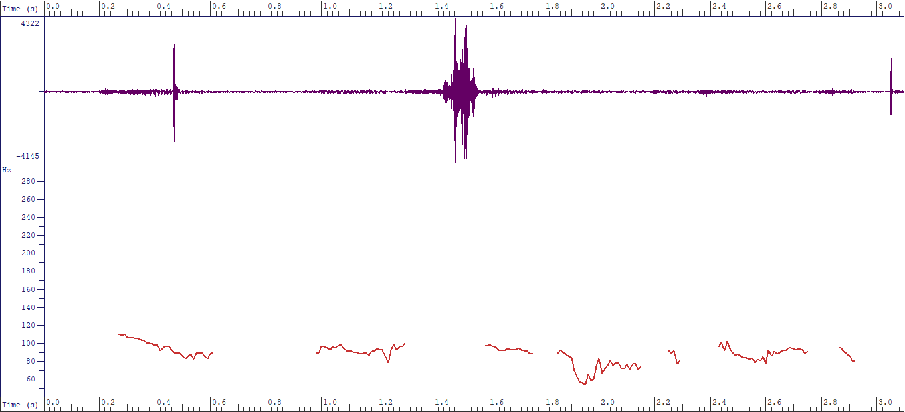
//James likes singing Juju music//
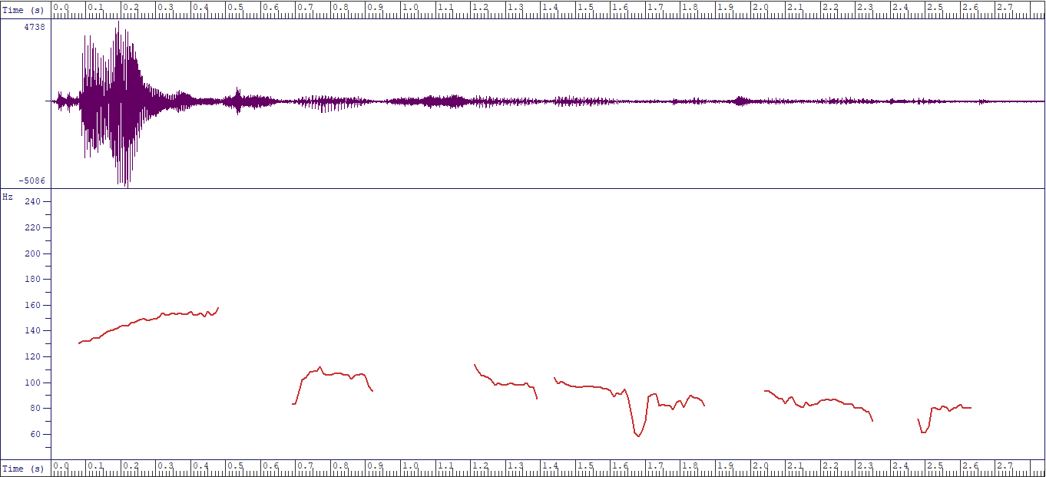
//James likes singing Juju music//
Fig. 2: Excerpt 2 showing near accurate accentuation
The test items in Excerpt 1 and Excerpt 2 are declarative sentences providing information, which by the rule of intonation tunes, are instances of “fall tune”. Excerpt 1 does not convincingly show the first tone unit “James” being accented to rise above other tone units, and to orchestrate the fall or downward glide of pitch on other tone units. Each of the tone units maintain equal modulation which does not represent a fall tune. While the pitch contour of Excerpt 1 marks departure from the rules of English intonation tune, Excerpt 2 shows near conformity. As required, the pitch rises on the accented first tone unit “James” and falls gradually onto to the last tone unit “music”.
Fig. 3: Excerpt 3 showing inappropriate accentuation
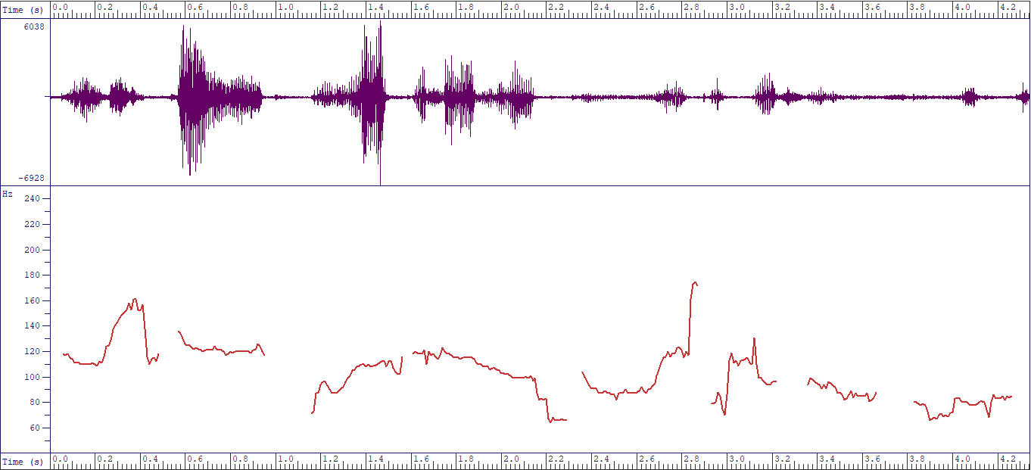
//Do you think regular work can make a person lose some weight//
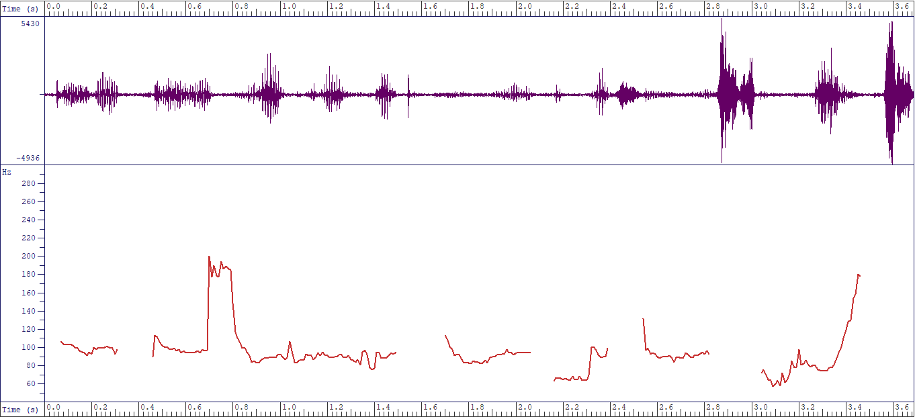
//Do you think regular work can make a person lose some weight//
Fig. 4: Excerpt 4 showing near accurate accentuation
Also, Excerpt 3 marks an instance of inappropriate accentual tune. As shown in the pitch contour, the rising of the pitch should have climaxed at the last tone unit “weight”, but on the contrary, pitch falls on it. The test item is a question that exemplifies the rise tune. However, Excerpt 4 marks contrariwise and shows appropriate accentuation of the test item. To mark an instance of rise tune, pitch contour shows modulation as pitch rises on “re”, the accented syllable in the first tone unit and climaxes at the final tone unit “weight”.

Fig. 5: Excerpt 5 showing inappropriate accentuation
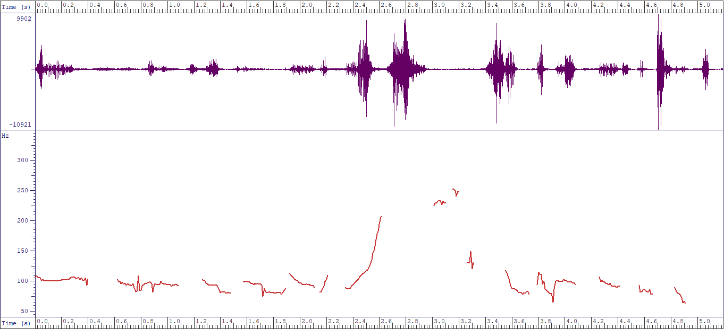
//While she volunteered to clean the house she could not finish the task//
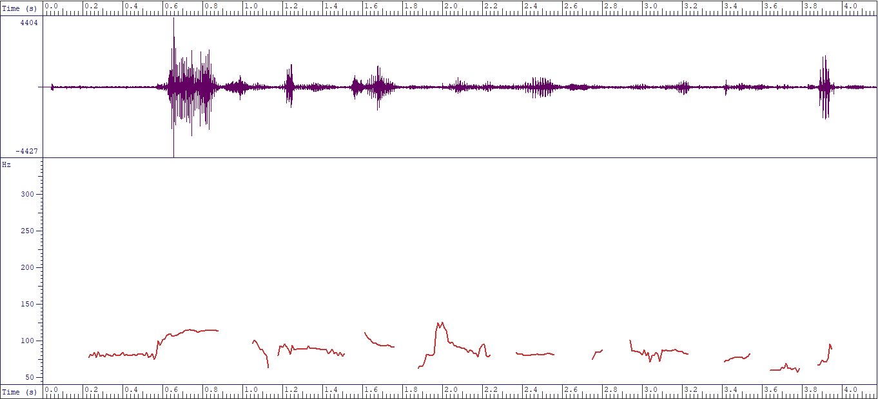
//While she volunteered to clean the house, she could not finish the task//
Fig. 6: Excerpt 6 showing near accurate accentuation
Furthermore, the test item in Excerpt 5 and Excerpt 6 is a complex sentence expected to mark the rise-fall intonation tune. While Excerpt 5 shows near accurate production, Excerpt 6 marks deviation. As captured in the pitch contour of Excerpt 6, pitch modulation does not indicate the accented word that should have triggered rise in tune. Conversely, the pitch rises on the last word in the first dependent clause “house”, and falls on the first word of the main clause “she”. Excerpt 5, although does not perfectly conform to rules of intonation, instantiates near accurate accentuation where the pitch should have risen on “vo”, the first syllable of the first tone unit. Arising from explanation offered on these spectrograms, it is evident that accentual intonation is problematic to Nigerian non-native users of English, specifically university undergraduates considered in this study.

5. Summary of Findings, Conclusion and Recommendations
Respondents’ frequency of occurrence at production level showed appropriate use of 134 (26.8%) while inappropriate use was 366 (73.2%) out of 500 expected results of accentual tunes. Production on gender basis revealed males and females' appropriate use at 67 (13.4%) each and inappropriate use was 183 (36.6%). Both males and females showed no difference in accentual tunes use at production level. On the other hand, interpretation of the accented syllables was higher for the participants. Out of 500 expected interpretation use, participants had 360 (72%) while 140 (28%) inappropriate interpretations are recorded. There seems to be an opposite performance between production performance and interpretation performance results. Though, results of respondents revealed competence in the interpretation of accentual intonation tunes (72%) but at the production level, respondents did not apply accentual tunes (26.8%) on English expressions. To corroborate the perceptual analysis, spectrograms showed pitch contours of some respondents' production. The pitch modulation expected on the focus syllable of the accented word was not applied by participant as observed from the acoustic /instrumental analysis. The implication of this is that participants seem to understand the use of prominence on the accented syllable of the focus items in the given sentences but articulating the accented syllables was problematic. It also implies that Nigerian spoken English accent differs significantly from native English and should be described as an outer circle English.
There is a significant difference in the production and interpretation of accentual intonation tunes of L2 leaners as affirmed from the results. Results also confirm that L2 acquisition in accentual intonation tunes tilts towards an excellent performance in the written interpretation of accentual tunes. However, at the production level, where respondents are expected to produce the accented syllables in English sentences given, the respondents had a very low performance (26.8%). This has some pedagogical implications on L2 acquisition. It implies that at the pedagogical level, gap exist between L2 competence on the subject matter and the reality. This implies that there is a gap between application of the classroom knowledge to actual production of this knowledge. A major observation is as a result of the fact that L2 acquisition is done in the classroom environment, what is naturally acquired in the native environment. Also, many of the L2 learners are from tone language backgrounds.
The core areas of the English prosodies of stress and intonation should be introduced to L2 leaners as early as possible. I am very much aware in some elite institutions in Nigeria currently exposes some L2 leaners to native English accents through non-enculturation sources (Akinjobi, 2013; Adesanya, 2021) such as video tapes, cable networks where native English accents are domiciled (cartoon networks) and materials from native accents in spoken English classes. This exposure should also be emulated and inculcated by government owned institutions across the educational strata. Adequate provisions should be made by institutions for efficient and effective digital language laboratory drills. Comprehension is very important in speech utterances. When communication is distorted, intelligibility problems set in. Therefore, in L2 acquisition, pedagogical target should be geared towards proper spoken English drills at the perceptual and production levels. This will eventually help to improve a spoken English that is locally, nationally and international intelligible.

References
Adejuwon, A. O. 2019. Discourse Intonation Patterns in the Non-Interrogative Utterances of Selected Educated Nigerian Speakers of English. Ghana Journal of Linguistics 8.2, 86-106.
Adesanya, A. F. 2021. Extending Frontiers of Nigerian English Vowel Reduction: The place of Technology-Based Non-Enculturation Sources of Native English. A paper presented at the 1st International Conference of Association of Phonetics and Phonologists in Nigeria. Obafemi Awolowo Universioty, Ile Ife, 3 -4th March, 2021.

Aina, M. O. 2018. Intonation tune assignment by English language teachers-in-training in selected public universities in southwestern Nigeria. PhD Thesis, University of Ibadan.

Akindele, J. A. 2020. Anacrusis and the rhythm of selected educated Edo Nigerian English speakers: Acoustic evidence. In: R. Oladipupo, J. Akindele & A. Osisanwo (eds.) Phonetics, Phonology and Sociolinguistics in the Nigerian context: A festschrift for Adenike Akinjobi. 157-170. Ibadan: Stirling Horden Publishers.
Akindele, J. A. 2018. Rhythm Ratio of Educated Edo (Nigerian) English Speakers Duration. An Acoustic Investigation. University of Uyo Journal of Humanities 22.1, 27-41.
Akindele, J. A. 2011. Variable Word Stress in Spoken Educated Edo English. M.Phil Thesis, University of Ibadan.

Akinjobi, A. A. 2013. Non-enculturation Sources of Standard Spoken English for Non-native speakers: the Nigerian Example. Lagos Review of English Studies LARES 17.2.
Akinjobi, A. A. 2012. Academic Competence and Linguistic Performance: A study of English Intonation Tune Assignment by Some Nigerian Postgraduate Students of the English Language. JNESA 15.2, 1-12.
Akinjobi, A. A. 2004. A Phonological investigation of Vowel Weakening and Unstressed Syllable Obscuration in educated Yoruba English. PhD Thesis, University of Ibadan.
Akinjobi, A. A. & Akindele, J. A. 2016. Measuring the Speech Rhythm of Educated Edo Variety of Nigerian English Speakers. Papers in English and Linguistics (PEL) 17.1, 69-81.
Akinjobi A. A. & Oladipupo, O. R. 2005. Patterns of intonation of some Nigerian television reporters. Ibadan Journal of European Studies 5: 1-16.
Akinjobi, A. A. & Oladipupo, O. R. 2010. Intonation and attitude in Nigerian English. LWATI: A Journal of Contemporary Research 7.1, 159-167.
Asadu, E. U., Okoro, F. O. & Kadiri, G. C. 2019. Analysis of Intonation Patterns of Selected Nigerian Bilingual Educated Speakers of English. English Language Teaching 12.6, 45-54.
Atoye, R.O. 1991. Word-Stress in Nigerian English. World Englishes 10.1, 1-6.
Awonusi, S. 2004. The Function of Nigerian English in relation to other Nigerian Languages. In: S. Awonusi & A.B.K Dadzie (eds.) Nigerian English Influences and Characteristics. 67-81. Lagos: Concept Publication Ltd.
Banjo, A. 1979. Towards a standard Nigerian spoken English. Abidjan: Actes du 8 congress de society linguistique de Africa Occidentials.
Cruttenden, A. 1986. Intonation. 2nd Ed. Cambridge: Cambridge University Press.
Crystal, D. 1980. A First Dictionary of Linguistics and Phonetics. Boulder, CO: Westview.
Folarin, O. O. 2015. Analysis of the Accentual Function of English Intonation amongst University Undergraduates. Undergraduate Thesis, Osun State University.
Jibril, M. 1982. Phonological variation in Nigerian English. PhD Thesis, University of Lancaster.
Odeyemi, J. O. 2017. Context and Discourse Intonation in English-Medium Product Advertisements in Nigeria's Broadcast Media. I-manager’s Journal on English Language Teaching 7.2, 13-28.
Okon, B. 2001. The Intonational structure of Nigerian English. PhD Thesis, University of Ibadan.
Oladipupo, R. 2008. The English intonation patterns of selected reporters on television stations in Lagos State Nigeria. Master’s Thesis, University of Ibadan.
Olusola, D. N. 2019. English intonation patterns in Nigeria national assembly plenary sessions. Master’s Thesis, Obafemi Awolowo University.
Pike, K. L. 1972. Phonetics: A Critical Analysis of Phonetic Theory and a Technic for the Practical Description of Sounds. Ann Arbor: University of Michigan Press.
Pike, K. L. 1945. The intonation of American English. University of Michigan Publications in Linguistics, 1. Ann Arbor: University of Michigan Press.
Sunday, A. 2008. Compound Stress in Educated Yoruba English. In: R. Atoye (ed.) Papers in English and Linguistics (PEL). 78-93. Ile-Ife: Obafemi Awolowo University Press.
Utulu, D. C. 2014. A phonetic analysis of Educated Urhobo English segmentals. PhD Thesis, University of Ibadan.
Udofot, I. 2003. Stress and rhythm in the Nigerian accent of English: A preliminary investigation. English World-Wide 24.2, 201-220.
Wells, J. 2006. English Intonation: An Introduction. Cambridge: Cambridge University Press.
Appendix
I thank you very much for voluntarily participating in this data gathering exercise. Please feel free to respond. These questions are purely for research and responses will be anonymised.
SECTION A- Please fill in the blank spaces or mark (X) where necessary.
- Nick Name………………………………………………………………………………
- Name of Institution ………………………………………………...........................................................
- Department……………………………………………………………. Level…………………………………………………
- Sex…………………………..
- Tribe………………………… Indigenous Language(s) Spoken ……………………………………………………
- Did you at any time study abroad? Y N
- If yes, where?............................. At what level?.......................... Course of Study………………………….
- Have you ever been introduced to the subject of English Intonation?
- If yes, at what level of your education?...........................................................................
- Have you ever attended any training school, workshop or conference meant to develop your knowledge of English Intonation? Y N
Section B: Please produce the sentences below into the recorded speech device, paying particular attention to the appropriate syllable of the accented words.
- ↓James likes singing JUJU music.
(a. James LIKES singing Juju music
(b. JAMES likes singing JUJU music
(c. James likes singing Juju MUSIC
(d. James likes SINGing Juju

- I will ↓celebrate Amina, if she makes a first class degree.
      - I will CELEBRATE Amina, if she makes a first class
      - I will celebrate AMINA, if she makes a first class.
      - I will if she makes a FIRST Class
      - . I will celebrate Amina if she MAKES a first Class

- …. While she volunteered ↓ to clean the house, she could not complete the task before dinner.
      - …. while she VOLUNTERRED to clean the house, she could not complete the task before dinner
      - …. while she volunteered to clean the HOUSE, she could not complete the task before dinner
      - …. while she volunteered to clean the house, she could not complete the task before DINNER
- Is there going↓ to be an in ↓crease in fuel pump in October?
      - Is there going to be an increase ↓ in fuel pumps in October?
      - Is there going to be an increase in FUEL pump in October?
      - Is there going to be an inCREASE in Fuel pump in October
- Nigeria is a muti-ethnic nation, isn’t it?
(a. ↓NIGERIA is a muti-ethnic nation, isn’t it
(b. Nigeria is a MULTI-ethnic nation↓↓ isn’t it
(c. Nigeria is a muti-ethnic NATION, isn’t it?

- I wish to become a↓ renowned professor in future.
(a. I wish to become a renowned professor in FUTURE
(b. I wish to become a REKNOWNED professor in future
(c. I wish to become a renowned PROFESSOR in future

- Is she ↓wearing a black shirt? I mean John
      - Is she WEARing a black shirt? I mean John?
      - Is she wearing a BLACK shirt? I mean John
      - Is she wearing a black shirt? I mean JOHN

- ↓Intonation can be problematic for non-native speakers of English
(a. Intonation can be PROBLEMatic for non-native speakers of English
(b. INTONAtion can be problematic for non-native speakers of English
(c. Intonation can be problematic for Non-native speakers of English
(d. Intonation can be problematic for Non-native speakers of ENGLISH

- Regular ex↓ercise keeps the body fits
      - Regular exercises keep the body FITS.
      - Regular EXercises keep the body fits.
      - REgular exercises keep the body FITS.
- Do you think ↓regular walk cam make a person loose some weights?
      - Do you think regular walk cam make a person loose some weights?
      - Do you think REgular walk cam make a person loose some weights?
      - Do you think regular WALK cam make a person loose some weights?
      - Do you think regular walk cam make a person loose some WEIGHTS?

