STORIES ON CORRUPTION: AN ANALYSIS OF SELECTED MEMES IN THE GHANAIAN MEDIA

Abstract
This study analyses an alternative portrayal of corruption stories in the Ghanaian media in the wake of growing concerns about rising corruption in Ghana’s political space. Using memes in 3.com’s Facebook page of TV3 News, a popular online news outlet in Ghana, the study discusses representations of corruption through memes, the role of memes, impact of humour, and how memes are employed in the Ghanaian media to fight against corruption. From a rhetoric perspective and using a qualitative content analytical approach, the study indicates how the Ghanaian media’s use of memes illustrates an alternate way of presenting and accessing important journalistic messages. The study shows how the use of memes in corruption narratives opens the public sphere to deliberative discourse on the subject. The analysis reveals memes as important contributors to the anti-corruption fight through representations communicated in visual rhetoric terms. This is achieved through the portrayal of corruption as disgusting, together with a call on religiosity, effective leadership, and collective action against the canker to engender social change. The study recommends that aside searching for, discovering, and reporting corruption stories, such information must be publicised in an accessible manner within a democratic society.
Keywords: Memes, Corruption Stories, Ghanaian Media, Anti-corruption Fight,
Rhetorical Analysis
Introduction
Over the decades, the media’s mediating role in democratic societies has been acknowledged globally by scholars, lawmakers, civil society groups, and religious organizations, among others. This is because of their unique place in the power structure of society, where they function as “watchdogs”, the fourth estate (Srivastava and Sharma, 2016), as sources of critical public information for education, entertainment, and socialization (Singh and Nitty, 2017). The media employ various avenues to fulfil these roles: news reportage, reports of investigative journalism, documentaries, panel discussions, and editorials. Through these functions, the media create and shape the opinion of the public and set agenda for public discussions, consensus building and participation in socio-political affairs.
In Ghana, the media have burgeoned with the deregulation of the media industry, particularly from the 2000s. This has resulted in tremendous developments in the media regarding public and private ownership, diversity and pluralism of programming and content, and different language media. Provisions of Chapter 12 of the 1992 Constitution has guaranteed massive freedom of expression in the media and political spaces, which have encouraged journalists in Ghana to adopt innovative means to present news stories to audiences. Some of these techniques include panel discussions of topical matters on radio and TV and the stylistic use of local languages (Ansah, n.d.; Fosu & Akpojivi, 2015), the use of cartoons (Rockson, 2012), and so on.
This study concerns the use of memes in the Ghanaian media as a strategy to negotiate public access to and participation in critical political issues such as corruption. There is no doubt that corruption is a pertinent issue that requires scholarly attention in Ghana and other developing countries. In fact, since Ghana attained independence in 1957, corruption has been one of the most prominent matters of national interest, receiving massive media and public attention because of its impact on good governance and national development.
Memes, from the word mimic, is a coined word by Richard Dawkins in his book, The Selfish Gene (1976). The word came from the Greek, ‘mime’, meaning ‘that which is replicated or imitated. As Davison (2009) explains, memes are easy-to-understand messages that are created from real-life issues and attractively presented and spread as digital entertainment pieces. They are employed as satirical elements to humorously address social, political, and economic issues (Laineste and Voolaid, 2017). Memes may occur in the media to excite people for them to imbibe, especially, grave, or sensitive issues in a light-hearted manner. In Ghana, the growing trend of meme production in the media and the significant role memes could play in fighting corruption are areas that require research attention yet have been largely under researched. Also, the focus on humour as a central element of memetic discourse has been understudied in relation to developing countries. Given these gaps, this study investigates the role of memes in the fight against corruption in Ghana and how the element of humour impacts the message of such memes. Specific questions the study seeks to explore are:
- What representations do political memes express in the Ghanaian media?
- What corruption-related roles could memes imply in Ghanaian media?
- How does the element of humour impact the meaning of memes about corruption in Ghana?
From a perspective of rhetoric, the analysis should shed some light on how media’s use of memes could illustrate an alternate means of creating, presenting and accessing important journalistic content (from mainstream media processes) to enhance a deliberative and democratic atmosphere around crucial national matters. It is argued that it is not enough to search for and discover corruption; it is more important to publicize such information in an accessible manner to help in fighting the canker.
Corruption and politics in Ghana
It is difficult to define corruption in specific terms. For the purposes of this study, we use corruption to imply not just bribery, dishonesty, and fraud in public and private spaces, but also defer to Sardan’s (1999) that corruption involves social activities including “nepotism, abuse of power, embezzlement and various forms of misappropriation, influence-peddling, prevarication, insider trading and abuse of the public purse” (cited in Ronning, 2009, p.156). It is incontrovertible that corruption is a global phenomenon (Cumbreras, 2019); Ronning, 2009; Werlin, 1973); yet, for obvious reasons, the occurrence is grievous in developing countries, whether it involves large scale corrupt practices by elites or petty corruption in any stratum of society. Scholars acknowledge the occurrence of corruption, especially political corruption, in Africa with dire consequences on development (Ronning, 2009, Le Vine, 1975; Werlin, 1973).
In Ghana, corruption remains a topical issue. In fact, all the coup d’états that have occurred in Ghana since 1966, whether successful or not, have touted corruption among the ruling and business elites as one of the main causal reasons. Thus, the belief that the Ghanaian society is replete with corrupt practices has been there since independence (Rahman, 2018; Le Vine, 1975; Werlin, 1973). It is widely believed in Ghana that most politicians enter public or political office to amass wealth for themselves, their family, and cronies through corrupt means. Even the venerated and nostalgic era of Kwame Nkrumah, Ghana’s first President from 1957 to 1966, was not spared of corrupt practices in political circles (Werlin, 1973). According to Le Vine (1975), the country witnessed some commissions of inquiry and other investigations on corrupt cases during those glorified early post-independence times.
The belief that corruption continues to thrive in Ghana keeps increasing by the day. In recent times, Ghanaian investigative journalists such as Manasseh Azure Awuni, (the current editor of the Fourth Estate, a publication of the Media Foundation for West Africa (MFWA)); Anas Aremeyaw Anas, with the New Crusading Guide; Seth Kwame Boateng, of the Multimedia Group; and others have produced some serious disclosures on corruption in the country. Anas Aremeyaw Anas provoked public interest about corruption in high places in Ghana’s judiciary in 2016, the Ghana Football Association in 2018, some Ponzi schemes and other political and social corruption in recent times. According to Rahman (2018), Ghana ranked disturbingly high among highly corrupt countries in the world. The author identifies political corruption, and other corrupt practices in businesses, the bureaucratic structure, the judiciary, the police, among others, in Ghana. And, scholars have indicated the impact of corruption, usually negative, on the socio-political fortunes of the country (Rahman, 2018; Ronning, 2009; Le Vine, 1975; Werlin. 1973).
Many of the known corrupt cases in the country usually find expression in media narratives, thanks to the high level of freedom of expression and the presence of many anti-corruption agents in the country. Without a free press at the time of Nkrumah, the corrupt stories found outlets in literary works such as Ayi Kwei Armah’s Beautyful Ones Are Not Yet Born (1968), Fragments (1970), and other works by other artists. In contemporary times, various media outlets have used strategies such as drama, memes and so on to simplify, ridicule, and generate public discussions on corruption revelations. This is expected to bring such detestable acts to public attention in a popular and hilarious manner. Thus, the application of memes in capturing and representing corrupt cases could provide an innovative alternative to the straight news reportage on the occurrence.
Memetic internet media and humour
Internet or social media memes have been described as cultural expressions that are often formulated as jokes or criticism about social happenings and become relevant through exchanges on the Internet (Deus et al., 2022; Davison, 2009). The use of memes in the news media contributes to enhance citizens’ participation in news production and consumption as people could create and share memes through new media platforms to narrate social events in creative ways. To Wiggins and Bowers (2015), internet memes are artefacts of participatory digital culture. Thus, by their very nature, memetic media could engender and advance discourse on socio-economic and political issues and contribute to deepening the democratic culture of nations (Mina, 2019). Memes may be used to simplify and “tell the news” (Börzsei, 2013) and to project the views of newsmakers on issues that are gaining or have gained public traction.
Internet memes permeate cultural spaces and carry connotations and judgements including commercial and political values (Lombard, 2014) that provide an avenue for people to express their beliefs (Husted, 2012). In the political arena memes may be used as a tool for creating a good image for politicians and/or their parties, shaping public opinions as well as promoting their political ideas whilst slandering their opponents (Christian et al, 2011). In the political landscape, memes have been explored in the form of tweets, funny gifs from political discussions and popular news, and they have a great impact on political discourse and public opinion (Leskovec et al, 2009). They have also become a tool for mobilizing political movements and expressions of political dissent (Mina, 2014) such as the fix-the-country movement in Ghana. People adopt, use and spread political memes as a way of expressing their individual political preferences (Bennett, 2014), with the memes serving as a site for political deliberations and action (Hristova, 2014).
Internet memes are said to play social functions in society (Laineste & Voolaid, 2017). They are very prevalent and tackle relevant and universal issues from problems of gender inequality, scandals, political and economic issues to mundane details from daily life. Mina (2014) asserts that social change memes express sentiments or feelings for changing a social or political issue. The writer noted that such memes, which come in diverse forms, provide avenues for individual and community expressions that directly affect people’s lives. However, while some memes are universal, others are more culturally specific, reflecting the beliefs and behaviour of specific groups (Knobel & Lankshear, 2007).
Humour is a natural and universal phenomenon associated with and exhibited by almost all cultures (Sen, 2012). Many studies associate humour with viral memes (Shifman, 2012; Knobel and Lankshear, 2007). As posited by Burgess (2008), a factor that influences an internet meme’s ability to go viral is its ‘inside jokes’. It uses words, images or actions to produce laughter or deliver entertainment to audiences (Ritchie, 2004). However, what constitutes humour, what conditions determine it, the acceptability or otherwise of a particular humour text depends on specific socio-cultural contexts, beliefs and practices of a people (Sen, 2012).
Researchers such as Rakib (2019) have provided detailed discussions of types and functions of humour. Knobel & Lankshear (2007) offer two types of humorous memes that have immediate relevance to this study: ‘quirky and situational’ humour. These reflect bizarre translations and ‘biting social commentaries’, respectively, to satirically address different political and social issues. Concerning functions, Kuipers (2008) offers three functions of humour that are germane: relief, control, and cohesion. Humour provides relief to audiences through the entertainment and laughter generated in texts. Concerning humour as a means of control, Stephenson (1951) observed that such jokes make fun of wrongdoings, thereby compelling people to be ethical and respect good social values. That way, humour becomes socially corrective since laughing at a behaviour identifies it as abnormal. And humour may induce social cohesion when it creates solidarity for people to collectively share in some fun (Kuipers, 2008, p.370).
Ghanaians have been noted to have a good sense of humour (Philips-Kumagah, et al., 2022), which is dramatised or expressed in every conceivable way and opportunity. People – musicians, footballers, and other prominent figures -- take advantage of humour to draw media attention to themselves, their work and others for publicity. The media themselves, especially the indigenous media, are known to depend on humour to carry their messages across in news presentation through exaggerations, the use of proverbs, among others (Fosu & Akpojivi, 2015). As Philips-Kumagah, et al. (2022, p.136) note, “Even grievances in a society like political corruption tend to be laughed away” in outlets such as cartoons and memes.
Theoretical Framework
Two categories of theories unite to underpin this study because of their explanatory and analytical adequacy to guide the analysis: theory of Visual Rhetoric (Foss, 2005) and theories of humour (Sen, 2012; Cooper, 2008; Kuipers, 2008). Foss (2005) related visual rhetoric to visual imagery (symbols and signs) as communication tools, focusing on features and purposes of communication artefacts that may apply to human act, process, and behaviour, or artefacts that may build, sustain or change attention, perceptions and behaviours. The study of visual rhetoric has broadened in its application given the prevalence of visual images in contemporary culture. Foss (2005) explains that before a visual image can pass for visual rhetoric, it must be symbolic, involve human intervention and must be presented to an audience for the purpose of communication and exchange. Involvement of human intervention means that the image is consciously created or generated by humans to communicate certain ideas to a real or ideal audience.
Of the many theories of humour (see Rakib, 2019; Cooper, 2008; Kuipers, 2008), three commonly referenced ones are adopted to underpin this study’s analysis: the relief, superiority, and incongruity theories (Sen, 2008; Shifman 2012; Cooper, 2008). The relief theory is about humour helping people to get relief from the tensions of life’s desires and fears (Cooper, 2008). According to Sen (2012), this theory explains a defence mechanism among humans used to overcome reality and protect themselves against emotional outcomes of adverse real-life happenings. The superiority theory, according to Cooper (2008), is a manifestation of a feeling of superiority people feel over others they laugh at or over their former bad situations. Sen (2012, p.2) explains further that a humorous utterance or image can signal a person mocking another person to feel inferior. Finally, the incongruity theory of humour focuses on the object at the centre of the humour (Cooper, 2008; Shifman, 2012). It means for something to be humorous, it must contain or display some incongruity, which may be the difference between what is expected and what the case is (Sen, 2012).
Methodology
Scholars acknowledge methodological challenges with the analysis of humour (Rakib, 2019; Sen, 2012) and memes (Al-Rawi et al., 2021; Deus et al, 2022). However, these scholars have proposed the use of qualitative approaches for such studies. And researchers such as Gbadegesin (2019) and Al-Rawi et al. (2021) have used qualitative methods to investigate humour-induced social media memes. Following from Davison’s (2009, p.2) description of memes ‘as being situated within the context of humour,’ this study occurred within a qualitative research approach, specifically employing qualitative content analysis (Elo & Kyngas, 2008). According to Wimmer and Dominick (2011), content analysis can be used to describe communication content. The study adopted an inductively focused descriptive approach (Elo & Kyngas, 2008) supported by detailed illustrations from the data. Ten memes were purposively sampled from many other memes on 3.com’s Facebook page of TV3 News, a station noted for uniquely generating and publishing memes on national issues on its social media site. The selection was based on the requirement that they reflected corruption stories published between 2016 and 2021, a period that witnessed many corruption allegations in Ghana. The 10 selected memes provided adequate data for the analysis such that including more memes would have led to data saturation (Guest et al., 2006) since all the political memes came with almost similar characteristics.
The content analysis used the category system to classify the media content in terms of the independent stories or messages they reflected. Following Coulson (2013), the content of each meme was coded and described or explained to enhance the understanding of contextual and multilayered meanings of the text. Inductive coding followed the emergent coding system (Wimmer & Dominick, 2011), which established the category of analysis from the data. Thereafter, the memes were rhetorically analysed based on factors which identify the elements of the memes as (1) corruption related (its ability to inform about corruption, its representations: anti-, pro- or passive-corruption, its ability to ridicule, shame or shun corruption and its ability to expose corruption) (2) based on its elements of humour (its ability to incite laughter, the level of pictorial exaggeration, its impact on meaning-making, and its humour functions).

Data Analysis and Discussion
The subsequent lines present an in-depth analysis of each of the ten sampled memes of the study. Many studies on memes and/or humour (Deus et al., 2022; Al-Rawi et al., 2021; Rakib, 2019) have been broad-based requiring many memes (of over 200) for inductive coding and thematic analysis (Braun & Clark, 2006). However, since this current study is narrowly focused on corruption memes for which reason 10 were sampled, the analysis systematically focused on each individual meme. As Sen (2012, p.2) has proposed, ‘humour may be ‘analysed either separately or within a thick description of the context.’ Thus, each sample is described, analysed and interpreted based on the physical features, the story or message behind the meme, and how it answers the research questions. This approach enabled a vivid and focused contextual description of each meme for a better appreciation of the message and its hilarious import.
To better appreciate the analysis, it is important to understand the unique political and cultural context of the study. Ghana is a developing country with severe socio-economic and fiscal management challenges. As such, the occurrence of corruption in the country is of immense concern Ghanaians and the nation’s development partners. Consequently, people expect the governments and other duty bearers not only to put mechanisms in place to prevent corruption, but also to shun it themselves. A popular saying by ex-President, Mr. John Kufuor, at his swearing into office as President of Ghana in 2001 that, “There will be zero tolerance for corruption’, continues to excite attention in Ghana’s public sphere. In fact, many institutions and legal regimes have been established over the years to fight corruption: the 1992 Constitution; Right to Information Act, 2019 (ACT 989); Serious Fraud Office (SFO) (now Economic and Organised Crime Office (EOCO); Attorney General’s Office; Special Prosecutor (SP); among others. These offices and public officers are expected to demonstrate a strong aversion to corruption not just in words but also in deeds by not being corrupt; establishing, empowering, and encouraging anti-corruption agencies and individuals; actively prosecuting corrupt public officers irrespective of their affiliations, and so on. Anything short of these amount to a potential incongruity or situational irony worth laughing at, as depicted in the subsequent analyses.
Meme 1 (M1)
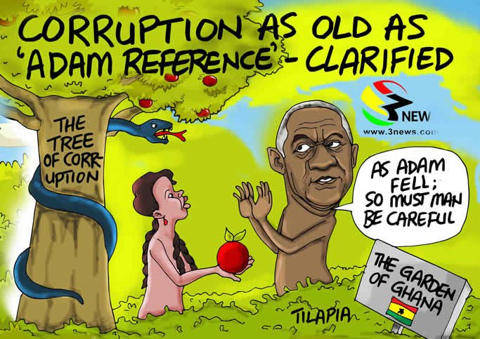
Description of the meme
M1 uses a biblical allusion of the original fall of man to recreate the tempting nature of corruption in Ghana. The main title – CORRUPTION AS OLD AS ‘ADAM REFERENCE’ – CLARIFIED; the identifiable character, ex-President of Ghana, John Kufuor; the signpost, reading THE GARDEN OF GHANA, all indicate the Ghanaian context of the meme. The ex-president once made the pronouncement captured in the heading, which sparked controversy with some people saying he supported corruption. In the story, Ex-president Kufuor is seen admonishing that people should strive to avoid corruption and not fall for it no matter how tempting it is.
As an anti-corruption media text
M1 in its metaphorical biblical allusion carries a message about corruption in Ghana. However, unlike Adam in the Bible story, the former president rejected the ‘forbidden fruit’. This is an indication that the message in the meme is shunning corruption. It creates the idea that Ghanaian leaders and duty bearers should and must play an active role in curbing corruption by taking a stance to reject it despite how aged or enticing (reference to the woman) corruption has become. This is in line with Mina’s (2014) position on memes as a tool for social change because the meme seeks to campaign in support of the eradication of corruption in the country. Thus, M1 is an anti-corruption media text. It presents an ideology that corruption is undesirable, and like the “forbidden fruit”, it symbolises the root of all the troubles and miseries of life and must be avoided.

Humour and its impact on the message
Various characteristics of the meme make it hilarious. The subjects are caricatured and exaggerated. The ex-president is represented as a tree like the tree of corruption. The ridiculous colours of the man, woman and snake make the meme funny. The way the man faces away from the woman with his eyes stealing a sideways glance her show the efforts he is making to avoid falling for the ‘apple’. The meme reflects a finding that Ghanaians use high profile national figures to address serious national issues in a humorous manner (Philips-Kumaga et al., 2020). Thus, the humour in this story brings relief through the amusement as theorised by Cooper (2008) and Kuipers, 2008) and teaches a moral lesson about being strong to avoid corruption (Addo, 2013).

Meme 2 (M2)
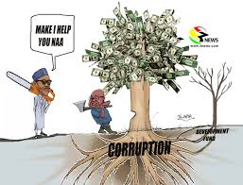
Description of the meme
This meme portrays the current presidents of Ghana and Nigeria trying ostensibly to eliminate corruption in Ghana. The two characters are identified by their unique physical description and manner of speaking. The Ghanaian President, Nana Akufo Addo, is typically short, while the Nigerian President, Muhammadu Buhari, is lanky and saying ‘NAA’ typical of Nigerians when they speak. Corruption is represented as a tree and the two characters have tree-cutting implements, an axe and a chainsaw, for the exercise. The Ghanaian President is chopping down the tree, while his Nigerian counterpart wants to assist.
As an anti-corruption text
The meme can be classified as an anti-corruption text. Firstly, it shows the effect of corruption (the blossoming money tree) on life symbolised in the withered plant with the tag “SEVEREMENT IVAS”. Though the word “severement” is ungrammatical, it could be said to be derived from two words: severe and sever. Severe could mean something that is “intense”, implying that the withered tree is showing the severity of corruption, so its links with the corruption tress must be severed. It also implies that when the corruption is not attended to early, it can cause the riches of a nation to be diminished as the withered tree in the meme. Thus, there is a need to eliminate the blossoming tree of corruption before things deteriorate. Secondly, the meme campaigns for a collective effort of committed leaders in Africa to fight against the canker. “Make I help you NAA” shows that individually, the fight against corruption could be arduous but it could be easier with support and collaboration among countries through their leaders. But while M2 shows some efforts in eliminating corruption, it shows subtly and humorously that the leaders’ action would not end corruption since they are not attacking the stem of the tree and not its roots or the root cause of the canker. Thus, the effort is just cosmetic since the tree (corruption) would sprout again if the roots are not destroyed.
Humour and its impact on the message
Humour is expressed in the exaggerated caricaturing of the two leaders since mocking prominent political figures in this manner induce fun in Ghana. The idea that their actions are temporary measures that could not completely eradicate the canker invokes the superiority theory of humour (Cooper, 2008; Shifman, 2012) since the audience could feel they could do better in the circumstances. It shows that the leaders either lack an understanding of how to really deal with corruption or the want to impress through rhetoric that they are fighting the canker.
Meme 3 (M3)
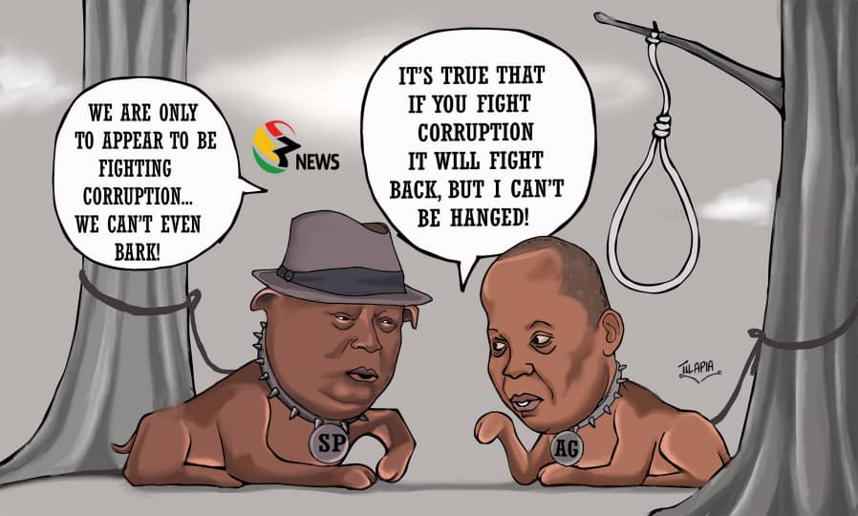
Description of the meme
M3 is a representation of two Ghanaian public officials who are past heads of key anti-corruption institutions in Ghana. Mr. Martin Amidu (in a hat) once headed the Office of the Special Prosecutor, while Mr. Daniel Domelovo was a past Auditor General of Ghana’s Audit Service. Their exit from public service sparked controversy that the Government was uninterested in its anti-corruption position and activities, a point the characters express in the meme. The meme portrays the two officials as leashed dogs who are controlled and not free to act when they were in office.
As an anti-corruption text
M3 criticises the “hollow” fight against corruption in Ghana. According to the meme, the two principal agents of state mandated to lead the fight against corruption and who appear committed to the job are not being supported by the Government to do so. Rather, and ironically, the Government is controlling and not giving them the free hand to act. The representation of these agents as dogs is very apt: dogs are supposed to protect people and their property, and they do so by being wild and attacking intruders and thieves. However, these dogs are far from being that, and they express despair thus: “We are only to appear to be fighting corruption...we can’t even bark”. This hopelessness regarding the fight against corruption is symbolised in the understanding that if these two principal actors are unable to fight corruption, then the fight against corruption is a sham, if not a scam. The story, thus, seeks to draw public attention for actions against corruption and government ineptitude. This position agrees with Wiggins and Bowers’ (2015) idea that internet memes are artefacts of participatory digital culture.
Humour and its impact on the message
Humour is clearly discernible in the symbolic representation of the two anti-corruption agents as dogs because of the huge anti-corruption profile of the two persons and the public discourses about them. Basically, the depiction seeks to heighten the expression of “toothless bulldogs”; dogs that are powerless to the extent that they cannot even bark. Their powerlessness is well captured by the leash that is holding their neck. The presence of a hanged rope in the meme humorously demonstrates the intimidation these persons suffered on the job. Thus, defying the boundaries set by the leash could get them hanged or sacked, impliedly. The expression: “It’s true that if you fight corruption, it will fight back, but I can’t be hanged!”, a prophetic statement by the then Auditor General that generated public discussion, exudes humorous sympathy and hopelessness about corruption in Ghana. The humour here functions as a social control mechanism for people to shun corrupt practices (Stephenson, 1951) and satisfies theories of relief (through laughter) and incongruity (Shifman, 2012; Cooper, 2008).

Meme 4 (M4)
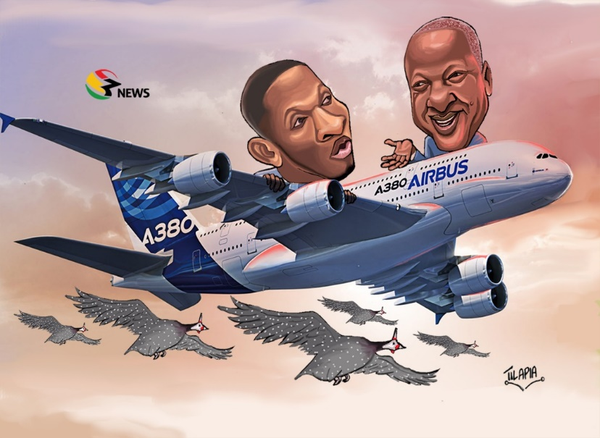
Description of the meme
This meme recreates some supposedly corrupt happenings when the current major opposition party, the National Democratic Congress (NDC), was the ruling Government in Ghana. It shows the then President (now former President), Mr. John Dramani Mahama and Mr. Samuel Gyamfi, the current Communications Director of NDC, flying an aeroplane named “AIRBUS A380” alongside a host of Guinea fowls. Both Airbus A380 and the Guinea fowls have been a subject of public discussion on corruption under the former NDC Government. It was alleged that the then Government spent more funds than needed to purchase the aeroplane. And after the Government had spent a huge amount of money to procure guinea fowls for rearing, the birds could not be accounted for with the speculation that they had flown back to Burkina Faso, where they were purchased.
As an anti-corruption text
The act of naming and shaming public officials who undermine their integrity is characteristic of the Ghanaian media. M4 simplifies a collection of alleged corrupt cases and political scandals under the NDC government. It relates to the simplification of news function of memes, (Börzsei, 2013), and the social function of memes as asserted by Laineste & Voolaid’s (2017). The anti-corruption sentiment of this meme is that it seeks to simplify the allegations of corrupt cases of the NDC Government for public attention to trigger public opinion on the matter. As viewers gain an understanding of the issues, they could better participate in the public discussion in ridiculing corrupt actions and people and in putting an end to possible corrupt cases in the current New Patriotic Party (NPP) Government.
Humour and its impact on the message
The pictorial elements in M4 qualify it as a satire, which ridicules corruption and its perpetrators. The representation of the Guinea fowls in the clouds flying about the same height of the aeroplane is an exaggeration because Guinea fowls may not be seen flying alongside an aeroplane, thereby achieving some humour, especially if one has in mind the history of the guinea fowl and airbus projects in Ghana. Thus, the projection of the guinea fowls to be flying alongside AIRBUS A380 is only an addition to the flying mysteries of the nation. The humour in this meme enhances the understanding of the general issue being projected and functions to brings relief, social control and solidarity through laughter (Kuipers, 2008; Cooper, 2008).
Sample 5 (M5)
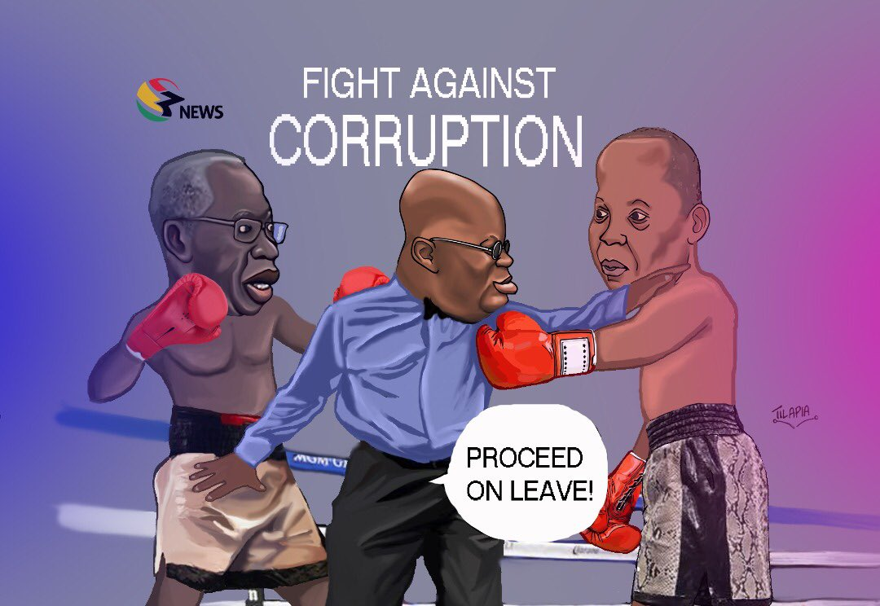
Description of the meme
M5 captures a corruption story that appears to be a sequel to M3. It comes in the form of a boxing fight involving some key agents who are supposed to work together in the fight against corruption in Ghana. By their physical features, it is realised the fight is between Mr. Yaw Osafo Marfo, Senior Minister and a prominent person in Ghana’s current Economic Management Team and Mr. Daniel Domelevo, the then Auditor General of Ghana. Interestingly, the referee is the current President of Ghana, Nana Akufo Addo, who appears to be favouring Mr. Osafo Marfo. The background of the meme is that the Auditor General had found the Mr. Osafo Marfo culpable in some alleged procurement malfeasance resulting in the Senior Minister taking the Auditor General to court. Not long after that the Auditor General was compelled by the Government to leave his office. These happenings seem to give some credence to a popular saying by the Auditor General that ‘if you fight corruption, corruption will fight back.
As an anti-corruption text
The meme seeks to analogize the fight against corruption with a boxing match. The meaning this meme seeks to create is that just as a referee of a boxing match cannot disqualify a boxer unless for some irregularities committed in the ring (BBBC, Rule 3.38 and 3.38. 1), so is the case in the fight against corruption. This meme captures a growing resentment in the Ghanaian community, following the directive from the Office of the President instructing Mr. Daniel Domelevo, the Auditor General to proceed on leave for 128 days. This directive was interpreted by some Ghanaians as an act to shield Mr. Yaw Osafo Marfo who was alleged to have been involved in some corrupt procurement deals, and with the Auditor General out of office, Mr. Yaw Osafo Marfo will be cleared of no wrongdoing. Against this background, the anti-corruption sentiment that the meme seeks to communicate is the idea of unfairness on the part of the biased referee, who symbolically shows reluctance in the fight against corruption in Ghana. This is clearly shown by the facial expression ascribed to the President as he appears to have frowned at Mr. Domelevo. As an anti-corruption message, it calls for Ghanaians to resist attempts by the powers that be to undermine the fight against the canker.
Humour and its impact on the message
Humour is strongly expressed in the conceptualization of the corrupt situation as a boxing match. The symbolic representation of the subjects as boxers with a bias referee represented as the President of the country identify the work as a successful satire. This is because it succeeds in ridiculing the characters and campaigns for probity in the fight against corruption. The humour here stems from situational irony where the very person who should champion the fight against corruption is the one making it easy for the canker to thrive. The impact of the humour on the message is that it simplifies the issue and makes it more understandable to the audience.

Meme 6 M6)
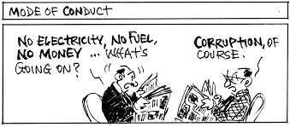
Description of the meme
In this meme, the negative consequence of corruption in the country is explained. Two characters who are reading newspapers are engaged in a conversation. The first character complains about the lack of basic utilities such as electricity, fuel, money, and so on, and wondered what’s happening. The second character immediately cites corruption as the cause in a way that suggests that this is common knowledge. The caption, “MODE OF CONDUCT”, suggests that the social problems of the day, caused by corruption, have now become entrenched or normal.
As an anti-corruption intervention
This meme presents an analogy or idea of the impacts of corruption on a country. It projects a link between corruption and the socio-economic challenges faced by ordinary citizens in the country. Specifically, corruption accounts for the poverty of the citizens and the lack of amenities like electricity. The ellipses shows that there are more problems created by corruption than can be listed and that this is obvious, something everybody must know. As an anti-corruption campaign, the meme calls for definite actions against corruption beyond the routine complaints about it. It can be concluded that the meme is informative and produces an anti-corruption effect as it highlights the negative results of corruption on a country, suggesting that something be done to end it.
Humour and its impact on the message
The humour draws on situational irony, where someone knows about something and still asks with genuine seriousness, “What is happening?” Thus, M6 may not be very obviously humorous perhaps because the message the meme seeks to communicate is very serious. The consequences of corruption in a developing society like Ghana is so serious that the meme creator might not want to be too comical to detract from the seriousness of the matter.
Sample 7:
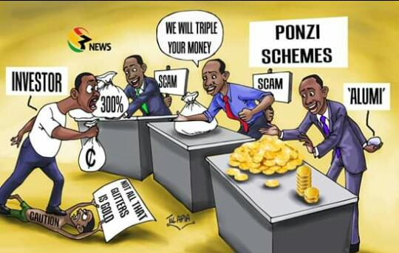

Description of the meme
This meme presents supposed corruption occurring because of political ineptitude. Ghana has, in recent times, witnessed many so-called financial firms offering ridiculous returns to potential investors, with the political system seemingly unconcerned. The firms succeeded in getting people to invest with them only to disappoint and dupe them later. Government and political institutions mandated to prevent such as occurrence watched for the fraud to happen, leading Government to spent huge sums of money to bailout such customers. M7 presents the situation of an “INVESTOR” being lured to invest in such firms. The investor’s dilemma is whether to invest with a gold dealer, a money doubler who promises to tipple the investment, or in a firm that promises “300%” interest on the investor’s money. All three traders have a third hand behind them which shows their fraudulent nature.
As an anti-corruption campaigner
As corruption is defined as an action committed by both the giver and receiver, so is the case with investors and traders of Ponzi schemes. The message the meme seeks to communicate is that customers who lose their investments with these schemes are major players or contributors in their misfortune as they defy all cautions to invest with duplicitous businesses and schemes. And as such, even though there are indicators that those trades are Ponzi schemes, their greedy eyes fall for those schemes, and they invest with them. Thus, as an anti-corruption campaign, the meme seeks to provide information that investors may not be privy to. Thus, the meme uses the third hand of the traders in the meme to show investors what they may not know and will never be told by the PONZI SCHEME traders. The essence is to educate investors to be cautious and find out more about organizations promising ridiculously unrealistic profits on investments as seen in the caution: “NOT ALL THAT GLITTERS IS GOLD.”
Humour and its impact on the message
The humour intended by the meme is depicted when the investor is seen trampling over CAUTION, rejecting information that “NOT ALL THAT GLITTERS IS GOLD” and showing eagerness to invest in an obvious PONZI SCHEME. His widely opened eyes and mouth, alongside his big stomach portrays him hilariously as a greedy person. Thus, the impact of the humour is to mark the degree of carelessness of many people who fall into the trap of Ponzi schemes.
Meme 8 (M8)
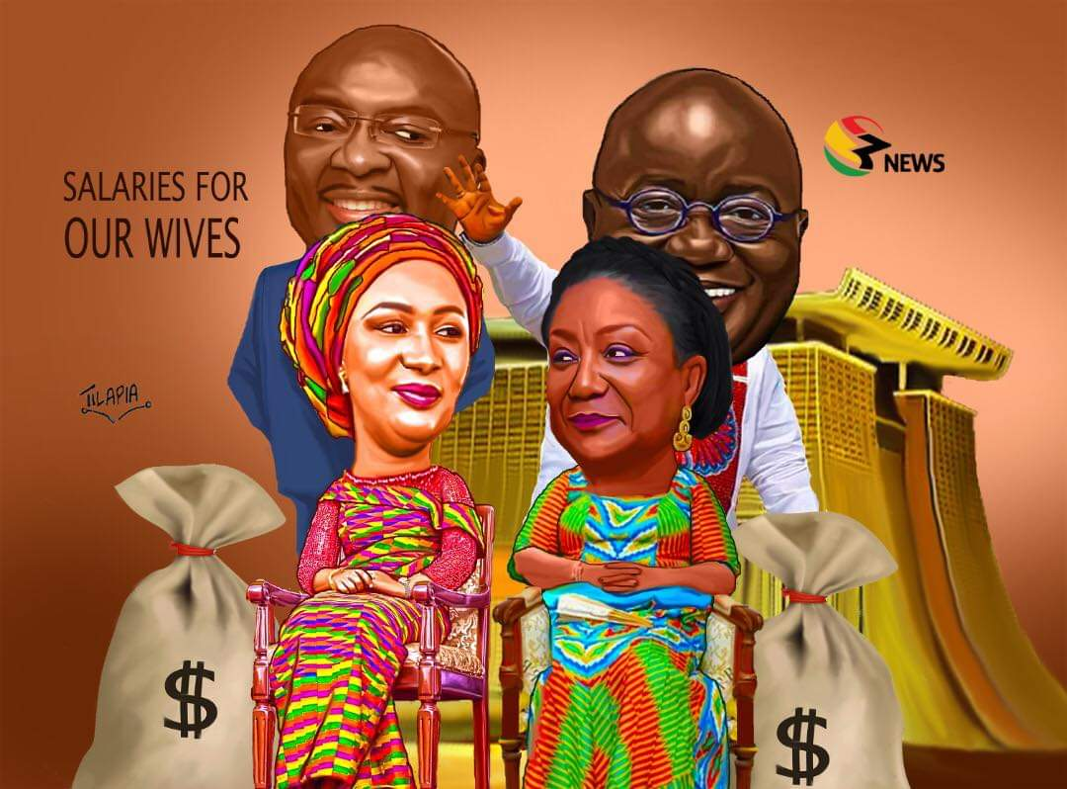

Description of the meme
M8 concerns a recent proposal by the NPP government to pay salaries to the wives of the president and the vice president of the country. This caused massive controversy and discussions in Ghana’s public spaces because until then, whether the ‘first’ and ‘second’ ladies were handed some payments because of their positions as wives of the president and vice had not come up for discussion. The meme presents the current president and his vice, Dr Mahamudu Bawumia, happily blessing the idea of the payment. The money, already paid in bags, sits beside the smiling nicely dressed wives sitting in state, with the Jubilee House silhouetted behind them.
As an anti-corruption media text
The meme is an anti-corruption portrayal. It tries to question the propriety of paying salaries to people for no work done. There is no officially recognised job for the wives of the President and Vice President, so, paying monthly to the wives from the national coffers could amount to not protecting the public purse, cardinal function the President had pledged to honour. This is particularly because the matter came up at a time the country was reeling under severe financial difficulties. The proposal to pay the ladies seems to reinforce the popular belief that the Jubilee House, the seat of Government, is the epicentre of corruption. Therefore, M8 is to rouse public disaffection for citizens to oppose the Government concerning the issue.

Humour and its impact on the message
The characters in the meme are easily identifiable, all of them humorously wearing knowing smiles in the face of the seemingly unpopular national reception of the salary idea. The meme seems to provide an answer to the question: “pay salaries to them for what?” The hilarious suggested answer is they are to be paid for dressing gorgeously and sitting in public. Following the incongruity and superiority theories of humour (Sen, 2012; Cooper, 2008), M8 shows the incongruity between the expectations of the Ghanaians regarding the judicious use of the country’s resources and the meme portrayal, where the characters presented as insensitive, greedy, and wasteful. Functionally, M8 creates humour that brings solidarity as people share in the fun and incites social uprightness regarding the abnormal behaviours so portrayed (Kuipers, 2008; Stephenson, 1951).

Sample 9:
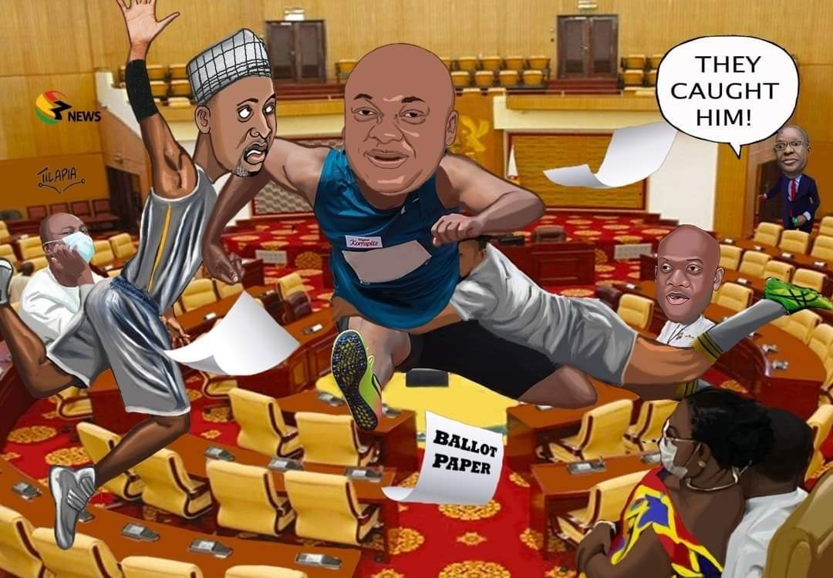

Description of the meme
This meme vividly describes a recent happening in Ghana’s Parliament during voting to determine if the 2nd Deputy Speaker as acting Speaker could have the right to vote on issues under discussion in Parliament. A member of parliament identified by his physical appearance as Mr. Carlos Ahenkorah of the NPP, was reported to have snatched and was escaping with a ballot paper but was chased and caught by some NDC MPs, one of whom is identified physically as Mr. Muntaka Mubarak. This meme dramatically captures the scene of fraud and corruption (cheating in elections) even in parliament.
As an anti-corruption media text
M9 elevates fraud and corruption in Ghana’s Parliament House for public ridicule making the meme an anti-corruption one since the idea is to stop such occurrences. Parliament, one of the three arms of government, houses democratically elected Members of Parliament (MPs) who represent constituencies. The MPs are lawmakers for which reason Parliament House is supposed to be a serious place for serious business, and the MPS, respectable and law abiding. Thus, the fraud involving an attempt to cheat or derail parliamentary business signifies corruption in the whole country. Mina (2014) has argued that memes could be a tool for social change. Thus, M9 seeks to campaign against such unparliamentary behaviour to eradicate fraud in the country.
Humour and its impact on the message
Characteristic of memes, the subjects, some of whom are identifiable because of some aspects of their physical description, are humorously caricatured. Presenting the protagonists of the story as athletes with Mr. Ahenkorah inflight as he runs and an NDC MP grabbing his mid-section with Mr. Muntaka crossing his path leaves no doubt about the humour of the text. Humour is also produced in the ironic situation where those who make laws to control society are the very people openly flouting the law. As a house with members representing the whole of Ghana, the meme implies the chaos and fraud in the whole country. While amusing and hilarious, the humour draws attention to the ironic situation and the lowered dignity of the parliamentarians as explained by the superiority and incongruity theories of humour (Sen, 2012) and calls for social and behavioural change (Kuipers, 2008).

Sample 10:
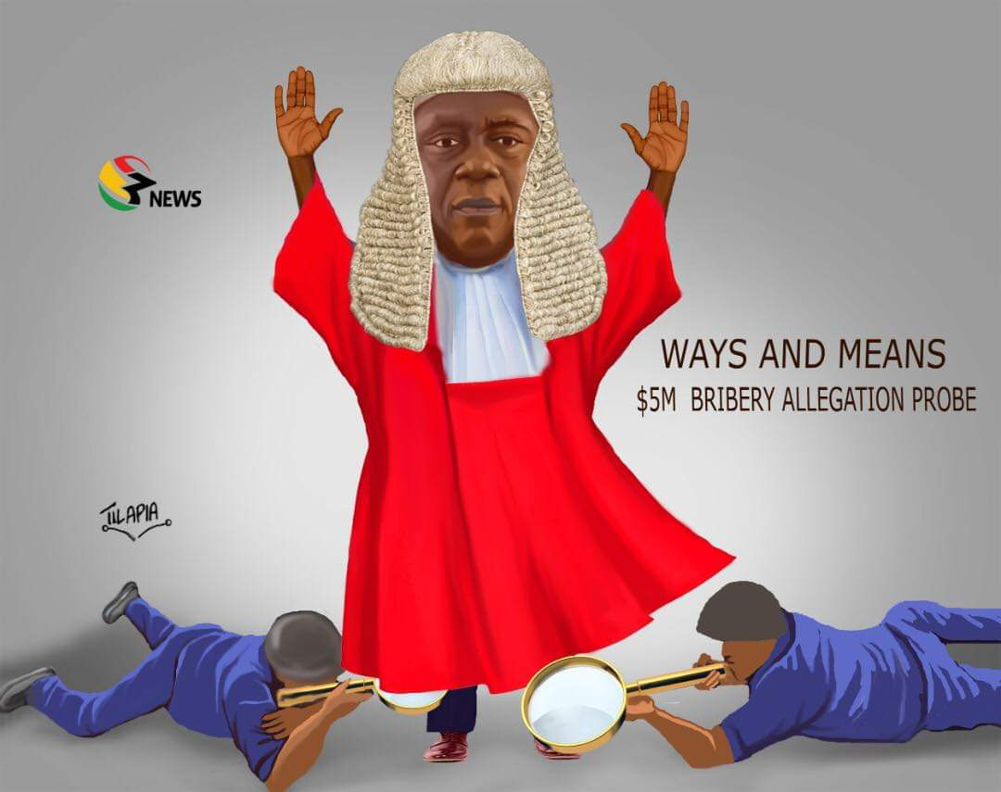
Description of the meme
The meme is about a recent allegation of bribery and corruption involving the Chief Justice of Ghana, Justice Kwasi Anin-Yeboah, who is captured in the red in the meme. He was said to have accepted a 5-million-dollar bribe to influence him in a case before the Supreme Court. There were calls for him to be investigated, but that did not happen. M10 presents the Chief Justice undergoing a body search for the said amount by persons using magnifying glasses.
As an anti-corruption media text
M10 advocates investigations of duty bearers whenever allegations of corruption are made against them. Issues of bribery and corruption in the judiciary are crucial because of its role in safeguarding the adherence to the laws of the country. While it was alleged in public spaces that the Chief Justice of Ghana had collected a 5-million-dollar bribe to influence a case before the Supreme Court, no investigation was carried out despite calls for it by some civil society groups. Thus, this meme is an anti-corruption story since it is a campaign for serious investigations by accredited agencies into corruption matters. The raised arms of the Chief Justice suggest that he is ready and would not obstruct scrutiny. As an inti-corruption meme, the story calls on persons on whom allegations of corruption are made to readily avail themselves for scrutiny.
Humour and its impact on the message
Ghana’s Chief Justice is presented in an unusual but picturesque red robe reaching to his toes. Humour is also strongly suggested in the manner of the search: The investigators are seen with what appears to be magnifying glass searching from below the long robes of the Chief Justice. That way, they would not miss the money wherever it is hidden. It means investigating agencies should do everything possible to find the truth in their investigation of corruption cases. The humour in this meme has the potential to bring social cohesion through solidarity, bringing audiences together to share fun (Kuipers, 2008).
Summary analysis and findings
The above analysis presents some noteworthy significance regarding access, meme characterisation, and types and functions of humour. The force of memes resides in their ability to be reproduced and shared virtually. Online analytics indicate that there were about 10, 500 likes, 2000 comments and 2,200 sharing of the memes of this study across other social media platforms. The pages did not display number of views, but it could be surmised that there could be a lot more people just viewing the memes. Going by the finding that internet penetration in Ghana is 48% (Worldometre, 2020), these data could indicate a modest access to the meme stories with the potential for more people to have access as internet penetration increases.
It is also noticed that most of the meme characters are prominent people in Ghana: former presidents (M1, M4); current President (M2, M5, M8); current Vice President (M8); Current First and Second Ladies (M8); Senior Minister (M5); Chief Justice (M10), Former Auditor General (M3, M5); Special Prosecutor (M3); Parliamentarians (M9). These constitute about 80% of the meme characters, emphasising the expectation that leaders and duty bearers of the land should be in the forefront in the fight against corruption as indicated by Mina (2014). Yet the memes show them as either condoning corruption or failing to act in ways that would enhance the fight. The few ordinary people that appear on the memes (M6, M7) are presented as helpless victims of corruption. The data thus presents a grim spectre of a losing fight against corruption.
Concerning humour, the characters and issues are presented in exaggerated ways that accentuate the hilarious nature of the memes as indicated by scholars. For in M1, ex-president Kufour is presented as a shapeless tress with a funny big head and eyes and gestures suggesting conflicting desires and emotions. M3 presents the former Auditor General and Special Prosecutor as harmless tethered dogs. While M9 present parliamentarians as playful sports people in Parliament House. Overall, the memes reflect the relief, incongruity, and superiority theories the humour. And in terms of function, the humour acts as social corrective making audiences mock and laugh at the predominantly prominent political elites who should feel ashamed and change for the better.

Conclusion
This study has demonstrated that memes could play a significant role in fighting social vices such as corruption. As an anti-corruption intervention text, the corruption memes have been shown to be purposely circulated on various social media platforms for propaganda purposes. The memes employ techniques such as the elements of disgusts, religious analogies, call to action elements, and humour in the physical and symbolic representation of the implied characters to dramatise the issue of corruption. As political corruption is a civil and moral crime against humanity, the memes focus on people in political authority, hilariously expose their complicity in the crime and through that contribute to making corruption unpopular in the society. The study therefore generally agrees with Mina (2014) concerning the social change function of memes and the enhancement of a participatory culture as held by Wiggins and Bowers (2015). As media texts, the memes demonstrate alternate watchdog functions intended, and with the potential, to hold political power accountable.
The research has also established the centrality of humour in the general meaning-making of meme messages as observed by Knobel and Lankshear (2007) and Shifman’s (2013). This study has affirmed the use of humour in memes to serve purpose such as clarifying the news, entertainment, enacting social change, among others. As these findings do not conclude knowledge on the topic of mimetic discourse, further studies could conduct a quantitative or mixed-method study into the impact of memes beyond politics on other social, political, and economic issues in Ghana.

References
Addo, A. A. (2013). Ananse as a Folkloric Character in New Ghanaian Drama. Unpublished thesis. University of Ghana
Al-Rawi, A., Siddiqia, M., Lia, X., Vandanb, N. & Grepinb, K. (2021). A thematic analysis of Instagram's Gendered Memes on COVID-19. Journal of Visual Communication in Medicine. 44(4), pp.1-44.
Armah, A. K. (1968). The Beautyful Ones are not yet Born. Berkshire: Cox & Wyman Ltd.
Armah, A. K. (1970). Fragments. Berkshire: Cox & Wyman Ltd.
[no date]. Lexical creativity and national development: The case of Akan talk radio in Ghana. Lancaster University, UK. Available from: https://www.academia.edu/6115182/LEXICAL_CREATIVITY_AND_NATIONAL_DEVELOPMENT_THE_CASE_OF_AKAN_TALK_RADIO_IN_GHANA
Bennett, E. (2014). Social media as a tool for improving research and teaching. Frontiers in Ecology and the Environment, 12(5): 259.
Bennett, W. L., & Segerberg, A. . (2013). Journal of Information, Communication and Society. The logic of connective action: Digital media and the personalization of contentious politics, 15(5):1-30.
Börzsei, L. . (2013). Makes a Meme Instead: A Concise History of internet Memes. New Media Studies Magazine 7.

Braun, V. & Clarke, V. (2006). Using thematic analysis in psychology. Qualitative Research in
Psychology, 3(2), 77-101.https://doi.org/10.1191/1478088706qp063oa
Burgess, J. (2008). All your chocolate rain are belong to us? Viral video, YouTube and the dynamics of participatory culture. In Video Vortex Reader: Responses to YouTube. Amsterdam, Netherlands: Institute of Network Cultures.
Chrisian, S. M., Garza, A. S. , & Slaughter, E. J. (2011). Work engagement: A quantitative review and test of its relations with task and contextual performance. University of North Carolina, Chapel Hill: Organizational Behaviour Department.
Cooper, C. (2008). Elucidating the bonds of workplace humor: A relational process model. Human relations. 61, pp.1087-1115.
Coulson, N. S. . (2013). How do online patient support communities affect the experience on inflammatory bowel disease? An online survey. JRSM Short Reports, 4(8).
Culler, J. (2002). The pursuit of signs: semiotics, literature, deconstruction. Cornell University Press.
Cumbreras, M. C. (2019). The effects of consumption of corruption-related news on political cynicism. Communication & Society. 32(4), 47-62.
Davison, P. (2009). The language of internet memes. In The social media Reader. M. Mandiberg
(Ed.), (pp. 120-134). New York: NYU Press.
Dawkins, R. , & Marshmallow, L. F. (2013). Just for Hits. (Dawkins, R. , Performer) Cannes Grand
Auditorium , Cannes , France .
Dawkins, R. (1976). The Selfish Gene. Oxford: Oxford University Press.
Deus, E. P., Campos, R. D., & Rocha, A. R. (2022). Memes as shortcut to consumer culture: A methodological approach to covert collective ideologies. Revista de Administração Contemporânea, 26(4), e210005. https://doi.org/10.1590/1982-7849rac2022210005.en
Elo, S & Kyngas, H. (2008). The qualitative content analysis process. Journal of Advanced nursing. 62(1), 107-115.
Fosu, M. and Akpojivi, U. (2015). Media convergence practices and production in Ghana and
Nigeria: Implications for democracy and research in Africa. Journal of Applied Journalism & Media Studies. 4(2): 277-292
Foss, K. S. . (2005). Theory of visual rhetoric. Handbook of Visual Communication: Theory,Methods and Media, 141-152.
Gal, N. (2018). Internet memes. In B. Warf (Ed.), The SAGE Encyclopedia of the internet (pp.
529–530). Thousand Oaks, CA: Sage Publications, Inc. doi:10.4135/9781473960367.n151
Gbadegesin, V.O. (2019). Gender ideology and identity in humorous social media memes. Digital
Scholarship in the Humanities, 35, pp.529–546, doi:10.1093/llc/fqz039

Guest, G., Bunce, A. & Johhnson, L. (2006). How many interviews are enough? An experiement with data saturation and variability. Field methods. 18(1), 59-82.
Hristova, S. . (2014). Visual memes as neutralizers of political dissent. Communication, Capitalism and Critique. Access Journal for a Global Sustainable Information Society, 265-276.
Husted, U. (2012). A Funny Thing Happened On the Way from the Forum: The Life and Death of Internet Memes. University of Minnesota Digital Conservancy.
Iloh, C. (2021). Do it for the Culture: The case of Memes in Qualitative Research. International Journal of Qualitative Methods. 20, pp. 1-10.
Knobel, M. , & Lankshear, C. (2007). Online memes, affinities, and cultural production. A New Literacies Sampler., 199-227.
Kobierecki, M. (2014). Internet memes as an example of political dissatisfaction of polls on the internet. Political Science Quarterly of the Centre for Political Analysis of the University of Warsaw, 243-269.
Kuipers, G. (2008). The sociology of humour: In the primer of humor research. Raskin, V. (ed) New York: De Gruyter Mouton, pp.361-398.
Laineste, L., & Voolaid, P. (2017). Laughing across borders: Intertextuality of internet memes. The European Journal of Humour Research, 26-49.
Leskovec, J., Backstrom, L., & Kleinberg, J. (2009). Meme-tracking and the dynamics of the news cycle. Association for Computing Machinery, 497-506.
Le Vine, V. (1975). Corruption in Ghana: The search for causes. Transitions. 47. Indiana
University Press, pp 48-61.
Lombard, J. K. . (2013). Art crimes: The governance of hip hop graffiti. Journal for Cultural Research, 255-278.
Mayring, P. (2014). Qualitative content analysis: Theoretical foundation, basic procedures and software solutions. Klaqgenfurt, Austria. Available from: https://www.psychopen.eu/fileadmin/user_upload/books/mayring/ssoar-2014-mayring-Qualitative_content_analysis_theoretical_foundation.pdf
Mina, A. X. . (2014). Batman, pandaman and the blind man: A case study in social change memes and internet censorship in China. Journal of Visual Culture, 359-375.
Mina, A. X. (2019). From Memes to Movements. Boston: Beacon Press.
Philips-Kumaga, L., Hansen-Garshong, R., Ackom, C. K., Teku, C., Osei-Tutu, A. (2022).
“Kwatakwata by June diεε…”: Internet humour used during the first phase of the COVID-19 pandemic by social media users in Ghana. The European journal of humour research. 10(1), 134-148. Available from: https://doi.org/10.7592/EJHR2022.10.1.600
Quayson, K. (2018). Humour in Highlife Song Texts: A Double-edged Sword? Unpublished
Thesis. Central University College. Ghana

Rahman, K. (2018). Overview of Corruption and Anti-corruption in Ghana. U4 Helpdesk
2018:21. Available from: overview-of-corruption-and-anti-corruption-in-ghana-2018.pdf
Rakib, M. I. H. (2019). Name A More Iconic Duo, I’ll Wait: Exploring the Role of Humour in
Bangladeshi Internet Meme Culture. Unpublished MA Thesis. Mount Saint Vincent University.
Ritchie, G. (2004). The linguistic analysis of jokes. London: Routledge.
Rockson, K. (2012). Akosua Cartoon in the Daily Graphic: A discourse Analysis. Journal of
Communication, Media & Society. 2(1), 48-76.
Ronning, H. (2009). The politics of corruption and the media in Africa. Journal of Africam media studies. 1(1). Intellect Ltd., 155-171.
Sen, A. (2012). Humour analysis and qualitative research. Social research update. Issue 63. University of Surrey. Available from: https://sru.soc.surrey.ac.uk/SRU63.pdf
Shifman, L. . (2012). An anatomy of a YouTube meme. New Media and Society, 187-203.
Shifman, L. . (2013). Memes in Digital Culture. Cambridge: MIT Press.
Singh, G. & Nitty. (2017). Role and impact of the media on society: A sociological approach with respect to demonetization. International Journal of Research in Humanities, Arts and Litterature, 5, 127-136.
Srivastava, M. K & Sharma, G. (2016). Research paper on media responsibility in national development. International Journal of Information Science and Computing, 3(1), 9-19.
Werlin, H. H. (1973). The Consequences of Corruption: The Ghanaian Experience. Political Science Quarterly. Academy of Political Science. 88(1), 71-85.
Wiggens, B. E., & Bowers, G. B. . (2015). Memes as genre: a structural analysis of the memescape. Delhi: Sage Publications.
Wimmer, R.D. , & Dominick, J.R. . (2011). Mass media research: An introduction. Belmount CA: Wadsworth.
British Boxing Board of Control (2020). Rules of boxing. Retrieved from http://bbbofc.com/content/rules-boxing-0

This is a 2021 social media driven pressure movement of predominant the youth in Ghana agitating for the government to “fix the country’s problems.”
Permission was duly sought orally from the original creator of the means, Tilapia for the use of the memes in this research, which was granted.
See https://m.facebook.com/TilapiaCartoons/?ti=as

