STORIES ON CORRUPTION: AN ANALYSIS OF SELECTED MEMES IN THE GHANAIAN MEDIA

Abstract
This study analyses an alternative portrayal of corruption stories in the Ghanaian media in the wake of growing concerns about rising corruption in Ghana’s political space. Using memes in 3.com’s Facebook page of TV3 News, a popular online news outlet in Ghana, the study discusses representations of corruption through memes, the role of memes, impact of humour, and how memes are employed in the Ghanaian media to fight against corruption. From a rhetoric perspective and using a qualitative content analytical approach, the study indicates how the Ghanaian media’s use of memes illustrates an alternate way of presenting and accessing important journalistic messages. That way, the study shows how the use of memes in corruption narratives opens the public sphere to deliberative discourse on the subject. The analysis reveals memes as important contributors to the anti-corruption fight through representations communicated in visual rhetoric terms. This is achieved through the portrayal of corruption as disgusting, together with a call on religiosity, effective leadership, and collective action against the canker to engender social change. Importantly, the study recommends that it is not enough to search for, discover and report corruption; it is also pertinent to publicize such information in an accessible manner within a democratic society.
Keywords: Memes, Corruption Stories, Ghanaian Media, Anti-corruption Fight,
Rhetorical Perspective
Introduction
Over the decades, the mediating role of the media has been acknowledged globally by scholars, lawmakers, civil society groups, religious organizations, among others, based on their unique place in the power structure of society. Scholars and institutions of state have ascribed roles such as “watchdogs”, the fourth estate (Srivastava and Sharma, 2016), entertainment, education, socialization and information (Singh and Nitty, 2017) to the media because of their critical role as information providers to society. They employ numerous strategies in fulfilling these roles, which may involve news reportage, reports of investigative journalism, documentaries, panel discussions, and editorials. Through these means, the media are able to create and shape the opinion of the public and set agenda in public spaces for discussions, consensus building and participation in socio-political affairs.
The Ghanaian media have burgeoned with the deregulation of the media industry, particularly from 2000s. Being largely state controlled by 1992, the media landscape thereafter has seen tremendous developments regarding public and private ownership, diversity and pluralism of programming and content, and different language media, the consequences of the 1992 Constitution of Ghana’s granting of media liberalisation. Obviously, the Ghanaian media also fulfil the roles and strategies specified in the previous paragraph in relation to executing their roles and work. With a political environment that largely tolerates free expression, journalists in Ghana appear to have felt at ease to adopt innovative means to present news and information to audiences. Importantly. Some media houses have been known to employ memes as a media tool in presenting critical issues of state such as corruption, sanitation, education, traditional rites, among others (Rockson, 2012).
Memes, from the word mimic, is a coined word by Richard Dawkins in his book, The Selfish Gene (1976). The word came from the Greek word, ‘mime’, meaning ‘that which is replicated or imitated. Memes are employed as satirical elements to address social, political, and economic issues of the nation through humour (Laineste and Voolaid, 2017).
The role of memes in the media, especially electronic and news media, is multipurpose (Dawkins and Marshmallow, 2013). The usage enhances participatory culture as more people could create and share memes through the new media platforms in narrating social events in creative ways. With this, Wiggins and Bowers (2015) define internet memes as artefacts of participatory digital culture. Their definition is based on three elements: Firstly, memes possess virtual physicality and are produced, used and reproduced. Secondly, memes play a social and cultural role in the new media landscape, offering information about the creation, usage and behaviour of its producers. Lastly, memes are purposefully produced and consumed.
The afore discussion demonstrates that memetic media could engender and advance discourse on social-economic and political issues in society. People could make merry with memes through the various media platforms for ecstatic and thrilling purposes, and through that imbibe the issue at stake in a light-hearted manner, especially when the issues are grave or sensitive. Thus, in Ghana, the growing trend of meme production in the media and the significant role memes play in fighting corruption in Ghana is an area that requires research attention; yet has received little of that. Also, the focus on humour as a central element of memetic discourse has not been studied in relation to the general meaning a meme seeks to communicate. Given these gaps, the present study seeks to focus on the role of memes in the media, how memes are employed in the fight against corruption in Ghana, and how the element of humour impacts the message of the meme. To achieve this, the study seeks to address the following research questions:
- What representations do memes express in the Ghanaian media?
- What corruption-related roles could memes imply in Ghanaian media?
- How does the element of humour impact the meaning of memes about corruption in Ghana?
From a rhetoric perspective, the analysis should shed some light on how media use of memes illustrates an alternate way of presenting and accessing important journalistic content. This should enhance a deliberative and democratic atmosphere around the subject in the country. It is argued that it is not enough to search for and discover corruption; it is more important to publicize such information in an accessible manner to help solve the problem.
Corruption and Memetic Media in Ghana
It is difficult to define corruption in specific terms. For the purposes of this study, we use corruption to imply not just bribery, dishonesty, and fraud in public and private spaces, but also defer to Sardan’s (1999) perspective of the concept, as cited by Ronning (2009, p. 156) as social activities including “nepotism, abuse of power, embezzlement and various forms of misappropriation, influence-peddling, prevarication, insider trading and abuse of the public purse.” It is incontrovertible that corruption is a global phenomenon (Cumbreras, 2019); Ronning, 2009; Werlin, 1973); yet, for obvious reasons, the occurrence is grievous in developing countries, whether it involves large scale corrupt practices by elites or petty corruption in any stratum of society. Scholars acknowledge the occurrence of corruption, especially political corruption, in Africa with its dire consequences on development (Ronning, 2009, Le Vine, 1975; Werlin, 1973), a perspective adopted in this current study.
Indeed, one of the critical issues that have received media attention and exposure since the birth of the country is corruption. In fact, all the coup d’états that have occurred in Ghana since 1966, whether successful or not, have touted corruption as one of the main reasons for the action. Thus, the belief that the Ghanaian society is replete with corrupt practices has been there since independence (Rahman, 2018; Le Vine, 1975; Werlin, 1973), and the country has witnessed some commission of inquiries on corrupt cases (Le Vine, 1975). Even the venerated and nostalgic period of Kwame Nkrumah, Ghana’s first President from 1957 to 1966, was not spared of corrupt practices (Werlin, 1973).
The belief that corruption continues to thrive in Ghana is on ascendency by the day. In recent times, the investigative journalist, Anas Aremeyaw Anas, has provoked public interest about corruption in high places in his revelation of Judicial scandals in Ghana in 2016, the corruption scandal of the Ghana Football Association in 2018, the Ponzi schemes, political and other social situations in recent times. According to Rahman (2018) Ghana ranked disturbingly high among highly corrupt countries in the world. At the time of writing this paper, Ghana’s Health Minister is being probed for an alleged corrupt procurement of COVID-19 vaccines. Rahman (2018) identifies political corruption, and other corrupt practices in businesses, the bureaucratic structure, the judiciary, the police, among others in Ghana. And, scholars have indicated the impact of corruption, usually negative, on the socio-political fortunes of the country (Rahman, 2018; Ronning, 2009; Le Vine, 1975; Werlin. 1973).
Many of the known corrupt cases in the country usually find expression in the media, thanks to the continuously high level of freedom of expression as well as the presence of many anti-corruption agents in the country. Without a free press at the time of Nkrumah, the corrupt cases found outlets in literary works such as Ayi Kwei Armah’s Beautyful Ones Are Not Yet Born (1968), Fragments (1970), and others by other artists. In contemporary times, various media outlets have used strategies such as drama, memes and so on to simplify, ridicule, and generate public discussions on corruption revelations. This is expected to bring such detestable acts to all, especially ordinary people in a more popular and hilarious manner. Thus, the application of memes in capturing and representing corrupt cases provides an innovative diversity to the straight media reports on the occurrence.
The application of memes in the media has essence in deepening the democracy of nations. Mina (2019) asserts in her book “From Movements to Meme” that:
In a democracy where the majority of people use the Internet, we should expect to see more memetic discourse on serious issues, as the artefacts of Internet culture spill over from social networking platforms and into our physical world and newscasts.
As a tool of the media, memes are used to simplify the news for the audience and to project the views of the newsmakers on issues that are gaining or have gained public attention. Hence, memes are used to “tell the news” (Börzsei, 2013). Despite the simplification of news role of memes in the media, it is not all memes or their elements that are understood by their target audience. This is because of their complex multi-layered structure (Coulson, 2013).
Major research identify humour as a key element of most memes. In a study conducted by Knobel and Lankshear (2007), it was discovered that humour was a central component of most viral memes. Among the nineteen (19) memes used in their study, seventeen (17) of them were found to be mostly satirical with elements of ‘biting social commentary’ humour. Shifman’s study in 2012 also revealed that analysis of memetic videos proved that humour continues to be a vital element of internet memes and enhances virality. As posited by Burgess (2008), one factor that influences an internet meme’s ability to go viral is if it carries ‘inside jokes’. Humorous memes can be classified into ‘quirky and situational’ humour which can be in the form of bizarre translations, and ‘biting social commentary’ where humour is used to address different political and satirical issues (Knobel & Lankshear, 2007). Shifman (2012) also classifies humour into three attributes: playfulness (where major characters in the meme are humorous in nature), incongruity (comic is derived from two incongruent elements like a pun or irony), and superiority (a situation whereby characters in the meme are unintentionally funny).
Memes permeate cultural spaces and have commercial and political values. Internet memes carry connotations, judgements, and values (Lombard, 2014). With the emergence of the internet, memes have also become a tool for meaning making and an avenue for people to exercise and express their religious and other beliefs (Husted, 2012). Advertising and public relations agencies adopt memes as a tool for publicity and marketing of goods and services. Also, politicians use memes as a tool for creating a good image for themselves, shaping public opinions as well as promoting political ideas of themselves whilst slandering their opponents (Christian et al, 2011). In the political landscape, memes have been explored in the form of tweets, funny gifs from political discussions and popular news, and they have a great impact on political discourse and public opinion (Leskovec et al, 2009). They have also become a tool for mobilizing political movements and expressions of political dissent (Mina, 2014) such as the fix-the-country movement in Ghana. The popularity of such movements today stems from their communicative techniques of combining both mass media and social media (Bennett & Segerberg, 2013). People adopt or use political memes and spread it as a way of expressing their individual political preferences (Bennett, 2014), and these memes serve as an act of common ground or a reference point for political deliberations and actions (Hristova, 2014).
Laineste & Voolaid (2017) posit the social functions played by memes in societies. Internet memes are very prevalent, and they tackle relevant and universal issues from problems of gender inequality, scandals, political and economic issues to mundane details from daily life. In the same vein, Mina (2014) asserts social change memes as those memes that express a sentiment or feeling for changing a social or political issue and they tackle issues like environmental pollution. She notes that social change memes which come in diverse forms provide avenues for individual and community expression of issues that affect their lives directly. She proffers that social change memes are powerful, and they exert control over broadcast and internet media. She adds that “they (memes) provide a visual rupture in hegemonic state media and messaging by using the language of participatory creative media” (Mina, 2014, pp. 362). However, while some memes are universal, others are more culturally specific, reflecting the beliefs and behaviour of specific groups (Knobel & Lankshear, 2007).
Theoretical Framework
This study is underpinned by the theory of Visual Rhetoric (Foss, 2005) due to its explanatory and analytical adequacy in relation to the subject under discussion and its specific analytical focus. Foss (2005) related visual rhetoric to visual imagery (symbols and signs) as communication tools, which focus on features and purposes of communication artefacts that may apply to human act, process, and behaviour, or artefact that may build, sustain or change attention, perceptions and behaviours. The theory also encapsulates symbols in all human domains including mathematics, music, dance, painting and architectural styles employed by humans as a strategic tool for influencing people’s thinking and behaviour. The study of visual rhetoric has broadened in its application given the prevalence of visual images in contemporary culture such as advertisements, television, film, fashion, and others. These visual forms may be classified based on their functions, whether for aesthetic purposes like paintings or utilitarian purposes like advertisements (Foss, 2005).
Foss (2005) explains that before a visual image can pass for visual rhetoric, it must be symbolic, involve human intervention and must be presented to an audience for the purpose of communicating to them. Symbolism as a factor deals with the ability of the visual image to stand for and connect to another object or its inference. Involvement of human intervention means that the image is consciously created or generated by humans like a painting or a sculpture, the intended purpose being to communicate. Finally, the image must be structured to go beyond being just a device for self-expression but communicate to an audience not necessarily always external to the creator, either real or ideal.
The theory applies to this study because it validates the memes as visual rhetoric since they are symbolic, are purposely generated to communicate certain ideologies, and are targeted to specific audiences. The sampled memes for the study were created by the TV3 news agency, they are symbolic, highlighting various national issues and ideologies of corruption and are purposely circulated on various social media platforms for propaganda and stimulation of deliberations among citizens.
Methodology
The study occurred within a qualitative research approach, specifically employing qualitative content analysis (Elo & Kyngas, 2008). According to Wimmer and Dominick (2011), content analysis can be used to describe communication content. The study adopted an inductively focused descriptive approach (Elo & Kyngas, 2008) supported by detailed illustrations from the data. Seven memes were purposively sampled based on the requirement that they reflected corruption stories published between 2018 and 2019. All seven memes were sampled from 3.com’s Facebook page of TV3 News, which is the only media house noted for generating and publishing memes on national issues on its social media site. The content analysis used the category system to classify the media content in terms of independent stories or messages they reflected. The content of each meme was coded and described or explained, following Coulson (2013), to enhance understanding of particularly multilayered and complex memes. The coding followed the emergent coding system which establishes categories after a preliminary examination of the data (Wimmer & Dominick, 2011). Thereafter, the meme is analyzed based on its physical features and the story or message behind it in line with the research questions and the purpose of the study. The category was based on factors which identify the elements of a meme as (1) corruption related (its ability to inform about corruption, its representations: anti-, pro- or passive-corruption, its ability to ridicule, shame or shun corruption and its ability to expose corruption) (2) based on its elements of humour (its ability to incite laughter, the level of pictorial exaggeration, and its impact on meaning-making).
Data Analysis and Discussion
The subsequent lines present an in-depth analysis of each of the seven sampled memes used in this study. The analysis is based on the physical features of the meme, the story or message behind the meme and how it answers the research questions. Each sample is described, analysed and interpreted in response to the study’s questions.
Sample One.
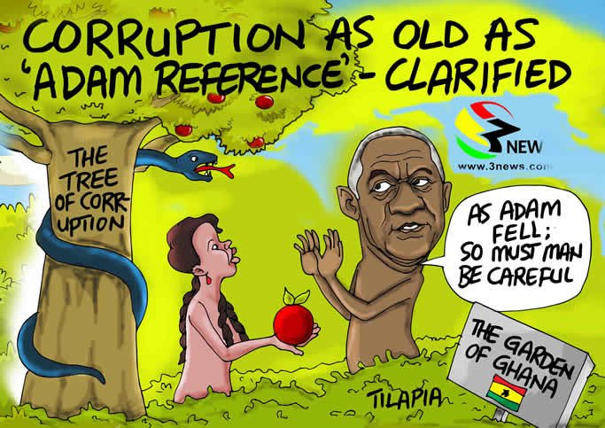
Description of the meme
The meme has a bold tag “Corruption as old as Adam reference clarified”. The meme shows a green garden which is represented by a signpost as the “THE GARDEN OF GHANA” with a symbol of the Ghana flag beneath the caption of the signpost. In the garden stands a blossoming tree, with a blue snake winding up the tree that has the tag “THE TREE OF CORRUPTION”. In the garden of Ghana is a woman handing a red apple to a man who appears to be rejecting the apple. The man in the garden has an appearance similar to that of a Former President of Ghana, Mr. John Agyekum Kufour who happens to be saying “As Adam fell, so must man be careful”.
As an anti-corruption media text
The content of the meme is a metaphorical allusion to the biblical story of Adam and Eve in the Garden of Eden. The meme primarily carries a message, an analogy of corruption that sharply contrasts with the story it is compared to. The analogy is that unlike Adam, the former president rejected the forbidden fruit. This is a clear indication that the message in the meme is shunning corruption. It creates the idea that Ghanaian leaders should and must play an active role in curbing corruption by taking a stance to reject it despite how aged or enticing (reference to the woman) corruption has become in the country. This is in line with Mina’s (2014) position on memes as a tool for social change, as the meme seeks to campaign in support of the eradication of corruption in the country. With this, it can be concluded that the meme is an anti-corruption media text. The meme also presents an ideology that corruption is undesirable. In this meme, corruption is depicted as a “forbidden fruit” which makes it undesirable as it is in symbol akin to the root of all the troubles and miseries of life.
Humour and its impact on the message
As a characteristic of memes, the subjects are not accurately represented as they appear in real life. The meme represented raises questions more than answers: (1) what is the reason behind the colour difference between the man and woman? And (2), why is the man represented as a tree, unlike the woman? The presence of these questions reduces the intensity of humour in the meme. The nature of the meme appears to be addressing a serious national issue by a high-profile national figure. In such context, it could be said that the toning down of humour shows the seriousness of the topic being discussed. This is not to suggest that the meme is bereft of any humour. The fact that the subjects are caricatured with the man not facing the woman but trying hard to look at her through the corner of his eyes evokes some humour, save that the humour is not pronounced. This is to say that the de-emphasis on humour in a memetic text contributes to the meaning of the message as very serious.
Sample 2.
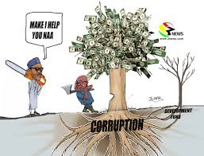

Description of the meme
In this meme, a tree which has money as its leaves is being cut. The tree is portrayed to have sprung from the root of corruption. Standing left to the tree is a short man who appears to be chopping down the tree with an axe. Standing left to the tree is a withered plant with the tag “SEVERITY IVAS” which has its root connected to the tree of corruption. The man with the axe is portrayed as the President of Ghana, Nana Addo Danquah Akufo-Addo. Standing behind Nana Addo is a man with a chainsaw on his neck saying: “Make I help you NAA”. This man is depicted as the President of Nigeria, His Excellency Muhammadu Buhari.
As an anti-corruption text
The meme can be classified as an anti-corruption text. First, it is an informative text. The reason is that it shows a withered plant with the tag “SEVEREMENT IVAS”. Though the word “severement” is ungrammatical, it could be said to be derived from the word “severe” which means something that is “intense”. Thus, the information being put across is that the withered tree is showing the severity of corruption when not attended to early, as it can cause the riches of a nation to be diminished as the withered tree in the meme. Based on that, there was a need to cut down the blossoming tree of corruption earlier before things deteriorate. Secondly, the meme campaigns for a collective effort of two leaders who have pledged to fight corruption in their countries to come together and do so. The word “NAA” in the statement “Make I help you NAA” is the abbreviation of Nana Akufo-Addo. The meme shows that individually, the fight against corruption could be arduous but collectively it could be easier with a “Chainsaw” than only an “Axe”.
Humour and its impact on the message
The complexity of the meme renders the meme with little to almost no humour. The task of understanding the import of the visual representation with the two trees and the use of the ungrammatical word “severement” creates little chance for humour for the viewers. However, the physical description between Nana Akufo-Addo and Muhammadu Buhari has been a longstanding joke between both Ghanaians and Nigerians. Hence, the physical representation of the two leaders may create some humour for those cognisant of that information. This is consistent with Shifman’s (2012) superiority class of humour. However, the general lack of humour shows the seriousness of the issue under discussion, and the little element of humour does not undermine the impact of the message.
Sample 3.
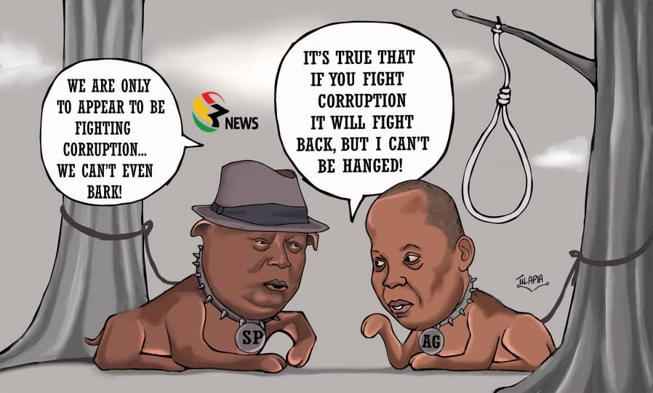
Description of the meme
The meme contains the representation of two Ghanaian public officials represented as dogs in leash. The first dog wearing a hat and with the identification, “SP” which means Special Prosecutor has the resemblance of Mr. Martin Amidu whilst the second dog with the tag “AG” meaning Auditor General has the resemblance of Mr. Daniel Domelevo, the previous Auditor General of Ghana. The first dog asserts that “WE ARE ONLY TO APPEAR TO BE FIGHTING CORRUPTION... WE CAN’T EVEN BARK” while the second dog with a hanging rope beside it asserts that “IT’S TRUE THAT IF YOU FIGHT CORRUPTION, IT WILL FIGHT BACK, BUT I CAN’T BE HANGED!”.
As an anti-corruption text
The meme criticises the “hollow” fight against corruption in Ghana. According to the meme, the two principal agents appointed by the state to fight against corruption express opinions of despair as corruption appears to be valued by the state beyond their authority, hence the expression “We are only to appear to be fighting corruption...we can’t even bark”. This communicates the idea of hopelessness to readers with regards to the fight against corruption. This is because if the two principal actors of the state are unable to fight corruption, then the fight against corruption is a sham, if not a scam. By projecting such image, the meme seeks to draw the attention of the public to this fact and call for actions and the voices of the citizens in combating corruption since state mechanisms do not allow for the fight against corruption. The meme thus calls for the participation of the public in adding their voices to the fight against corruption in the government. This concept agrees with Wiggins and Bowers’ (2015) idea of internet memes as artefacts of participatory digital culture.
Humour and its impact on the message
The element of humour is visible in this meme. The symbolic representation of the two anti-corruption agents as dogs triggers some humour. Basically, the depiction seeks to heighten the expression of “toothless bulldogs”. Thus, dogs who are very powerless, and even in this context, the first dog says, “we can’t even bark”. Their powerlessness is well captured by the leash that is holding their neck. The presence of a hanged roped in the meme further demonstrates the intimidation these persons suffer on the job. Thus, any of them who defies the boundaries set by the leash could get hanged on the rope that has already been set, hence the expression: “It’s true that if you fight corruption, it will fight back, but I can’t be hanged!”. This expression creates some humour. It also triggers some emotions of sympathy and hopelessness from the viewers on the issue of corruption in Ghana.
Sample 4.
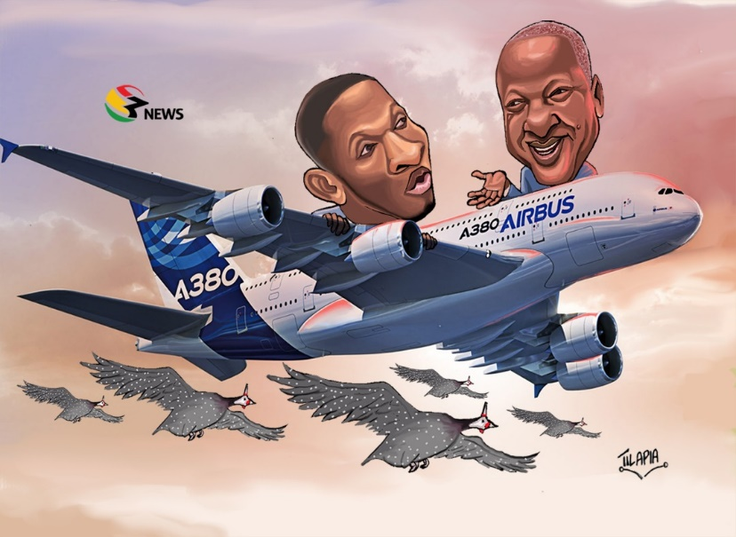

Description of the meme
This meme projects the image that looks like the former president of Ghana, His Excellency John Dramani Mahama and Mr. Samuel Gyamfi, the Communications Director of the National Democratic Congress (NDC) flying an aeroplane named “AIRBUS A380”. Beneath, the flying plane is a host of Guinea fowls flying alongside. In this meme, both Airbus A380 and the Guinea fowls have become subject of public discussion on the issue of corruption under the former NDC government.
As an anti-corruption text
The act of naming and shaming public officials who undermine their integrity is characteristic of the Ghanaian media. A compendium of alleged cases of corruption and political scandals under the NDC government has been simplified in this meme. This relates to the simplification of news function of memes (Börzsei, 2013), and the social function of memes as asserted by Laineste & Voolaid’s (2017). The anti-corruption sentiments teased out of this meme is that it seeks to simplify the allegations of corrupt cases of the NDC government to gain public attention and trigger public opinion on the subject. As the viewers gain a clearer understanding of the issue, they could better participate in the public discussion in ridiculing corruption and in putting an end to possible corrupt cases in the current New Patriotic Party (NPP) government.
Humour and its impact on the message
The pictorial elements in the meme qualify the meme as a satire. This is because since the meme seeks to ridicule corruption, it simultaneously achieves some humour. This is so due to the presence of the Guinea fowls in the meme. The representation of the Guinea fowls in the clouds to be flying about the same height of the aeroplane is an exaggeration. Realistically, Guinea fowls do not fly to higher altitudes into the clouds. This exaggeration achieves some humour. However, the presence of the guinea fowls is only serving as a reminder of the alleged corruption scandal associated with the Savannah Accelerated Development Agency (SADA), an initiative by the NDC that sought to invest in Guinea fowl farming but after some few months, there was sudden news that the guinea fowls had flown back to Burkina Faso, where they were purchased. Against this backdrop, the projection of the guinea fowls to be flying along AIRBUS A380, another alleged corruption scandal of the NDC, is only an addition to the flying mysteries of the nation. Thus, the humour intended in this meme adds meaning and enhances understanding of the general issue being projected.
Sample 5.
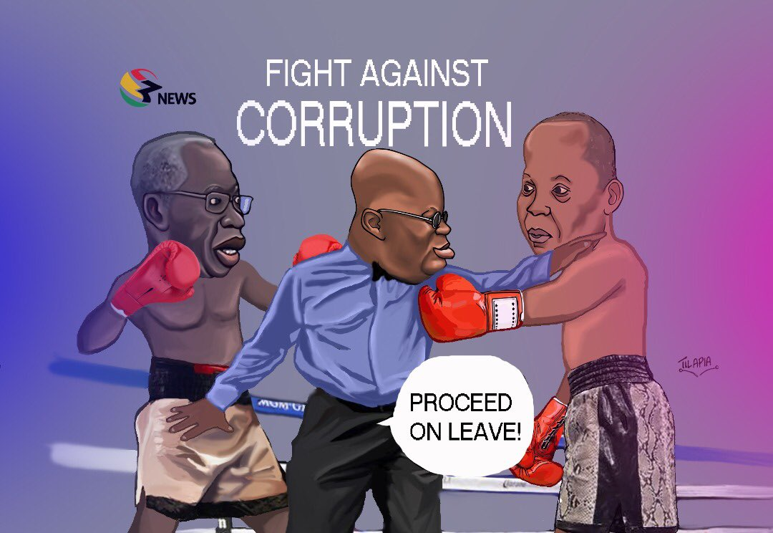
Description of the meme
The meme captures a boxing “FIGHT AGAINST CORRUPTION”. This fight features personalities that look like Mr. Yaw Osafo Marfo, the Senior Minister of the Government of Ghana, and Mr. Daniel Domelevo, the Auditor General of Ghana. In the middle of the two men is a referee who resembles the current President of the Republic of Ghana, Nana Akufo-Addo. The referee is presented as a biased referee who is telling Mr. Daniel Domelevo to “PROCEED ON LEAVE” while the fight against corruption is still in session.
As an anti-corruption text
The meme seeks to analogize the fight against corruption with a boxing match. The meaning this meme seeks to create is that just as a referee of a boxing match cannot disqualify a boxer unless for some irregularities committed in the ring (BBBC, Rule 3.38 and 3.38. 1), so is the case in the fight against corruption. This meme captures a growing resentment in the Ghanaian community, following the directive from the Office of the President instructing Mr. Daniel Domelevo, the Auditor General to proceed on leave for of 128 days. This directive was interpreted by some Ghanaians as an act to shield Mr. Yaw Osafo Marfo who was alleged to have been involved in some corrupt deal and by asking the Auditor General to proceed on leave, Mr. Yaw Osafo Marfo will be cleared of no wrongdoing. Against this background, the anti-corruption sentiment that the meme seeks to communicate is the idea of unfairness on the part of the referee, and symbolically shows some bias in the fight against corruption in Ghana. This is clearly shown by the facial expression ascribed to the President as he appears to have frowned at Mr. Domelevo.
Humour and its impact on the message
Humour is strongly expressed in the conceptualization of the corrupt situation as a boxing match. The symbolic representation of the subjects as boxers with the President of the country represented as a biased referee identify the work as a successful satire. This is because it succeeds in ridiculing the subjects and campaigns for probity in the fight against corruption. The humour here stems from situational irony where the very person who should champion the fight against corruption is the one making it easy for the canker to thrive. The impact of the humour on the message is that it simplifies the issue and makes it more understandable to the audience.
Sample 6.
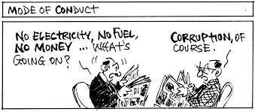
Description of the meme
In this meme, two characters who are reading newspapers are engaged in a conversation. The first character exclaims: “No electricity, no fuel, no money… What’s going on?”. The second character retorts: “Corruption of course”. On top of the picture is a caption, “MODE OF CONDUCT”. The caption on top of the meme indicates that the social problems and its link with corruption are an everyday discussion that every person is conversant with. Despite the daily discussions, nothing really happens, hence corruption has been seen as normalcy in the country.
As an anti-corruption intervention
This meme presents an analogy or idea of the impacts of corruption on a country. In the meme, a projection is made to link corruption to the socio-economic challenges faced by the ordinary citizens in the country. It presents the idea that corruption accounts for the poverty of the citizens, leads to lack of equitable access to social utilities, like electricity, and with the ellipses, shows that there are more problems created by corruption than can be listed. However, the meme presents the idea that beyond merely complaining about corruption, no action takes place to halt it. Therefore, as an anti-corruption campaign, the meme calls for a step beyond the routine talking about corruption. It calls for strict action to be taken against corruption rather than words. It can be concluded that the meme is informative and produces an anti-corruption effect as it highlights the realistic negative impacts of corruption on a country and what needs to be done to end it.
Humour and its impact on the message
The meme is hardly humorous. In situations where there is little or no humour in a meme, the message the meme seeks to communicate is very serious. The consequences of corruption in a developing society like Ghana is so serious that the meme creator might not want any humour to detract from the seriousness of the matter.
Sample 7.
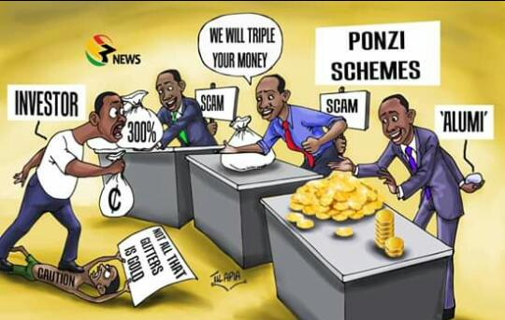
Description of the meme
The meme presents the situation of an “INVESTOR” who is in a dilemma as to what venture in which to invest his capital. Three trade options are investing in gold with a gold dealer, investing with a money doubler who promises: “WE WILL TRIPLE YOUR MONEY” whilst the last is investing in a firm that promises to give “300%” interest on the investors’ money. All three traders are shown to be having a third hand behind them which shows they are all fraudulent. The gold dealer is presented to be dealing with “ALUMI” (Aluminium). The remaining two traders are tagged as “SCAM”. Behind the three traders is a bold label with the caption “PONZI SCHEMES”. Amidst all these, the investor is portrayed to be trampling down on “CAUTION” and advice that “NOT ALL THAT GLITTERS IS GOLD”. This meme captures the situation of customers of business organizations who lose their money after investing in organizations and businesses that promises to provide them with abnormal profits on their small investment.
As an anti-corruption campaigner
As corruption is defined as an action committed by both the giver and receiver, so is the case with investors and traders of Ponzi schemes. The message the meme seeks to communicate is that customers who lose their investments with these schemes are major players or contributors in their misfortune as they defy all caution to invest with duplicitous businesses and schemes. And as such, even though there are indicators that those trades are Ponzi schemes, their greedy eyes fall for those schemes, and they invest with them. Hence, as an anti-corruption campaigner, the meme seeks to provide information that investors may not be privy to. Thus, the meme uses the third hand of the traders in the meme to show investors what they may not know and will never be told by the PONZI SCHEME traders. The essence is to educate investors to be cautious and find out more about organizations promising to give more profits than their actual investment could yield.
Humour and its impact on the message
The humour intended by the meme is depicted when the investor is seen trampling over CAUTION, rejecting information that “NOT ALL THAT GLITTERS IS GOLD” and going ahead to show great zeal in investing in a PONZI SCHEME. with widely opened eyes and mouth. This scene, as it creates a situation for humour as well shows the degree of carelessness on the path of investors of those PONZI SCHEMES. Thus, the impact of the humour is to mark the degree of carelessness of many people who fall into the trap of Ponzi schemers.

Conclusion
This study has demonstrated that memes play significant roles in fighting social deficiencies such as corruption. As an anti-corruption intervention text, memes employ techniques such as the elements of disgusts, concepts of collectiveness, religious analogies, call to action elements, and the physical and symbolic representation of the implied characters to show the ills of corruption on society. As corruption is a civil and moral crime against humanity, the use of religious and other mundane elements in presenting issues was relevant technique memes employ. The study therefore generally agrees with Mina (2014) on the concept of the social change function of memes and the enhancement of a participatory culture as held by Wiggins and Bowers (2015).
The research again finds the element of humour as part of the general meaning-making of a meme and not as a mere element for entertainment. The study finds that the presence or absence of humour in a meme tells the level of seriousness of the topic under discussion or the degree at which things occur. The absence of humour in some memes also negates Knobel and Lankshear (2007) and Shifman’s (2013) views on the centrality of humour in memes. This study also finds that the application of humour in a meme serves a purpose such as clarifying the news. As these findings do not conclude knowledge on the topic of mimetic discourse, further studies could conduct a quantitative or mixed-method study on the impact of memes on other social, political and economic issues in Ghana.

REFERENCE
Armah, A. K. (1968). The Beautyful Ones are not yet Born. Berkshire: Cox & Wyman Ltd.
Armah, A. K. (1970). Fragments. Berkshire: Cox & Wyman Ltd.
Bennett, E. (2014). Social media as a tool for improving research and teaching. Frontiers in Ecology and the Environment, 12(5): 259.
Bennett, W. L., & Segerberg, A. . (2013). Journal of Information, Communication and Society. The logic of connective action: Digital media and the personalization of contentious politics, 15(5):1-30.
Börzsei, L. . (2013). Makes a Meme Instead: A Concise History of internet Memes. New Media Studies Magazine 7.
Burgess, J. (2008). All your chocolate rain are belong to us? Viral video, YouTube and the dynamics of participatory culture. In Video Vortex Reader: Responses to YouTube. Amsterdam, Netherlands: Institute of Network Cultures.
Chrisian, S. M., Garza, A. S. , & Slaughter, E. J. (2011). Work engagement: A quantitative review and test of its relations with task and contextual performance. University of North Carolina, Chapel Hill: Organizational Behaviour Department.
Coulson, N. S. . (2013). How do online patient support communities affect the experience on inflammatory bowel disease? An online survey. JRSM Short Reports, 4(8).
Culler, J. (2002). The pursuit of signs: semiotics, literature, deconstruction. Cornell University Press.
Cumbreras, M. C. (2019). The effects of consumption of corruption-related news on political cynicism. Communication & Society. 32(4), 47-62.
Dawkins, R. , & Marshmallow, L. F. (2013). Just for Hits. (Dawkins, R. , Performer) Cannes Grand Auditorium , Cannes , France .
Dawkins, R. (1976). The Selfish Gene. Oxford: Oxford University Press.
Elo, S & Kyngas, H. (2008). The qualitative content analysis process. Journal of Advanced nursing. 62(1), 107-115.
Foss, K. S. . (2005). Theory of visual rhetoric. Handbook of Visual Communication: Theory,Methods and Media, 141-152.
Hristova, S. . (2014). Visual memes as neutralizers of political dissent. Communication, Capitalism and Critique. Access Journal for a Global Sustainable Information Society, 265-276.
Husted, U. (2012). A Funny Thing Happened On the Way from the Forum: The Life and Death of Internet Memes. University of Minnesota Digital Conservancy.
Knobel, M. , & Lankshear, C. (2007). Online memes, affinities, and cultural production. A New Literacies Sampler., 199-227.
Kobierecki, M. (2014). Internet memes as an example of political dissatisfaction of polls on the internet. Political Science Quarterly of the Centre for Political Analysis of the University of Warsaw, 243-269.
Laineste, L., & Voolaid, P. (2017). Laughing across borders: Intertextuality of internet memes. The European Journal of Humour Research, 26-49.
Leskovec, J., Backstrom, L., & Kleinberg, J. (2009). Meme-tracking and the dynamics of the news cycle. Association for Computing Machinery, 497-506.
Le Vine, V. (1975). Corruption in Ghana: The search for causes. Transitions. 47. Indiana
University Press, pp 48-61.
Lombard, J. K. . (2013). Art crimes: The governance of hip hop graffiti. Journal for Cultural Research, 255-278.
Mayring, P. (2014). Qualitative content analysis: Theoretical foundation, basic procedures and software solutions. Klaqgenfurt, Austria. Available from: https://www.psychopen.eu/fileadmin/user_upload/books/mayring/ssoar-2014-mayring-Qualitative_content_analysis_theoretical_foundation.pdf
Mina, A. X. . (2014). Batman, pandaman and the blind man: A case study in social change memes and internet censorship in China. Journal of Visual Culture, 359-375.
Mina, A. X. (2019). From Memes to Movements. Boston: Beacon Press.
Rahman, K. (2018). Overview of Corruption and Anti-corruption in Ghana. U4 Helpdesk
2018:21. Available from: overview-of-corruption-and-anti-corruption-in-ghana-2018.pdf
Rockson, K. (2012). Akosua Cartoon in the Daily Graphic: A discourse Analysis. Journal of Communication, Media & Society. 2(1), 48-76.
Ronning, H. (2009). The politics of corruption and the media in Africa. Journal of Africam media studies. 1(1). Intellect Ltd., 155-171.
Shifman, L. . (2012). An anatomy of a YouTube meme. New Media and Society, 187-203.
Shifman, L. . (2013). Memes in Digital Culture. Cambridge: MIT Press.
Singh, G. & Nitty. (2017). Role and impact of the media on society: A sociological approach with respect to demonetization. International Journal of Research in Humanities, Arts and Litterature, 5, 127-136.
Srivastava, M. K & Sharma, G. (2016). Research paper on media responsibility in national development. International Journal of Information Science and Computing, 3(1), 9-19.
Werlin, H. H. (1973). The Consequences of Corruption: The Ghanaian Experience. Political Science Quarterly. Academy of Political Science. 88(1), 71-85.
Wiggens, B. E., & Bowers, G. B. . (2015). Memes as genre: a structural analysis of the memescape. Delhi: Sage Publications.
Wimmer, R.D. , & Dominick, J.R. . (2011). Mass media research: An introduction. Belmount CA: Wadsworth.
British Boxing Board of Control (2020). Rules of boxing. Retrieved from http://bbbofc.com/content/rules-boxing-0

This is a 2021 social media driven pressure movement of predominant the youth in Ghanaagitating for the government to “fix the country’s problems.”

