CONTEXT-MOTIVATED ENGLISH INTONATION CHOICES IN NIGERIA NATIONAL ASSEMBLY PLENARY SESSIONS

ABSTRACT
Existing studies on Nigerian English Intonation have described the grammatical, attitudinal and accentual features of intonation, while the discourse feature of Nigerian English Intonation has not been duly examined. A good instance of context of naturally-occurring speeches where intonation can be better described is the plenary session of the Nigerian National Assembly. This present study explored the intonation patterns used at Nigerian National Assembly plenaries by identifying the intonation patterns, categorising and describing them, and examining the influence(s) of the interactional context on the intonation patterns.
Forty-one non-interrogative tone units of selected Nigerian federal legislators in the 8th parliamentary session (2015-2019) were analysed. The selection of these tone units was based on the structural types and how central they were to the message of the excerpts drawn from six different videos of their plenary sessions. Brazil’s (1997) Discourse Intonation Model formed the theoretical framework for discussing the intonation tunes deployed on the tone units and spectrograms were generated with PRAAT. While sixteen participants demonstrated total conformity to DI, five performed on exact average. The study also found out that there were noticeable differences in the intonation patterns of male and female Nigerian federal legislators. While the male participants, to some extent, conformed to DI in their use of tunes on both interrogative and non-interrogative tone units, the female participants upheld the grammatical rule-based intonation patterns.
The patterns of Nigerian federal legislators were not consistent with DI; rather they were hugely in line with the formalised intonation rules. They were not conscious of the communicative value of English intonation in discourse but they were mainly concerned with structural patterns of these tone units. Thus, it was suggested that DI should be emphasised in schools at different levels to foster proficient use of intonation in context.

Keywords: Naturally-occurring speeches, Nigerian federal legislators, National Assembly plenary sessions, Discourse Intonation

- Introduction
Intonation is dynamic in nature and cannot always be regulated by grammatical rules, especially in the context of naturally-occurring or spontaneous speeches. McNeill et al. (2001) opine that “the organisation of discourse is inseparable from gesture and prosody” and that “[they are] different sides of a single mental communicative process”. Nigerian English, on the other hand, is a “variety of English which has often been suggested to differ from other varieties of English, especially in the area of prosody” (Gut, 2005: 154). Scholars have explored the prosodic features: stress, intonation and rhythm of Nigerian English. While many existing studies on English intonation patterns of Nigerian speakers have concentrated on rule-governed patterns, very few researchers seem to have explored the intonational choices of Nigerian speakers in spontaneous utterances.
Jowitt (1991) avers that in an L2 situation, intonation patterns cannot be acquired as used by native speakers. They are consciously learnt and since their complexity — like stress — timing tends to repel all but motivated learners, they go for the most unlearned part to account for the meaning which they could not achieve with the tunes. Further, Udofot (1997) observes that pauses between intonation groups are shorter in Nigerian English than in British English. She notes that there is a preference for ‘end-stress’ in intonation phrases. Lending credence to the observations of Ufomata (1997), Adetugbo (1977) and Eka (1985) view that the most problematic area of Nigerian English phonology is rhythm and having studied the systematic differences in the intonational patterns between Nigerian English and British English, Jowitt (2000) enumerates the characteristics of Nigerian English intonation system:
- Fall predominates in a statement, WH- questions and command,
- Rise predominates in yes/no and tag questions,
- Complex tunes were seldom used, although there are some instances where the rise-fall is used for strong emphasis,
- End stress is a general rule for information group,
- Lexical words carry a pitch accent, and invariably pitch accents are relatively high.
- The core pattern for heads is an initial high pitch followed by down drift before the commencement of the nucleus.
- Where the core pattern includes a falling nucleus, it is a low-falling nucleus.

Education is a fluid variable that can be affected by other variables. Adejuwon (2016: 33) commented that his data cannot be extended to all Nigerian users of English as there are Educated Nigerians who are more proficient in the use of English intonation than his participants. In addition to this, the context could have also affected the rendition of the participants; while some might be trying to impress the researcher, some might be afraid.
Furthermore, the study of Adejuwon (2003) revealed that the majority of Nigerian radio broadcasters in South-western in Nigeria were unable to interpret intonation tunes played back to them. Also, they do not usually deploy these tunes while casting news. Buttressing the opinion of Adejuwon (2003), Atoye (2005) opines that the level of perception of intonation was higher than the level of interpretation of meaning in his study investigating the perception and interpretation of a subclass of sentence intonation by some Nigerian users of English. There is however a need to mention that the data read by the broadcasters were prepared by the researcher and this “could not be devoid of affectations” (Adejuwon 2016) or “observer’s paradox” (Labov, 1972).
Fajobi (2013) carried out an acoustic investigation of intonation in Nigerian English, concentrating on the extent to which Yoruba influences speakers’ spoken English. Her study examined on Yoruba-influenced-Nigerian-English intonation of eight Yoruba native speakers, four had lived in London for 25years and the other four resided in Nigeria. She generated pitch contours from PRAAT software and her analyses were buttressed statistically using SPSS. The study thus found out that “to a very large extent and irrespective of where Nigerians speakers are located, Yoruba Nigerian English intonation relates more to Yoruba than to the native English intonation system” (Fajobi, 2013: 75). Although this study set out to explore Nigerian English intonation, it concentrated on the Yoruba Nigerian English. Also, there is a gap of discourse intonation.
Odeyemi (2016) examined context and Discourse Intonation in English medium product advertisements on radio and television in Nigeria. Using Discourse Intonation as his framework, he explored how Nigerians use intonation in radio and television advertisements. Jingles used in electronic media advertisements are sometimes scripted and usually recorded and edited after a series of rehearsals. This defines the utterances considered in his study as different from naturally-occurring utterances.
In a study on Natural Speech and Intonation Rule Patterns, with 200 tone units of selected Educated Nigerian speakers of English, Adejuwon (2016) concludes that there is a remarkable gap between the natural speech intonation patterns of educated Nigerian Speakers of English and formalised intonation rules. Using the Discourse intonation proposed by (Brazil 1997), two different groups of Educated Nigerians were studied. While the data of group A were electronic data recorded during television and radio interviews, the data of group B, the focus group, were discussion-generated. According to him, DI is yet a strange model in the English intonation of Nigerian Educated speakers of English; thus, he concludes that educated Nigerian speakers of English, generally, lack the knowledge on the use of the discourse intonation model, and there is a disparity between their intonation patterns in natural speeches and the formalised intonation rules. His findings, therefore, corroborate some of the positions of Udofot (1997); Gut (2004), and Jowitt (2000). Although this study covers people from all walks of life, it does not include legislators and how intonation is used in the process of law-making.
Again, few scholars seem to have deployed the DI in the study of the English intonation patterns of Educated Nigerians. Thus, the study of Adejuwon (2016) and Odeyemi (2016) can be regarded as pioneering elaborate works on the discourse intonation patterns of educated Nigerian speakers of English. However, one gap that is yet to be adequately addressed is the contextual influence(s) on intonation (especially in the process of law-making), which DI can duly explore. By investigating how Nigerian federal legislators make choices from the intonation patterns, this study hopes to avoid observer’s paradox (Labov, 1972), affectations (Adejuwon, 2016), and generate reliable data to make plausible suggestions and contributions to the positions of scholars on Nigerian English intonation.

2. Brazil’s Discourse Intonation
The theoretical framework of this study is the discourse intonation approach to intonational analysis proposed by Brazil (1997). Brazil’s model elucidates the underlying principles regarding the communicative value of intonation in naturally-occurring interactions. The importance and relevance of DI have been acknowledged by many scholars. First, it provides the most satisfactory explanation for the intonation choices speakers make. The model is attractive because it is simple and has a powerful explanatory force; not only can it account for frequently-occurring patterns in conversation; it equally provides the exceptions to those patterns (Ranalli, 2002). Adejuwon (2016) says DI is concerned with the speakers’ moment-by-moment context-referenced choices. Thus, given the currency of this theory, its wide acceptance and profound relevance to naturally-occurring speech, the present adopts it.

2.1 DI Systems of Speaker Choice
With emphasises on naturally-occurring context-referenced tone patterns, DI has four systems of speaker choice: prominence, tone, key and termination. The relationship between the four systems is that prominence fixes the domain of the three variables of tone and key or termination, all of which contribute to the communicative value of the tone unit (Brazil 1997). They foster intonation to represent the existential context that projects the role-relationship and the state of convergence between the speaker and the listener.

3 Methodology
In respect to the aim and objectives of this study, the data, the intonation tunes used by the study participants were identified and the frequency of occurrence was determined. Forty-one non-interrogative tone units are purposively selected for analysis from six excerpts based on their structural types and how central they are to the messages in these excerpts. Twenty-four Nigerian federal legislators constitute the participants for this study; twelve legislators from the Senate and the other twelve from the House of Representatives in the 8th Parliamentary Session (2015-2019 Administration). Following the provisions of the 1999 constitution of the Federal Republic of Nigeria, Nigerian legislators hold at least the First School leaving Certificate educational qualification, and are not younger than 35 years (for Senate) and 30 years (for House of Representatives). The present researcher, therefore, concentrates on those who hold educational qualification higher than SSCE. For the acoustic analysis, the selected utterances were played back on PRAAT software on the computer. Some of the visual representations of the tone units (spectrograms) extracted from the utterances in the excerpts were generated and discussed in relation to the interactional context.

4. Participants’ Intonational Patterns in Non-Interrogative Tone Units
There were 41 non-interrogative tone units produced by participants at different sessions. While 10 were produced with the referring tune, the proclaiming tune was used on remaining 31 tone units. Nigerian federal legislators seem to conform to DI in their patterns of tunes, especially in non-interrogative tone units. While sixteen participants demonstrated total conformity to DI, five performed on an exact average. It should also be added that 100% proclaiming tune was used in six excerpts (Excerpts 1A, 3A, 3H, 4C, 4E & 6A); 100% referring tune was recorded in four excerpts (Excerpts 3B, 3I, 4G, & 4I); 50% on both tunes was recorded in (Excerpts 2A, 3D, 3E, 4A, 4B, 4F & 6B), and 33.3% proclaiming and 66.6% referring were recorded in (Excerpts 3C, 3G, & 4D).
First, complete compliance was noticed in some excerpts where participants used the proclaiming tune, referring tune or even both to either provide new information or establish common ground. The choice of proclaiming tune in the two non-interrogative tone units with both the non-sentence-final and sentence-final positions in 1A aligns with DI. The participant here made an announcement, and the information was regarded as new.
Figure 1: Excerpt 1A
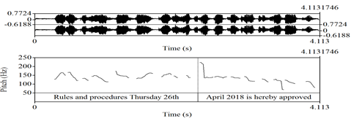
// p rules and procedures Thursday 26th/ p April 2018 is hereby approved//
Figure 2: Excerpt 4C
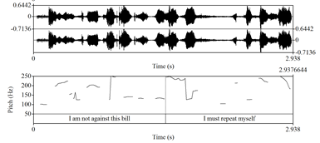
// p I am not against this bill/ p I must repeat myself//
Similarly, the utterance in Excerpt 4C has two tone units, and the two tone units were produced in a proclaiming tune. This was hugely in conformity to the DI; the participant expressed his personal opinion with the two tone units. Both the tone unit at the sentence-final and the one at the non-sentence-final positions were produced in the proclaiming tune.
Figure 3: Excerpt 3A
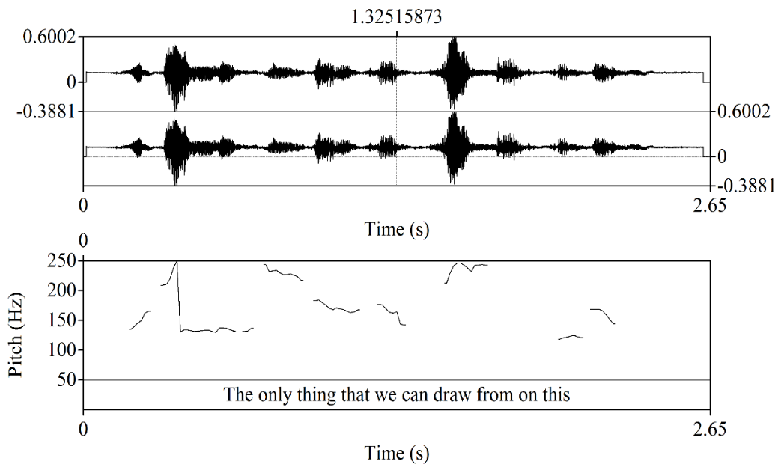
// p the only thing that we can draw from on this//
Figure 4: Excerpt 3A (II)
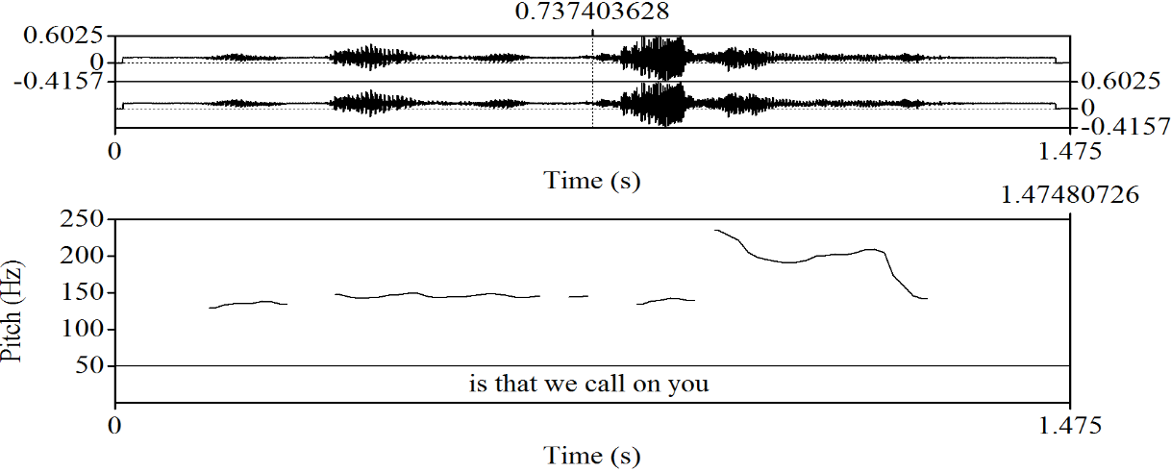
//p is that we call on you//
In Excerpt 3A, the two tone units were produced with the proclaiming tune. The participant used the proclaiming tune on both the non-sentence-final tone unit and the sentence-final one. Using the proclaiming tune on both tone units here suggest that their information are newly introduced to the context of interaction. Of course, in the debate, this participant said something different from earlier submissions; he suggested invoking a provision for the impeachment of the President. Thus, the choice of proclaiming tune here is in accordance with DI.
Figure 5: Excerpt 4A
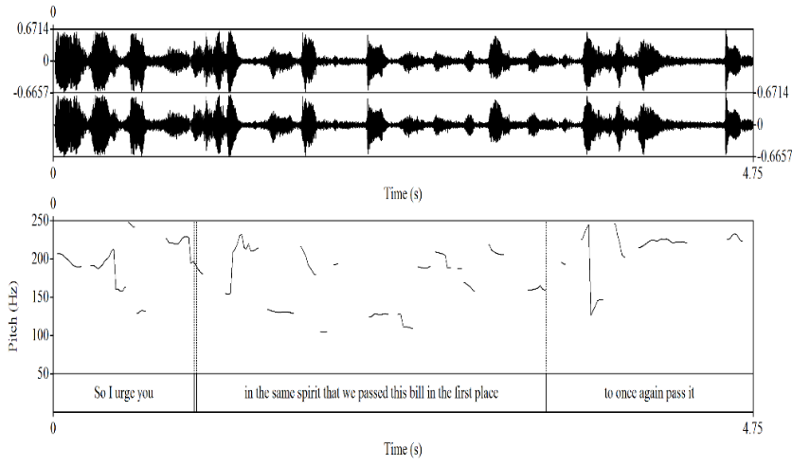
//r in the same spirit that we passed this bill in the first place/p to once again pass it//
This utterance was meant to remind other legislators that the bill had been passed before and to appeal that it should be passed again. The participant here, therefore, used both the referring and the proclaiming tune respectively. The choice of tune on the first tone unit is suitable, according to DI and so also is the choice of tune on the second tone unit giving the new information. It is important to mention here that the tone unit carrying the referring tune is non-sentence final and the one produced with the proclaiming tune is sentence-final.
Figure 6: Excerpt 2A
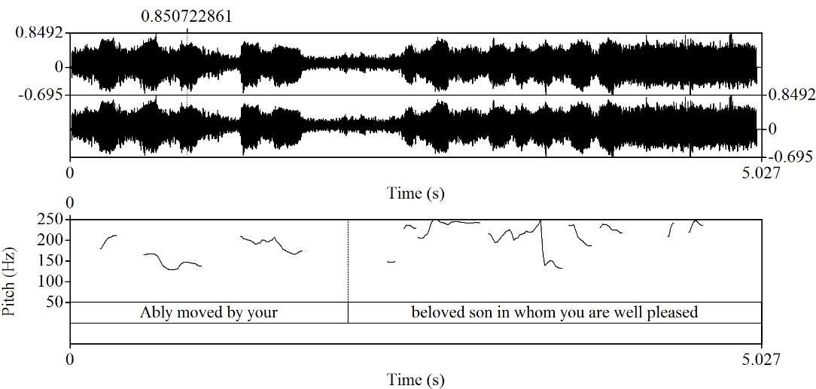
//r beloved son in whom you are well pleased//
Figure 7: Excerpt 2A
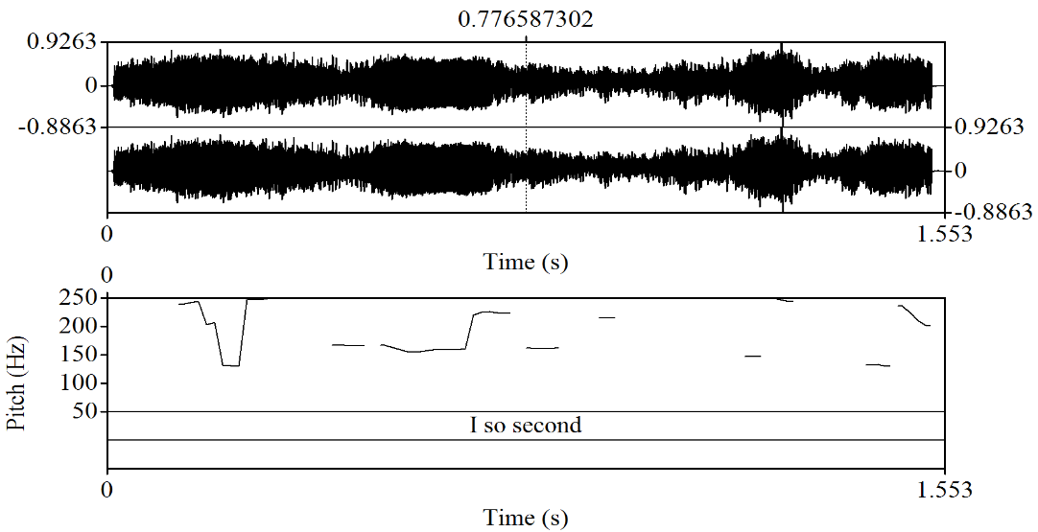
//p I so second//
In the first tone unit, the speaker alludes to a popular quote in the Bible and uses this to remind others of the shared knowledge. Therefore, the selection of a referring tune here conformed to DI; it was used to bring to remembrance that the legislator called to move the motion was the Speaker’s favourite. Further, in the second tone unit, the speaker draws her conclusion with a proclaiming tune. The participant expressed her support for a motion earlier moved; her use of the proclaiming tune here conforms to the provision of DI. Although the motion has been moved earlier, she brought fresh insights to the interactional context before she proceeded to support the motion.
Figure 8: Excerpt 3B
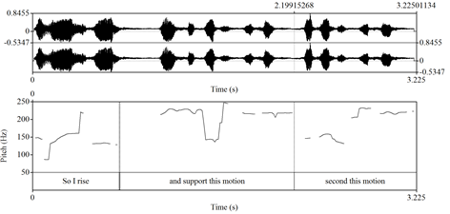
// r so I RISE/ r and SUPport this Motion//
Participant 3B’s utterance has three pre-sentence final tone units. The first two tone units selected were uttered in the referring tone. The participant was contributing to the common ground; thus, his choice of the referring tone is appropriate and aligns with DI.
Figure 9: Excerpt 3E
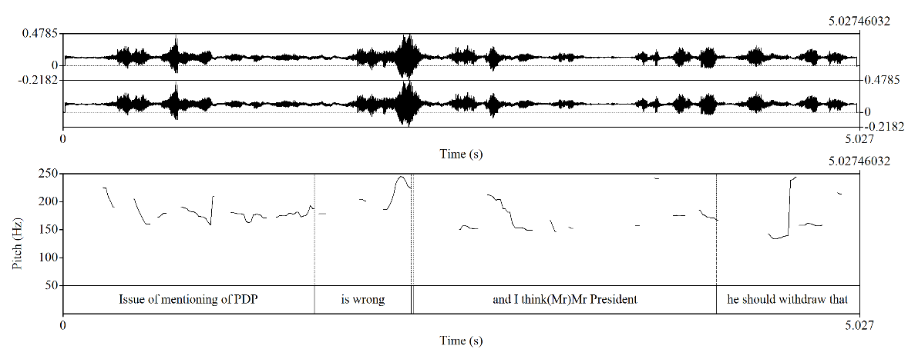
//r Issue of mentioning of PDP/ p is wrong//
The participant in excerpt 3E appropriately used the referring tune on the tone unit which agrees with the common ground and a proclaiming tune on the new information. The utterance was preluded by a submission of another federal legislator’s submission. In 3E’s opinion, the first tone unit refers to the preluded submission while the latter tone unit shares his view.
Figure 10: Excerpt 4G
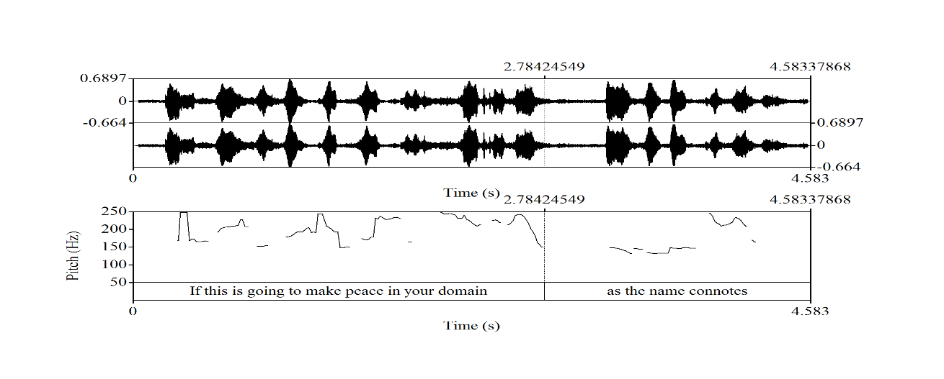
//p If this is going to make peace in your domain/ p as the name connotes//
The tone units here were said using the proclaiming tune. It suffices to add that the two tone units are non-sentence-final tone units; thus, the choice of such a tune on them calls for attention. Uttering the first tone unit with a proclaiming tune is in accord with the DI because the first tone unit, although a subordinate clause, provides new information. But placing the same tune on the second tone unit does not conform to the DI as the tone unit provides a piece of information already existing in the context of interaction and it is therefore expected that it is said in a referring tune. Using a proclaiming tune on the latter tone unit which is sentence-final tone unit suggests that the choice of the participant is hugely guided by the grammatical rules of intonation.
Figure 11: Excerpt 3C
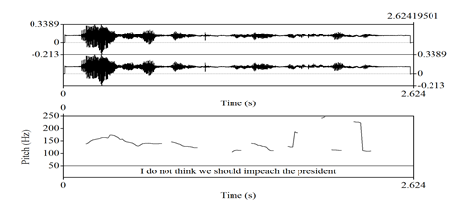
//p I DO not think we should impeach the PREsident //
Before this utterance was produced, the previous speaker lends support to another legislator who already moved for the impeachment of the president. However, this participant drove the argument to another side. The proclaiming tune was deployed in producing the only non-interrogative tone unit in excerpt 3C. This non-sentence-final tone unit is a contribution to an ongoing argument at the plenary and this choice of proclaiming tune makes the participant conform to DI.
Figure 12: Excerpt 6A
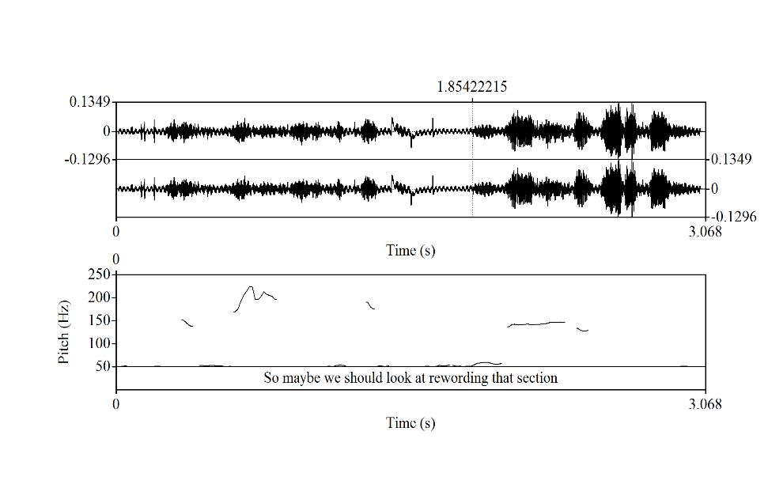
// p So maybe we should look at rewording that section//
The lone tone unit in this utterance expresses the speaker’s suggestion and contribution. Therefore, deploying a proclaiming tune here is in line with the DI. However, we should also add that the tone unit is a sentence-final one.
Figure 13: Excerpt 3G
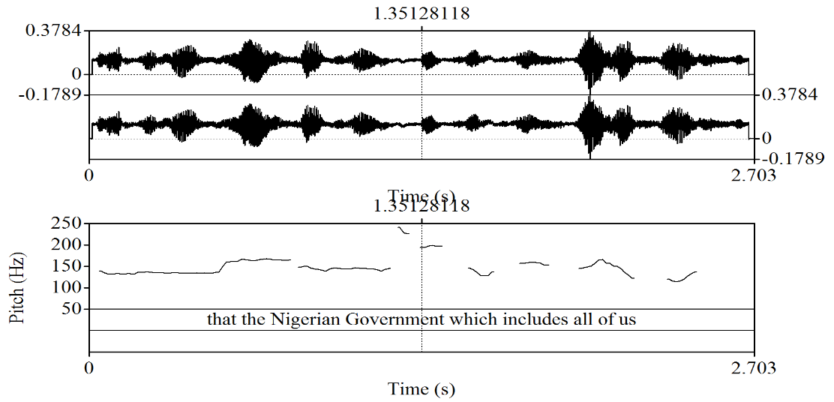
//r that the Nigerian Government which includes all of us//
This tone unit is a non-sentence-final and it expresses a shared knowledge. The participant referred to all the Nigerian federal legislators as part of the Nigerian government, and this is a known fact. Thus, the use of the referring tune here is in line with the DI. However, since the tone is a non-sentence-final one, it becomes too early to conclude.
Figure 14: Excerpt 3G
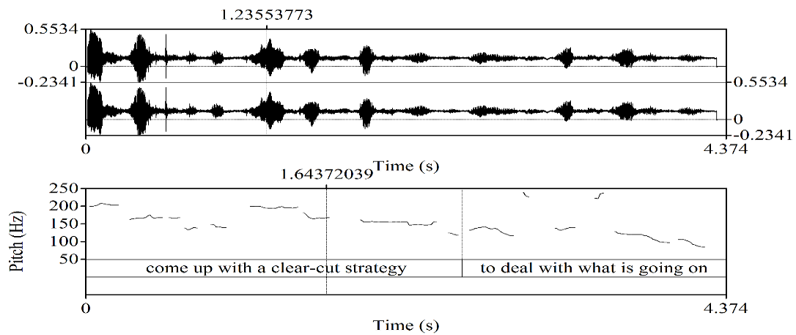
//p come up with a clear-cut strategy to deal with what is going on//
The sentence-final tune here has a proclaiming tune. This choice is appropriate since the speaker shares a personal opinion which is new in the interactional context.
On the other hand, average conformity to DI was recorded in three excerpts as mentioned earlier (Excerpts 4E, 4F, and 6B). In 4E, the participant did not introduce something new to the context of interaction with the first unit yet he placed a proclaiming tune on it. However, the second tone unit, the participant shared a personal opinion with a proclaiming tune.
Figure 15: Excerpt 4E
-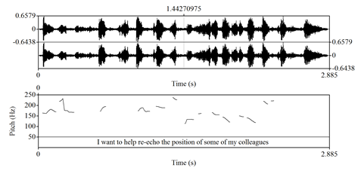
Figure 16: Excerpt 4E (II)
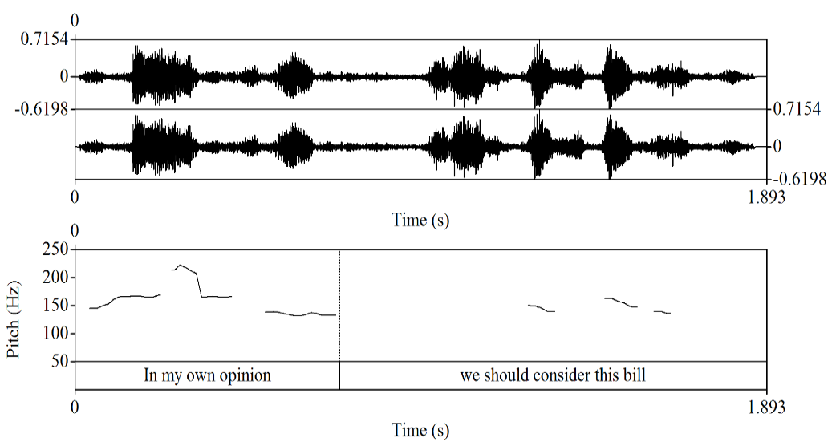
//p we should consider this bill//
In 6B, the two tone units have both proclaiming and referring tunes respectively. Since the initial tone unit is a non-sentence-final tone unit, the choice of a referring tune here is appropriate following the provisions of grammatical rule-based intonation. However, because the information in these tone units are new in the context and are also the contributions of the speaker which have not been said before, they should both have the proclaiming tune (not only on the second tone unit) according to DI. Thus, this made the tone unit to be averagely in line with the DI.
Figure 17: Excerpt 6B
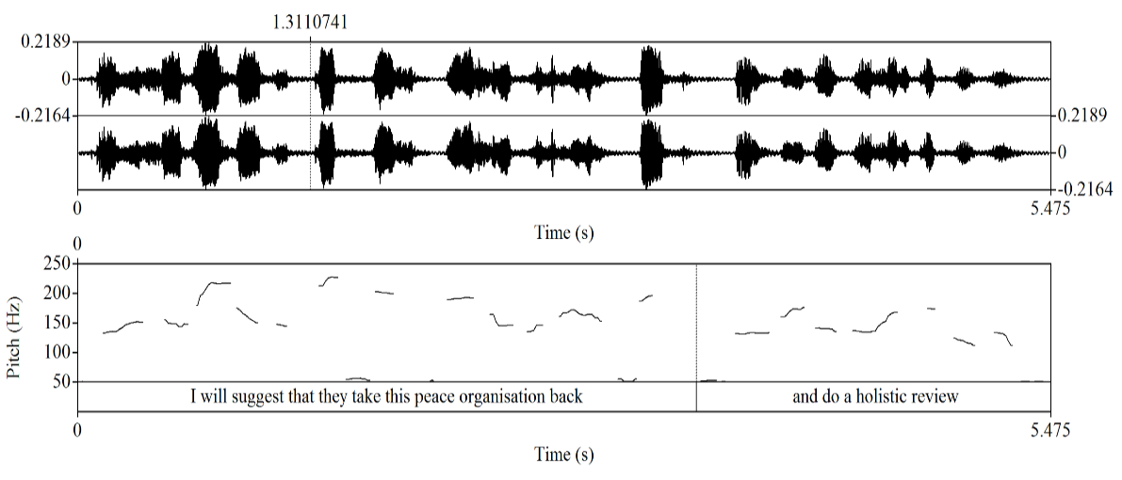
//r I will suggest that they take peace organisation back/p and do a holistic review/
Figure 18: Excerpt 3D
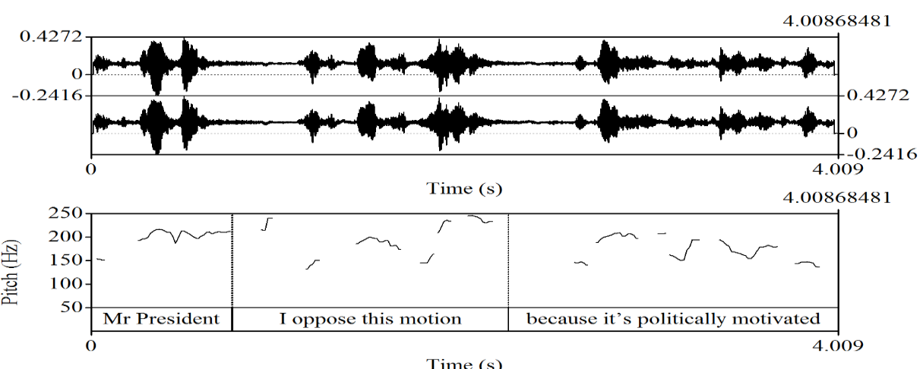
//r I oppose this MOtion/p because it’s politically MOtivated//
Also, in excerpt 3D, the participant averagely conformed to the DI; the two tone units in that excerpts had one proclaiming tune and one referring tune respectively. Since the two tone units are new in the context of interaction, it is expected that the proclaiming tune is deployed.
Figure 19: Excerpt 4B
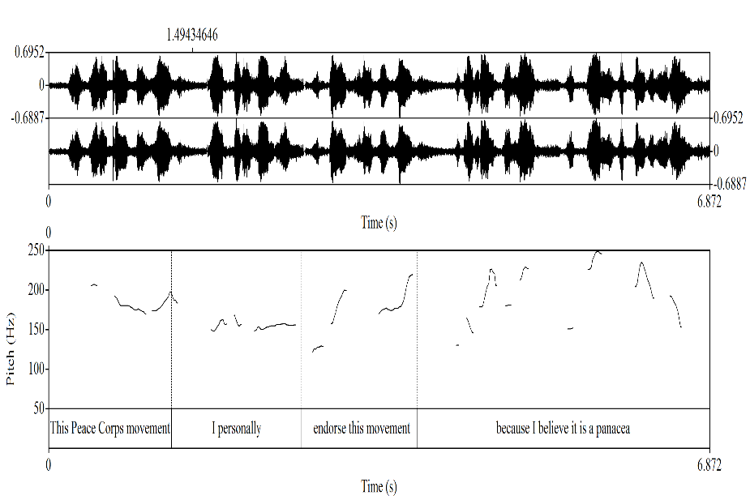
//r I personally/ r endorse this movement//
As stated earlier in this study, in DI, the referring tune is also used with disjuncts to show solidarity with other interlocutors; thus, the choice of a referring tune on the first tone unit conforms to the DI. However, the choice of a referring tune on the second tone unit, although a non-sentence-final tone unit, does not conform with the DI because the speaker has not shown his position about the subject of discussion before then.
In summary, while the percentage of excerpts which are completely in accord with DI scores 76.2%, the one with average conformity has 23.8%. Thus, a vast number of Nigerian federal legislators conform to DI in their patterns on non-interrogative tone units.

4.2 Analysis of Tone Units by Gender
Since the Nigerian federal legislators comprise of both male and female members, a study of their intonation patterns should distinguish tune choices made by the different gender. There are much fewer female federal legislators than male in Nigerian national assembly; there about six female senators in the 8th parliamentary administration. Excerpts 2A, 3I and 4G were produced by female participants while all other excerpts were uttered by male participants.
There are noticeable differences in the intonation patterns of male and female Nigerian federal legislators. On the non-interrogative tone units, it was found out that female scored 80% in their choice of referring tune than the male participants who had 45.9%. Here, the female participants strictly adhered to the grammatical rules of intonation. The only proclaiming tune was used on the lone sentence-final tone unit, whereas the 4 non-sentence final tone units left were produced in the referring tune. Although the contextual influence of these tunes has earlier been discussed to be in line with DI, the recent discovery here shows that the female participants are not aware of the DI. Rather, their pattern of intonation on non-interrogative tone units is informed by the grammatical functions of intonation.
Still on the non-interrogative tone units, male participants had 54.1% in their choice of proclaiming tune and 45.9% in the use of referring tune. A careful examination revealed that 18 of their non-interrogative tone units were non-sentence-final, and only two was uttered in the proclaiming tune while the rest were produced in the referring tune. Excerpts 1A and 3A, although non-sentence final, were uttered in the proclaiming tune. As discussed earlier, this choice conforms to DI. Also, on the 19 sentence-final tone units, only one (Excerpt 4D) was produced in the referring tune. Again, considering the context of this tone unit, the choice of referring tune here is in accordance with DI. Hence, the male participants demonstrated, to some extent, the knowledge of DI in their choice of tunes on non-interrogative tone units.
Following the findings in this sub-section, it is not wrong to submit that there is a distinction in the patterns of English intonation of Nigerian federal legislators based on gender. While the male participants, to some extent, conform to DI, the female ones completely adhere to the grammatical rules of intonation in their choice of intonation on non-interrogative tone units. This is similar to the position of Adejuwon (2016, p. 129) that “gender, to some extent influences intonational choices”. However, on their choice of tunes on interrogative tone units, both do not have a difference; they conform to the grammatical rules.

5. Conclusion
From the data collated, analysed and discussed, this study found out that the English intonation patterns of the Nigerian federal legislators on non-interrogative tone units largely conform to DI. They were able to use both the referring tune and the proclaiming tune to reiterate what was already known or previously said and to contribute new information respectively. Deploying Brazil’s Discourse Intonation in analysing the tone units of Nigerian federal legislators at plenaries has shown how they use English intonation patterns in naturally-occurring speeches. The findings of this study buttress the classification of Nigerian English by Taiwo (2012). The Variety III, as classified by Taiwo (2012), constitutes a variation of Nigerian English close to RP with speakers with university education. Majority of the participants of this study hold at least a university degree, and they were able to vary patterns of their English intonation patterns on the different structural types of tone units.
The patterns of Nigerian federal legislators, in summary, are not consistent with DI; rather they are hugely in line with the formalised intonation rules. They seem not to be aware of the context-motivated intonation patterns. They are not conscious of the communicative value of English intonation in discourse but they are mainly concerned about structural types of their utterances and the kinds of tunes used with them.

6. Suggestions for Further Studies
This study concentrated on the choice of tunes of the Nigerian federal legislators between August 2017 and May 2018. This scope delimits the present researcher to plenaries available within that time frame. Consequently, polar interrogative tone units produced by a female were not available.
As mentioned earlier, this study concentrated on the choice of tunes, which is just a component (tone) out of the four components of Brazil’s DI. Since DI provides three other components: termination, key and prominence, further researchers may base their studies on Nigerian intonation on these components. This will foster in-depth knowledge on the ongoing studies of English intonation of Nigerian speakers and second-language speakers of English language.
7. Recommendations
With the present state of Nigerian English intonation as revealed by this study that Nigerian federal legislators are not quite consistent in the how they deploy intonation tunes to construe intentions in the English language, the following recommendations are tendered for the provisions of necessary amendments and advancement.
There is a need to look into the aspect of formal education — the school. Discourse Intonation should be emphasised in schools. In addition to the grammatical based rules of intonation taught in schools, both the primary and secondary schools’ language syllabi should reflect DI. Nigerians should be made to understand how to properly use either the proclaiming or referring tune on any structural types of sentence and convey their intention(s) without being misunderstood. To an extent, Nigerian pupils and students are aware of the type of tune that is used on a polar question, a wh-question and a non-interrogative statement respectively, but there is need to enlighten them on how to make context-based choices of tunes based on intentions. This can be done in several ways, but it must first be added to the syllabi. Pupils/students can also be made to play different roles to see how they deploy intonation patterns. For instance, they can be instructed to play market scene where some of them act as buyers and the other sellers.

References
Adejuwon, A. O. (2003). The English intonation patterns of some radio broadcasters in Southwestern Nigeria. M. A. Thesis. Department of English, Obafemi Awolowo University, Ile-Ife.

________. (2016). Natural speech and intonation rule patterns of selected educated Nigerian speakers of English. PhD Thesis. Department of English, University of Ibadan, Ibadan.

Atoye, R. O. (2005). Non-native perception and interpretation of English intonation. Nordic Journal of African Studies, 14(1), 26–42

Chun, D. (2002). Discourse intonation in L2. Amsterdam: John Benjamins.

Coulthard, M. (1985) Intonation: an introduction to discourse analysis. London: Longman.

Brazil, D. (1997). The communicative value of intonation in English. Cambridge: Cambridge University Press.

Eka, D. (1985). A Phonological Study of Standard Nigerian English. Doctoral dissertation, Ahmadu Bello University, Zaria.

Gut,. U. (2005). Nigerian English Prosody. English world-wide, 26(2), 153-177.

Jowitt, D. (2000). Patterns of Nigerian English Intonation. English World Wide, 21(1), 63-80

_______. (1991). Nigerian English Usage: An Introduction. Lagos: Longman

Labov, W. (1972). Sociolinguistic Patterns. Philadelphia: University of Pennsylvania Press.

McNeill, D., Quek, F., McCullough, K.-E., Duncan, S., Furuyama, N., Bryll, R., Ma, X.-F. & Ansari, R. (2001) Catchments, Prosody and Discourse. Gesture 1(1), 9-33.

Odeyemi, J. O. (2016). Context and Discourse Intonation in English medium product advertisements on radio and television in Nigeria. PhD Thesis. Department of English, University of Ibadan, Ibadan.

Ranalli, J. M. (2002). Discourse intonation: to teach or not to teach?. University of Birmingham. Retrieved from http://www.cels.bham.ac.uk/resources/essays/Rannali4.pdf

Taiwo, R. (2009). Polysemous usage in domesticated English varieties: A case study of the verb see in Nigerian English.Samara AltLinguo E-Journal #4. Available online at: http://samaraaltlinguo.narod.ru/ejournal/409_rtaiwo.pdf

Udofot, I. (1997). The rhythm of spoken Nigerian English. (Doctoral dissertation), University of Uyo, Nigeria.
Ufomata, T. (1996). Setting Priorities in Teaching English Pronunciation in ESL Contexts. http://pitch.phon.ucl.ac.uk/home/shl9/ufoma ta/titiE

