A CONTRASTIVE ANALYSIS OF SOME SEMANTIC FIELDS OF STUDY IN ENGLISH AND IBIBIO

Abstract
In every human society, language is an important tool for social interaction. The culture of any given society to a large extent influences and ultimately determines the type of language that would exist because different language users have distinct views of similar realities. This paper attempts a contrastive analysis of some semantic fields in English and Ibibio to expose the similarities and differences between the two languages and thus foreground the fundamental relationship between lexical and socio-cultural realities. It relies on Lexical semantic relations theory to account for meanings of lexical items in both languages and to explain the relationships that exist among the lexical items that belong to the same semantic field. Data were gathered from respondents who speak Ibibio in Akwa-Ibom State. The results indicate that there are significant distinctions in lexemes assigned to animals, parts of the body and kinship terms in both languages because the lexemes’ representations do not exist in the language users’ worldview or are not commonly used. The similarities in the semantic fields represent shared contact, roles or responsibilities and physiology in the language users’ worldview.
The paper concludes that there is an inextricable link between peoples’ lexical choices and their socio-cultural realities and this might pose learning and teaching difficulties for second language speakers.
Keywords: Semantic field, language, culture, English, Ibibio

Introduction
Language is a potent tool employed for the purpose of communication. Sapir (1921) views language as a purely human and non-instinctive method of communicating ideas, emotions and desires by a means of voluntarily produced symbols. Language as a means of communication has been graded into different levels ranging from phonology, morphology, syntax and semantics.
The power of language to reflect culture and influence thinking was first proposed by an American linguist and anthropologist, Edward Sapir (1884-1939) and his student, Benjamin Whorf (1897-1941). The Sapir-Whorf hypothesis opines that language shapes human thoughts (Denhem & Lobeck 2013:355). The hypothesis argues that different thoughts are brought about by the use of different forms of language. It further argues that one is limited by the language used to express one’s ideas or feelings. Different languages will undoubtedly create different worldviews.
Pertinently, language is used to express meanings. People’s worldviews differ culturally hence, these differences reflect in their linguistic choices and cultural realities. Words are never created for objects that have not been experienced. People only create words for objects within their worldview (Ikhimwin, 2011). In view of the following, this paper therefore examines a contrastive analysis of three semantic fields in English and Ibibio.

An Overview of the English and Ibibio Languages
Ibibio is the native language of the Ibibio people who are found as indigenes in at least eighteen out of thirty-one local government areas in Akwa Ibom, a state in the South-South geopolitical region of Nigeria. According to the 2006 National Census reports, Ibibio which belongs to the Lower Cross languages, a sub-family of the Benue Congo Phylum is said to be the fourth major language in Nigeria with nearly four million speakers. Outside of its indigenous abode, Ibibio is spoken by a considerable number of people in Bende in Abia State, Calabar South, Odukpani and Akpabuyo local government areas in Cross River State (Udosen et al, 2017).
According to Willie (2011), the Ibibio language has some variants or dialects with various degrees of mutual intelligibility with the standard Ibibio. These include what Essien (1990) calls “small languages” like Ito, Itu Mbon Uso, Ikwere, Nkari and Ukwa. The speakers of these “small languages” claim that ethnically they are Ibibio and their languages are mutually intelligible to one another though there is a clear unilateral intelligibility between the speakers of these varieties and the speakers of the Standard Ibibio; a situation where they can understand standard Ibibio but the speakers of standard Ibibio hardly understand them. On the other hand are the other groups of Ibibio speakers like Oron, Okobo and Annang who, though clearly speaking variants of Ibibio, claim that ethnically they are not Ibibio. The Ibibio are divided into six sub-cultural groups: Eastern Ibibio or Ibibio proper; Western Ibibio or Annang; Northern Ibibio or Eyong; Southern Ibibio or Eket; Delta Ibibio or Andomi-ibeno; and Riverine Ibibio or Efik (Offiong, 1983).
Udosen et al. (2017) posit that the status of Ibibio in the neighbouring Cross River State is largely due to the existence of the two states as one administrative entity before September 23rd, 1987 when Akwa Ibom State was carved from the erstwhile Cross River State. Migration for socioeconomic activities such as farming, fishing and trading has also led to this.
On the other hand, English has become a global language with over 380 million people speaking it as their first language and over 200 million people taking it as their second language. Another billion of people are in the process to learn it (Alfarhan, 2016). Bamgbose (1971) captures the importance of English in Nigeria by declaring that of all the heritages left behind in Nigeria, by the British at the end of colonial administration, probably, none is more important than the English language. It is now the language of government, business and commerce, education, the mass media, literature and much more internal as well as external communications. As a result, the language has also been taught as a first language, second language or foreign language in different parts of the world.
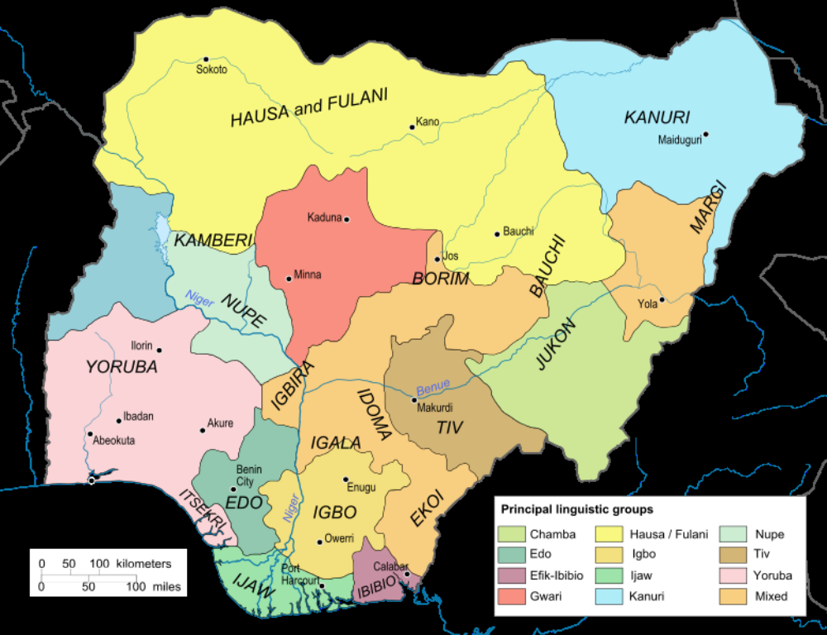
Figure 1: Linguistic Map of Nigeria
(Source: www.researchgate.net)
The Semantic Field Theory
The theory of semantic fields is a linguistic theory which assumes that the lexical items of a natural language can be classified into sets, or fields, related semantically. According to this theory, in any given language, words are grouped into lexical fields and each lexical field comprises a set of lexical items whose meaning have something in common. This theory proposes that a set of lexical items whose meanings share appreciable similarities constitute a semantic field. For instance, the field of “Colour” in English includes such lexemes as black, white, yellow, orange, green, blue, etc.
The semantic field theory was brought into its puberty by German scholar J. Trier in the 1930s. Trier’s version is seen as a new phase in the history of semantics. Wu (1988, p.94-95) cited in Gao and Xu (2013) summarized Trier’s semantic field theory as follows:
- The vocabulary in a language system is semantically related and builds up a complete lexical system. This system is unsteady and changing constantly.
- Since the vocabulary of a language is semantically related, we are not supposed to study the semantic change of individual words in isolation, but to study vocabulary as an integrated system.
- Since lexemes are interrelated in sense, we can only determine the connotation of a word by analyzing and comparing its semantic relationship with other words. A word is meaningful only in its own semantic field.

Theoretical framework
This study is woven around lexical semantic relations. Lexical semantic relations theory presumes that the actual value of a word can only be ascertained by its relatedness with other items in a paradigm. The central claim of this theory is that the meaning of a lexical item in a language cannot be acquired in isolation rather, in looking at various relationships such word has with other words in that language. According to Asher (1994) cited in Onwukwe (2015), lexical semantic relations theory explains “those approaches that reject the view that the vocabulary of a language is an unordered set of items that belong together on the basis of their meaning…” (p.45) Apparently corroborating this stance, Agbedo (2000) claims that the value of a word is acquired by virtue of its relatedness with other items in the unit. The theory therefore accounts for meaning of lexical items in language in terms of relationships which group words into semantic set or are said to belong to a semantic field.

Methodology
Data for this research were gathered from respondents who speak Ibibio in Akwa-Ibom State. A total of four Ibibio-English adult bilinguals comprising two from the University of Uyo were selected. The researcher embarked on an extensive online interview with the respondents in order to actualize the objectives of this research. The online interview where snapshots of the semantic fields in English were taken and sent to respondents ensured the primary source data. The researcher asked questions and most of the time engaged the respondents in discussions. More so, the researcher had to consult the Ibibio-English dictionary to complement the primary data. Data obtained from both the primary and secondary sources were properly categorized and evaluated.

Animals in English and Ibibio
There exist a wide variety of animals in English. Most of these animals do not have names in Ibibio perhaps due to their non-existence in the land or because they have gone into extinction. More so, one could trace the absence of these animals to the fact that some do not have their natural habitat here in Nigeria and a host of others have been hunted on past occasions.
On the other hand, all around the world, many different types of animals are present. Many animals are quite similar to each other while some are different from others. This could be said of some animals that also exist in Ibibio but do not have English names. Animals in English are categorized into different classes:

Animals
Fish
Amphibians
Reptiles
Birds
Mammals

Vertebrates Invertebrates

English Ibibio English Ibibio English Ibibio English Ibibio English Ibibio
Icefish dek iyak frog mbe snake asabọ parrot inim rat ekpu
Salmon (X) salamanda (X) lizard akpọk owl n̄kịrịkịt cat akpọọsi
Shark anim toad ikuọt chameleon akube penguin (X) pig édi
Tilapia (X) newt (X) crocodile afiom eagle akukuọ dog ewua
Mackerel (X) gecko (X) vulture utere bear (X)
Catfish inara tortoise ikịt ostrich (X) lion (X)
Eel unian̄ python ibọm quail (X) tiger (X)
Mudfish abon turtle (X) dove ibiom leopard ekpe
Knifefish (X) pigeons (X) sheep edon
Darter (X) duck (X) squirrel adua
Goldfish (X) goose (X) rabbit ekpu
Flamingo (X) elephant eniin
giraffe (X)
fox (X)
antelope aso
zebra (X)
whale (X)
monkey ebọk
gorilla idiok
goat ebọk

Invertebrates
English Ibibio
Bedbug ndang
Octopus (X)
Spider utu ekpe
Crab isobo
Cockroach mfem
Mosquito abọn̄
Snail ekuọn̄
Periwinkle mfi
Ant akpa ison̄
Earthworm etim
Butterfly akpufiop
Millipede etim
Centipede mkpetimutak
Beside those identified above, there are some animals in Ibibio which do not have equivalents in English. They are only given vague descriptions in English. Some of these are:
Ibibio Gloss
Amasa a kind of fish
Ekue a kind of fish
Ibe a kind of fish
The following contrastive statements can be provided:
- Many animals in English do not have Ibibio equivalents because they do not exist in the people’s worldview. For instance, cold weather animals like bears and penguins or wild animals like giraffe and zebra. More so, some kinds of fish like Darter, Goldfish and Knifefish do not exist in Ibibio because they originate from freshwater habitats.
- Also, many animals which exist in both languages appear to be animals that have an extensive relationship with humans beyond simple predation and have adapted to human niche (dogs, cats, parrot, rats, etc.). They also include those that are tameable and targeted for food (cow, sheep, goat, monkey, etc.) and those that are in contact with humans on occasions (snake, eagle, frog, cockroach, ant, dove, etc.)
- Some animals are named in Ibibio that do not have English equivalents while some do not exist in the people’s worldview
Based on the above statements, it can be said that many animals in English will sound unfamiliar to Ibibio-English speakers since they do not exist in their language and this will pose difficulties recognising, describing and identifying them in textbooks, magazines, journals, etc.

Parts of the Body
The human body is the entire structure of a human being. All around the world, humans share similar physiology, organs and similar body plans. We all control our body chemistry using similar hormones and we all similarly react to changes.
However, these similarities in organs, hormones, etc. are characterised and represented by different languages. Thus, it is pertinent to examine the two languages in question.

Body (idem)
head
leg
trunk
(iwuot)
(adukpit idem)
(ukot)

face (iso) neck (itọn̄) thigh (ifʌkkọ)
hair (idet) throat (adidian itọn̄) hip (iwọn̄)
eye (anyen) shoulder (afara) knee (edọn̄)
eyeball (mkpọrọ anyen) hand (ubek) ankle (ekpaha
ear (utọn̄) arm (ubọk) foot (itetise)
nose (iwuo) forearm (X) toe (ukot)
nostril (esid iwuo) elbow (ekʌn̄ ubọk) toenails(nnuun ukot)
tongue (edeme) chest (esit)
mouth (inua) heart (esit)
lips (mkpog enua) liver (esit)
jaw (mban̄) belly (idip)
cheek (mfʌk) waist (isin)
Tooth (edet) palm (esịteka ubọk)
Finger (nnuun)
Fingernails (nnuun ubọk)
It is noticed from the tree diagram above that Ibibio has matching names for the words representing the parts of the body in English. Consequently, the Ibibio speaker may not encounter difficulties representing these in English.
However, in Ibibio, the word ‘esit’ stands for chest, heart and liver in English. Therefore, this could pose a problem for an Ibibio speaker as a case of underdifferentiation may likely occur. The speaker may see the words as equivalents.
Moreover, given the multiplicity of meaning in the word ‘esit’, the learner may have problems identifying the translation equivalence of the word. This can lead to inhibition of learning.

Kinship Terms
Kinship terms are words used in a speech community to identify relationships between individuals in a family. Different societies classify kinship relations differently. It is pertinent to note that different cultures collapse different relatives under one name. Cultures that share systems of kinship terminology also tend to be similar in residence patterns, descent rules and family organisation (Levinson and Malone 1980).
English Ibibio
father ete
mother eka
child ayịn
son ayịn owodeen
daughter ayịn owowaan
brother ayịneka owodeen
sister ayịneka owowaan
cousin (X)
uncle ayịneka etemmi
niece (X)
nephew (X)
aunt (X)
grandfather etebom
grandmother ekam
grandchildren ndito
great grandfather (X)
great grandmother (X)
great grandchild ayeyin
father-in-law ètéébémmì
mother-in-law ekaebemmi
brother-in-law ayineka-ebemmi owodeen
sister-in-law ayineka-ebemmi owowaan
son-in-law ebeayinmmi
Looking at the data above, it is observed that some kinship terms in English (cousin, nephew, niece, aunt) do not have names for them in Ibibio. This appears to be because they are not commonly used and distinguished among the people. In the Nigerians context, Nigerians rarely use cousins, nephew and niece, what is common is “brother” or “sister” substituted for these terms unlike the English context where these terms are used. It is important to note that blood ties happen to be the basis for kinship, however kinship goes beyond biological ties or common ancestry to include marriage, adoption or Godparents (in churches or political life).
Also, some of the names in Ibibio are represented with two or more lexical items put together to give a particular semantic meaning and not free like those in English. For instance we have:
Ibibio Gloss
ayin owowaan daughter

child female
ayineka owodeen brother

brother male
ayineka owowaan sister
sister female
Based on gender distinction, the lexemes owodeen (male) or owowaan (female) is employed in Ibibio. These help greatly in distinguishing relationships unlike English where such distinction does not exist.
Based on the contrastive statements above, the absence of some of the lexical items in Ibibio can lead to disparity in kinship terms which can cause problems when the mother tongue interferes as learners may use one term in place of another. For instance, if a speaker says “come with your brother” when he/she actually meant ‘nephew.’
Moreover, kinship names act to reinforce cultural expectations about how kin will behave towards one another. Thus, relatives who seem to be called by the same name in Ibibio tend to be identified with similar roles or responsibilities. For instance, brother and nephew might be taken to have similar roles or responsibilities.

Findings and Conclusion
In this research, there has been an attempt to do a contrastive analysis of three semantic fields in which lexical items can be categorized in English and Ibibio. It is observed that there is a link between peoples’ lexical choices and their socio-cultural realities. Objects or activities not seen, perceived or encountered are likely not to be assigned any names as in the case of some animals which do not have equivalents in Ibibio.
Furthermore, it is observed that words are assigned to the various parts of the body in both languages under focus. This can be traced to the fact that human beings all around the world share similar physiology, organs and similar body plans thus, every language group must be able to account for the various parts making up the structure of a human being. Lexical items for animals and kinship terms vary as they are based on different socio-cultural realities. These might pose learning and teaching difficulties for second language speakers.
The study opens up further areas of CA investigation into semantic fields in English and other indigenous languages. It is hoped that future CA researches will further unravel the intricate bonds that hold between language and culture to proffer solutions to the problems that second language speakers are saddled with.

References
Agbedo, C.U. (2000). General Linguistics. An Introductory Reader: Nsukka: ACE Resources Konsult.
Alharfan, I. (2016). English as a Global Language and the Effects on Culture and Identity: American Research Journal of English and Literature (ARJEL), Volume 2016, 6 Pages
Bamgbose, A. (1991). Language and the nation: The Language question in Sub-Saharan Africa. Edinburgh: Edinburgh University Press.
Chunming Gao & Bin Xu (2013). The Application of Semantic Field Theory to English Vocabulary Learning. Theory and Practice in Language Studies, Vol. 3, No. 11, pp. 2030-2035
Denhem & Lobeck (2013). Linguistics for everyone: An Introduction (2nd Ed &, International Edition). Rosenberg. United States.
Ikhimwin G.A. (2011). A Contrastive Analysis of some Semantic Fields of Study in English and Edo. Knowledge Review Volume 23 No. 3, December, 2011
Offiong, D. A. (1983). Social Relations and Witch Beliefs among the Ibibio of Nigeria. Journal of Anthropological Research. 39 (1): 81–95.
Onwukwe C. (2015). Hyponymous Reationship of Verbs of Cooking in Igbo.International Research Journal of Arts and social Science Vol. 4(3) pp. 61-69
Sapir, E. (1921). Language: an introduction to the study of speech. New York: Harcourt Brace.
Udosen et al. (2017). The Structure of Idioms in Ibibio. International Journal of Language and Literature December 2017, Vol. 5, No. 2, pp. 185-196
Urua et al. (2014). Uyo Ibibio Dictionary. ABUILD Language Documentation Curriculum Project
Www.researchgate.net (accessed February 9, 2020)
Willie W.U. (2011). Lexical Aspect and Lexical Saliency in Acquisition of Past Tense-Aspect Morphology among Ibibio ESL Learners. A Dissertation Submitted to the Graduate Faculty of the University of Georgia

