Cyberpragmatic Analysis of memes in tweets of responses to former Nigeria Minister of health’s statement on resident doctors in Nigeria

Abstract
This paper examines internet memes as semiotic tools through which sociological, cultural and ideological views about an issue are forgrounded. Using Cyberpragmatics (Yus, 2011) and Multimodality (Jewitt, 2014) this study aims to show the inferences in people’s tweets containing memes of the former Nigeria minister of health’s comment on resident doctors: ‘…We can't all be specialists, some will be farmers, some will be politicians, some will be tailors….’ To achieve this aim, the study attempts to examine how the ensemble of the linguistic and pictorial elements in the memes under scrutiny portray the neglected healthcare sector in Nigeria; to examine how the linguistic and image in the memes assist in drawing inferences of the undertone meanings encoded in the memes, and to find out through description the different categories of memes in the corpus. The study is qualitative and analyses memes gathered from online tweets posted in the months of September to November 2018. The study found that of the eighty-five memes in the corpus, forty-two memes depict helplessness; seven memes come under the Synecdoche category, eighteen memes are sarcastic in their text/picture combination, Innuendo memes and Transferred epithets memes have eleven and seven respectively. The study concludes that the textual/pictorial combination of memes assist readers’ cognitive role in completing the unmentioned meanings in the memes when they are assessed based on the socio-cultural context of the happenings of a particular issue. All the verbal and pictorial elements in the memes are meaningful in the context in which they have been used.
Keywords: Nigeria minister of health, internet memes, semiotic resources, multimodal elements, inference

1.0 Introduction
Before the 21century, linguistic items and how they encode meanings in different discourse settings and platforms have been the focus of most academic enquiry. Now, the advances and changes in technology allow regular people to contribute to the general media environment through their online activities—and those contributions have the potential to reach a wide audience. The implication of this is that offline and online discourse have taken new forms and dimensions. In other words, communication is now multimodal rather than mono-modal. Apart from linguistic elements, online chats and tweets deploy other semiotic resources such as memes in passing across messages. Memes are remixed media artefacts that are deployed both online and offline to portray sociological, cultural and ideological views about an issue. Coined by a biologist Richard Dawkins in his book The Selfish Gene in 1976, the term ‘meme’ has been widely adapted in many disciplines, like psychology, philosophy, anthropology, folklore. In linguistics, it has received insignificant attention even though in recent times it has been one of the most deployed semiotic resources in online communication.
Some people’s online tweets comprise reactions to the former Nigeria’s minister of health, Professor Isaac Adewole’s speech on the state of medical doctors in Nigeria. According to the minister, when asked why it was becoming increasingly difficult for newly minted medical doctors to find a place for residency training in a bid to become specialists in the various disciplines of medicine, the minister said that it is not necessary for all doctors to become specialists in medicine, as some of them can try their hands on other professions or vocations such as farming, politics, or even gown-sewing. To give an example, the minister said that his tailor makes the best gowns in spite of being a medical doctor. This statement cannot be inspiring coming from a medical doctor who has practiced the profession for several decades both in the clinic and the academia, and having risen through the academic ranks to become a professor of obstetrics and gynecology, plus a privilege to serve as the Vice Chancellor of a foremost institution of higher learning in Nigeria. This seemingly explained why some Nigerians took to twitter to express their anger in response to the minister’s comment pertaining resident doctors in Nigeria. Also, part of the background knowledge why people reacted so angrily to the comment is that the healthcare sector in Nigeria is in dire straits, some of the contributing factors include: corruption across the healthcare horizon, poor education of management specialists, ill-trained nurses, unavailability of medication and lack of funding of health facility. The consequences of these do not only create a want in empathy from the medical practitioners themselves, it also leads to an even greater disadvantage for Nigeria, by encouraging brain drain. With all these, it is not surprising that people reacted both online and offline to the former minister of health’s comment.
Tweets are some of the online tools which youngsters use to communicate; in it, they deploy different semiotic elements to interact. The use of internet memes (IM) is one of such semiotic element. Some scholars aver that IMs are trivial and humorous (Burgess, 2008; Davidson, 2009, 2012). Davidson notes that an accurate definition for the concept of an IM is lacking and defines IM as “a piece of culture, typically a joke, which gains influence though online transmission (Davison, 2012).” In other words, memes communicate humor based on shared socio-cultural knowledge. The view taken in this paper is in disagreement with Davidson’s definition of meme as being merely trivial and jocular items; the argument here is that memes encode and express deep cultural meanings about an issue.
There are other contrary views to Davidson’s definition. Some authors aver that IMs handle and foreground serious societal issues (Miltner 2011, Shifman 2014). Milner (2012) defines IM as “amateur media artifacts, extensively remixed and re-circulated by different participants on social media networks.” This definition corresponds to some extent to the ideas expressed in the theories of multimodality and Cyberpragmatics which are also discussed in this research paper. On his part, Shifman (2014) argues that in an era marked by networked individualism people use memes to simultaneously express both their uniqueness and their connectivity. As a result of the late arrival of the internet to Nigeria, as against what is obtainable in more advanced countries, scholars in Nigeria have not really carried out many studies on IMs; this study therefore is an answer to this call. Multimodal approach and Cyberpragmatic tools are adopted in this study in recognition of the need to identify how the ensemble of linguistic and visual mutually portray the neglected healthcare sector in Nigeria. The way the memes are portrayed in response to the former Nigeria’s minister of health’s comment meet the objective of this study as well necessitate the adoption of Cyberpragmatic/multimodal approach in the study of the memes under scrutiny. This study argues that memes are not accidental; the ensemble of each meme is consciously chosen by the meme creator. Internet memes are viewed as semiotic resources which are used by internet users for communication purposes. Tweeps employ different creative ways of communicating different ideas, both serious and trivial on the internet.
According to the minister of health, ‘‘It might sound selfish, but we can’t all be specialists. We can’t. Some will be farmers, some will be politicians. ‘‘The man who sews my gown is a doctor. He makes the best gown. And some will be specialists, some will be GPs, some will be farmers.’’
The extract above is the section of the speech that generated so much backlashes from the public on the traditional media and on the social media like twitter. The minister made the speech at the 38th Annual General Meeting and Scientific Conference of the National Association of Resident Doctors of Nigeria (NARD) on Friday, September 21, 2018. This study aims to show the inferences in people’s tweets containing memes of the former Nigeria minister of health’s comment on resident doctors: ‘…We can't all be specialists, some will be farmers, some will be politicians, some will be tailors….’. The objectives are: to examine how the ensemble of the linguistic and pictorial elements in the memes under scrutiny portray the neglected health sector in Nigeria; to examine how the linguistic and image in the memes assist in drawing inferences of the undertone meanings encoded in the memes, and to find out through description the different categories of memes in the corpus. Applying Cyberpragmatics and Multimodality in this study, I shall attempt to answer three research questions: how does the ensemble of the linguistic and pictorial elements in the memes under scrutiny portray the neglected health care sector in Nigeria? How does the linguistic and image in the memes assist in drawing inferences of the undertone meanings encoded in the memes, and what are the discernable categories of memes in the corpus? The theories of Cyberpragmatics and Multimodality are important because they help to draw inferences from the combined semiotic elements in the memes analysed in this study.

2.0 Linguistic and pictorial signification patterns of internet memes (IM)
Recently, IMs have attracted growing public interest. Earlier studies on the use of IM such as (e.g. Milner, 2012) considered meme as public discourse; for their functions as rhetoric (Anderson & Sheeler, 2014), and (Shifman, 2014; Yeku, 2015) for their memetic qualities and photo-based genres. Although IMs have been seen as colloquially short term jokes or practices (Burgess, 2008; Davidson 2009), an increasingly growing body of research indicates that IMs may in practice serve to fill deeper needs of the topic they portray than mere humour (Miltner, 2011).

Ever since Dawkins (1976) coined and defined the term ‘meme’ several scholars (Davidson, 2009; Miltner, 2011; Milner, 2012; Shifman, 2014; Anderson & Sheeler, 2014) have put forward their own definitions either in support or in modification of Dawkin’s definition. To buttress this view, Olesen (2009) points out the lack of agreement in a definition of the notion of ‘meme’ by scholars; and defines meme as “any form of cultural phenomenon that can be copied from one mind to another” (Olesen, 2009). This operationalization of meme positions the term as a social and cultural phenomenon from a starting point. It is not intended in this article to dabble in this controversy of definition of the term ‘meme’. Instead the focus in this article is on the meaning potential of the linguistic and pictorial ensemble in the memes that foregrounds the socio-cultural inferential meaning of the former Nigeria’s minister of health’s ‘demeaning’ comment on resident doctors in Nigeria. One uniting variable in scholars’ definitions of meme is the notion that memes are visual signifying tools through which socio-cultural ideas whether serious or jocular are expressed.

A brief examination of IM shows that there are countless other pseudopictograms of expressions and objects which are regularly added to typed communication. Emoticons, code-mixing, pidgin, formal language, slang or any other form capable of representing glyphs can be used to frame meme content as positive or negative, serious or joking, and any other number things. D’Angelo (2009) argues that because memes are highly visual and intertextual, meaning that they reference multiple texts and events, like other forms of visual signifying elements, they contain visual arguments that readers/viewers can infer which may influence their opinion about an issue. Foss (2004) notes that IMs are rhetorical artifacts open to individuals to construct meaning. This way, memes can act as visual persuasive devices. Memes can contain many visual rhetorical techniques stemming from the intertextual practices of appropriation and juxtaposition used to create them. They can be satirically humorous when referencing societal issues, also acting as tools to criticize social vices.

Milner (2012) states that memes are used in networks of mediated cultural participation as multimodal artefacts (the integration of image and text) to tell a joke, make an observation or advance an argument. Milner (2012) identifies types of memes and separated them into remixed images and stable images, arguing that image macros are not only the most common genre of memes, but are also “one of the clearest examples of inter-play of imitation and transformation in the process that guides the construction of memes.” De la Rosa-Carrillo (2015) refers to Brown (2012) when describing image macros as “captioned images that typically consist of a picture and a witty message or a catchphrase. The structure of an image macro usually consists of a picture with text above and below the image in the macro”. Variations of the typical structure of an image macro can also occur, especially when the image macro is used to comment on something. Image macros without any text also occur. Image macros with variation in structure or without text are normally referred to as reaction shots. What all these views by scholars show are that memes have unique forms of presentation; words in whatever presentation and images are deployed in memes to foreground the creator’s intention. Apart from words, memes deploy visual signifying elements that encode meanings of the social issues they tend to portray. The photo in the meme usually provides either the non-verbal aspect of the context, or the background information needed in order to interpret the meme correctly.

Most studies on IMs in Nigeria have focused more on the humorous side of memes (cf. Adeyemi & Oyebode, 2015; Onanuga, & Ajao, 2017). Others have examined more areas of memetic discourse (Yeku, 2015; Anurudu & Obi, 2017; Dike 2018). While Yeku (2015) examines photo-based memes in Nigeria digital publics, Anurudu & Obi (2017) examine memes as metaphors. Dike (2018) looks at how memes can constitute viable tools for opposing Nigerian politicians’ flaws. Although Dike’s study failed to clearly point out that the society covertly aids impunity by not punishing corrupt leaders promptly, it has shown that IMs encode meanings that have the ability to foreground societal feelings about an issue.
While the studies above have considerably contributed to the literature on IMs especially in Nigeria, having examined memes from the perspective outlined above, none focused on how the ensemble of memes can assist readers/viewers draw inferences of the encoded meanings of the situation they depict. Apart from Anurudu and Obi’s (2017) study which focused on memes in online sales, all others focused on politics. The present article proposes an alternative way of looking at memes from a theoretical framework that argues that memes are in fact linguistic and pictorial icons which contextualize and transmit meanings through inferences of the socio-cultural happenings of a given geographical location. This article constitutes a novel approach to memes because it examines memes using concepts from Cyberpragmatics and Multimodality which have not been included in previous studies.

3.0 Theoretical Thrust
Cyberpragmatics (Yus, 2011) and Multimodality (Jewitt, 2014) are the theories upon which most of the arguments in this paper draw their impetus. Cyberpragmatics was coined in Yus (2001) as an attempt to study Internet-mediated communication from a cognitive-pragmatics point of view specifically, from the theoretical framework of relevance theory (Sperber & Wilson, 1995); although other theoretical approaches were also incorporated. Relevance theory claims that human cognition is biologically geared to the maximization of relevance from the different inputs that reach our minds. Yus (2011) focuses on how the interpretation of the combination of text and picture demands the user’s active participation in combining sources of information (background knowledge) to reach a satisfactory interpretation of the encoded meanings of the semiotic resource. Yus (2011) provides information on how combination of interpretations from text and picture provides iconic knowledge in order to process adequately the linear and time-demanding word-by-word processing of the text and the instantaneous visual impact of pictures on memes. The information obtained from a picture will often lead to an inferential backtracking (and re-interpretation) after the accompanying text has been processed, as regards the information provided by the visual content. Yus (2011) stresses the point that Internet users resort to inferential strategies when interpreting messages on the internet. The inferential strategies are arrived unconsciously at by the overall contextual clues of the situation depicted. Readers/viewers are able to turn words and images into relevant interpretations, regardless of the type of utterance, the channel used, and the richness of contextual information. Addresser users in this case meme creators, expect their virtual interlocutors to access some specific contextual information that enables them to reach the intended interpretation of their messages. Also, readers/viewers invariably access contextual information as an inherent part of their relevance seeking inferential activity. Pragmatic presupposition refers to the common ground knowledge that is assumed to exist between language users such as assumed knowledge of a particular situation. A semiotic resource user, in this case meme creators create memes using different semiotic elements to pass across their intentions based on their assumption (or presupposition) of what the reader/viewer is likely to ‘know’ and what the reader/viewer will infer from what is said or written. That is, communication takes place against a background of beliefs and assumption shared, or presumed to be shared’ (Delogu, 2009, p. 198). The reader/viewer of the image in a meme has to make inferential hypotheses concerning the role that it plays in the overall comprehension of the meme. A reader/viewer needs to infer whether the picture has a purely denotative quality or whether it has a wholly inferential connotative quality that can only be obtained from the combination of the picture and contextual information. Meanings obtained from image in memes can be direct and indirect. The direct one, the reader/viewer simply identifies the visual information in the picture and immediately matches it with the most appropriate mental referent. On the contrary, the indirect meanings are fully inferential and have to be obtained with the aid of context. Therefore, interpreting a meme entails processing of the text, the processing of the picture, and the identification of possible connotative meanings. We shall see these shortly in the memes analysed.

Multimodality was developed in the early 2000s and originated, in particular, from the work of Michael Halliday on language as a social semiotic system. According to Jewitt (2013: 252), Halliday’s work shifted the attention from language as a static linguistic system to language as a social system. Jewitt (2014) made some useful remarks about multimodal text (a) all communication is multimodal; (b) analyses which focused solely or primarily on language cannot adequately account for meaning; (c) each mode has specific affordances arising from its materiality and from its social histories which shape its resources to fulfill given communicative needs; and (d) modes concur together, each with a specialized role, to meaning-making; hence relations among modes are key to understand every instance of communication. In the specific case of meme communication, co-occurrence of text and picture the last assumption according to Jewitt (2014), proves very useful here. Picture-text combination for a pragmatic (i.e. Cyberpragmatic) analysis is the one in which the eventual meaning of the meme cannot be obtained from the partial meanings of text or picture taken separately, but only from their combined meanings that yield implications. Presupposition/inference and common ground are pragmatic tools in addition with Multimodal approach are adopted in this study in recognition of the need to identify how the ensemble of linguistic and visual mutually portray the neglected healthcare sector in Nigeria. The way the memes are portrayed in response to former Nigeria minister of health’s statement meet the objective of this study as well as necessitate the adoption of the theoretical approaches chosen in this study.
4.0 Data collection and methods
The data for this study are eighty-five online memes containing text and images in reaction to the former Nigeria minister of health’s comment on resident doctors. According to the then Nigeria’s minister of health ‘‘It might sound selfish, but we can’t all be specialists. We can’t. Some will be farmers, some will be politicians. ‘‘The man who sews my gown is a doctor. He makes the best gown. And some will be specialists, some will be GPs, some will be farmers.’’ The comment generated a lot of reactions on the traditional media and on the social media. Twitter posts were chosen because of their non-interactive nature. The twitter reactions came in the form of linguistic and non-linguistic elements; that is, posts with only texts and posts with graphic images with texts (memes). Picture-text combination memes were selected. This fits into Yus (2011)’s assertion that ‘‘just as in face-to-face communication, the addresser users (in this case meme creators) have communicative intentions and have to devise their messages in such a way that the intended interpretation is selected by their addressee users’’. It was discovered that in the eighty-five memes which constitute the corpus for this study had variations (categories). Three memes were chosen to represent each category in the analysis. The memes chosen are picture-text combination; the eventual meaning of each meme cannot be obtained from the partial meanings of text or picture taken separately, but only from a combination of semiotic elements yield inferential meanings. In the analysis, attention was devoted to determining which contribution each mode (text/picture) makes to the overall meaning of the meme. In online tweets, active participants in the comment thread that is, those who write comments are registered users who most often display nicknames, while passive, non-registered users can only read the comments, the author of this article is one of such passive participants. The present paper concentrated on the comments written by active participants.

5.0 Data Analysis
According to the former minister of health, ‘‘It might sound selfish, but we can’t all be specialists. We can't. Some will be farmers, some will be politicians. ‘‘The man who sews my gown is a doctor. He makes the best gown. And some will be specialists, some will be GPs, some will be farmers.’’
5.1 Our findings revealed different categories of memes. Each shall be taken in turn:
5.1.1 Memes depicting hopelessness
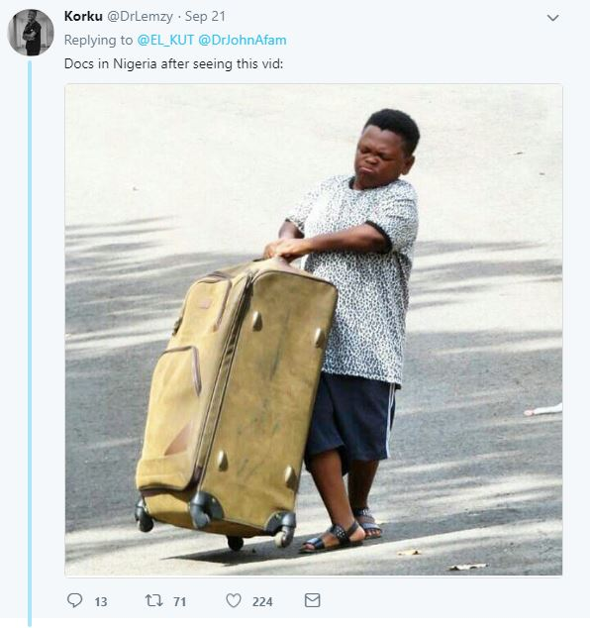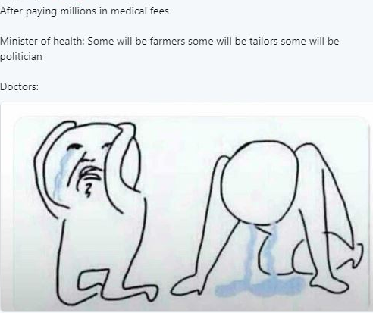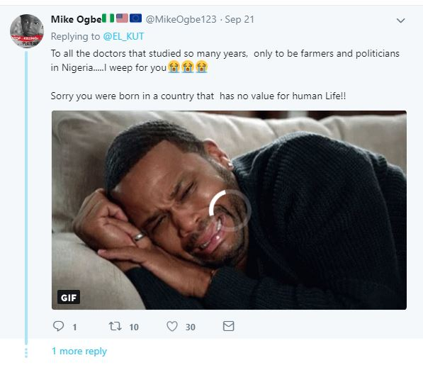
Figs. 1, 2, 3
Figure 1 meme amplifies the inference of the negative feelings associated with the former minister of health’s statement. The human image in the meme Osita Iheme popularly known as ‘pawpaw’ is a diminutive Nigerian actor who is popular for his comic, humorous and mischievous roles in film. The text: ‘Docs in Nigeria after seeing this vid:’ gave rise to doctor(s) represented by the human image carrying his luggage ostensibly out of the country. The diminutive man with large luggage visibly too big for him to carry and the text, makes it easier for the reader/viewer to build up a make-sense frame of the helplessness and hopelessness of the average Nigerian doctor. The sternness in his face connotes Nigeria’s resident doctors who are directly affected by the minister’s comment. Juxtaposing his size with the size of the luggage he is carrying creates a sort of desire from the viewer to want to help with the luggage. The average Nigerian doctor wants to get out of the country of ‘helplessness’ after being told by a minister who is supposed to push for their interest that ‘… some will be farmers, some tailors and some politicians…’. At another level, the big luggage could mean the huge problems Nigerian doctors are facing. He is not carrying a small sized luggage but a big one, seemingly showing his desire not to want to come back to the country. The reader/viewer is expected to be able to retrieve from the common ground the communal knowledge of the neglected healthcare sector in Nigeria and be able to process the link between the textual part of the meme and the human image.
Figure 2 meme has a header which provides some background information in assessing the other semiotic elements in the meme. The inferred dialogue between the minster and doctors makes more meaning with the knowledge of the header. All collectively depict the dire straits condition of medical doctors in the country. It is presumed a shared knowledge that medical students get better jobs after paying so much money in medical school, for the minister to counter this presupposition with his speech sets up a tension for the reader/viewer. This way, the text and the image jointly pass across to the reader the helpless situation of the healthcare sector in Nigeria. This enhances Chan’s (2011) assertion that, the relationship between a text and the image is enhanced when the text adds an informative element to the picture.
Figure 3 meme is a reiteration of the helpless situation depicted in the figure 2 meme. This meme combined so many semiotic elements in foregrounding the socio-cultural environment that gave rise to the meme. The meme creator deployed weeping emojis, linguistic, and human image in its signification. According to Eco (1984, p. 7) an author (a meme creator) has to foresee a model reader who is, supposedly, able to deal interpretatively with the expressions in the same way that the author deals generatively with them. The weeping emojis contribute emotional meaning to the meme. The three semiotic resources reinforce the meaning in each. In the text, the meme creator mentions ‘weep’ the weep is reinforced in the weeping emojis and also demonstrated in the human image weeping. The category is related to what Jewitt (2016) calls multimodal ensemble, where all the modes combine to convey a message’s meaning. The information is distributed across modes, and “any one mode in that ensemble is carrying part of the message only: each mode is therefore partial in relation to the whole of the meaning” (p. 73). The multimodal ensembles are inferential strategies that aid the reader to accurately interpret the contextual meaning of the meme.
5.1.2 Synecdochical memes: the memes in this category pass across meaning through using an inclusive term for something included or including something through an inclusive term. For example:
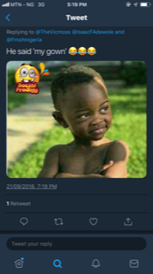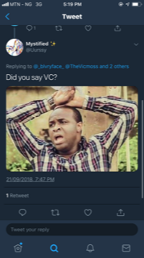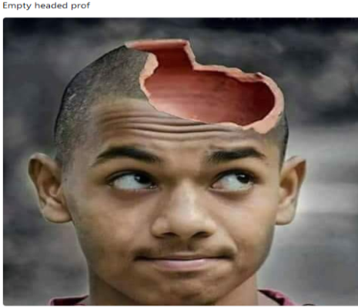
Figures 4, 5, 6,
The linguistic element ‘gown’ of figure 4 is an inclusive word of the medical profession. ‘‘My gown’’ mentioned by the minister in some part of the speech drew the ire of this meme creator. According to the health minister, ‘‘The man who sews my gown is a doctor…’’. The former Nigeria health minister presupposes that the audience listening to him knows he is a doctor, this presupposition makes this meme creator to reiterate the known (in the textual part of the meme) and cues the reader into assessing the insensitivity of the minister in making such a statement. Men ordinarily do not wear gowns, but in this context, the meaning broadens to include the medical profession.
The meme creator of figure 5 used the rhetorical question (Did you say VC?) as common ground to cue the reader to get the presupposed meaning that such derogatory statement demeans him as a former Vice Chancellor of a University. Although the mean creator did not mention the controversial remark by the health minister, the reader is able to assess the meaning of the meme based on the context of its creation. The image of a man with both hands on his head, mouth wide open and look of anger on his face all show his disappointment. To add to his disappointment is that the controversial statement was made by a former Vice Chancellor (VC) representing an entire University. The meme creator’s deployment of the rhetorical question ‘Did you say VC’ is not to gain a response but to reiterate the disappointment shown on his face.
Figure 6 presents a boy with half broken head, who ought to be dead if in real life. The image is ostensibly used to depict and conjure in the mind of the reader how empty-headed the Professor who is the minister of health is to have made the statement that has led to the creation of this meme. Coegnarts & Kravanja (2012) suggest that the quality of a text should be represented either in terms of abstract or concrete concept. Within the image above, our source domain is concrete since the image can appeal to our sense of sight. Whatever the Prof is, is reduced to the image in the meme. His insensitivity to the plights of medical doctors in the country sets him up as empty-headed as depicted by the meme and the text (Empty headed Prof). The image’s upward gaze is as if looking inside the Professor’s head and then concludes it is empty. The Professor’s utterance shows he is not conscious of the state and condition of the healthcare sector in Nigeria, this, to the meme creator shows he is empty-headed. The image is used to appeal to our sense of reasoning and sight. The linguistic items and picture of this meme is an exemplification, in which words help the reader/viewer reach a more fine-grained interpretation of the related picture, as intended by the creator of the meme.
5.1.3 Sarcastic memes
The memes in this category mock and show contempt either through words or image, but all eventually convey the likely meaning of the meme creator: for example:
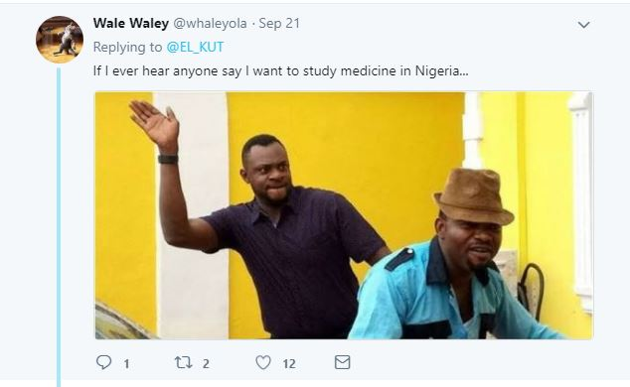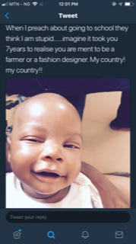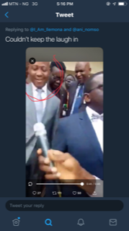
Figures 7, 8, 9
Figure 7 meme on the surface looks humorous but pours contempt on the minister of health for the controversial statement. The image of Nigerian actor Odunlade Adekola with raised hand depicts him trying to slap another man; ostensibly, the meme creator frames the man as a potential and intending medical student in Nigeria. The text assists the reader to contextualize the meaning of the image. The ellipsis at the end of the linguistic structure is expanded further in the visual image. The text and the image seem to suggest that potential and intending medical students need to be beaten for saying they want to study medicine in Nigeria. No need studying medicine in Nigeria, since after all, when you graduate, according to the former minister of health you would be ‘a farmer, a politician or a tailor’.
The textual part of figure 8 (when I preach about going to school, they think I am stupid … imagine it took you 7 years to realize you are meant to be a farmer or a fashion designer. My country! My country!!), looks humorous, but underlying it is the disdain for the minister’s insensitivity in making the statement. In other words, the seven years spent in training to be a doctor is wasted when after all you will end up as a farmer or a fashion designer. The sarcasm in the text is further heightened by the human image laughing. The picture in the meme plays a part in the creating incongruity between the text and the laughing child. The reader/viewer as a result of the background knowledge and context finds the adequate inferential strategies in decoding the meaning from all parts of the meme.

The laughter of the man in figure 9 is not out of fun but out of contempt and mockery for the former health minister. The meme creator ostensibly chose this to equally convey his/her contempt for the minister’s statement. The reader is able to process the meaning of the laughter as a show of contempt rather than joy based on the context of the utterance. The picture may help trigger an incongruity during the construction of an appropriate scenario for the interpretation of the meme. The laughter of the child in the meme and the text build up a make-sense frame of contempt for the minister.
5.1.4 Innuendo memes:
The memes in this category are parallel, where words and picture follow different courses but the context unites them to give the intended meaning of the meme creator. The common ground knowledge and inference help the reader to sieve out the meaning of each semiotic element to jointly process the meaning of the multimodal ensemble. Consider these memes:
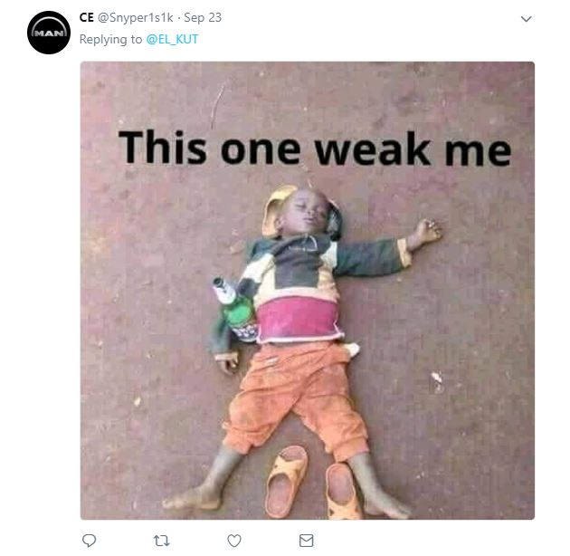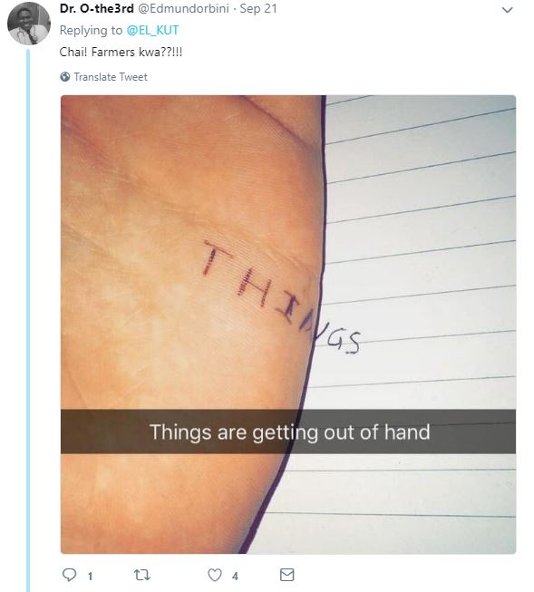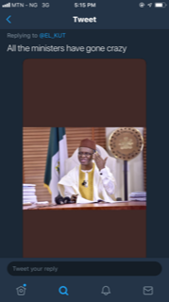
Figure 10, 11, 12
In the example of figure 10, the meme creator presupposes that s/he shares with the reader the same knowledge of the reason for the creation of the meme. The image and the linguistic items of this meme are combined for entertainment purposes; but beyond the denotative is the undertone meaning of the picture and the text. The meme presents the picture of a helpless street tough little boy probably asleep as a result of drunkenness suggested by the half empty bottle of beer by his side. According to Jewitt (2013, p. 251–252), the “meanings in any mode is always interwoven with the meanings made with those of other modes cooperating in the communicative ensemble’’. The beer’s effect on him is juxtaposed with the minister’s comment. The beer is a metaphor for the minister’s speech. The inference is that just as an overdose of beer makes someone weak, a critical assessment of the minister’s comment has the ability to weaken one. The meme creator ostensibly for his message to reach a wider audience, constructs the text in pidgin—the language used by most Nigerians for communication in informal settings.
In figure 11, one loses the meaning of the semiotic elements if one views the meme out of context. The context in which the minister makes the statement disambiguates the meaning for the reader/viewer. The linguistic items (things are getting out of hand) across the image of the half shown hand reinforce the meaning encoded in the image. The text and the image jointly draw the reader into the signification process of the insensitivity of the health minister. The minister’s insensitivity is further reinforced by the interrogative expression on top of the image ‘Chai! Farmers kwa??!!!’. The onomatopoeic item ‘Chai’ is used mainly by the Igbos, a tribe in Nigeria to express distress; ‘kwa’ is also an Igbo expression to show emphasis. The meaning jointly conveyed by ‘Chai! Farmers kwa??!!!’ is further expanded in the image. The double question marks and the multiple exclamation marks suggest frustration and anger in the tone of the meme creator. Ordinarily, the expression could be used in any situation to express abnormality, but when assessed within the context of the former minister’s speech and the accompanying code-mixed items, the meaning becomes clearer that, it as an outburst of frustration.
Figure 12 displays the human image El Rufai, a onetime minister of the Federal Capital Territory, Nigeria and the present Governor of Kaduna state who is famous for commenting on social issues. He is probably used in this meme to add some measure of effectiveness to the meaning of the meme. He is ostensibly depicted responding to the utterance of the minister of health with a frown and a hand gesture close to his head to support the linguistic code of ‘all ministers have gone crazy’. The inference is that the minister of health is crazy for making the controversial statement. The gesture of the human image juxtaposes with the linguistic to portray the intended meaning of the meme creator. Here according to Wu, (2014), the words are supplementary and play an exemplification role to the picture. That is, the words exemplify situations in which the gestures provided by the picture might be produced. The picture plays the role of amplifying the meaning of the text. The meme, because of the human image in it is worth the attention of the reader, and the text merely emphasizes the attributes of the person depicted in the meme. In this case, the reader is expected to be able to retrieve from background knowledge the specific information which justifies the appearance of the famous person in the meme (the image in the meme is known for his critique and comments on social issues). So, the meme creator seemingly uses this knowledge to draw the reader into the signification process.
5.1.5 Transferred epithets:
The memes in this category make meaning through transferring of the attributes of a word to a person. Some are obvious while some are arrived at through inferences. Examples:
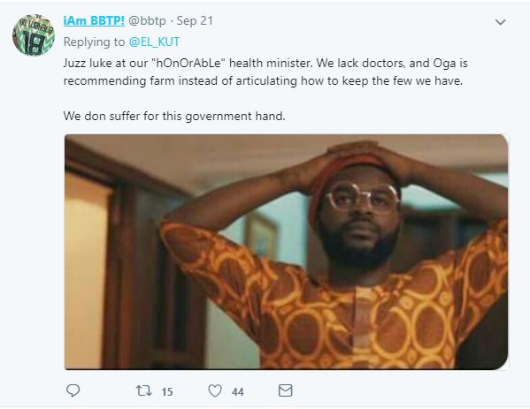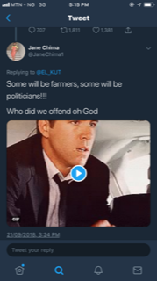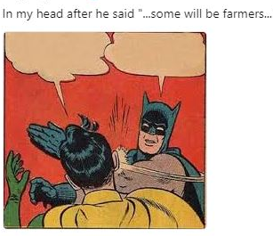
Figure 13, 14, 15
In figure 13, the government is epitheted as cruel as a result of the minister of health’s statement. The minister of health in extension represents the government. The human image in the meme is a known Nigerian musician, an actor and a comedian. The deviant spellings of some of the lexical items in the text of this meme show anomaly, but when juxtaposed with the minister’s statement that led to the creation of the meme the meaning becomes clearer. The adjective ‘hOnOrAble’ used by the meme creator to qualify the health minister is in scare quotes depicting that the minister is not honourable to have made the controversial statement. The context of context speech makes the image’s expressionless face, a distant look, hands on his head clearer. The appearance of the human image and the linguistic items all together build up a make-sense frame of sheer sadness and somewhat bleak future for the common man and the healthcare sector in Nigeria.
The meme of figure 14 triggers the inference of anger and helplessness, based on the context of the minister’s statement. The expressionless face of the human image expands the meaning of the linguistic items (some will be farmers, some will be politicians!!! Who did we offend God). The rhetorical question seemingly meant for the health minister is directed to the invisible audience. The invisible audience having the background knowledge is able to draw the inference of helplessness of Nigerians through the use of ‘we’.

In figure 15, the meme creator focused on what to him/her is the most salient in the minister of health’s statement ‘…some will be farmers…’. The whoosh sign close to the man’s head signifies the slap which the viewer did not see, but was made to see through the whoosh sign emanating from the slap from the cartoon character batman. The dazed feeling is like that of a man being slapped hard on his head as depicted in the image. The meme creator worked on the belief that the reader is aware of the distressing situation of the healthcare sector in Nigeria and the minister of health’s statement. Through the deployment of the kinesthetic semiotic element, the meme creator has drawn the viewer into meaningful and contextualized interpretations. The minister’s statement actually came as a shock to some people.

But you said you would discuss 85 memes??? Where are others??? Better still, I suggest that you recast that 15 memes constitute the data for the study.

6.0 Discussion of findings
In the memes, the reader’s background knowledge on the status of the healthcare sector in Nigeria, the minister of health’s work history, the level of unemployment especially of doctors are crucial to understanding the meme properly, to the extent that, very often, each meme makes little sense if it is separated from the specific time-frame and pieces of news that justified its creation. The combination of words and images create inferential strategies that readers/viewers deploy when turning the schematic meaning of the words and images into meaningful and contextualized interpretations. The category of meme that are most common in the corpus are the memes that depict helplessness; of the eighty-five memes in the corpus, forty-two belong to this category. Seven memes come under the Synecdochical category, eighteen memes are sarcastic in their text/picture combination. Innuendo memes and Transferred epithets have eleven and seven respectively. All the memes in the corpus assist the reader to draw inferences of the encoded meaning of helplessness, insensitivity of the health minister and the neglected health care sector in Nigeria. The final undertone meaning of the memes is a passionate plea to the government and other relevant authorities to focus attention on the healthcare sector.
The study notes that in spite of the fact that some of the meme creators use cartoon characters (figures 2 and 15), the meaning they express is not shrouded. The linguistic items in the memes pass across meanings that have been expanded more in some of the accompanying images. Some use known human figures who are Nigerians to draw attention to the message of the meme. Some of the memes are comical, humorous and funny in spite of this, they embed more meanings beyond the ordinary, this disagrees with (Davison, 2012) definition of memes essentially about humour.

All the memes in one way or another contain visual clues that viewers can perceive and connect with the intended meanings of the meme creators; recognizable glyphs represent the intent or emotional state of the person transmitting them. For example, figure 2 uses the cartoon of weeping doctors to draw the viewers into his mode of signification. In other words, the cartoon has according to Chan (2011) enhanced the modal affordances of the perceived verbal dialogue between the minister of health and the doctors. The words in the memes exemplify situations in which the gestures provided by the picture might be produced (Wu, 2014, p. 1417). This indicates that pictures generally play either the role of accentuating, emphasizing or amplifying the meaning of the text, or are combined with the text in order to generate interpretations which can only be obtained from this combination.

You need to apply more of your theoretical thrust in your discussion of findings.

7.0 CONCLUSION
This study has demonstrated that IMs are designed by meme creators to draw viewers into the argument constructed be the meme creators through the reader’s cognitive role in completing the unmentioned meanings in the memes. It has also been established in the study that IMs are meaningful when analysed based on the socio-cultural context of the happenings of a particular issue. All the verbal and pictorial elements in the memes are meaningful in the context in which they have been used.
Finally this study has gone beyond identifying how the ensemble of the linguistic and visual elements in memes embody deep meanings by suggesting ways of looking at IMs beyond their superficial appearances. Online memes express the feelings and thoughts of tweeters along with the advances and changes in digital communication. One thing that remains the same is humans’ desire to connect with one another and create a shared culture. Trivial as they may seem, memes contribute to this shared culture by fostering people’s imagination, creativity and involvement in the society through the internet. Internet memes are examples of how images, linguistic items, art, language, creativity, myths, and popular culture relate with one another. The IMs analysed in this article contain the aforementioned, as well as reflect the state of the healthcare sector in Nigeria and some people’s state of mind concerning the sector. It may be that not all viewers will take away the same message from a meme, just like any other piece of work, but memes all the same transmit some form of messages in their presentations. The analysis in this article of the memes regarding the health minister’s comment on resident doctors might encompass a more cultural and sociological twist, this differentiation, should be subjected to further empirical analysis. Because of the paucity of research on IMs, it is also clear that more work is needed in excavating the wealth of knowledge deriving from the different manifestations of IMs, the meanings they encode in digital communication.

REFERENCES

Adeyemi, Adegoju, & Oluwabunmi Oyebode, 2015 “Humour as discursive practice in Nigeria’s 2015 Presidential election online campaign discourse” Research journals.sagepub.com, 17 (6),643-662

Anurudu, Stephen Madu, & Obi, Maureen Isioma, 2017 “Decoding the Metaphor of Internet Meme: A Study of Satirical Tweets on Black Friday Sales in Nigeria” International Journal of Language, Literature and Gender Studies (LALIGENS), Bahir Dar- Ethiopia 6 (1), 91-100.

Burgess, Jean, 2008. All your chocolate rain are belong to us? Viral video, YouTube and the
dynamics of participatory culture. In G. Lovink, & S. Niederer (Eds.), Video vortex reader: Responses to YouTube. Amsterdam, Netherlands: Institute of Network Cultures. (101–110)

Coegnarts, Maaten, & Kravanja, Peter, 2012. A theoretical framework for analyzing structural-
conceptual metaphors and image metaphors in film. Image and narrative, 13(1), 96-113.

Chan, Eveline. 2011. Integrating visual and verbal meaning in multimodal text comprehension:
Towards a model of intermodal relations. In Shoshana Dreyfus, Susan Hood & Maree Stenglin (Eds.), Semiotic margins. Meaning in multimodalities (pp. 144–167). London: Continuum.

Davidson, Patrick. 2009. The Language of Internet Memes. http://www.veryinteractive.net/content/5-library/20-the-language-of-internet-memes/davison-thelanguageofinternetmemes.pdf. Accessed February 10 2020.

Davison, Patrick, 2012. The language of internet memes (M. Mandiberg, Ed.). In The social media reader (pp. 120-134). New York: New York University Press.

D’ Angelo, Frank, (2009). The Rhetoric of Intertextuality. Rhetoric Review, 29, 31-47.

Dawkins, Richard. 1976. The selfish gene. London: Oxford University Press.

Delogu, Francesca, (2009). ‘Presuppositions’, in Verschueren, J. and Östman, J.O. (eds.), Key Notions for Pragmatics, Amsterdam/ Philadelphia: John Benjamins, pp. 195–207.

Dike, Deborah, (2018) “Countering political narratives through Nairaland meme pictures”
https://journals.openedition.org/etudesafricaines/22163

Foss, Sonja, (2004). Framing the study of visual rhetoric: Toward a transformation of rhetorical
theory. In C. A. Hill & M. Helmers (Eds.) Defining visual rhetorics (303-313). Mahwah, N.J.: Lawrence Erlbaum Associates.

Jewitt, Carey. 2013.“Multimodal Methods for Researching Digital Technologies.”In The Sage
Handbook ofDigital Technology Research, edited by S. Price, C. Jewitt, and B. Brown, 250–265. London: Sage. Accessed October 3 2016. https://multimodalmethodologies.fileswordpress.com/2018/11/chapter_17.pdf.

Jewitt, Carey. 2014. (Ed.), The Routledge handbook of multimodal analysis (2nd ed). (Routledge handbooks). Milton Park, Abingdon: Routledge.

Jewitt, Carey. (2016). Multimodal analysis. In Alexandra Georgakopoulou & Tereza Spilioti (Eds.), Handbook of language and digital communication (pp. 69–84). Abingdon: Routledge.

Milner, Ryan, (2012). The world made meme: Discourse and identity in participatory media
(Doctoral Dissertation). University of Kansas.

Olesen, Mogens. (2009). Survival of the mediated: Speech, the printing press and the internet as selection mechanisms in cultural evolution. København: Museum Tusculanum.

Onanuga, Ayodele, & Ajao, Adewole. 2017. ‘‘Power And Personality On The Internet: A Multimodal Analysis Of Online Memetic Representations Of Goodluck Jonathan’’ The African Symposium (TAS). 16 (1)

Shifman, Limor. 2014. Memes in digital culture. Cambridge, MA: The MIT Press.

Yeku, James, 2015, ‘Photo-based Memes, Identity, and Politics in Nigerian Network Society’ Yeku, J.https://www.researchgate.net/publication/280881975_Photo-based_Memes_Identity_and_Politics_in_Nigerian_Network_Society
Yus, Francisco, 2011. Cyberpragmatics. Internet-mediated communication in context. Amsterdam and Philadelphia: John Benjamins.

Face of Nigerian memes award goes to Odunlade Adekola https://www.pulse.ng/gist/pop-culture/nigerian-comedy-face-of-nigerian-memes-award-goes-to-odunlade-adekola-id6736908.html accessed November 28th 2019.

https://www.bbc.com/pidgin/tori-45600654

Igala Alan Shore @I_Am_Ilemona·

