MULTIMODAL BEVERAGES: A SOCIAL SEMIOTIC STUDY OF SELECTED
ALCOHOLIC DRINK ADVERTS IN SOUTH-WESTERN NIGERIA
Abstract
This paper examines the communicative resources deployed in the design of alcoholic beverage advertisements in South-western Nigeria. It investigates how these resources have been used to conceptualise the prevalent social practices that portray some of the socio-cultural realities of the nation. The data comprise six purposively selected billboards of alcoholic drinks obtained from some cities in South-western Nigeria. The study applies the tenets of Visual Grammar pioneered by Kress and van Leeuwen and Multimodal Critical Discourse Analysis (MCDA) by Djonov and Zhao. The study shows that semiotic resources are strategically appropriated by Nigerian beverage advertisers to portray the influence of popular culture on the commercial world, reflect socio-culturally motivated messages, assert the legal order of the land to alcohol drinking and construe ideologically based meanings consumers can identify with. Through the investigation of multimodal interaction of these resources, the study concludes that the choice of images in the realization of a text is in tandem with certain social and power structures within the context in which the text is produced.
Key words: Multimodal Critical Discourse Analysis, Social Semiotics, Alcoholic Beverage, Cultural Matrix, Libation Pouring, Social Order

Introduction

Semiotics is a discipline concerned with everything that can be taken as a sign (Eco, 1976). Natural phenomena and the society at large constitute the goal of exploration of semiotics. Social semiotics is a branch of semiotics which investigates human signifying practices in specific social and cultural circumstances, and it attempts to explain meaning-making as a social practice (Janssen, 2017). Social semiotics is thus the study of the social dimensions of meaning, and of the power of human processes of signification and interpretation in shaping individuals and societies. According to Thibault (1990), social semiotics focuses on social meaning-making practices of all types, whether visual, verbal or aural. Thus, these different systems for meaning-making (speech, writing and images) are known as semiotic modes. Social semiotics can also include the study of how people design and interpret meanings, the study of texts, and the study of how semiotic systems are shaped by social interests and ideologies, and how they are adapted as society changes. It explores the many possibilities for semiotic analysis that are created by the assumption that signs and messages must always be situated within the context of social relations and processes (Hodge and Kress, 1988).

Leveraging on the positive side of alcoholic drinks such as the themes of gyration, drinking is fun, modern and enlightening activity, social and prestige giving, advertisers design alcoholic adverts in such a way that they reflect certain social/cultural practices in the Nigerian state. This paper, therefore, seeks to examine how advert designers have used dominant cultures and practices within the society to convey their messages and propagate consumerism in South-western Nigeria, using a social semiotic framework. Though scholars such as Apkan (1996), Olaosun (2006), Opeibi (2007), Okanlawon and Oluga (2008), Coker and Raheem (2012), XXXXX and XXXXX (2011), have worked on different linguistic dimensions of advertising in Nigeria, scholarly interrogation of posters/billboards of alcoholic beverages from multimodal perspective has not been accorded adequate attention in Nigerian discourse studies. This study, therefore, examines different layers of meaning embedded in these multimodal texts as well as the construction of social order inherent in them.

Drinks, also fondly referred to as beverages in the West, are without doubt a form of socialisation. The devotion to drinks by human beings cannot be overemphasized. In Africa for instance, drinks have, since early civilizations, been attached to the worship of deities becoming an integral part of the culture in the process. Broadly, they can be categorized into alcoholic and non-alcoholic beverages. While the alcoholic drinks refer to all kinds of beverages with relatively high percentage of alcohol such as wine, beer, rum, liquor, locally made gins; non-alcoholic drinks possess little or no alcohol and they include; milk, juice, tea, coffee, soft drinks, malt products, etc. Different kinds of drinks have their origins in different places and the ingredients for making them peculiar to these origins. Lasebikan and Ola (2016) acknowledge that alcohol consumption is a well-known aspect of the Nigerian culture and frequently part of festivals and celebrations. In times past in some parts of South-western Nigeria, Seaman’s Aromatic Schnapps was used to pray for new couples at traditional weddings, house warming ceremonies, purchase of new cars etc.

Popular beverages such as malt, beers and tea have gradually become part of the daily menu in many homes, official and unofficial meetings, restaurants, eateries and parties. Drinks are also used for toasting especially when a person is appreciated publicly by friends, colleagues or even family members. In fact, if some kinds of drinks are not served either along or after a meal, at parties, people would adjudge the situation as incomplete.
Product Advertising in Nigeria
As opined by Cook (2001, p.6), “advertising is the dynamic synthesis of many components that comes into being through them.” It entails pictures, images, font and shapes of the letters and colour. Hence, it is a complex phenomenon. Advertising is multifunctional and multifaceted in nature. According to Woods (2000, p. 3), advertisers employ diverse strategies (both informative and persuasive ones) to fulfill the function of providing information as well as urging the consumer to buy. As such, the discourse of advertising is liberally peppered with persuasive devices at every level since the ultimate objective is promotional (Woods, ibid). There are different types of advertisement; however, scholars have used different parameters to make the distinction. While Dunn and Barbon (1986, p. 11), classify advertising using four criteria: audiences, types of advertisers, media and functions, Nayak (2000) broadly classifies it into two divisions which are: commercial and non-commercial on the basis of the object and purpose of advertising. Cook (2001) submits that advertisement can be categorized according to the medium, product, technique and consumer. The above shows there is no straight jacket rule to these categories.
Notwithstanding, there are many factors to be considered before one can adequately place adverts to the actual accurately categorise adverts. The following basic things are highly imperative to any successful advertisements: (1) attracting attention, (2) commanding interest, (3) creating desire, (4) inspiring conviction, and (5) provoking action (Nayak, 2000). These five functions work hand in hand to promote the selling power of the product advertised or that of the service or idea intended for public consumption. For these functions to be achieved in the production of an advertising copy, the text and the context as operationalised by Cook (2001) have to be considered.
Product adverts, also known as commercial consumer adverts according to Nayak (2000), refer to those adverts that are used as tools to propagate consumerism in society. The target audience is represented and beckoned to in the adverts in such an inescapable manner. Hence, product adverts uniquely engender consumerism in the Nigerian public and reflect dominant cultures of the time most importantly because of the outdoor medium the product advertisers utilize to advertise these products. Ajayi (2005, p. 26) opines that outdoor advertising, also referred to as posters and display media (cf Seidman, 2008) are those products displayed or exposed to the public with a view to drawing attention to them and creating willing or potential buyers. The medium, though expensive on the part of the advertisers, is one of the media that has the widest coverage and permanence. It is an involuntary medium and that part of the public picture that is seen willy-nilly, always deriving its effects from the slowness of the passing masses. In a nation like Nigeria, posters as a medium of advertising remain that driving force behind the consumerist culture as they overcrowd the public space reaching out to all and sundry.
Posters/billboards provide an all-year round exposure of messages to the target audience. The audience has the opportunity to always go back and view a product advertisement at their convenience as many times as necessary. This is difficult to obtain in other media like radio and television whereby obtaining the recordings of a broadcast poses a lot of challenges in terms of cost and accessibility. Posters, as XXXXX and Unuabonah (2013) opine, also capture and reflect the value system of any society as well as its ideological beliefs. This makes it possible for product advertisers to design their advertisements around dominant cultures and values within a particular society. Thus, the situational/cultural context of the posters shape the communicative resources utilized in their production.

Alcoholic Beverages Advertisements in Nigeria

Recently, the introduction of billboard adverts has boosted the advertisement of alcoholic drinks, giving it more prominence. The ubiquitous nature of billboards on alcoholic drinks has also helped in the promotion of alcoholic beverages in the country. Young people are featured on billboard adverts and the general impression is that drinking is status giving. On these billboards, young men and women are often pictured having a good time drinking thereby projecting drinking as an essential part of relaxation and a time to really have fun.

Obot et al. (2002) reiterating the opinion of Gureje et al. (1996) note that the adverts on alcoholic drinks are usually designed to capture the distinct nature and /or good quality of particular alcoholic beverages. This is in an attempt to suggest that alcoholic beverages are not as bad as the public usually suppose. Recently, some television stations feature brewing industries adopting a marketing strategy of sponsoring essay competitions, fashion shows, sporting events, conferences etc., where drinks are either served free or with a reasonable discount. Some of these shows have allotted a lot of money as prizes for winners of these games, shows and competitions to serve as an attraction to young people. Examples are Guilder Ultimate search, Maltina Dance, Big Brother Africa, Big Brother Naija, among others.

Akanidomo et al. (2005) note that, the rural-urban migration increased the development of the urban centres, with adolescents and particularly young males migrating in their thousands from rural areas to urban centres in search of jobs. The poor economic state of the nation which informed this exodus has also added to the distress that has attracted drinking which is associated with some form of antisocial behaviours such as violence (Ndom & Adelekan, 1996). Another reason for mass movement is ethnic or religious crisis. An instance is the Niger Delta secession moves in the Eastern part of the country. Some of these movements have affected family stability and resulted in some people engaging in excessive drinking and drug abuse. As a result, there is obvious impact on the level of production and consumption of alcoholic drinks in Nigeria.
Theoretical Framework
MCDA is an analytical approach that allows for a systematic exploration of how linguistic elements interact with visuals and other semiotic resources used in communicative events to create and challenge social meanings and practices. It is an eclectic approach that accommodates a mixture of theoretical perspectives (Djonov & Zhao, 2014). The tenet of MCDA, as posited by Djonov and Zhao (2014), rests on the notion that communication is intrinsically multimodal and multimodal communication is inherently social and ideological. Hence, the major concern of MCDA is that images, just like language also perform social roles. This aligns with the position of Halliday that language is a semiotic mode which represents three major communicative metafunctions which are: ideational, interpersonal and textual. This position serves as the bedrock for Kress and van Leeuwen’s (1996, 2006) social semiotic approach to visual texts in their seminal book Reading Images. To them, images and all other visual modes of communication are semiotic resources for representation of socially and culturally motivated meanings.

Kress and van Leeuwen (2006) submit that all visual modes are inherently capable to form texts and complex signs which internally cohere with each other and externally with the context in and for which they were produced (Liu, 2013). Interestingly, these visual modes are also capable of representing a particular social relation among the text producer, the viewer and the represented object. Thus, semiotic systems are seen as systems of communication that make it possible for discourse producers to negotiate social and power relations. And any kind of image used for communication is therefore seen as a means to articulate ideological position. This then portrays the critical dimension in MDA which aligns with Djonov and Zhao (2014) view. Concepts such as vector, modality, gaze, composition, perspective, line and colour serve as signifiers deployed in visual communication to explore how visual texts are realised.

The tenets of Kress and van Leeuwen’s (1996, 2006) MDA approach to visual resources are representational (experiential) meaning, interactive (interpersonal) meaning and compositional (textual) meaning, and they operationalise these by appropriating them in the analysis of multimodal texts. They identified two kinds of images for representational meaning which are narrative images and conceptual images. While narrative images have four processes: action process, reactional process, speech and mental process, and conversation process; conceptual images involve three kinds which are: classificational process, analytical process and symbolic process. Three ways are however proposed for examining interactive meaning of images. These are: contact (demand or offer), social distance (intimate, social, or impersonal), and attitude (involvement, detachment, viewer power, equality, representation power etc.). Similarly, three interrelated systems are given as a means of doing compositional meaning of images: information value (given or new, ideal or real, important or less), salience (achieved through size, colour, tone, focus, perspective, overlap, repetition, etc.), and framing. This study therefore attempts to explicate how visual resources have been motivated as an ensemble to construct a kind of social order in the posters of alcoholic beverages in Nigeria.

Methodology
The data for the study comprise six purposively selected posters of alcoholic drinks in Nigeria. The data were sourced from some cities in South-western Nigeria. They consist of semiotic texts (visual and verbal) produced by Nigerian beverage advertisers to woo consumers. The data were purposively sampled to explore how semiotic resources are strategically deployed by Nigerian beverage advertisers to (a) portray the influence of popular culture on the commercial world, (b) reflect socio-culturally motivated messages, and (c) construe ideologically based meanings consumers can identify with. Thus, the model of analysis adapted for the data is that which integrates Multimodal Discourse Analysis with Critical Discourse Analysis, referred to as Multimodal Critical Discourse Analysis (henceforth MCDA). This theoretical orientation is deemed appropriate for this work because it will allow us to explore the intersections between the communicative resources (verbal and visual) and social practices portrayed in our data as well as empirically relate multimodal communication to social power. The data were labelled in Arabic numerals from figure 1 to 6. Through this work, we will be able to unravel how semiotic resources are motivated in the product posters to depict the dominant cultures within the specified social context that is germane to the Nigerian public.

Analysis and Discussion
Although the discourse of alcoholic beverages is broad in scope, major socio-cultural practices peculiar to the drinking of these beverages within the selected social context are examined in the texts. These are: depiction of popular culture encapsulated in analogy technique such as ‘Big Mannism’ and ‘Sport culture’; portrayal of cultural matrix depicted in patriachal order, locally brewed products and libation pouring; and projection of the legal order guiding drinking alcoholic beverages in Nigeria. These issues are germane to the practice of drinking alcholic beverages, thus a purposive sampling technique was deployed to select billboards that focus on each of these divisons from a pool of data. Our analyses were then carried out based on each of these issues.

Depiction of Popular Culture in Alcoholic Beverages Adverts
One major culture that is commonplace to people given to the drinking of alcoholic beverages is living a ‘larger than life’ lifestyle. Many atimes, the people that drink alcoholic beverages in South-western prefer to go to bar or beer parlour to drink. This will enable them to hang out with friends and ladies in order to socialise and enjoy themselves. This reiterates Heath’s (1995) submission that “drinking is essentially a social act.” Text 1 below showcases how semiotic resources are deployed as a narrative technique to depict a particular ideological sentiment which is that of a ‘larger than life’ lifestyle. This is subtly construed in the text to suggest a kind of lifestyle anybody that gives in to drinking this particular beverage will live.

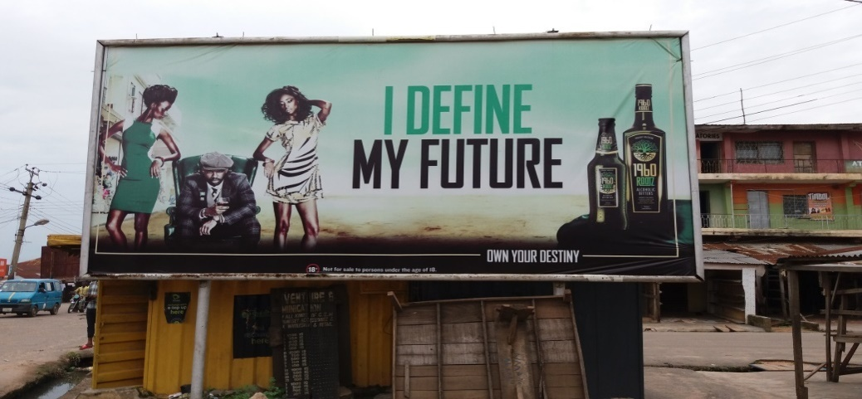
TEXT 1

Through the composition of the participants in the visual text which are human beings, the images of the product and the linguistic elements used, an interpersonal relationship is established which helps the text producer to strategically promote consumerism culture. Hence, the message conveyed resonates with his target audience – the people that drink. The setting of the text portrays a party mood. While two of the participants are portrayed as the principal players in the text, that is, the ‘Big Boy’ on the chair and the product itself, other participants seem to be subordinate to them. This is evident in the posture of the ‘Big Boy’ on the chair whom two ladies hover around. Thus, there is a representation of the divide between the high and low on the social strata in the text.

The action and reactional processes of narrative images are operationalised in the text to project the dynamics of the ideological sentiment depicted. First, the framing of the ladies who are depicted as hanging on the ‘Big Boy’ as if they are waiting on him suggests an unequal social status. Their positioning confers some form of authority on the guy as a ‘lord’. Through the vector which is the tilting of the ladies towards the guy at the centre, the man is pointed at as an important persona who dictates every action in the text by virtue of his life-style of drinking ‘1960 ROOTZ ALCOHOLIC BITTERS’. The framing is also suggestive of a master/servant relationship that seems to be at play in many African societies. Hence, a particular social practice which is that of patriarchal order is reinforced by this framing to portray the dominant culture in this social context which is, assigning a higher social status to the male members of the society.

In the typical African setting, the male members of the society are held in higher esteem than their female counterparts. It is not unusual to hear such sayings that men are the head or are supposed to lead while women are to serve under them or complement what they do. Arguably, the text producer leverages on this shared knowledge and uses the framing as a discursive strategy to endorse the social practice in order to promote consumerism – the purchase of the product. The subtle endorsement of this seemingly oppressive social order is not surprising. However, considering the place of production of the product which is Nigeria. The statement, ‘Proudly Nigerian’ inscribed on the bottle of the product in conjunction with the colour of the bottle, which is green, as well as the black roots indicate that the product is of African origin. The semiotic resources also suggest that the text producer/ manufacturer shares the patriarchy sentiments depicted in the narrative images.

Conversely the posture of the man, his dressing as well as the glass of drink he is holding reinforce the action process portrayed in the text that the man operates on a higher pedestal than the ladies. Through the composition of these resources, the man is depicted as someone given to ‘jiving’ and enjoyment. ‘Jiving’ is an aspect of popular culture whereby the youth embrace a celebrity life and live a ‘larger-than-I lifestyle’. This is reiterated in one of the popular tracks of Chief Ebenezer Obey, a Nigerian artist who sang:
Alówó má j’ayé èyin lé mò
Awon to j’ayé lana dàà?
Wón ti kú, wón ti lo…
The song means if you are rich and you fail to enjoy it that is your own cup of tea. Where are those who enjoyed life yesterday? They have died and passed away…

Usually, the popular culture is a male dominated domain where there is a high and low divide (Djonov & Zhao, 2014). Men are portrayed as being rich and comfortable while ladies in turn depend on them and hover around them. As depicted in the text, the hovering of the ladies around the guy is suggestive of the reality of the economic down-turn in the nation whereby ladies have to depend on rich people or take to prostitution in order to earn some money for living (XXXXX, 2005). This framing, therefore, creates a social distance between the man in the chair and the ladies. It also confirms that the guy is the one in charge of all that is happening within the visual space. In fact, the distance between the guy and the images of the beverages also suggests the power of choice. Through the use of eye-line which is a vector used to indicate reactional processes in visual text, the man is presented as acceding to the higher social status assigned to him by the action of the ladies and the product. Hence, he is represented as the main actor in the text. The reason is that the main targets of alcoholic beverage adverts are males: women are secondary because they consume less and they generally spend less on alcohol.

In Nigeria, drinking of alcoholic beverages is usually campaigned against due to some health challenges traceable to them. As a result, every advertisement on tobacco products and alcoholic beverages must by law bear the golden rule of ‘Not for sale to persons under the age of 18+,’as written in text 1 above. This is imperative as it is believed that persons under 18 are still minors who cannot decide on what is right for themselves. However, once a person is 18 and above, it is believed that such a person can decide on what he/she wants for life and take responsibility for their choice. Hence, through the background distance between the guy and the product, the power of choice is depicted to show that the choice of drinking the beverage is the man’s and that he was not in any way forced to drink.

The distance shows the producer’s detachment from the consumer regarding the consequences of choosing to drink the alcoholic beverage. It is also a discourse strategy subtly deployed by the text producer to depict that they adhere to the law of the land on alcoholic beverages and project the power of choice by the consumer. This is further reinforced in the imperative statement “own your destiny” given by the manufacturer which is followed up by a kind of response from the consumer in the declarative “I Define My Future”. With these linguistic resources, the participants invoke a working understanding that they both are aware of the existing social practice about alcoholic beverages. As Matheson (2005 p. 36) opines, this visual text attempts to make its own meaning against the backdrop of the power of the existing discursive structures of meaning-making. Hence, the above text invokes a particular cultural work in relation to the wider social practice within the African setting.

One of the arsenals of advertisement is its parasitic nature (Cook, 2001). Advertisements draw from shared cultural resources in familiar social situations, attempt to make people think in new ways and then mix cultural practices in distinctive ways for marketing strategy (Matheson, 2005). This is the situation in text 2 below whereby the sport culture is invoked to create a specific effect on the consumer.

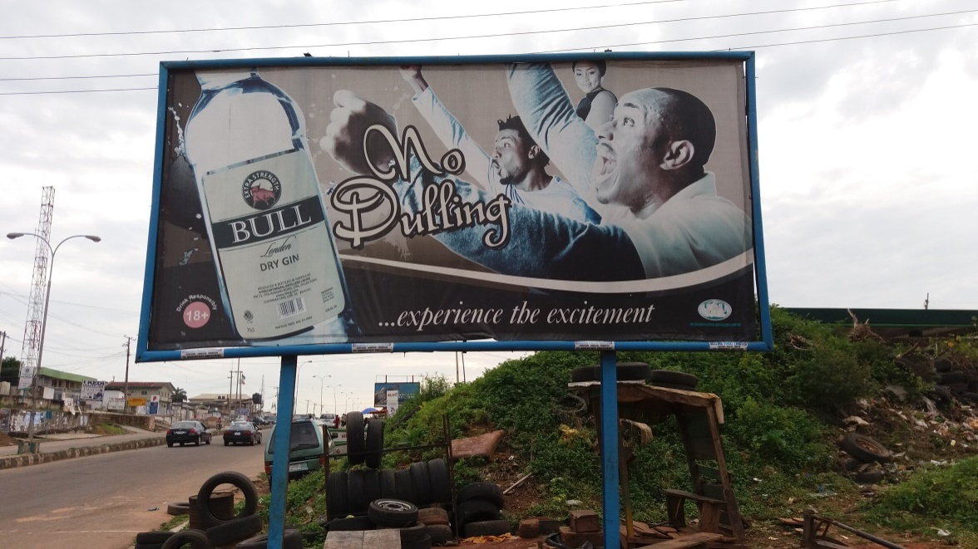
TEXT 2

Through the posture, dressing, facial expressions, and the representations of the men in an excited mood, the text producer subtly deploys intertextuality as a discourse construct to portray a dominant culture in the sport space traceable to what is obtainable during the English Premier League. This is reinforced by the word ‘London’. The statement ‘no Dulling’ is also an instance of intertextuality in popular culture which is suggestive of the type of passion men display during football games as well as the type of lifestyle embraced. Thus, action process which is depicted in the stretching of arms, facial gestures and expressions of the men, is deployed as intertextuality in this text to promote an ideological stance that with ‘BULL’ alcoholic beverage, life can be enjoyed to the fullest.

Four important participants are displayed in the visual text – the product, the men at the centre and the lady gazing at them. However, salience is on two of them – the men. The positioning of the men at the centre is significant for meaning. The positioning beams light on them as the centre of attraction through whom the potency of the beverage, BULL – an energy giving substance is displayed. Similar to what we observe in text 1, the framing of the ‘men’ indicates a mood of excitement and suggests a feeling of ecstasy one tends to have when this beverage is taken. It also depicts that the beverage is some kind of energy booster that enhances a high level of performance or action in men. Through intertextuality, the text producer subtly invokes that the drink has the ability to make men perform extra-ordinarily well to the point of being a centre of attraction to ladies. This can be established in the way the lady is amorously represented in the text. The gaze of the lady is a mental process which is suggestive of some kind of admiration for the action of the men in the text.

Considering the textual meaning of the text (i.e. the meaning depicted by compositional patterns of the signifiers in a multimodal construction), most importantly the text seems to be sexist in its orientation. Like text 1, the text producer subtly promotes a particular social order within the African setting which frowns at women drinking alcoholic beverages in the public. Although it is commonplace in the West (Europe, North America etc.,) where the product originates from, considering its name, to see their women drink and smoke. Within the African setting, especially in Nigeria, such behaviour is often considered social aberration. Any woman caught drinking, in the public, is usually regarded as an outlaw and cannot earn respect from her kinsmen or her community. Hence, in spite of the influence of the western world on the Nigerian cultures, the visual text suggests that certain social practices are still held in high esteem and kept intact. Consequently, the text producer is subtly portrayed as accenting to this social practice.

Also, just as social distance is used in text 1 to suggest that the power of choice is exercised by the consumers and the fact that the text producer/manufacturer of the product is aware of the government policy about alcoholic beverages, that is, the legal order guiding the drinking of alcoholic beverages in Nigeria, social distance is used again in this text to confirm these positions. The golden rule, 18+ is flashed in red colour with the imperative statement “DRINK RESPONSIBLY” in upper case to sound a note of warning to the consumers and for the text producer/manufacturer to show that they recognise the law of the land as well as distance themselves from the decision taken by the consumers. Thus, the social distance is deployed as a strategic discourse construct in the text to invoke an ideological stance.

Proudly Nigerian: Portrayal of Locally Brewed Products in Alcoholic Beverages Adverts
Advocacy for patronising locally/home grown products is one of the cardinal agenda of the present administration in Nigeria. This is done in order to ensure a boost in the Nigerian economy and the brewing of alcoholic beverages is not left out most especially when important ingredients that make up these beverages are readily available in our clime. Text 3 below reiterates this position by creatively inviting the public to patronize a locally brewed beverage.

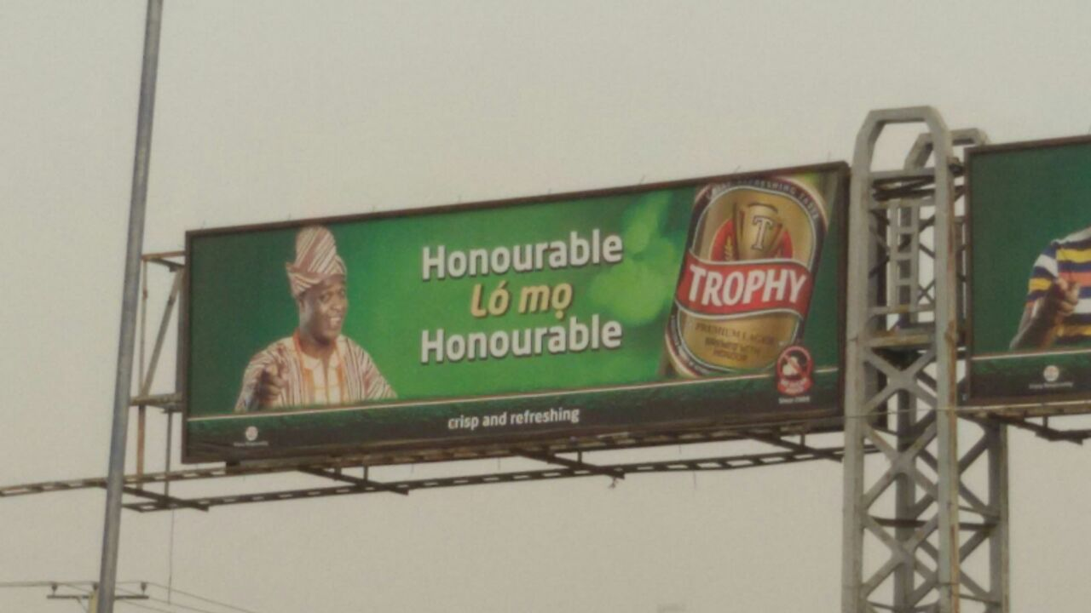
TEXT 3

The semiotic resources deployed in this text are strategic. The use of the Yoruba language and the representation of the image of Femi Adebayo, a prominent Nollywood star, set a tone of ownership and locally brewed for the product. A reactional process is deployed in this text as a narrative technique to engage the audience and offer quality assurance of the product. Through intertextuality, the text producer subtly portrays a sense of inclusion of the other members of the society who are not educated. This is suggested in the represented image and the indigenous language used as narrative that the product is not elitist, and not only for the working class or the educated but also for every adult in the society. This is strategic as it gives the people of this region some sense of belonging.

The text producer imbues the social milieu of the location of the text into the advert in order to assert that the product is brewed in Nigeria especially in Ilesha which is a Yoruba city. Hence, the indigenous language is used as a form of identification with the people’s culture and ways of life. The text also draws on the existing discourse in the Nigeria state on the advocacy on patronising locally made products in order to build the nation’s economy. According to van Leeuwen (2008, p.5) all texts draw on and transform social practices. This means elements of social practices somehow enter into texts in a bid to convey a particular ideology. Arguably, the text producer in this text lends himself/herself to the government position on locally made products and supports the idea. The dressing of the actor as an important persona, reinforces that the product, though locally made, is honourable among its kind (other alcoholic beverages either brewed at home or abroad). Hence, there is a subtle competition (marketing strategy) between foreign and locally made liquor deployed here.

The gaze and gesture of the actor which is that of pointing are image acts used to place an offer to the consumers that the product is indeed “honourable” and could make one become honorable. The visual frame is deployed as a persuasive strategy to recommend the product. Leveraging on the actor’s personality as a versatile Yoruba Nollywood actor, the product is presented to the Yoruba audience as that which is brewed with finest ingredients and perfect excellence. Hence the image of Femi Adebayo is used as an endorsement strategy to persuade the Yoruba audience to give the product the kind of recognition and respect they accord the actor in the movie world. This is further reiterated in the declarative statement, ‘Honourable Lo mo Honourable’, meaning only the honourable person can identify what is honourable. This statement is instructive as it serves as a testimonial to the quality. Thus Femi who is honourable is attesting to the fact that ‘Trophy Lager Beer’ is indeed honourable among other alcoholic beverages. In the same vein, Goldberg another alcoholic beverage brewed in Nigeria adopts this same marketing strategy in text 4 below to create a sense of ownership as well as that of belonging.

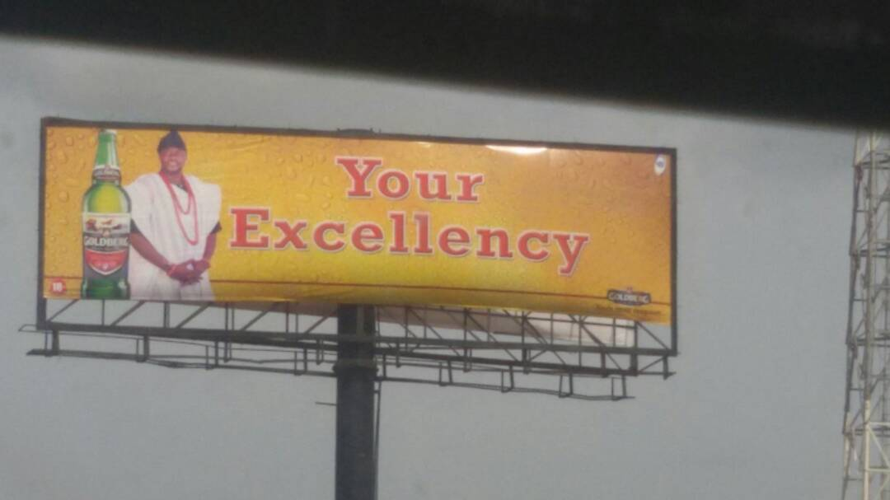
TEXT 4

The image of Adekola Odunlade, another trailblazer in the Nigerian movie industry is strategically used in this text to indicate a sense of ownership. Just like Femi Adebayo, Odunlade’s dressing in this text lends credence to the fact that the product is locally made, however with a touch of excellence. This is reiterated in the caption ‘Your Excellency’. This strategically sets a tone of excellence for the product even though it is locally brewed. This reinforces our argument in text 3 above that there is a subtle competition (marketing strategy) deployed in the adverts.

Arguably, the ideological stance portrayed in these texts is that the products are purely locally made and they are of good quality which can compete with even the foreign ones, people should therefore patronize them. This is a subtle campaign strategy to support government on its fight against importation so as to strengthen the nation’s economy.

Projection of Libation Pouring as a Cultural Matrix in Alcoholic Beverages Adverts

Text 5 below projects another important social practice integral to many Africans. Libation pouring is a social practice performed by the elders in the African setting to pronounce blessings on people for good life, long life and prosperity and the alcoholic beverage is one of the significant ingredients used to perform this ritual.

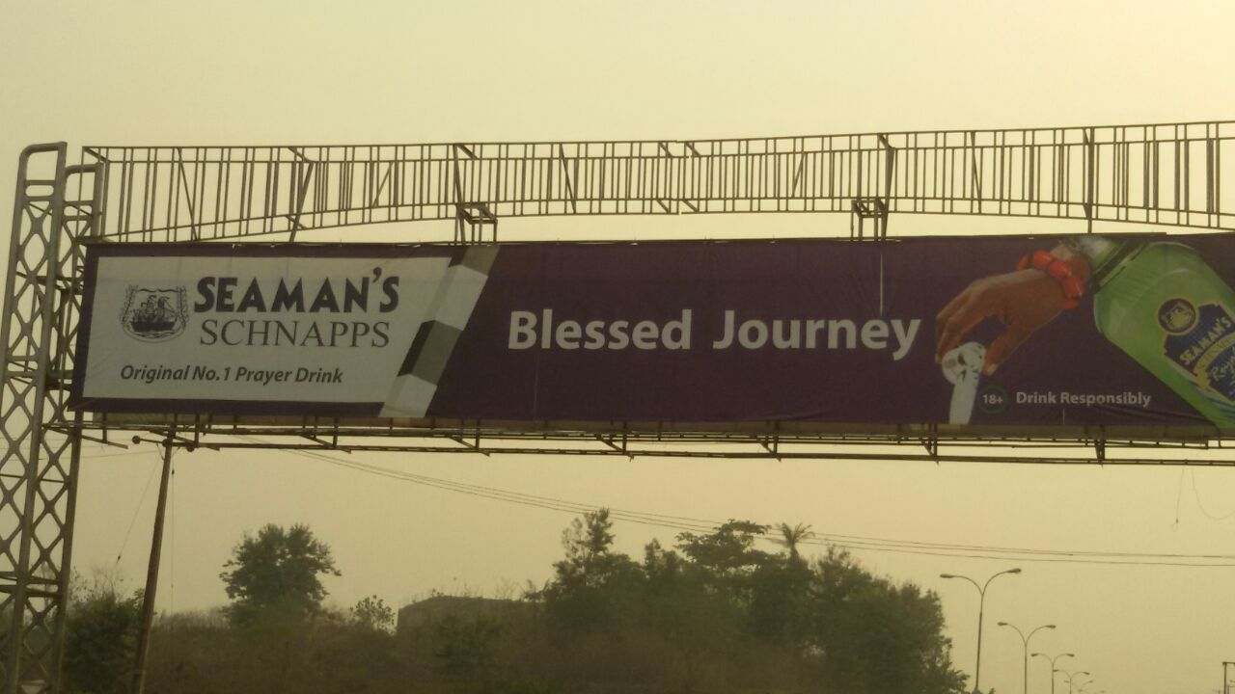
TEXT 5

According to Nehusi (2016), libation pouring is a ritual practised throughout the African world and it is a drink offering to every category of beings and things in the cosmos although every category may not be addressed in every libation statement. Reinforcing this position, Ahinful (2015) posits that,
libation pouring is a ritual embedded in many of the African traditional customs such as marriage ceremonies, birth and naming rituals, divorce, enstoolment of a chief, burials and funerals or praying for deliverance or exorcism, or for blessings from God. And in all these, there is libation pouring ostensibly to God, then to the gods and ancestral spirits.

Libation pouring is commonplace in Africa and SEAMAN’S SCHNAPPS seems to be the number one drink common for enacting this practice especially in Nigeria. Although any drinkable liquid, including water, milk, wine, beer, or strong spirits may be used to perform this ritual, alcohol especially akpeteshie or schnapps has been the dominant choice in West Africa (Nehusi, 2016). This is further reinforced in the declarative statement: “Original No. 1 Prayer Drink”, and the deployment of the Nigerian national colours. Through these semiotic resources, the text producer tries to indigenise the beverage to showcase its significance to this particular social practice in Nigeria.

SEAMAN’S (one of the brands of schnapps) SCHNAPPS is usually referred to as the ‘drink of the elders’ in the Nigerian setting because it is used by the elders to bless people. The text producer, through action process, therefore, artistically re-contextualises this social practice in text 5 to show how libation pouring is enacted and depicts one of the things it is used for – “blessed journey”. The imperative statement, “Blessed Journey” and the location of the advert which is a highway in Osogbo, the state capital of Osun State, literally suggest the manufacturer’s positive wish/prayer for safe journey/farewell to all the travellers plying that road. However, beyond the superficial, in the African setting, the life of man is metaphorically referred to as a journey which needs a supernatural enhancement such as invocation of blessing to land safely. This can be substantiated by Okediji’s (2002, p. xi) submission that “Life … is a marathon journey for a people who conceptualise themselves as perpetual pilgrims on this planet, on a homeward trip to ‘orun’ (heaven), or the spiritual world.” In the Yoruba cosmology, for example, it is generally believed that we are all on a journey and the usual prayer is that may our heads lead us home. Thus, journey is used symbolically as a metaphor in the text to depict either a process of physical travel or the pursuits of a particular goal in life and libation is being poured to positively invoke supernatural help for the person to farewell in life.

The fact that the drink is fondly referred to as the “Oti Awon Agba”, that is, “the Drink of the Elders” is further reinforced in text 6 below.

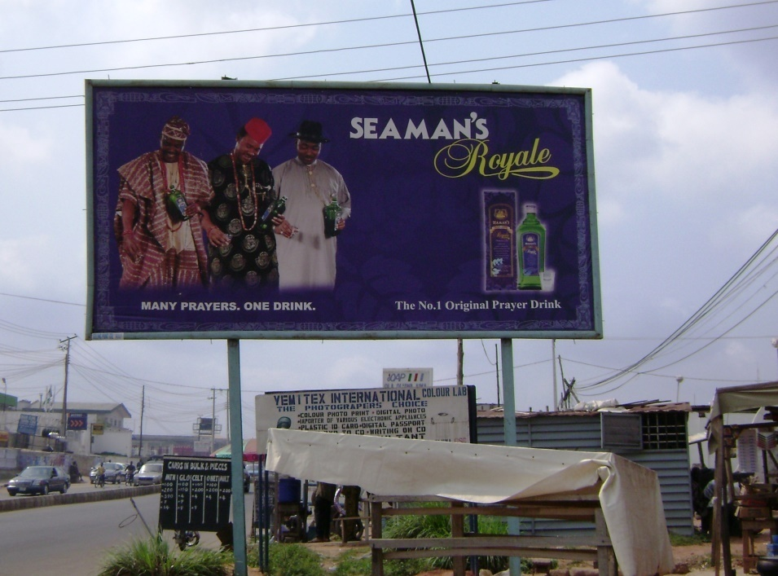
TEXT 6

The representation of three full grown men in this text shows that libation is a ritual performed by elders in the African setting. Culturally, elders are the repository of culture and customs and they stand in the position of authority to watch over the state of affairs in the society, maintain social order and pronounce blessings on the young ones in the society or curses as events may require. The action process of the artistic enactment of pouring libation depicted in this text strategically affirms that the performance is the same across culture. This reinforces oneness as far as the ritual of libation is concerned among Africans no matter their ethnicity. The declarative statement, “MANY PRAYERS, ONE DRINK”, further corroborates this stance. Nigeria is a heterogeneous country with over 250 ethnic groups. Three of these ethnic groups, Yoruba, Igbo and Ijaw, are represented in text 6 above to reiterate the fact that libation pouring is a common social practice in Nigeria and Africa at large.

Thus, beyond showing how visual grammar works with the use of multiple modes in the two texts, an ideological stance is invoked as a re-contextualisation of the practice of libation pouring in Nigeria. Indeed as Eyo and Ekawan (2016, p. 60) opine
The practice of libation rituals is a quintessential aspect of African culture and spirituality. It is a mark of piety and devotion to the gods and ancestors in an attempt to define a meaningful moment of communion, to honour the ancestors, and to chart a new form of consciousness as required by customs. Libation expresses the relationship between the Supreme Being and the ancestors on the one hand, and the ancestors and man on the other.

The text producers (manufacturers) therefore, indicate their social significance to the sustainability of this particular cultural ritual. Through the choice of semiotic modes deployed, they portray a total endorsement of the libation culture by re-enacting it and projecting it as one of the cardinal forces fundamental to Africans´ socio-cultural order.

Conclusion

This study has attempted to explore the semiotic dimensions that characterise the posters of alcoholic beverages in South-western Nigeria. The analysis shows strategic appropriation of multimodal resources to construct specific social practices as espoused by Djonov and Zhao’s (2014) work and Kress and van Leuween’s (1996; 2006) visual semiotic approach. The text producers utilise different narrative processes such as action, reactional and mental processes to give salience to different ideological stances they attempt to engage and project in the texts. Through the investigation of multimodal interaction of semiotic resources in the context of alcoholic beverages, we are able to unravel specific social structures and practices such as jiving, patriarchy order, advocacy against importation to build national economy, libation ritual, etc. These social practices reflect the belief system of the people about alcoholic beverages, project the power relations that exist among male and female members of the society and reveal the position of the law of the land about drinking alcoholic beverages.

Thus, beyond investigating the interactions that exist in the visual grammar of a text, this study has vividly revealed that the choice of images in the realization of a text is purposive, political and ideological. Through the theoretical framework adopted for the study, we are able to discover that images should never be taken ostensibly as ordinary in visual texts, they are couched to achieve specific social goals. This then strengthens the position that texts exist through the deployment of a range of representational and communicational resources which are in tandem with certain social and power structures within the context in which they are produced. Also through the theoretical orientation of the study, we are able to empirically relate multimodal communication to social power.
Acknowledgements
The authors wish to thank an anonymous reviewer, Drs K Ayoola and M. Ademilokun of Obafemi Awolowo University for the useful comments made on earlier drafts of this article. We also thank Mr B. XXXXX and Mr A. Adeleke for their assistance in data collection.

Funding
The authors received no financial support for the study, authorship or publication of this article.

References
Ahinful, K. (2015). “Christians and african traditions – libation to the Gods is a sin. –
christians can play ‘Asafo’ only if …” Retrieved from https://www.modernghana.com/news/633525/christians-and-african-traditions-libation-to-the-gods-is.html.
Ajayi, B. O. (2005). Understanding outdoor advertising. Lagos: Fem.
Akanidomo, J. I., Adebola, V.A., Zubairu D., Haruna K.& Ochiyna, O. (2005). The contexts of alcohol consumption in Nigeria. In I. S. Obot &R. Room(Eds.), Alcohol, gender and drinking problems: Perspectives from low and middle income countriesDepartment of Mental Health and Substance Abuse, Geneva: World Health Organization 2005.

Akpan, I. (1996). A semiotic appraisal of advertising print copy imperatives and their implications for meaning sharing. Journal of Humanities, 4, 156 – 165.

Blume, S. B. (1997). Women and alcohol: Issues in social policy. In R. W. Wilsnack& S. C. Wilsnack (Eds.), Gender and alcohol: Individual and social perspectives (pp. 462-489). New Brunswick, NJ: Rutgers Center of Alcohol Studies.
Boyle, P.Boffetta, P., Lowenfels, A. B., Burns, H., Brawley, O., Zatonski, W., & Jürgen R. (2013). History of alcohol consumption. Oxford Scholarship Online. Retrieved from DOI: 10.1093/acprof:oso/9780199655786.001.0001.2013.05
Coker, O. & Raheem, S. O. (2012). Arts for ad sake: Advertising language as literary language in selected advertising copy in Nigeria African Symposium, 12 (2) , 11 – 17.
Cook, G. (2001). The discourse of advertising. London & New York: Routledge.

Demmel, R. & Hagen, J. (2004). The structure of positive alcohol expectancies in alcohol- dependent inpatients. Addiction Research Theory, 12(2004), 125-140.

Dunn, W.S. & Barbon, M. A. (1986). Advertising: Its roles in modern marketing. USA: CBS College .
Djonov, E., & Zhao S. (2014). Critical multimodal studies of popular culture. London:
Routledge.
Ebie, J.C. & Pela, O.A. (1981). Some socio-cultural aspects of the problem of drug abuse in
Nigeria. Drug and Alcohol Dependence, 8, 302–306.
Eco, U. (1976). A theory of semiotics. Indiana: Indiana University Press.
Eyo, M., & Ekawan, S. (2016). The language of libation rituals among the Efik.
Anthropological Notebooks,22 (1),59–67.
Gureje, O. et al. (1996). Comparison of alcohol and other drugs: Experience from the WHO
collaborative cross cultural applicability research (CAR) study. Addiction, 91, 1529-1538.
Heath, D.B. (1995). An anthropological view of alcohol and culture in international
perspective. In D. Heath (Ed.), International handbook on alcohol and culture (pp. 328-347). Wesport, CT; Greenwood Press. .

Hodge, R. & Kress, G. (1998). Social semiotics. Cambridge, UK: Polity press.
Kress, G., & van Leeuwen, T. (2006). Reading images: The grammar of visual design(2nd
ed.). New York: Routledge.
Lasebikan, V. O., & Ola, B. A. (2016).Prevalence and correlates of alcohol use among a sample of Nigerian semi-rural community dwellers in Nigeria. Journal of Addiction, (20)16, 1-6.doi:10.1155/2016/2831594
Liu, J. (2013). Visual images interpretive strategies in multimodal texts. Journal of
Language Teaching and Research,4(6), 1259-1263. doi:10.4304/jltr.4.6.1259-1263.
Janssen, A. (2017). Social semiotic multimodal analysis of discourse in banking. In P. Mickan, & E. Lopez (Eds.),Text-based research and teaching (pp.75-95).London: Palgrave Macmillan.

Maclatchy-Gaudet, H. & Stewart, S. H. (2001). The context-specific positive alcohol outcome expectancies of university women. Journal of Addictive Behaviors, 26(1) 31-49.
Matheson, D. (2005). Media discourses: Analysing media texts. McGraw- Hill Education(UK) Maiden Head: Open University Press.
Ndom, R.J.E. & Adelekan, M. (1996). Psychosocial correlates of substance use among undergraduate in Ilorin University. East African Medical Journal 73(8),541-7.
Nayak, S. (2000). Language of advertisements in Tamil mass media (Ph.D. Dissertation, University of Mysore). Retreived from http://www.languageinindia.com/may2002/sandhya thesis.html.
Nehusi, K. S. K. (2016). Libation: An Afrikan ritual of heritage in the circle of life.
Lanham:University Press of America.
Okanlawon, B. O., & Oluga, S. O. (2008). An examination of language use in contemporary
Nigerian advertisement copy messages. Marang Journal of Language and Literature, 18, 37 – 48.
Okediji, M. B. (2002). African renaissance: Old forms, new images in Yoruba art.
Colorado: Colorado University Press.
Obot, I.S. & Room, R. (2005). Alcohol, gender and drinking problems: Perspectives from low and middle income countries. World Health Organisation 2005.
Obot, I.S, Ibanga, A.J & Karick, H (2002). Images of power and success: Alcohol promotion and marketing in Nigeria. Paper presented at the Kettl Bruun Society meeting, Paris, 3- 7 June 2002).
Olaosun, I. E. (2006). Language and visuality in selected commodity advertisements in some Nigerian newspapers (PhD’s thesis). Department of English, University of Ibadan,
Nigeria.
XXXXX, M.A. (2005). Commercial sex workers’ narrative structure in hot zones, In M. A.
XXXXX & L. Oyeleye (Eds.), Perspectives on language and literature(pp. 215-226). Ile-
Ife: Obafemi Awolowo University Press.
Opeibi, T. O. (2007). One message, many tongues: An exploration of media multilingualism in Nigerian political discourse. Journal of Language and Politics, 6(2), 223–248.
XXXXX, O. O., & XXXXX, M. A. (2011). Imperative mood as message enhancer in
billboard product adverts in Nigeria. Oye: Ogun Journal of Arts. 17.
XXXXX, O. O., & Unuabonah, F. O. (2013). Coping with HIV/AIDS: A multimodal discourse
analysis of selected HIV/AIDS posters in South-western Nigeria. Discourse and Society, 24(6), 810-827.
Seidman, S. A. (2008). Posters, propaganda, and persuasion in election campaigns
around the world and through history. New York: Peter Lang.
Thibault, P.J (1990). Social semiotics as praxis: Text, social meaning making and Nabokov’s Ada. University of Minnesota Press.
van Leeuwen, T. (2008). Discourse and practice: New tools for critical discourse analysis. New York: Oxford University Press.
Wilsnack, R. C., Wilsnack, S. C., & Obot S. I. (2005). Why study gender, alcohol and culture? In I. S. Obot, & R. Room (Eds.),Alcohol, gender and drinking problems perspectives from low and middle income countries. Department of Mental Health and Substance Abuse, Geneva: World Health Organization 2005.
Wilsnack R. W. & Wilsnack,S. C. (Eds.). (1997). Gender and alcohol: Individual and social perspectives. New Brunswick, NJ: Rutgers Center of Alcohol Studies.
Wood, N. (2006). Describing discourse: A practical guide to discourse analysis. London: Hodder Arnolds.

