National and Ethnic Identities as Discursive Styles in Selected State-Sponsored Social Transformation Campaigns in Nigeria
Abstract
This paper examines the agency of national and ethnic identities in select state-sponsored social transformation campaigns in Nigeria. Data for the study comprises social transformation campaign texts in Nigeria that touch on restoration of values/positive attitudinal change, patronage of Nigerian products and democratic propriety. The data was drawn from jingles, speeches and advertisements being the major media used by the government for the delivery of messages on social transformation in Nigeria and covered the period March 2013 to March 2018. The five-year span was informed by the wide gamut of negative realities in the nation at the time frame which led to increased mediatisation of social transformation messages in the nation. The analysis shows that the discourse participants deploy linguistic resources to consciously construct national and ethnic identities as a strategy for strengthening the messages of social transformation in Nigeria. The paper reveals that national identity is invoked in the discourse to appeal to the sense of collective in the people of Nigeria to value their nation by embracing acts that would foster social transformation. The paper further shows that ethnic identities serve the purpose of appealing to Nigerians of various ethnic groups in order to stimulate them to embrace the crusade for social transformation in the country. The paper concludes that state agencies are conscious of the role of national and ethnic sentiments in stimulating Nigerians to embrace their social transformation agenda and thus make national and ethnic identities integral elements of their discourse.

Keywords: national identity; ethnic identity; discursive styles; social transformation; Nigeria

1. Introduction
The relationship between language and the society has been established over the years, as both influence each other. However, in recent times, the world has witnessed an increase in the use of language as an indispensable tool to promote and propagate issues that encourage public policy, social mobilisation, good governance, fundamental human rights and citizens’ welfare. Both cultural and national values are projected through language as the basis for mobilising citizens and organisations towards genuine national development and global peace. This article projects the role of language in shaping the society grounded in the Sapir-Whorfian idea of linguistic determinism which says that our thinking is determined by our language (van Troyer, 1994: 164). Specifically, the study pays attention to the functionality of language in engendering social change in human societies. Greenwood and Guner (2008:1) simply define social change as “a shift in the fraction of society ascribing to a particular attitude or mode of behavior”. In the context of Nigeria which constitutes the background to the study, the idea of social change borders on the campaign for the positive transformation of the numerous social problems bedeviling the country.
Krey (1997:1) reflects on the position of language in causing social change in the world where money and power are so powerful and quotes Robert Bellah who says that people have often tried to bring the world to the life-world by making it a more human place, and they have done so through language”. Fairclough (2003:8) also states that “texts have causal effects upon, and contribute to changes in people (beliefs, attitudes, etc.), actions, social relations and the material world”. Lacan (1997:65) however succinctly captures the power of language in changing the world when he says “it is the world of words which creates the world of things”.
The present study, in particular, examines the agency of national and ethnic identities in the discourse of social transformation in Nigeria. The premise of the study is that identity as an interpersonal element of language use can also be deployed for mobilising people to embrace certain ideas and ideals. Even though the discourse of social change in Nigeria is largely ideational, it also features a significant use of interpersonal elements as the discourse participants deploy identity construction in order to strengthen the meanings in the texts and appeal to the audience to receive the message of the advocacy positively. Therefore, the discourse of social transformation in Nigeria is a useful domain for marking identity construction for functional purposes in the society. This functional quality of identity construction makes it worthy of scholarly exploration which the present study seeks to achieve. While previous studies on language and identity in Nigeria have focused on military barracks and the youth (Akande 2016; Mensah and Nkamigbo, 2016), hip-hop music (Adegoke 2011; Gbogi 2016) and nativisation of English (Kehinde 2004; Ayeleru 2011; Ayoola 2014 etc.), there is a dearth of research on the construction of identity for strategic social transformation advocacy in the nation. Thus, this study seeks to explore the use of identity construction in the discourse of social transformation that is generated by government in Nigeria.

2. Language and Identity: From Definition to Scholarly Explorations in Nigeria
Identity is a construct that has received a great deal of attention from diverse academic traditions such as sociology, psychology, anthropology, linguistics, among others. According to Edwards (2009:15), scholars have noted “a ´veritable explosion´ of interest in identity”. Essentially, identity is concerned with the perception of an individual in relation to certain groups that he or she belongs to. According to Djite (2006:6), identity refers to the everyday word for people’s sense of who they are. Such a perception could be individual in which a member of a group, whether a family, culture or society views him or herself in relation to other members of the group as a distinctive entity or as sharing certain features of such a group. Therefore, while one could have personal identity, there are also forms of identity such as religious identity, social identity, ethnic identity, gender identity, among others.
Edwards (2009:20) captures the relationship between language and identity by stating that “since language is central to the human condition, and since many have argued that it is the most salient distinguishing characteristic of our species, it seems likely that any study of identity must surely include some consideration of it”. According to Joseph (2004), the early 80s marked a time that there was an explosion of interest in the linguistic elements of identity in language use. From the linguistic perspective, Kroskrity (1999:111) remarks that identity refers to the linguistic construction of membership in one or more social groups or categories. Omoniyi (2011:260) asserts that “Language use is a parameter in determining identity, whether of individuals or groups”. The reality of the reflection of identity in language is incontestable and has been for long. The sociolinguistic concept of idiolectal variation, for instance, elucidates how the features of the language of an individual mark out such individual without having to make recourse to physical features. The same principle of language as an index of identity is reflected in the concepts of sociolect and dialect. However, with the recent interest in language and identity from the critical discourse analysis perspective, the focus on the relationship between language and identity is mainly on how such a relationship is used in mediating certain socially contentious subjects in the society by using language to represent social actors in certain ways in order for readers to interrogate and understand their roles in the subject of attention.
Scholars have examined the relationship between language and identity in various situational language usages in Nigeria. There are studies that focus on the role of language in the promotion of Nigerian identity in English-medium Nigerian novels (Adejumobi 1999; Kehinde 2004; Ayeleru 2011; Abdullahi-Idiagbon & Olaniyi 2011; Coker and XXXXX 2013; Ayoola 2014; XXXXX 2017, etc). Such studies have paid attention to the various ways different generations of Nigerian literary writers preserve their Nigerianness in their writing through the nativisation of their language of literary expression. There are also studies on language and identity in the Nigerian novel that focus on how names and loan words are used to construct multiple identities such as that of the novelist, characters in the novel or that of the society (Mbarachi & Igwenyi, 2018) and ethnic, cultural, national and gender identities (see Aboh 2018).
Scholars have also examined the use of language for the promotion of identity by certain ethnic/cultural/national groups. For example, Nwagbo (2015) studies identity patterns in the language use of Liberian refugees in Oru Camp, Ogun State of Nigeria by showing the attitudes of the refugees to their indigenous languages and the language of their host community. The study shows that the refugees exhibit strong positive identity for their indigenous languages while demonstrating negative attitudes towards Yoruba which is the language of their host community. The paper argues that through such display of attitudes, the discourse producers maintain their identity while resisting the identity of their new community. The implication of this is that successful acculturation does not take place which would hinder diversity that is very important for cross-cultural relations. Also, Igbokwe (2013) examines the negative impact of the reduced interest in Igbo language on the popularisation of the Igbo identity in Nigeria. The author laments that the emphasis on foreign languages among Igbos vitiates the projection of the Igbo identity through language in the recent times.
The interaction of language and identity has also been studied in the context of Nigerian hip-hop music (e.g. Adegoke 2011; Gbogi 2016). Adegoke (2011) argues that the linguistic resources in Nigerian hip-hop music, in particular, the pidginised and creolised forms are used to create national identity. The author further posits that the projection of the challenges of postcolonial Nigeria in the hip-hop musical tradition in Nigeria also bears national identity. On his part, Gbogi (2016) states that hip-hop music is used to create multiple identities. The study shows that language is used to create cultural, political and multilingual identities in the music and to sustain “the in-groupness of a growing urban youth sub-culture in Nigeria”.
Scholars have also examined the relationship of language and identity in online communications of Nigerians (e.g., Raheem 2017; Kperogi 2018). Raheem (ibid) examines the sociolinguistic construction of identity in some social media sites in Nigeria, showing that multiple identities such as national, ethnic and youth identities, among others, are constructed through language use on such platforms. Kperogi (ibid) however focuses on identity construction in online email scams, showing that the text producers inadvertently create unique identity for Nigerians through peculiar stylistic and sociolinguistic features of such emails.
Mensah and Nkamigbo (2016) also examine language and identity in the context of youth linguistic behaviour in Calabar, Cross River, Nigeria. The study shows how sexual metaphors are used among the youth to mark a peculiar identity for themselves as sleazy and sexually active. The authors remark that sexual metaphors are used by the youth to describe sexual activities and the gratification derivable from it. The authors conclude that the use of such sexual metaphors is aimed at enhancing intimacy among the youth, asserting masculine hegemony through the cultural privileges of the dynamics of sexual activities and to assert youth-centred collective essence.
The review of literature above shows that the interaction of language and identity has received attention in Nigerian linguistic research in the context of literary productions, especially the Nigerian novel, language attitudes, hip-hop music, online communications and youth language. The literature however shows that the peculiarity and functionality of identity construction in social transformation campaign in Nigeria has been largely neglected. Since the discourse of social transformation is quite popular in Nigeria in the present times and is characterised by creative and strategic usage of language for predisposing Nigerians to embracing positive actions, the present study investigates the imbrication of the dynamic interaction of language and identity in the discourse. The present study seeks to account for the nature of such interaction of language and identity in the service of such campaign for social transformation in Nigeria.

3. Methodology
Data for the study was obtained from the government (state actors). For the purpose of the present study, we consider state actors as government functionaries and parastatals such as National Orientation Agency (NOA), Ministry of Information, Nigerian Television Authority (NTA), Independent National Electoral Commission (INEC), etc. The data comprises texts on aspects of social transformation campaign in Nigeria that centre on restoration of values/positive attitudinal change, patronage of Nigerian products and democratic propriety. The data was drawn from advertisements (jingles and printed text) and speeches being the major media used by the government for the delivery of messages on social transformation in Nigeria and covered the period March 2013 to March 2018. The five-year span was premised on the fact that Nigeria witnessed numerous challenges in the areas of insecurity, financial misappropriation and democratic impropriety which led to the intensification of the campaign for social transformation in the nation. The excerpts used for illustration were purposively selected as attention was paid to their richness and aptness in exemplifying the construction of ethnic and national identities which the paper is pre-occupied with.

4. Theoretical Framework
This study is grounded in critical discourse analysis (CDA) focusing on Fairclough’s (2013) dialectical-relational and Machin and Mayr’s (2012) critical multimodal approach which draws heavily on Fairclough’s approach. Therefore, the discussion of identity in the discourse transcends the descriptive view of it as attention is paid to the role that identity serves in discourses for power negotiation and ideological projection. CDA emphasises the idea that language, which is always social, is used to do ideological work and always bears the structures of power and identities in its environment of use because it is socially constitutive and constituted (Fairclough & Wodak, 1997:258). According to Wodak and Meyer (2009:27), Fairclough’s dialectical relational approach to CDA “focuses upon social conflict in the Marxian tradition and tries to detect its linguistic manifestations in discourses, in specific elements of dominance, difference and resistance”. The approach provides affordances for the analysis of discourses by focusing on the dialectical relationships between semiotic systems and social practices. In the context of the present study, social practice refers to the peculiar desires of the participants in Nigeria’s discourse of social transformation to construct identity for themselves for various motivations.
Fairclough (2015:129) lists the linguistic features that can be used for critical discourse analysis as entailing vocabulary, grammar and textual structures. Therefore, in the analysis of the data, we pay attention to the expressive values of lexical and grammatical resources for identity construction in the discourse.
Machin and Mayr’s critical multimodal approach extends the general principles in critical discourse analysis as it shows that the principles of CDA can also be applied to the analysis of visual texts. For this study, we find its treatment of language and identity useful as a guide, as we draw on the representational strategies enunciated by the authors. Such representational strategies are personalisation and impersonalisation, individualisation and collectivisation, specification and genericisation, nomination and functionalisation, use of honorifics and anonymisation.

5. Analysis and Discussion
In this section, we carry out the analysis of the representation of national and ethnic identities in the discourse of social transformation in Nigeria while discussing their linguistic signifiers, socio-cultural functions and relevance in the Nigerian nation. The identities are examined in turn.

5.1 National Identity and Social Transformation Campaign in Nigeria
The discourse of social transformation in Nigeria being one that focuses on a national concern which borders on restoration of sanity in the national, public and individual lives in Nigeria for the proper development of the Nigerian people and nation, is such that exhibits the Nigerian national identity. Since the ideologies of nationalism and nativism are strongly expressed by Nigerians, they use language to construct a peculiar identity for themselves as Nigerians, among other forms of identity expressed, through their linguistic choices. The national identity created in the discourse serves as a symbol of national unity and unification of purpose in the campaign for social transformation in the nation. Below is a multimodal text that serves the purpose:


Figure 1: Multimodal Text from State Actor (NOA)
The jingle produced reads:
Everyone is calling out for change but nobody wants to change. True change begins with the individual. So look in the mirror and ask yourself, who me? Yes you. Are you doing the right thing to change Nigeria? Let the change begin with you. Be positive, be patriotic, be right, make a change. Do the right things always to transform Nigeria, Nigeria. Do the right thing to transform Nigeria. (Italics mine)
State Actor Jingle (NOA), November 21, 2016

In the multimodal text above, a distinct Nigerian identity is created to emphasise the fact that the primary target of the audience is Nigerians and that the message is intended to capture an issue that concerns the nation, Nigeria. This is a way of delimiting the readership to Nigerians alone and defining the content of the text as important to them. A critical look at the text shows that the nation, Nigeria, is indeed focused in it just to emphasise the significance of the message for the nation. Omoniyi (2011) discusses the concept of focusing in the relationship between discourse and identity as the fronting and foregrounding of certain markers of identity in a text to create certain meanings. A close look at the visual component of the text shows that through colour, a peculiar Nigerian identity is created as the green colour which is the primary colour of the flag of the nation is given salience. Similarly, white which is the second colour of the Nigerian national flag is foregrounded as the coat of arms of the nation is presented in white in the visual image. This use of colours is not accidental; the colours are intentionally given prominence to construct a peculiar Nigerian identity for the text and to signify that the message is for Nigerians.
Beyond the colours which label the text as of a Nigerian concern, the presentation of the coat of arms of Nigeria in the image also gives a distinct Nigerian identity to the text. The coat of arms of course is an emblem of the nation which functions like a signature on anything in which it is displayed as distinctly Nigerian. Similarly, in the written component of the text, the word Nigeria occurs three times to project that the text has a Nigerian character. This also serves the purpose of focusing in identity construction as any lay reader of the text is able to discern without having read the full content that the text dwells on Nigeria.
The text is produced by the National Orientation Agency, which is a parastatal created by the government of Nigeria to sensitise the Nigerian people about government policies and activities so that those policies and activities could be well accepted by the people. The conscious construction of the Nigerian identity by the National Orientation Agency is even reflected by the fact that the agency also marked out the text as distinctly produced by them. The name of the agency National Orientation Agency and its acronym NOA both appear strikingly in the text in order to show to the public that the agency is responsible for the message and not other possible agencies such as Ministry of Information or Ministry of Culture.
The lexical and syntactic resources used in expressing the actions required of Nigerians for the nation to develop are constructive. Such lexemes as positive, patriotic, right and change are used to align certain attitudes and attributes with what Nigerians should be for their nation to transform significantly. This shows that Cillia, Reisigl and Wodak’s (1999) idea of national identity reflects in the discourse of social change in Nigeria as their paradigm recognises constructive strategies. Similarly, the syntactic structuring of the expressions in which the lexemes feature reveals the elements of persuasion captured by the persuasive linguistic elements which Cillia et al. (ibid) subsumed under constructive strategies. Below is another text that reflects national identity in the discourse:

I welcome you all to this important occasion of the launching of the National Reorientation Campaign, called ‘Change begins with Me”. Nigeria is passing through a challenging moment where hardly anything works in a normal manner. Many have attributed this phenomenon to the total breakdown of our core values over the years.
Change Begins with Me Inauguration Speech
September 8, 2016

There is the construction of a Nigerian/national identity in the text above through the proper noun Nigeria and the collective pronoun our. The mention of Nigeria in the text clearly shows one that the content of the text is related to Nigeria. The thematisation of Nigeria in the second sentence of the text further gives prominence to the identity that is being created in the text. Such thematic appearance of Nigeria immediately makes the reader to know the focus of the text. It is interesting that in the text, the speaker who is the President of Nigeria also projects national identity through the use of the collective pronoun our. The pronoun our is used to humanise the Nigerian people and give them a sense of belonging by their President. Cillia, Reisigl and Wodak (1999) refer to this strategy for marking identity as constructive identity as in the words of the authors such strategy “invite identification and solidarity with the ‘we-group’”. It portrays the people of Nigeria as one united people in spite of their ravaging challenges. Therefore, the president creates a collective identity for Nigerians through the representational strategy that Machin and Mayr (2012: 80) refer to as collectivisation, making them appear generic.
The representation of Nigerians as one whole united people and the identification of the President with the people through the strategy can be said to have the ideological effect of manipulating and persuading the people by the President in line with his desire on the matter. This is because the reality of the Nigerian nation is that there is so much division, part of which the government has even been alleged to be guilty of. For instance, many people have criticised the government on lopsided appointments and more recently the undue favoritism and protection of the Fulani herdsmen who killed innocent people in Benue State. Therefore, the our used by the President might be seen as the normal sexy use of language by politicians to attract and deceive the people. Below, we present another text for illustration on the construction of national identity in the discourse. The text is however a multimodal one produced in the context of the campaign for the patronage of local products by Nigerians:

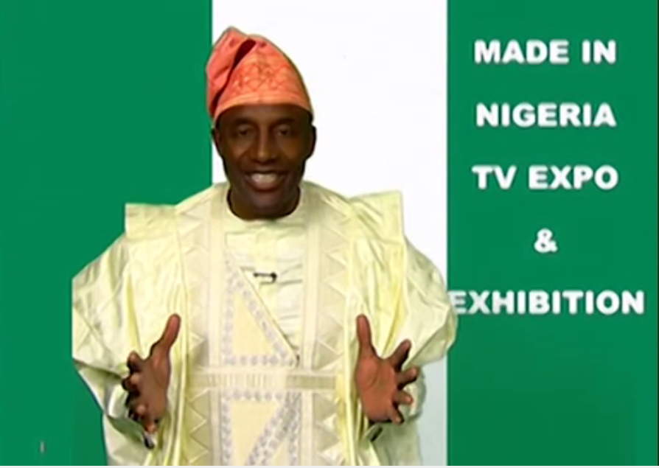

Figure 2: State Actor Text, Nigeria Television Authority (NTA)
Audio: Great Nigeria people, great Nigerian products. All made in Nigeria. Made in Nigeria (4 times). Patronise made in Nigeria. Quality is guaranteed. Made in Nigeria is where we are going now.
SA Jingle marking Nigerian Identity (NTA)
Youtube, April 1, 2016

In the text above, the text producers complement the audio sounds in the production based solely on the need for Nigerians to patronise local contents with certain verbal and visual signifiers that project the Nigerian image. This depiction synchronises with Jones´ (2015) account of authentification as a marking identity, as the text producers try to evoke the feeling of authenticity in Nigerians through their subscription to indigenously Nigerian attires which serves as a metaphor for Nigerians’ patronage of local contents. Apart from the fact that the salient background of the actor in the multimodal text is used to give visibility to Nigerian identity as that is the colour of the national flag of Nigeria, the dressing of the actor in the image also reinforces the Nigerian identity being constructed in the text. Even though the dressing does not represent the entire range of dressing styles characteristic of Nigeria and Nigerians of various ethnic groups, it marks a notable typical dressing style in the country that is indigenous and even cuts across the major ethnic groups in the nation. The word Nigeria in the limited verbal text in the image also contributes to constructing a vivid Nigerian identity as it shows that the subject of the text is of significance for Nigeria.
Apart from the signifiers projecting national identity in the image, the short audio which accompanied the image in the jingle is also laden with expressive resources foregrounding the Nigerian national identity. The lexeme Nigeria occurs eight times in the short text while Nigerian occurs once, thus essentialising the Nigerian character of the text and its message. The verbal rendition of the nominal Nigeria also reflects the emphasis on the national identity being constructed as the high pitch and rising tunes that characterise the production of the word are further indicative of the emphasis placed on Nigerian identity in the text. It is also significant that as a way of motivating Nigerians for positive social transformation rooted in the patronage of indigenous materials and products, the text producer creates a positive identity for Nigeria and Nigerians through the adjectival lexeme great and the nominal lexeme quality which are used to describe Nigerians and the products from Nigeria respectively. Even though such positive identity construction may be criticised by cynical people in view of the numerous challenges of Nigeria such as negative taints in international cycles and moribund manufacturing sector, such positive labels have the potential of awakening the national consciousness of Nigerians for acting in ways that will advance the country such as patronising Nigerian products.
It is remarkable that the construction of identity for Nigeria in the discourse is not only positive but also sometimes negative. Even though one may consider this unpatriotic, it reflects the perception of the discourse participants about the true situation or character of their country. These negative associations can in fact be said to trigger many of the campaigns for social change in the country and the virile civic engagement in the nation. Below is an example of a negative identification given to Nigeria by a discourse participant in reflection of his frustration at the Nigerian nation:
It is safe to say today that honesty, hardwork, Godliness have given way to all kinds of manifestations of lawlessness and degeneration in our national life.
State Actor Speech, September 8, 2016

The text above which is produced by the President of Nigeria, Muhammadu Buhari, constructs a negative image for Nigeria. The impression created of Nigeria by the text producer is that of an entity characterised by absolute lawlessness and uncivility. And it is remarkable that such a negative ascription to Nigeria has a high tendency of being taken seriously by the international community owing to the substance and position of the person who produces the text. The usual reaction to such a negative construction is likely to be that if the President of a country could speak of his country like this, then that must be totally true. This thus can be said to be a reflection of Cillia et al.´s (1999:161) idea of destructive strategy as the declaration by the President negates the campaign during the regime of his predecessor that Nigerians are great people.
It is even more remarkable that the manner in which the President made the declaration is assertive as he uses the adjective safe to describe his proclamation. The fact that he considers it safe in his own judgment as the number one citizen of Nigeria tends to make one think that Nigeria is an all-round home of insanity, lawlessness, inhumanity, without any taints of positivity. The collectivisation and genericisation invoked in the construction of a negative identity for Nigeria makes the effect of the identity more vivid and pungent. By using the nominal group expression our national life, where the collective pronoun our is used to involve every single Nigerian in the negative reality and the adjective national to generalise that the negativities are manifest in every sphere of the Nigerian society, the President paints a picture of an overwhelming label of disorderliness for Nigeria. This however is contestable because even though such identified negative attitudes may manifest largely in the country, it is obviously not the case that every Nigerian is involved and that it happens in every aspect of the Nigerian life.

5.2 Ethnic Identity as a Reinforcer of the Message of Social Change
Ethnic identity refers to certain features that associate a particular person with members of an ethnic group in contrast to members of other ethnic groups. Ethnic identity is also expressed through language, as dialect, for instance, has for many years been an index of ethnic identity. In the civic engagement of Nigerians and the discourse of social transformation in Nigeria generally, ethnic identity becomes inevitable in view of the fact that Nigeria is a multi-ethnic society.
According to Ojo (2016), Nigeria is believed to have over 250 ethnic groups. Ogoanah (2012:147) also expresses the idea that the numerous ethnic groups in Nigeria connect 400 languages belonging to Nigeria-Congo, Nilo-Sahara and Afro-Asiatic Phyla language families. This depiction of the nature of the ethnic and linguistic complexities of Nigeria is in itself suggestive of the numerous problems that such ethnic and linguistic character portend for the nation. Odeyemi (2014:1) indeed states that ethnic diversity is an obstacle to Nigeria´s development as most Nigerians tend to view themselves as belonging first to an ethnic group before their nation.
In view of the above, any discourse that seeks to have national significance on a national issue must reflect the ethnic diversity of the Nigerian nation in view of the fact that none of the ethnic groups wishes to be seen as inferior to another or be shortchanged in the process of mediating a crucial national issue. Similarly, it is common that many Nigerians, while using the English language naturally, reflect their ethnic identities as such features are noticeable in their use of the language, most especially, at the phonological level. Beyond the phonological level of marking identity in the discourse however, ethnic identity also manifests in sociolinguistic and discourse features such as code-switching, the use of indigenous languages and even proverbial use of language. Below, we consider a text that expresses ethnic identity in the discourse:

Hear the call. Call to change. Stand up, Nigeria. Change is here. It’s going to stay. Change begins with you. O ya make we go. Asiko ti to, so let the change begin from within. Lokaci yayi. O ge ruwo la. Change begins with you and me. Change begins with me. Change begins with me.
Jingle, NOA, November 21, 2016

The text above indexes how ethnic identity is marked through the discourse style of code-switching. Whereas the Nigerian identity is well created in the text through the mention of the word Nigeria, the text producer also intentionally identifies with specific ethnic groups in Nigeria through the use of the languages associated with those ethnic groups alongside the English language in the text. In this instance, unlike Grad Fuchsel and Martin Rojo (2003) who indicate that ethnic identities serve the purpose of polarisation, the ethnic identities in the text serve a unificatory or nationalistic purpose. This can be said to be a conscious strategy to appeal to those segments of the country to consider themselves as important to the change agenda of the nation and actively involve themselves in the activities or vision of the government of the nation regarding the desired change in the nation. This approach to the construction of ethnic identity in the discourse negates Kang’s (2004) idea on ethnic identity as various kinds of self-categorisation. For instance, there is the use of Yoruba language in the text in the expression Asiko ti to. The expression creates the vivid impression that Yoruba people are actively involved in the change agenda of Nigeria and are fully interested in partaking in it without any delays.
The use of the particular Yoruba expression is also symbolic in view of the fact that in the typical traditional Yoruba settings, the concept of asiko (time) is taken seriously as it evokes a sense of predestination which should be given sufficient attention. Therefore, recourse is made to the folklore and cosmology of the Yoruba as a strategy for creating ethnic identity in the text. The Yoruba culture being such that believes in the existence of destiny values asiko (time), and thus holds that at the appropriate time for a particular event to take place, such event is bound to happen and it cannot be changed. Therefore, the sense is conveyed through the expression that the time for Nigeria’s social transformation is here; it cannot be changed and everybody should support it.
The use of the indigenous expression lokayi yayi is also meant to foreground another ethnic or cultural group in the Nigerian nation. The expression is Hausa and since the Hausa are very populous and have a proud heritage, it is pertinent to reflect them in the discourse with a view to giving them a sense of belonging in the campaign for social change in Nigeria. Similarly, the use of Ogeru wola is targeted at identifying with another ethnic group in the Nigerian society, especially from the Southeastern part of the country. Through the conscious appeal to the segment of the Nigerian nation by the use of the expression, the people of the region would feel happy to associate with the campaign for social change in Nigeria. It is significant that there is the use of Pidgin English in the text as this can also be said to be a strategy of appealing to some segments of the Nigerian society. Even though many people of different ethnic groups now use pidgin for communication especially in cosmopolitan cities like Lagos and Abuja, there is a sense in which pidgin is primarily associated with the people of Southeastern Nigeria. There are, for instance, many Igbo people who acquire pidgin as their mother tongue because it is the language of the home. Therefore, the use of pidgin in the code-switched text can be said to be a conscious strategy of giving a sense of belonging to the Igbo people who primarily use pidgin in the Nigerian society.
This construction of ethnic identities in the text is significant considering the fact that the text is produced by an arm of the government, National Orientation Agency. It shows that the government is conscious of the need to give due recognition to different ethnic groups for the purposes of cross-ethnic solidarity and national cohesion which are required for the advocacy campaigns of the government for social change to be successful. The fact that the text producers value the various people of Nigeria in the campaign for social change in the nation also reflects in the use of the pronouns you and me in the text. In fact, the use of you and me in the text is significant, as it shows that the text producers, NOA, subsequently realised that they needed to include themselves in the audience of the message since they are also Nigerians. In this case, the government does not exclude itself as part of the change needed for the Nigerian society as opposed to an earlier jingle in which the government focused only on the citizens as the ones who need to change. Below is another text that features the construction of ethnic identity in the discourse:

YAGO FUN ORO ENU LASAN. GBE Igbese lati dibo lona ti o mogbon dani.
AJO ELETO IDIBO (INEC): IBO RE NI IPA… LATI FI IJOBA TIWANTIWA
MULE
Translation:
Don’t just talk but act. Make efforts to vote in a meaningful way. From the electoral body in Nigeria (INEC): You vote has power to entrench democracy.
INEC Print Advertisement (ND)

The text above is intended to mobilise the electorate to partake in a forthcoming election in the country. However, it is remarkable that the text is constructed only in Yoruba language. This of course projects Yoruba language and thus creates an ethnic identity in the text by foregrounding the Yoruba ethnic group to which the language is primarily associated. The use of the Yoruba language limits the readership in this instance as it indicates that the text is specifically for the Yoruba readers who are valued by the text producer. This is in view of the fact that the text is circulated in an environment that is inhabited mainly by the Yoruba – Osun State of Nigeria. Beyond projecting the Yoruba ethnic identity, the motivation for using the language might not be unconnected to the desire to capture in the message those who are not privileged to understand the English language among the Yoruba speakers. This also reflects the utility of ethnic identity in making different categories or members of a society to appreciate the message of social transformation being conveyed by the government in order for the campaign to be successful.
To show that ethnic identity is consciously constructed in the text, we present some images of a particular jingle in the discourse:

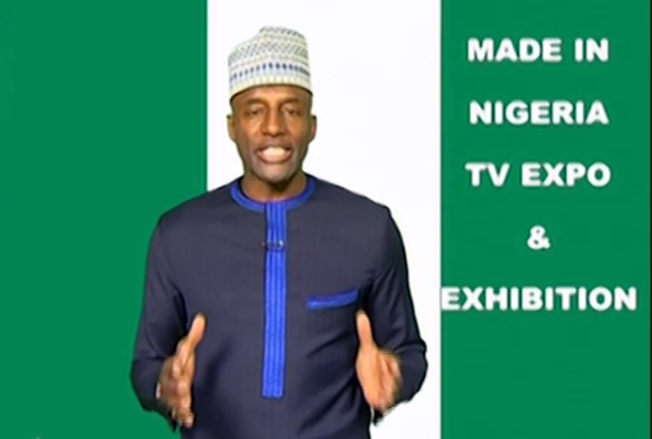
Figure 3: State Actor Jingle (NTA)
Youtube, April 1, 2016

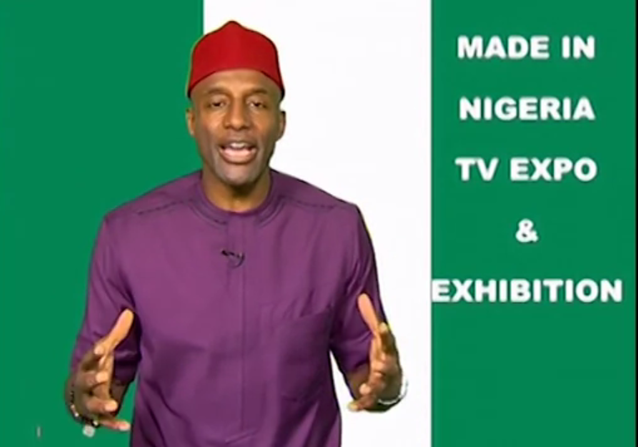
Figure 4: State Actor Jingle (NTA)
Youtube, April 1, 2016

The images above which are drawn from the jingle on the need for Nigerians to patronise local contents referenced under the discussion of national identity earlier are used to create, in addition to national identity, ethnic identities. As already mentioned, even though the images essentially are intended to promote local products for the benefit of Nigeria, attention is paid to the construction of ethnic identities mainly for the reason of demonstrating sensibility to the ethnic diversity of Nigeria in order to appeal to the people from the various ethnic groups. Similarly, such could avert the ethnic bickering that could ensue if a particular ethnic group is projected at the expense of another. Since the Yoruba, Igbo and Hausa ethnic groups are the major ethnic groups in Nigeria, the three are represented in the jingle through the clothes and styles of dressing that typically serve as identification for people of the ethnic groups. The dressing style in figure five earlier presented reflects the dressing style of the Yoruba which is used to give prominence to Yoruba identity as a subset of the Nigerian identity which the discourse producer intends to strengthen. Similarly, in figure 3, the dressing style of a Hausa man, especially the cap, is used to index the Hausa culture while in figure 4, the red cap which is typical of the Igbo culture is used to mark the Igbo identity in the discourse. All of this shows that dressing as a kind of non-verbal communication serves the purpose of identity construction in discourses, and in particular, the discourse of social change in Nigeria. It also shows that unlike Grad Fuchsel and Martin Rojo (2003), ethnic construction does not only feature discursive practices and goals of polarisation but can also be deployed for unification. Finally on ethnic identity, we present another text for exemplification:
I am Charles Dozie, I am the future of this nation, I will not cheat
during exams. My name is Zainab Lawal, I am a student. I AM
THE PRIDE OF THIS NATION, THEREFORE I WONT Sell my
body for marks. I am Goodness Ojo, I no go do yahoo-yahoo again
or 419 again, I dey spoil the name of our country. My name is Sade
Fortune, I now use local fabrics for all my designs. This will help
to revive our textile industry and boost our economy. Change begins
with me. This message was brought to you by the National Orientation
Agency in conjunction with the Federal Ministry of Information and
Culture.
Jingle, NOA and Federal Ministry of Information and Culture
September 20, 2017

The excerpt above further exemplifies the conscious effort made by state agencies in Nigeria to appeal to the different ethnic groups in the nation and by so doing appeal to people from the different ethnic groups in order to ensure wide circulation and acceptance of their message of social transformation in Nigeria. However, the interesting thing about the appeal to ethnic solidarity in this instance is that the expressive resource for such identity construction is names. Names are, no doubt, signifiers of identity and are in fact considered very important in most Nigerian cultures for marking identities, as names are usually not given arbitrarily by families but indicate certain features of the circumstances of the birth of the named or other important realities in the family or society to which the child is born. Brendler (2012:29) also captures this sense even though from a European background when he says “names go with identities and identities go with names” and that among other functions, names tell about the identities of bearers.
The unificatory role of the ethnic identities constructed in the text manifests in the fact that the names in the text are from the Igbo, Hausa and Yoruba ethnic groups in Nigeria, representing the major cultural groups in the nation. While Charles Dozie is typically Igbo, Zainab Lawal is intended to construct Hausa identity while Goodness Ojo and Sade Fortune are evidently creating Yoruba identity, indicating that the message of inculcation of appropriate values being expressed in the text is meant for all children from the different ethnic groups in Nigeria.
The fact that the text is also produced by the National Orientation Agency in conjunction with the Federal Ministry of Information and Culture in Nigeria shows that the government consciously deployed the markers of ethnic identities to appeal to the peoples of the respective ethnic groups for their messages to have meaningful impact. This further brings to the foreground the observation at the beginning of this section that the issue of ethnicity is an important one in Nigeria that has to be carefully handled in order to record success in sensitive national issues, such as that of the social transformation drive of Nigeria.

6. Conclusion

This paper has tried to analyse the construction of national and ethnic identities in the social transformation advocacy texts in Nigeria. The analysis shows that the discourse participants deploy linguistic resources to construct the two identities as a strategy for strengthening the messages of social transformation in Nigeria. The paper reveals that national identity is invoked in the discourse to appeal to the sense of collective in the people of Nigeria to value their nation by embracing acts that would foster social transformation. This sense of collectivisation is achieved through linguistic elements such as the inclusive plural subject we and the possessive plural pronoun our which is used to refer to certain aspects of the national identity in Nigeria. The paper also shows that through the use of semiotic resources such as Nigerian clothes and dressing styles, the text producers encourage Nigerians to embrace their identity and contribute to social transformation in the country through the patronage of Nigerian made products.
The paper further shows that unlike in many other studies where ethnic identities are constructed for the purpose of establishing difference, the construction of ethnic identity in this study is meant for the purpose of unification of Nigerians in order to appeal to all the ethnic groups to embrace the crusade for social transformation in the country. This is given attention due to the high heterogeneity of ethnic groups in the nation and predominant ethnic consciousness of Nigerians which make ethnicity an important factor to consider in mediating national issues in Nigeria. Prominent markers of ethnic identity in the discourse are the use of indigenous language, the use of pidgin English, naming lexemes and the use of peculiar Nigerian attires and dressing styles. The study concludes that the construction of national and ethnic identities is strategically deployed to impress the message of social transformation on Nigerians with a view to conditioning them to embrace it.

References
Abdullahi-Idiagbon, M. & Olaniyi, O. (2011). Coinages in Nigerian English: A sociolinguistic perspective. African Nebula, 3, 78-85.
Aboh, R. (2018). Language and the Construction of Multiple Identities in the Nigerian Novel. South Africa: NISC Limited.
Adegoke, A. (2011). Language and identity representation in popular music. International Journal of Innovative Interdisciplinary Research, 1, 150-164.
Adejumobi, M. (1999). Routes: Language and the identity of African literature. The Journal of Modern African Studies, 37 (4), 581-596.
XXXXX (2017). Aspects of Yoruba Lingual-cultural retentions in Abimbola Adelakun´s Under the Brown Rusted Roofs. Ghana Journal of Linguistics, 6(3): 59-80.
Akande, A. (2016). Multilingual Practices in Nigerian Army Barracks. African Identities, 14(1), 38-58.
Ayeleru, B. (2011). Linguistic innovation in the new West African Europhone novel: Between interlanguage and indigenization. California Linguistic Notes, XXXVI (I), 1-32.
Ayoola, K. (2014). “Things fall apart as the avant-courier of the Nigerian variety of English”. In C. Anyadike & K. Ayoola (Eds.) Blazing the Path: Fifty Years of Things Fall Apart (pp. 192-207). Ibadan: HEBN Publishers.
Brendler, S. (2012). Identity of names as a crucial problem in name studies, or Towards the recognition of onymic identity as a principal onomastic concept. OSLA Volume, 4(2): 29-44.
Bulcholz, M. & Hall, K. (2005). Identity and interaction: A sociocultural linguistic approach. Discourse and Society, 7(4-5), 585-614.
Cillia, R., Reisigl, M. & Wodak, R. (1999). The discursive construction of national identities. Discourse and Society, 10(2), 149-173.
Coker, O. & XXXXX (2013). An appraisal of the language question in third-generation African fiction. The African Symposium, 13(2): 86-93.
Djite, P. (2006). Shifts in linguistic identities in a global world. Language Problems and Language Planning, 30(1), 1-20.
Edwards, J. (2009). Language and Identity: An Introduction. Cambridge: Cambridge University Press.
Emeka-Nwobi, N. (2015). The place of indigenous Nigerian languages in national development. Research on Humanities and Social Sciences, 5(12), 112-116.
Fairclough, N. & Wodak, R. (1997). Critical discourse analysis. In T. van Dijk (Ed.) Introduction to Discourse Analysis (pp.258-284). London: Sage Publications.
Fairclough, N. (2003). Analysing Discourse: Textual Analysis for Social Research. London: Routledge.
Fairclough, N. (2009). “A dialectical-relational approach to critical discourse analysis in social research”. In R. Wodak & M. Meyer (Eds.), Methods of critical discourse analysis (pp. 162-186). London: Sage Publications Limited.
Fairclough, N. (2013). Critical Discourse Analysis: The Critical Study of Language. New York: Routledge.
Fairclough, N. (2015). Language and Power. London: Routledge.
Gbogi, T. (2016). Language, identity and urban youth sub-culture: Nigerian HIPHOP Music as an Exemplar. Pragmatics, 26(2), 171-195.
Grad Fuchsel, H. & Martin Rojo, L. (2003). “Civic” and “ethnic” nationalist discourses in Spanish parliamentary debates. Journal of Language and Politics, 2(1), 31-70.
Greenwood, J. & Guner, N. (2008). Social change. IZA Discussion Papers, 3485, 1-67.
Igbokwe, B. (2013). Language and identity: A case of Igbo in Nigeria. International Journal of Development and Management Review, 8(1), 144-158.
Joseph, J. (2004). Language and Identity: National, Ethnic, Religious. Basingstoke: Palgrave Macmillan.
Kang, M.A. (2004). Constructing ethnic identity through discourse: Self categorisation among Korean-American camp counsellors. Pragmatics, 14(2): 217-233.
Kehinde, A. (2004). English and the postcolonial writer’s burden: Linguistic in Femi Fatoba’s My Older Father and Other Stories. West African Review, 6, 75-90.
Krey, P. (1997). The impact of language on the society. Retrieved from http://www.scholardarity.com/?page_id=1069.
Kroskrity, P. (1999). Identity. Journal of Linguistic Anthropology, 9(1-2), 111-114.
Kperogi, F. (2018). “Your English is suspect”: Language, communication and the pathologisation of Nigerian cyber identity through the stylistic imprints of Nigerian email scams. Journal of Communication Inquiry, 42(3): 218-240.
Lacan, J. (1997). Ecritis: A Selection. London: Tavistock.
Machin, D. & Mayr, A. (2012). How to Do Critical Discourse Analysis: A Multimodal Introduction. London: Sage.
Mbarachi, C. & Igwenyi, E. (2018). Language, identity and the cultural context of names in selected Nigerian novels. International Journal of Language and Literature, 6(1): 29-37.
Mensah, E. & Nkamigbo, L. (2016). All I want is your waist: Sexual metaphors as youth slanguage in Nigeria. Sociolinguistic Studies, 10 (1-2), 177-198.
Nwagbo, O.G. (2015). Identity and language attitudes among Liberian refugees in our camp, Ogun State, Nigeria. Procedia – Social and Behavioral Sciences, 212: 106-110.
Odeyemi, J. (2014). A political history of Nigeria and the crisis of ethnicity in nation-building. International Journal of Developing Societies, 3(1): 87-95.
Ogoanah, F. (2012). The evolution of national vocabulary in Nigeria: Implications for national cultural integration. Language Matters, 43(2):
Ojo, O. (2016). Ethnic diversity in Nigeria: A purview for national integration. Afro-Asian Journal of Social Sciences, VII(III): 1-13.
Omoniyi, T. (2011). “Discourse and Identity”. In K. Hyland & B. Paltridge (Eds.), The bloomsbury companion to discourse analysis (pp. 260-276). London: Bloomsbury.
Raheem, S. (2017). A Sociolinguistic Study of Identity (Re)Construction in Selected Social Media in Nigeria. Unpublished doctoral thesis submitted to the Department of English, Obafemi Awolowo University.
van Djik, T. (2003). Ideology and Society: A Multidisciplinary Approach. London: Sage.
Van Troyer, G. (1994). Linguistic determinism and mutability: The Sapir-Whorf hypothesis and intercultural communication. Jalt Journal, 6(2), 163-178.
Wodak, R. & Meyer, M. (2009). “Critical discourse analysis: history, agenda, theory and methodology”. In R. Wodak & M. Meyer (Eds.), Methods of critical discourse analysis (pp. 1-33). London: Sage Publications Limited.

